**Analysis Conclusions**

The final KNIME workflow is shown below:

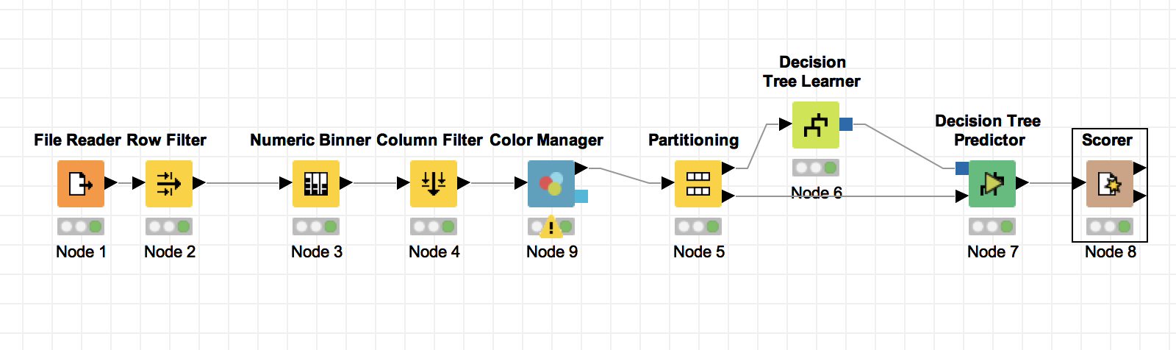

What makes a HighRoller vs. a PennyPincher?

Based on the structure of the decision tree, the users using iPhone are more likely to be HighRoller, while the users on the other platforms tend to be PennyPincher.

|  |
| --- |
| **Specific Recommendations to Increase Revenue** |
| 1. Compare the differences between the iOS app and the interface on the other platforms, and try to find the possible reasons (i.e. there might be some features only available on iPhone) why iOS users are more likely to spend more. |
| 2. After finding the possible reasons mentioned above, launch A/B testing for some new features accordingly on all the platforms except for iOS, and analyse which features could help to increase the revenue. |