**Evaluation**

A screenshot of the confusion matrix can be seen below:

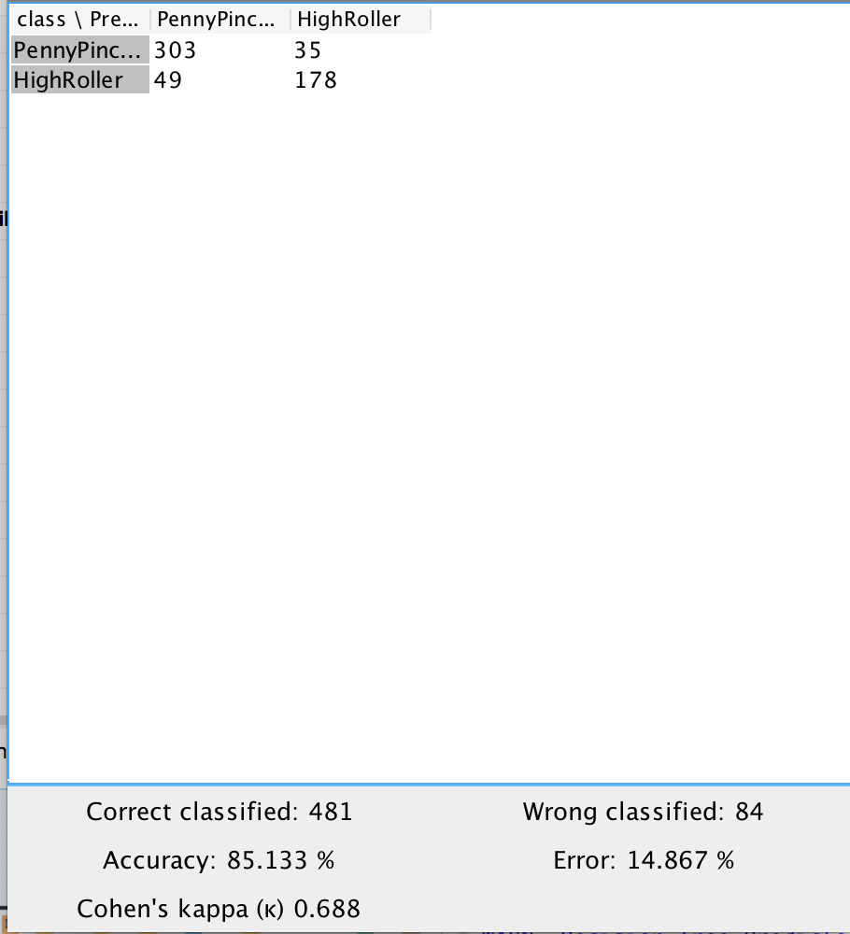

As seen in the screenshot above, the overall accuracy of the model is 85.133%

The value 303 at top-left cell means that 303 PennyPickers were correctly classified.

The value 35 at top-right cell means that 35 PennyPickers were incorrectly classified as HighRoller.

The value 49 at bottom-left cell means that 49 HighRollers were incorrectly classified as PennyPickers.

The value 178 at bottom-right cell means that 178 HighRollers were correctly classified.