**Nuclear Magnetic Resonance spectroscopy**

**Mohammad Mirsaeedi , Yasaman Nazemi**

**Department of physics , Sharif university of technology**

**Abstract**

NMR (Nuclear Magnetic Resonance) spectroscopy is one of the most popular tools to elucidate chemical structures of an unknown molecule . In practical application, NMR can also be used to validate new structures because it provides information about scalar coupling, which is an indirect interaction of the nuclei of atoms in a magnetic field.

**A short brief about physical concepts**

**scalar couplings**

J coupling constants (scalar couplings) obtained from an NMR spectrum contain information about relative bond distances and angles in a molecule. This is useful for determining the connectivity of atoms in a molecule.

J coupling is an indirect interaction between the nuclear spins of 2 atoms in a magnetic field. The number that comes before the J in the J coupling types (1J, 2J, 3J) denotes the number of bonds between the atoms that are coupling. So 1J, 2J, 3J coupling will have 1, 2, and 3 bonds between the atoms, respectively.

If we look at the distribution of the distance between atoms in the different types of coupling below, we can see that 1J has the lowest distance between atoms, and 3J has the highest distance between atoms, with 2J somewhere in the middle. The increase in bonds between atoms is observed as an increase in the distance between them. The distance feature contains information about the arrangement of atoms in space which could help a model predict the J coupling constant more accurately.

Some properties that affect the scalar coupling constant are:

dihedral angles — the angle between two intersecting planes

substituent electronegativities — the tendency of an atom to attract a shared pair of electrons)

hybridization of atoms — contains information about the number of atoms bonded and the coordination of the molecule

ring strain — instability in a molecule due to abnormal bonding angles found in a ring.

**Frequencies**

The Larmor fequency is specific to each nucleus. It is measured during the NMR experiment, as it is dependent on the magnetic field that the nucleus experineces.

**The Dataset**

In general, our goal is that we want to reconstruct the non-uniformly-sample nmr signals so that we can derive the nmr spectrum from them. This is important for us to be able to achieve good resolution in very low dimensions at low nmr, because as we know, there is more data in the high dimensions, and the reconstruction time increases, which is not desirable.

Here we have a signal in terms of time, which in our simulation problem is 4096 (which of course can be changed, but here we chose 4096 )

Next We use 256 of it as a Poisson function on random sampling. We use the Poisson function. Then we take this array of 4096 as a random sample of it. We can not get FFD from the array . The first way is to put 0 between these and then get FFD, which will reduces our resolution. There is a second way to use Deep learning, in this case all input signals are 256 and the output of all spectrum signals is 32000 . Here, our features are the amount of signals in each of those arrays that we chose randomly, and of course in this case we have 256 features with 32000 dimensional output. And physically, that means that we reduced the number of our samples to make the signal in less time. We generated our data using MATLAB and the spinach library, and the number of our samples is 100000.

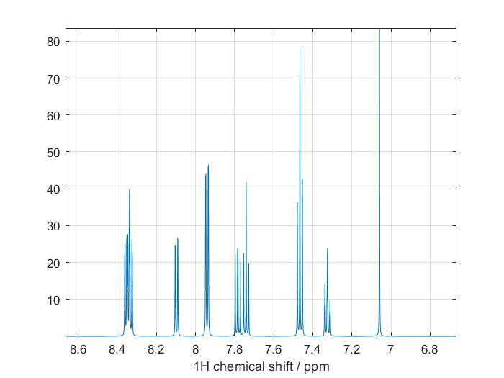

**Refrences**

1 - Compressed sensing: Reconstruction of non-uniformly sampled multidimensional NMR data by Mark Bostock and Daniel Nietlispach

2 - Using Deep Neural Networks to Reconstruct Non‑uniformly Sampled NMR Spectra by D. Flemming Hansen

3 - NMR signal processing, prediction and structure verification with Machine Learning techniques by Carlos Cobas