**Hyper Drive**

1. **Instructions for compiling and executing:**

* Locate index.html inside hyperdrive folder
* Open index.html in google chrome or firefix
* In browser right click 🡪 inspect element 🡪 console tab
* Click on “run simulation”

The 3D plot represents the best solution for the current simulation. Run simulation several times to get different results.

Outputs are shown in the console.

I implemented the hyperdrive in JavaScript to get the plot of the final result and 1000 outputs.

1. **Plot:**

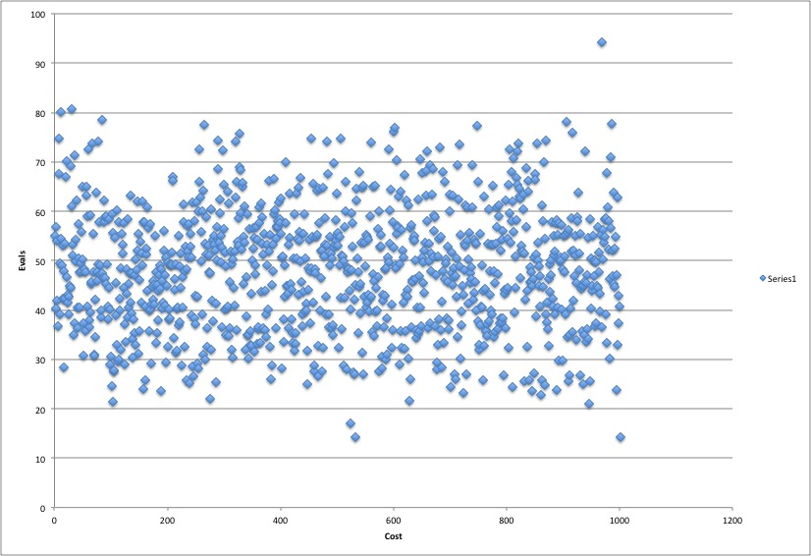

1. **Explanation:**

Based on the initial starting point and the number of neighbours that are generated and evaluated there might be unexplored points that has less cost.

Based on the evals which shows the complixity of the search problems and considering to the whole space there are many unexplored points which is not cover the whole space so there might be better solutions that are not discovered due to our random initials we search amongst the neighbours by one hamming distance of the initial point to find the minimum and repeat the same to get the minimum cost of the neighbours until there is no other min cost points left.

The greedy descent algorithm is based on cost to find the better solution and the min cost is based on the random initial point. So the effectiveness of the algorithm is based on where is the initial point. Using another algorithm to optimize initialize points would make the cost of search algorithm less.