AGENDA: Integration of multiple payment on client – socialmediapulsemonitor

Multiple payment gateways to be implemented:

1. Paypal
2. Square
3. Stripe
4. Google pay
5. Apple pay
6. Razorpay
7. Paytm
8. Pay-U

Requirements:

1. Website is not secure (convert to https)
2. SSL (Secure Socket layer) certificate or a TLS domain-validated certificate must be installed.
3. A supported payments gateway or a Payment Card Industry Data Security Standard (PCI DSS) compliant server environment that's suitable to store decrypted payment information

Payment gateway integration technique

1. 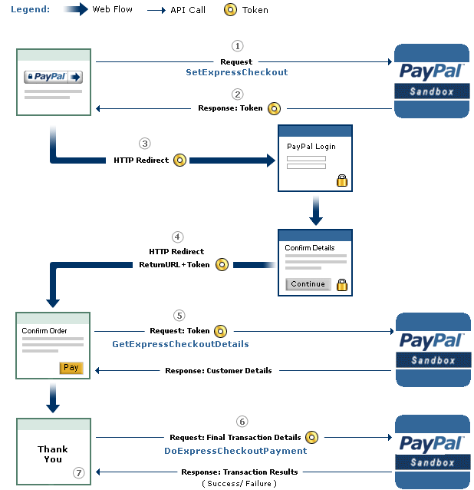Paypal

2: