|  |
| --- |
| Software Requirements Specification for Grade Performance Analyzer |
| Version 1.0  Prepared by A.Y Dissanayake |
|  |



DJ Grader

Index No: 120126K Date: 12/07/2015

Table of Contents

1. Introduction 3

1.1 Purpose 3

1.2 Scope 3

1.3 Definitions, Acronyms, and Abbreviations 3

1.4 References 3

1.5 Overview 3

2. Overall Description 3

3. Specific Requirements 3

3.1 Functionality 3

3.2 Usability 3

3.3 Reliability 3

3.4 Performance 3

3.5 Supportability 3

3.6 Design Constraints 3

3.7 On-line User Documentation and Help System Requirements 3

3.8 Purchased Components 3

3.9 Interfaces 3

3.9.1 User Interfaces 3

3.9.2 Hardware Interfaces 3

3.9.3 Software Interfaces 3

3.9.4 Communications Interfaces 3

3.10 Licensing Requirements 3

3.11 Legal, Copyright, and Other Notices 3

4. Supporting Information 3

|  |
| --- |
| Introduction |

This project is about to make an application which can visualize student’s performance at their examinations and according to that predict what would be the next result he will get. And also this application can visualize by graphs the standards of that student by comparing other student’s results.

## Purpose

The basic purpose of this application is improving the grades of students at the examination. According to current situation student can’t have any idea about his grades until he write the exam. By this application student can have early warning about their low performance and he has time to improve it before he fails any examination or any interviews. This application should be very accurate when doing future prediction. Since I intend to use 2 algorithms and considering their accuracy again assign weights for them and do linear regressions again. I intend to use graphical method to show outputs such as comparison of result to make easy of understanding.

## Scope

In present situation in universities because of the heavy work load university lectures has no time to analyze their student’s progress personnel. Then he can’t give some warning to their student before the examination to improve their academic work. Because of that probability of getting low marks at examination became high. It affects both lectures as well as student. And also when giving recommendation it is useful for get some idea about that student. Since scope of this application is lectures in universities.

## Definitions, Acronyms, and Abbreviations

|  |  |
| --- | --- |
| **Term** | **Definition** |
| Polynomial Regression: | **Polynomial regression** is a form of linear **regression** in which the relationship between the independent variable x and the dependent variable y is modeled as an nth degree **polynomial**. |
| Locally weighted regression | **Locally weighted regression** (LWR) is a memory-based method that performs a **regression** around a point of interest using only training data that are ``**local**'' to that point. |
| curve fitting | **Curve fitting** is the process of constructing a **curve**, or mathematical function that has the best **fit** to a series of data points, possibly subject to constraints. |
| fast fourier transform | A **Fast Fourier Transform** (**FFT**) is an algorithm to compute the discrete **Fourier transform** (DFT) and its inverse. This showed how fitting the Fourier transform to the S&P 500 index data series produced a perfect curve-fit on past data, giving the illusion that this technique would predict the major turning points of the S&P 500.  Meyers.gif |
| Hidden Markov models | A **hidden Markov model** (**HMM**) is a statistical **Markov model** in which the system being modeled is assumed to be a **Markov** process with unobserved (**hidden**) states. A **HMM** can be presented as the simplest dynamic Bayesian network. The mathematics behind the **HMM** was developed by L. E. Baum and coworkers.  2000px-HiddenMarkovModel.svg.png |

## References

[1] [https://en.wikipedia.org/wiki/**Polynomial**_**regression**](https://en.wikipedia.org/wiki/Polynomial_regression)

[2] [www.cs.cmu.edu/afs/cs/project/jair/pub/volume4/cohn96a.../node7.html](http://www.cs.cmu.edu/afs/cs/project/jair/pub/volume4/cohn96a.../node7.html)

[3] [https://en.wikipedia.org/wiki/**Curve**_**fitting**](https://en.wikipedia.org/wiki/Curve_fitting)

[4]<http://traders.com/Documentation/FEEDbk_docs/1999/05/Abstracts_new/Meyers/Meyers9905.html>

[5][*https://en.wikipedia.org/wiki/****Hidden****_****Markov****_****model***](https://en.wikipedia.org/wiki/Hidden_Markov_model)

## Overview

The remainder of this document includes two chapters. The second one provides an overview of the system functionality and system interaction with other systems. Further, the chapter also mentions the system constraints and assumptions about the product.

The third chapter provides the requirements specification in detailed terms and a description of the different system interfaces. Different specification techniques are used in order to specify the requirements more precisely for different audiences.

# 

|  |
| --- |
| General Description |

This section will provide an overview of the system as a whole. Here it will be explained how the system behaves in its context and interacts with other systems, the external interfaces and the basic functionalities. It will also describe what type of stakeholders will be using the system and what functionality is available for each type of them. Finally, the constraints and assumptions for the system will be presented.

## Product Perspective

This system is for university lectures. By this system lectures can continuously add their student’s marks on examinations as well as including other writing examinations mid exams and in class exams. Then system store those values and analyze them using "curve fitting" using "Locally weighted linear regression" (allocate different weights for end examinations > Mid Examinations > In-class Assignments) for analyzing their work on their activities for make this more accurate. I intend to use Fast Fourier Transformation base prediction algorithms since there are some cases unusual result may happen (ex: when student was sick at the examination), then those values should be ignored when considering his usual pattern of examination marks.

I intend to take more accurate prediction on student’s likely grade in an exam by taking prediction in both ways and get average value. For comparison with other student who has registered with that system for same course I propose to use graphical representation of performances with respect to multiple variables. As a second part another analysis can be to assess how each course module depends on each other, how they impact each other for the performance of the student. For this, a correlation between grades (CA and exam) can be taken. Further, predicting results of a subject based on the performance of the other subjects, Hidden Markov models can be used and also can add some time series calculations to predict future results based on past activity as mentioned before.

**Uses of Curve fitting and locally weighted linear regression**

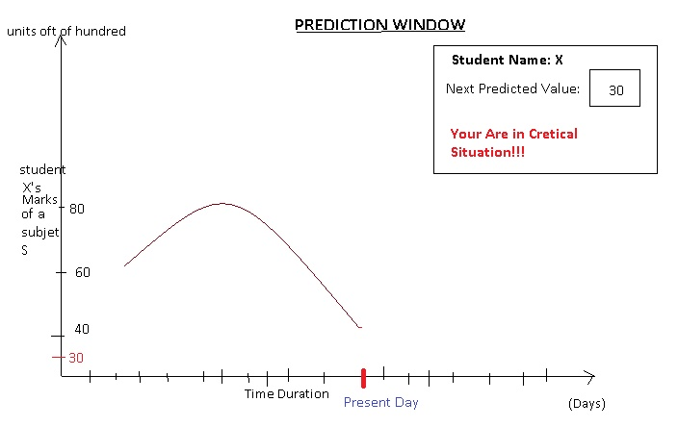

.

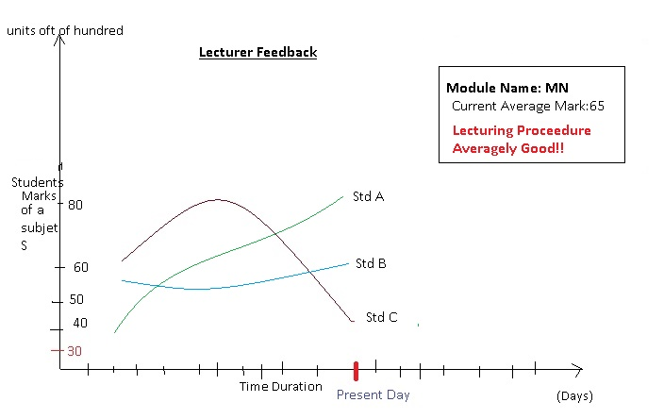

**Uses of Hidden Markov Model**

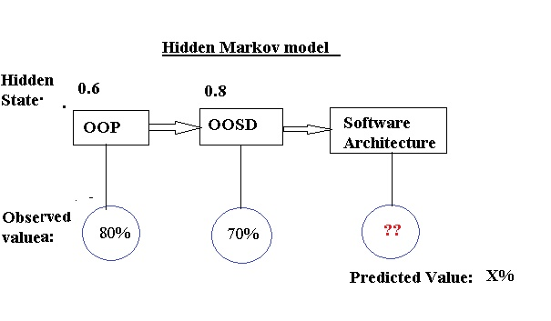

## Product Functions

## User Characteristics

The general users of the app university lectures and teachers who really need to have to get continues progress of their lectures (E.g.: the way of lecture should change if average progress of student is too low) and Lectures who have to give recommendation on students. And also using Hidden Markov Model lecture can decide whether that student is suitable for that course before they enroll that module. Because of that lecture can reduce the percentage of failure student in his module.

.

## Assumptions and Dependencies

The first important assumption is that the application always runs on a device with enough resources. If the required amount of memory or any other resource is not available (A large amount of memory being used by the user for other applications) there may be incidents where the app is not working properly.

|  |
| --- |
| 3 Specific Requirements |

This section provides a detailed description of the functional and quality requirements of the system. It explains the system and all its features in deep.

## Functional Requirements

This section describes specific features of the software project. It consists of the fundamental functionalities of the application.

### Personalization

Description: Provide facility to store marks in database within that particular academic time. After time period they can delete tables or can store it for next semesters.

### Data Reporting

Description: The data recorded on the database can be represented using graphs showing the progress of the students over time. It will show the variation of the marks over time as well as different students.

### Data Entry

Lectures manually enter the data to the system if they are not already in database.

## Non-Functional Requirements

Discussed below are the non-functional requirements associated with the app. These requirements need to be achieved at an overall system level rather than at a unit level.

## 3.1 Functionality

### System should be efficient when calculating output

User should not wait for a long time to and display those outputs

### System should occupy low memory

Since this is for individual user for single use, if this system takes high memory then users may refuse to use this system.

## 3.2 Usability

### System should be user friendly and very low in training time

Since this system is for both school and university lectures we could not expect to have good knowledge in software handling from them. Therefore all guidelines should be given and UI should be very clear for use.

## 3.3 Reliability

### System should be well accurate

When calculating the prediction the system should be more accurate. And also it needed when taking the decision on course successfulness or fail in particular course.

## 3.4 Performance

### Response time should be very high

### Resource utilization low

Resource utilization, such as memory, disk, communications etc. should be very low since this system use in single computer

## 3.5 Supportability

### System should provide well guideline

Since this is for student which has no good knowledge on software system should be user friendly.

## 3.6 Design Constraints

This section indicates any design constraints on the system being built. Design constraints represent design decisions that have been mandated and must be adhered to.

### 3.6.1 Software languages

Since this is the scientific and mathematical system I used python for this system fom make more accuracy

### 3.6.2 Software process requirements

As a processes requirement of the system I used previous batch data

### 3.6.3 Prescribed use of developmental tools

I used JetBrain PyCharm IDE for this system and several mathematical frameworks like math plot library, Unittesting etc.

### 3.6.4 Class libraries

Math plot lib, Image PLT, Py Unit

## 3.7 User Documentation

Describes the requirements, if any, for o-line user documentation, help systems, help about notices, and so forth.

## 3.8 Purchased Components

For this system I never use any purchased item only lisened IDE which freely issued for students are been used.

## 3.9 Interfaces

This section defines the interfaces that must be supported by the application. It should contain adequate specificity, protocols, ports and logical addresses, and the like, so that the software can be developed and verified against the interface requirements.

### 3.9.1 User Interfaces

There are several UI for entering data of a students like grades and index numbers

### 3.9.2 Software Interfaces

There is no any other software interfaces since this is a standalone system

## 3.10 Licensing Requirements

When entering the other student marks to the data base system user should have permission on university

## 3.11 Legal, Copyright, and Other Notices

For this system I used currently used logo then that should have copyright permission. Other libraries are open source and then they did not need permission.

## 4 Applicable Standards

Since this system for lecturer personnel usage this system does not have any international standard. But the privacy of the data should be protected since the current legal situation of the university it is not allowed to published other marks to other student.

***************************End of Document*********************************