Top 200 ranks which calculated from 7 algorithms

all plots of re-tweet+favorite vs age

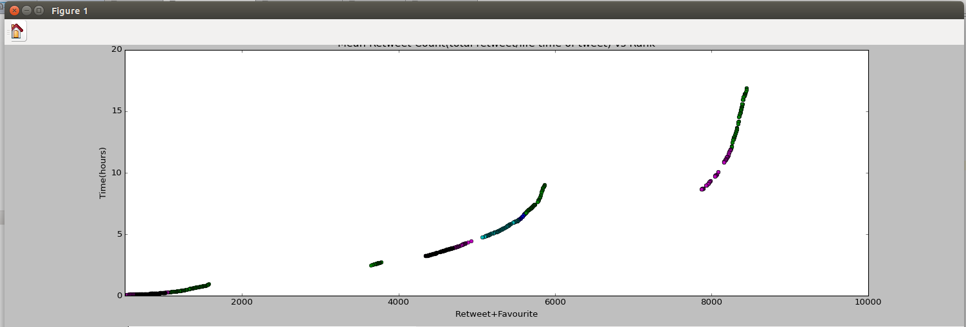

Used Formulas

cyan-math.log((Ft+2*Rt))-(float(diff)/105000)

red-(13000*math.log((Ft+2*Rt))-100*(float(diff)/892800)-25000*math.log(float(1.1-math.exp(-1*float(diff)/892800))))

blue-0.75*math.log((Ft+2*Rt))-(float(diff)/259280)

green-(2.2*math.log((Ft+2*Rt))-(float(diff)/95590)-0.9*math.log(float(1.00001-math.exp(-1*float(diff)/95590))))

magenta(Hacker News Formula)-calculate_score((Ft+2*Rt),(int(diff)/(60*60)),1.8)
def calculate_score(votes, item_hour_age, gravity=1.8):
return (votes - 1) / pow((item_hour_age+2), gravity)

yellow-(1.8*math.log((Ft+2*Rt))-(float(diff)/95590)-math.log(float(1.00001-math.exp(-1*float(diff)/95590))))

Black-(math.log((Ft+2*Rt))-(float(diff)/95590)-0.5*math.log(float(1.00001-math.exp(-1*float(diff)/95590))))

Plot of Lowermost (1st in acceding)rank of all algorithms

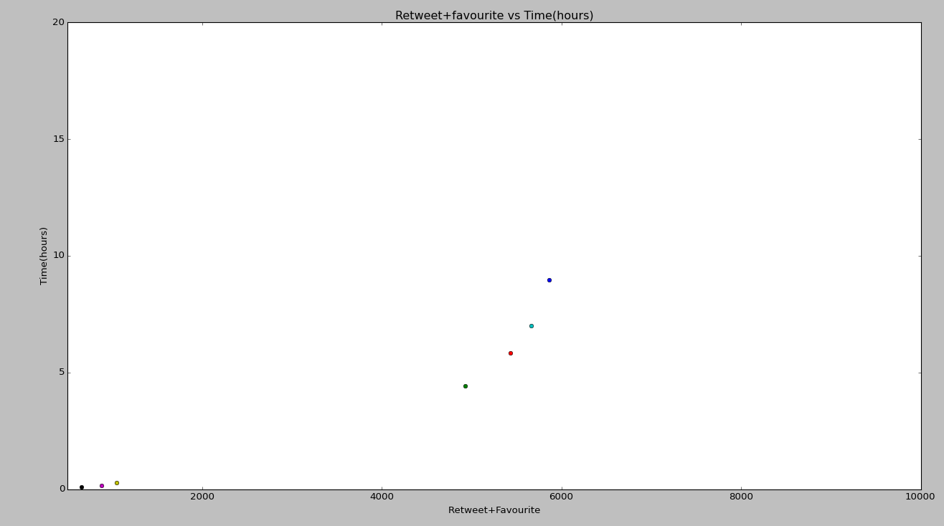

Plot of Uppermost(200th in acceding) rank of all algorithms
