tem=(13000*math.log((Ft+2*Rt))-100*(float(diff)/892800)-25000*math.log(float(1.1-math.exp(-1*float(diff)/892800))))

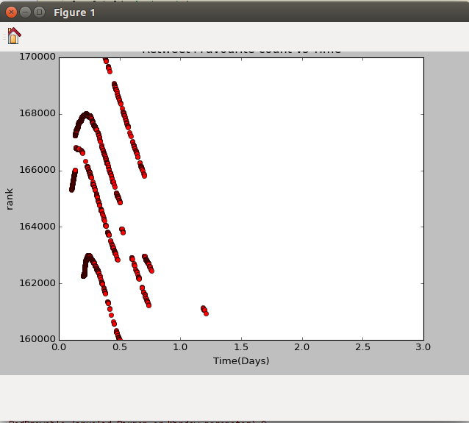
Age (Days) vs Rank graph

Retweet count vs Rank Graph

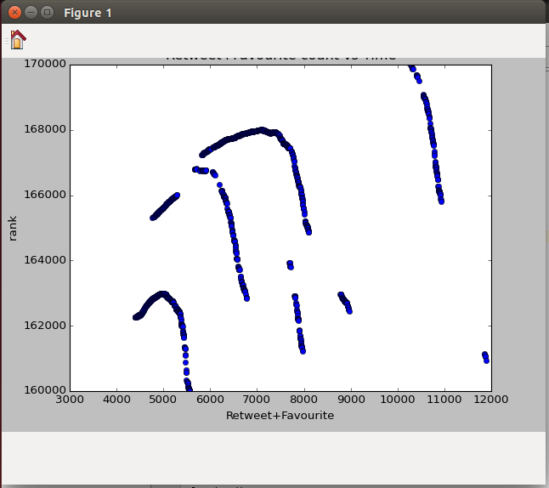

Retweet vs age graph for top 200

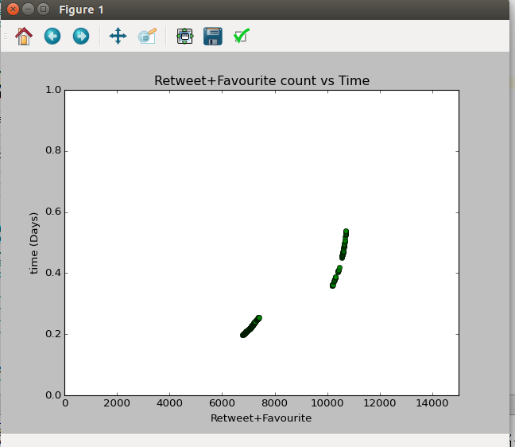

for top 200 cutoff values:
re-tweets: 6780-10717
age:0.5378009259259259 -0.19708333333333333 days

-----------------------------------------------------------------------------------------------------------------------

tem=0.75*math.log((Ft+2*Rt))-(float(diff)/259280)

Retweet count vs Rank Graph
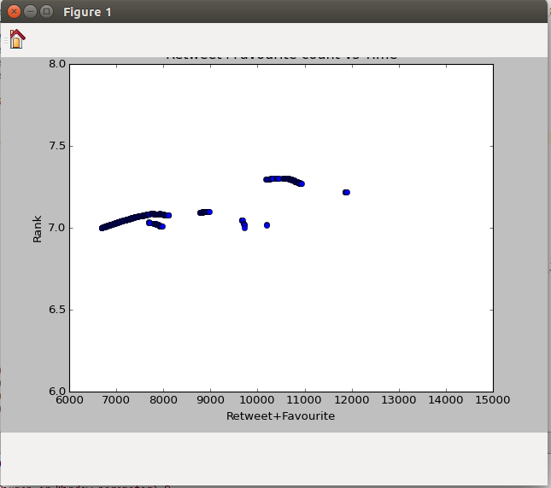

Age (Days) vs Rank graph
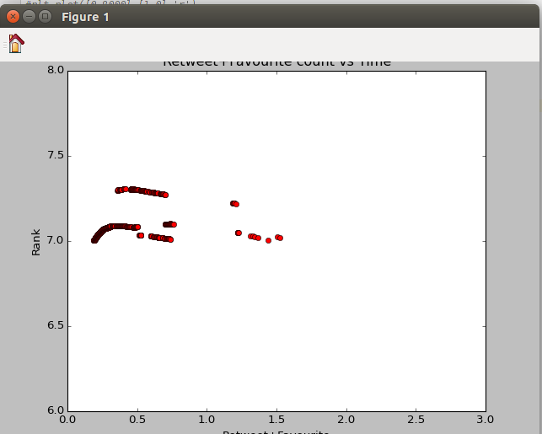

Retweet vs age graph for top 200

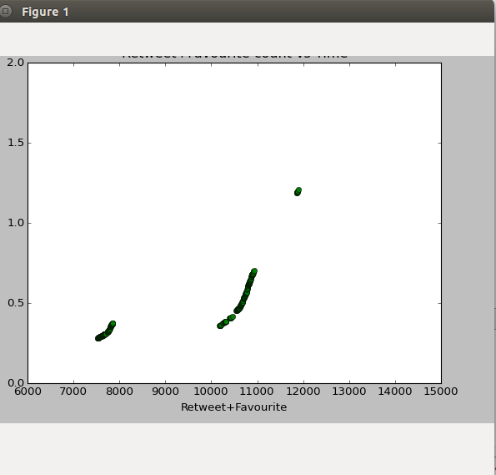

for top 200 cutoff values:
re-tweets: 7529-11893
age:0.2798148148148148 -0.1.209074074074074 days

---------------------------------------------------------------------------------------------------------------------
tem=(2.2*math.log((Ft+2*Rt))-(float(diff)/95590)-0.9*math.log(float(1.00001-math.exp(-1*float(diff)/95590))))

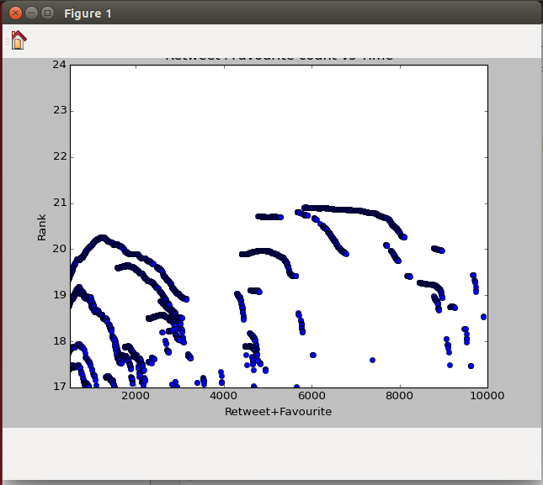
Retweet count vs Rank Graph

Age (Days) vs Rank graph

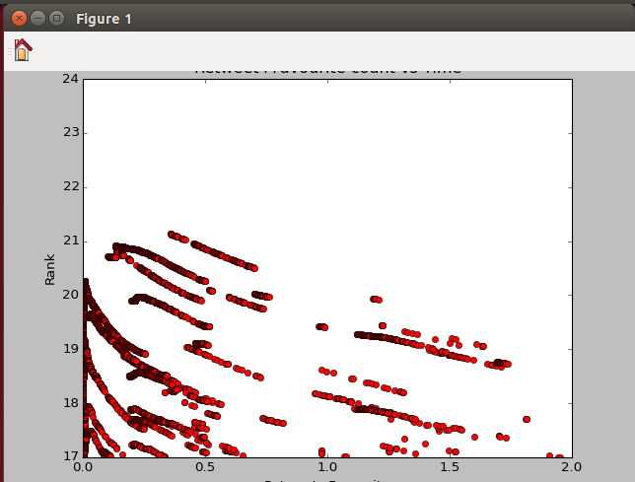

Retweet vs age graph for top 200

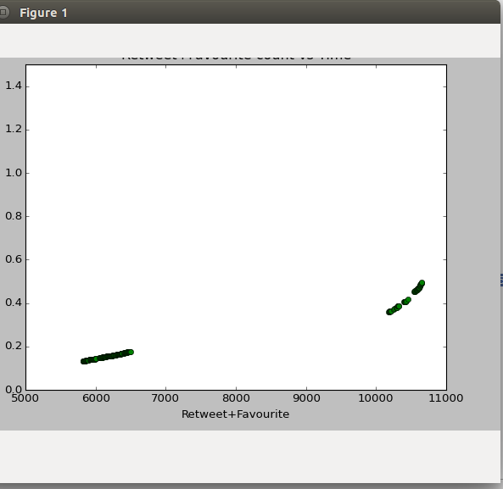

for top 200 cutoff values:
re-tweets: 5821-10655
age:0.1338888888888889-0.4948726851851852 days
-----------------------------------------------------------------------------------------------------------

tem=math.log((Ft+2*Rt))-(float(diff)/105000)
Retweet count vs Rank Graph

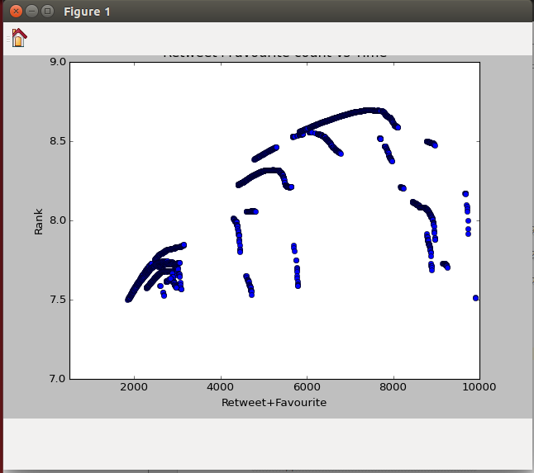

Age (Days) vs Rank graph
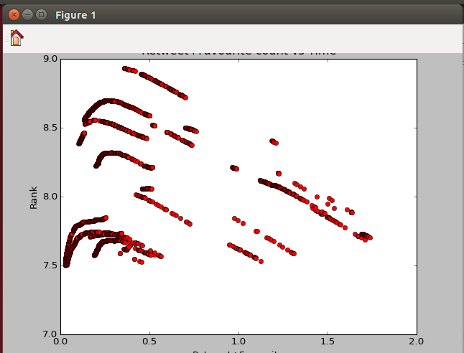

Retweet vs age graph for top 200

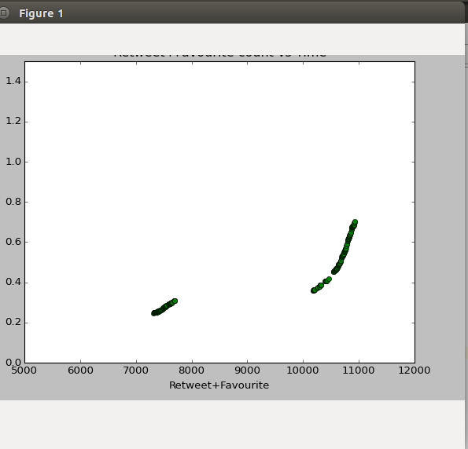

for top 200 cutoff values:
re-tweets: 7321-10929
age:0.2477662037037037-0.7030671296296296 days

