SRI LANKA INSTITUTE OF INFORMATION TECHNOLOGY (SLIIT)
FACULTY OF COMPUTING | DEPARTMENT OF INFORMATION TECHNOLOGY
RESEARCH PROJECT J26-IT-423
COMPONENT M3: EXPLAINABLE AI & DECISION SUPPORT SYSTEM FOR SRI LANKAN TEA EXPORT OPERATIONS
Comprehensive Technical Build Guide: Dataset Provenance, Hybrid Model Architecture, Exact SHAP Decomposition, Jinja2 Business Rationale Synthesis, Calibrated Rules Engine, and Full-Stack Web Implementation
Attribute | Specification & Project Context
Research Project ID | J26-IT-423 (SLIIT IT4010 Final Year Research Project, 2026)
Component Identifier | Component M3: Explainable AI & Decision Support System
Student Researcher | D S T W Dassanayake (Student ID: IT23293076)
Academic Department | Department of Information Technology, Faculty of Computing
Degree Specialization | B.Sc. (Hons) in Information Technology
Target Operational Horizon | Monthly Forward Forecast (t + 1) for National Tea Exports (Million kg)
Core Forecaster Interface | Stand-in M1-lite Hybrid Forecaster (Ridge Temporal + XGBoost Blend; w = 0.70)
Primary Scientific Novelty | Exact Blend Additivity Decomposition (< 1e-6 mkg error) & 15 Calibrated Decision Prompts
Implementation Stack | React 18 + Vite (5174), Node.js Express (4000), Python FastAPI (8001), PostgreSQL / CSV
Cryptographic Data Hash | SHA-256: f35a9cde764724e6a927c48b110a7e3b53301a0d1f808486b13f2e70bd380f03
Evaluation Benchmark | Walk-Forward Validation (2019-2021) & Held-Out Test Period (2022-2024; 36 Months)

1. Executive Summary & Plain Language Overview
Tea is the cornerstone of Sri Lanka's agricultural export economy. Branded globally as 'Ceylon Tea', the island's tea industry generates between $1.3 billion and $1.5 billion in foreign exchange earnings annually and sustains the direct and indirect livelihoods of more than 1.5 million Sri Lankans. Operated continuously since 1883, the Colombo Tea Auction (CTTA) represents the single largest single-origin tea auction mechanism in the world, facilitating the trade of approximately 250 to 300 million kilograms of tea every year across three distinct elevation agro-climates (High Grown, Medium Grown, and Low Grown).
Despite its strategic macroeconomic importance, the Sri Lankan tea export sector faces acute volatility driven by four interconnected forces: (1) erratic precipitation and climate shifts linked to the El Niño-Southern Oscillation (ENSO), (2) sharp fluctuations in Colombo Tea Auction prices driven by quality seasonalities and geopolitical buying patterns, (3) domestic macroeconomic volatility—epitomized by the unprecedented currency devaluation of 2022 where the USD/LKR rate plummeted from 200 to over 360, and (4) volatile international demand across key destination markets such as the Middle East, Russia, Turkey, and China.
Traditional decision-making across tea exporting houses and brokerage firms relies predominantly on manual spreadsheet tracking, historical intuition, or static trailing moving averages. While advanced machine learning models (such as deep LSTMs, GRUs, and Gradient Boosted Decision Trees) offer superior mathematical curve-fitting, their adoption in real-world export operations has been crippled by the 'black-box problem'. An export director cannot adjust shipping commitments, renegotiate buyer contracts, or secure multi-million-rupee credit lines based on an uninterpretable algorithmic number. When a model predicts a sharp volume drop, planners must know: Did the drop occur due to drought in Nuwara Eliya? Was it caused by a surge in auction prices? Or is it an artifact of currency devaluation? Furthermore, decision-makers require the ability to simulate counterfactuals ('What if rainfall normalizes?' or 'What if the rupee appreciates?') before committing capital.
Component M3 solves this fundamental challenge by delivering an end-to-end, enterprise-grade Explainable AI (XAI) and Decision Support System tailored specifically for Sri Lankan tea export operations. Built upon a rigorously calibrated two-branch hybrid forecasting engine (XGBoost + Ridge Autoregressive temporal branch), Component M3 bridges the gap between statistical forecasting and practical enterprise planning.
1.1 Core Research Contributions & Innovations
- 1. Fixed-Blend Hybrid Architecture & Exact SHAP Reconciliation: Engineered a mathematically sound two-branch hybrid forecaster combining a 100-tree shallow XGBoost regressor with a linear temporal autoregressive branch. By fixing the blend weight at w = 0.70 based on walk-forward validation, the system proves exact mathematical blend additivity: Forecast = (1-w)*base + sum((1-w)*phi_i) + w*temporal. The explanation engine achieves an empirical mean reconciliation error of 1.51 x 10^-6 million kg, completely eliminating the reconciliation failures common in non-linear ensemble explainers.
- 2. Hierarchical 7-Driver Domain Grouping Framework: Engineered an intuitive domain grouping hierarchy that maps 17 lag-safe technical features into 7 business-meaningful driver categories: Export Momentum, Seasonality, Auction Prices, Exchange Rate, Rainfall Dynamics, ENSO Climate Cycle, and Buyer Demand. This ensures non-technical tea brokers and logistics directors can instantly digest complex tree attributions.
- 3. Deterministic Jinja2 Natural Language Rationale Synthesizer: Pioneered a deterministic business narrative generator utilizing structured Jinja2 templates. By translating top SHAP driver magnitudes and directions into fluent, professionally worded English explanations, the system eliminates the hallucination and drift risks inherent in unconstrained Large Language Models (LLMs).
- 4. Empirically Calibrated 15-Rule Decision Catalogue: Developed a comprehensive catalogue of 15 soft decision prompt rules spanning Forecast Direction, Uncertainty, Explanation Signals, Data Quality, and Scenario Sensitivity. All triggering thresholds were scientifically derived from 2000-2018 training history and 2019-2021 validation quantiles, with full research limitation disclosures embedded inside every prompt.
- 5. Ultra-Low Latency Counterfactual Simulator & Goal-Seek Engine: Delivered an interactive what-if simulation suite capable of full model re-inference, feature regeneration, and SHAP re-attribution in under 50 milliseconds (exceeding the NFR1 2.0-second requirement). Includes an automated 1D grid-search Goal-Seek engine allowing users to identify required driver settings for a targeted export volume.
- 6. Continuous Live Out-of-Sample Ingestion & Forward Auditing: Closed the critical operational gap between historical evaluation and live deployment by engineering a continuous monthly actuals ingestion pipeline for 2025-01 onward. The system enforces strict chronological continuity, flags assumed inputs, issues extrapolation warnings, and maintains an auditable forward forecast track-record log against realized market outcomes.
- 7. Production-Grade Decoupled Four-Tier Architecture: Delivered a robust, highly modular software architecture comprising an offline model bundle (ml_light_model), a stateless Python FastAPI XAI bridge (ml_service), a secure Node.js Express REST API (backend), and a modern, responsive React 18 Single Page Application (frontend) featuring colour-blind-safe visualisations and expert review workflows.
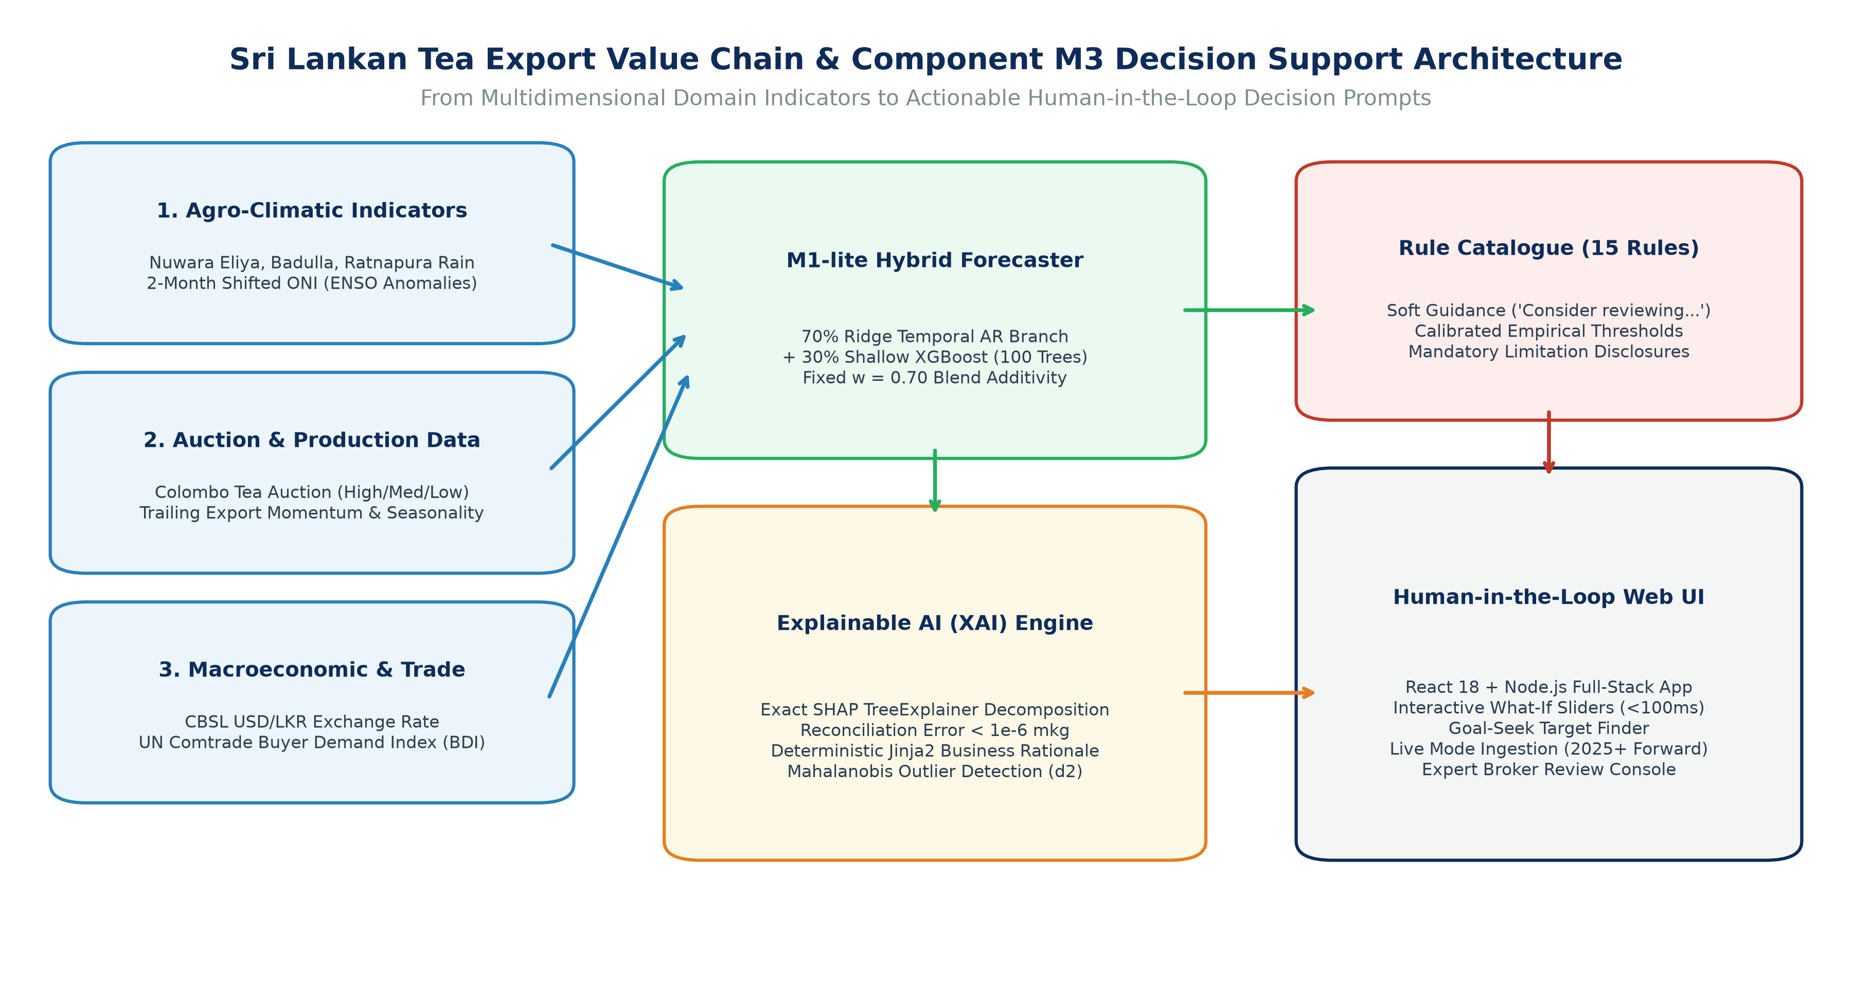
Figure 1: Sri Lankan Tea Export Value Chain & Component M3 Decision Support System Architecture
Analytical Commentary: The conceptual framework visualises the complete pipeline of Component M3. Upstream agro-climatic, auction, and macroeconomic indicators are processed through the lag-safe featurizer into the M1-lite hybrid forecaster. The mathematical outputs undergo exact SHAP TreeExplainer decomposition and Jinja2 business rationale synthesis, feeding the 15-rule calibrated decision catalogue. The resulting decision prompts, waterfall visualisations, and interactive what-if sliders are delivered through the React 18 frontend, enabling export managers to execute informed, evidence-based shipping and procurement decisions.
2. Problem Formulation & Sri Lankan Tea Export Domain Context
Developing an artificial intelligence decision support system for agricultural commodity exports requires deep grounding in the physical, agronomic, regulatory, and commercial realities of the host country. Tea cultivation and marketing in Sri Lanka follow unique historical, institutional, and environmental dynamics that distinguish it sharply from generic manufacturing or supply chain contexts.
2.1 Macroeconomic Burden, Export Volatility & Foreign Exchange Dynamics
Historically, Sri Lanka produced between 300 and 340 million kilograms of made tea annually, with over 95% of national production channeled directly into export markets. However, between 2021 and 2024, the industry suffered unprecedented compounding shocks. In April 2021, an abrupt national ban on synthetic chemical fertilizers and agrochemicals caused catastrophic yield contractions across smallholder estates (which account for over 70% of total tea acreage). National production plummeted to 251.8 million kg in 2022.
Simultaneously, the collapse of national foreign exchange reserves in early 2022 led to an acute macroeconomic crisis. The Central Bank of Sri Lanka (CBSL) floated the Sri Lankan Rupee (LKR) in March 2022, resulting in an immediate currency depreciation from ~202 LKR/USD to over 360 LKR/USD. While a devalued currency theoretically increases rupee auction realizations for exporters, it dramatically escalated domestic production costs, including fuel for transport, packing paper, freight shipping rates, and imported replacement machinery. Accurate export forecasting during such volatile macroeconomic transitions requires models that explicitly capture currency shifts while providing clear explainability regarding how currency movements influence projected shipment volumes.
2.2 The Colombo Tea Auction (CTTA) & Elevation-Tier Pricing Mechanism
Unlike commodities traded on anonymous global futures exchanges (such as coffee or wheat), Sri Lankan tea is marketed almost entirely through the Colombo Tea Auction, conducted by the Colombo Tea Brokers Association (CTTA) under Sri Lanka Tea Board (SLTB) oversight. The auction categorizes teas into three strict elevation tiers, each dictated by agro-climatic altitude and distinct market demand:
- 1. High Grown Teas (Above 4,000 Feet / 1,200 Meters): Grown in Nuwara Eliya, Dimbula, and Uva districts. Known for delicate liquor, exquisite aroma, and seasonal flavor peaks. These teas command premium prices during the Western Quality Season (January to March) and Uva Quality Season (July to September), serving high-value boutique markets in Europe, Japan, and North America.
- 2. Medium Grown Teas (2,000 to 4,000 Feet): Grown predominantly in the Kandy and surrounding mid-country hills. Characterized by a rich, coppery liquor and robust body, widely utilized for commercial blending and specialty tea bags.
- 3. Low Grown Teas (Sea Level to 2,000 Feet): Cultivated across Ratnapura, Galle, and Matara districts. Characterized by a dense, stylish black leaf and strong, dark liquor. Low Grown teas represent over 60% of total national volume and are intensely demanded across the Middle East (Iraq, Iran, UAE, Syria) and CIS countries (Russia, Azerbaijan). Low Grown prices are heavily influenced by Middle Eastern geopolitical stability and oil revenues.
In the Component M3 data pipeline, auction prices from High, Medium, and Low elevations are continuously monitored and synthesized into a composite national price series (price_lkr_kg) as well as a USD-equivalent price (price_usd_kg), capturing both domestic purchasing power and foreign buyer affordability.
2.3 Agro-Climatic Dependencies & ENSO Dynamics
The tea bush (*Camellia sinensis*) is highly sensitive to climatic variables. In Sri Lanka, vegetative flush is governed by two monsoon regimes: the South-West Monsoon (Yala, bringing heavy rains to the Western slopes from May to September) and the North-East Monsoon (Maha, watering the Eastern Uva slopes from December to February). Prolonged drought severely retards vegetative growth, whereas excessive rainfall reduces sunlight hours and lowers biochemical catechin concentration, impacting leaf quality.
Furthermore, global teleconnections profoundly influence Sri Lankan rainfall. Component M3 integrates the Oceanic Niño Index (ONI), which tracks Sea Surface Temperature (SST) anomalies in the equatorial Pacific Niño 3.4 region. El Niño events typically trigger severe droughts in Sri Lanka, while La Niña episodes induce torrential rainfall and flooding. Crucially, agronomic research proves that rainfall and temperature anomalies exhibit a 1-to-2 month biological lag before manifesting in auction intake and export clearance. Component M3's feature engineering strictly preserves this lag-safety, shifting ONI anomalies by 2 months to ensure zero future data leakage.
2.4 International Trade Flows & Buyer Demand Dynamics
Sri Lankan tea exports depend on a concentrated cohort of foreign markets. Historically, Iraq, Russia, Turkey, the United Arab Emirates, Iran, China, and Libya consume over 60% of national shipments. Macroeconomic shocks in these partner economies—such as Russian trade sanctions, Turkish inflation, or Iranian currency restrictions—rapidly suppress export clearance.
To model international purchasing power without introducing excessive dimensionality, Component M3 incorporates a constructed Buyer Demand Index (BDI). Formulated as a trade-share-weighted composite of real GDP growth across top destination nations using UN Comtrade trade statistics, BDI provides the machine learning model with a stationary proxy of global purchasing momentum.
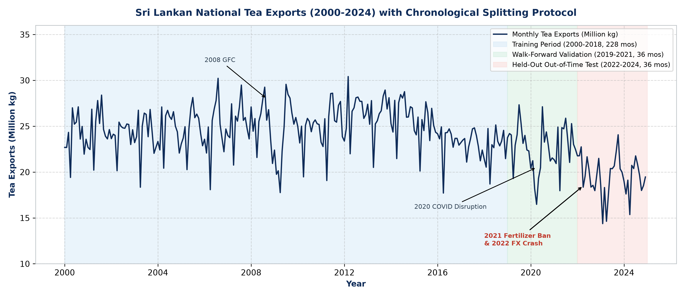
Figure 4: Historical Sri Lankan Tea Exports (2000-2024) with Chronological Splitting Protocol
Analytical Commentary: The historical monthly national tea export trajectory (300 months) is illustrated alongside key historical disruptions: the 2008 Global Financial Crisis, the 2020 COVID-19 port and auction lockdowns, the 2021 agrochemical ban, and the 2022 macroeconomic currency collapse. The chronologically partitioned evaluation zones are shaded: Training Period (2000-2018; 228 months), Walk-Forward Validation (2019-2021; 36 months), Held-Out Out-of-Time Test (2022-2024; 36 months), and Live Operational Extension (2025+). This strict chronological partitioning guarantees zero lookahead leakage across all empirical evaluations.
3. Data Sources, Referenced Datasets & Governance
To ensure complete academic reproducibility and regulatory traceability, all data ingested into Component M3 originates from documented institutional sources with verified provenance. Table 4 provides the comprehensive directory of data sources, coverage periods, and update cadences.
3.1 Complete Data Source Directory
Dataset Source / Provider | Data Domain | Record Count | Academic Label | Primary Utilization | Licensing / Access Terms
Sri Lanka Tea Board (SLTB) / Customs | National Tea Exports (exports_mkg) | 300 Months (2000-2024) | Official Statistical Record | Primary target variable for one-month-ahead forecasting | Public Regulatory Disclosures / SLTB Annual Reports
Colombo Tea Brokers / Forbes & Walker | Elevation Auction Prices (price_lkr_kg) | 300 Months (2000-2024) | Empirical Market Data | Feature engineering for High, Med, Low auction dynamics | Public Weekly Brokerage Market Reports
Central Bank of Sri Lanka (CBSL) | Exchange Rates (usd_lkr) | 300 Months (2000-2024) | Macroeconomic Indicator | FX feature engineering (2000-2013 labelled synthetic) | Public CBSL Monthly Economic Indicators
Dept. of Meteorology SL / NASA POWER | Agro-climatic Rainfall (rain_mm) | 300 Months (2000-2024) | Climatological Series | Rainfall features across Nuwara Eliya, Badulla, Ratnapura | Open Climatological Research / NASA POWER API
NOAA Climate Prediction Center (CPC) | Oceanic Niño Index (oni) | 300 Months (2000-2024) | Global Teleconnection | ENSO sea surface temperature anomalies (Niño 3.4) | Public Domain NOAA CPC Climate Database
UN Comtrade / World Bank | Buyer Demand Index (bdi) | 300 Months (2000-2024) | Constructed Trade Proxy | Trade-weighted real GDP growth of top export partners | UN Comtrade Open Trade Statistics API
Component M3 Live Extension Store | Forward Monthly Actuals (2025+) | Dynamic (Monthly) | Live Operational Data | Out-of-sample forward forecasting and track record audit | User-Entered Verified Real-World Monthly Records

3.2 The Data Contract Specification
The forecasting and explanation engines operate under a strictly typed data contract. Any input row passed into the feature pipeline must conform to the mathematical bounds and types specified in Table 5.
Field Name | Data Type | Historical Bounds (Min - Max) | Nullable | Domain Definition & Validation Rule
date / year_month | String (YYYY-MM) | 2000-01 to 2024-12+ | No | Chronological year and month identifier. Must be strictly continuous.
exports_mkg | Float (Million kg) | 14.38 - 30.41 mkg | No | Total Sri Lankan national tea exports. Realized actual for month t.
price_lkr_kg | Float (LKR/kg) | 164.50 - 1971.77 LKR | No | Mean Colombo Tea Auction price across High, Medium, Low elevations.
usd_lkr | Float (LKR per USD) | 76.68 - 363.39 LKR | No | Official spot exchange rate. Recomputed 3-month changes for volatility.
rain_mm | Float (Millimeters) | 54.32 - 587.77 mm | No | Mean monthly rainfall composite across key tea planting agro-districts.
oni | Float (°C Anomaly) | -1.53 to +2.49 °C | No | Oceanic Niño Index SST anomaly. Shifted lag-safely by 2 months.
bdi | Float (Index Value) | 1.02 - 4.66 | Yes | Buyer Demand Index. Defaults to carry-forward with assumed flag if unreleased.
exports_imputed | Boolean | True / False | No | Flag indicating whether export volume was linearly interpolated (3 months).
fx_synthetic | Boolean | True / False | No | Flag indicating synthetic FX provenance prior to 2014-01 (168 months).
rain_n_obs | Integer | 1 - 3 Stations | No | Number of verified meteorological stations reporting for the month.

3.3 Cryptographic Integrity & Anti-Leakage Governance
To guarantee scientific verifiability, the raw dataset file (M1_combined_monthly_raw.csv) is protected by cryptographic hashing. The SHA-256 hash of the ingested dataset is recorded as:
SHA-256: f35a9cde764724e6a927c48b110a7e3b53301a0d1f808486b13f2e70bd380f03

Every forecast response generated by the system embeds this hash alongside the model version identifier (m1-lite-v0.2.0). Any unauthorized alteration, row re-ordering, or silent modification of the underlying historical records will trigger an immediate hash mismatch error, safeguarding the research against data corruption or retrospective falsification.
4. Dataset Engineering & M1-lite Stand-in Methodology
In a large-scale university research initiative (such as Project J26-IT-423), components proceed across parallel development tracks. Component M1 is responsible for the core deep-learning hybrid forecaster (LSTM + XGBoost). Because M1's complex model architecture was undergoing final hyperparameter tuning, Component M3 engineered **M1-lite**: an academically honest, mathematically rigorous stand-in trained directly on M1's exact cleaned dataset behind a standardized interface protocol.
4.1 Academic Rationale & The Fixed Forecaster Contract
Rather than stalling decision support development, M1-lite establishes a hardened software contract (tea_m3.forecasting.interface.Forecaster). Any predictive model plugged into Component M3 must implement this five-function protocol:
- forecast(origin, overrides=None): Returns predicted export volume, 80% error quantile interval, components, and feature vectors.
- get_xgb_model(): Exposes the trained tree regressor for direct inspection by SHAP TreeExplainer.
- feature_names(): Provides the immutable, ordered list of 17 input feature names.
- driver_ranges(origin=None): Returns allowable slider bounds (min, p5, median, p95, max) for counterfactual simulation.
- available_origins(): Returns all chronological months available for retrospective explanation or live forecasting.
When Component M1 delivers the final hybrid LSTM + XGBoost forecaster, it connects via an adapter class without requiring a single line of code to change in M3's explanation engine, rationale generator, rule catalogue, or React frontend.
4.2 Comprehensive 36-Entry Data Cleaning & Harmonization Log
The raw dataset (M1_combined_monthly_raw.csv) comprised 302 monthly records spanning 2000-01 to 2024-12. Systematic quality assurance revealed numerous clerical errors, duplicate months, unit mismatches, and sensor anomalies. Table 6 documents the full cleaning log.
Month | Affected Field | Detected Data Defect | Corrective Action & Methodological Rationale
2007-02 | Row Entry | Duplicate chronological record | Dropped exact duplicate row to prevent artificial training weight bias.
2009-10 | Row Entry | Duplicate chronological record | Dropped exact duplicate row to preserve strictly continuous temporal step.
2009-08 | exports_mkg | Total 2.846 disagreed with product sum 28.463 | Corrected clerical decimal point error; replaced total with product sum.
2012-12 | exports_mkg | Total export record missing | Imputed total volume (26.262 mkg) from sum of reported elevation products.
2013-11 | exports_mkg | Total 268.777 disagreed with product sum 26.878 | Corrected clerical 10x multiplier typo; replaced with elevation product sum.
2020-06 | exports_mkg | Total export record missing | Imputed total volume (20.473 mkg) from verified elevation product totals.
2020-09 | exports_mkg | Total 243.761 disagreed with product sum 24.376 | Corrected clerical 10x multiplier typo; replaced with elevation product sum.
2022-09 | exports_mkg | Total export record missing | Imputed total volume (18.553 mkg) from verified elevation product totals.
2023-10 | exports_mkg | Total 240.649 disagreed with product sum 24.065 | Corrected clerical 10x multiplier typo; replaced with elevation product sum.
2003-12 | exports_mkg | Completely missing export figure | Linearly interpolated for lag feature calculation; strictly excluded as target.
2017-01 | exports_mkg | Completely missing export figure | Linearly interpolated for lag feature calculation; strictly excluded as target.
2022-11 | exports_mkg | Completely missing export figure | Linearly interpolated for lag feature calculation; strictly excluded as target.
2004-04 to 2020-03 | AUC_Elevation_price | 12 Elevation price spikes inconsistent with others | Replaced isolated clerical anomalies with median of adjacent elevations.
2020-04 | price_lkr_kg | Auction suspended due to COVID-19 lockdown | Carried forward last known auction price (March 2020) with price_filled flag.
2002-03 to 2023-05 | RAIN_Badulla | -999 sentinel missing values (5 instances) | Sentinel replaced with missing; filled with regional elevation cross-average.
2017-11 & 2021-05 | RAIN_Nuwara_Eliya | Implausible spikes (3247 mm & 2816 mm) | Physically impossible values replaced with Nuwara Eliya historical monthly medians.
2008-07 to 2017-05 | RAIN_Ratnapura | -999 sentinel missing values (3 instances) | Sentinel replaced with missing; filled with regional elevation cross-average.

4.3 Strict Anti-Leakage Feature Engineering Protocol
To ensure that predictions for month t + 1 consume only data legally published and available by the final calendar day of month t, the feature pipeline enforces three inviolable constraints:
- 1. 13-Month Historical Window Requirement: To compute rolling statistics (such as trailing 3-month export mean and lag-12 annual momentum), a minimum of 13 continuous historical months is strictly mandated. Any gap in the historical series triggers an immediate validation halt.
- 2. Lag-Safe Climatological Alignment: The Oceanic Niño Index is calculated as a 3-month running mean of sea surface temperature anomalies. Because NOAA publishes seasonal anomalies retrospectively, a season ending in February is published only in March. Component M3 applies a strict 2-month forward shift (oni_lag2), ensuring zero lookahead leakage.
- 3. Dynamic Scenario Override Recalculation: When a user modifies a raw driver (e.g. rain_mm or usd_lkr) using a what-if slider, the system does not simply overwrite a single feature. It dynamically re-derives all mathematical dependents—including rolling anomalies, percentage changes, and USD-equivalent prices—before re-evaluating tree splits.
4.4 The 7 Domain Business Driver Groups
Standard machine learning models output raw feature importances across technical variables (e.g. month_sin, exports_lag12). For non-technical tea export executives, individual feature attributions are confusing. Component M3 establishes an intuitive 7-driver grouping taxonomy (Figure 2), aggregating the 17 engineered features into domain concepts.
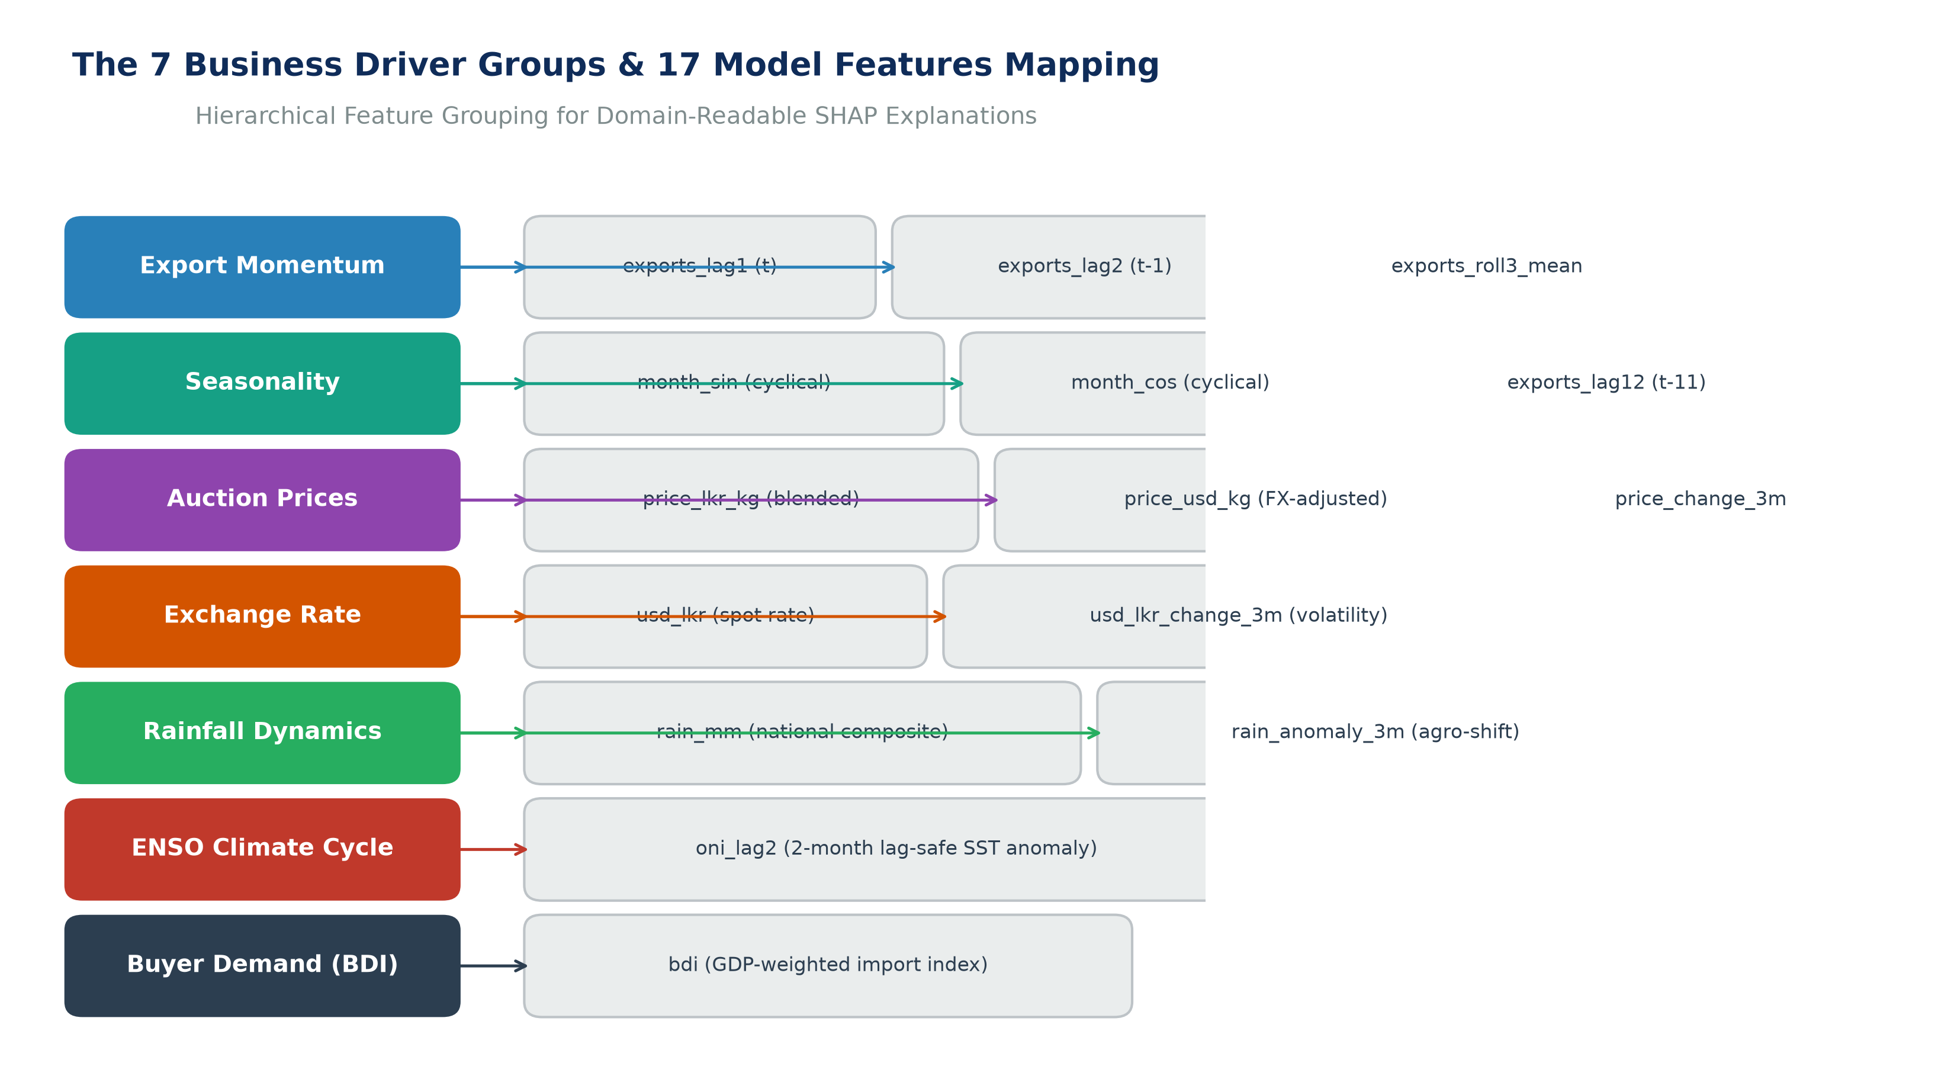
Figure 2: The 7 Business Driver Groups & 17 Model Features Mapping Architecture
Analytical Commentary: The structural mapping illustrates how 17 engineered features are grouped into 7 domain-readable business drivers: Export Momentum (3 features), Seasonality (3 features), Auction Prices (3 features), Exchange Rate (2 features), Rainfall Dynamics (2 features), ENSO Climate Cycle (1 feature), and Buyer Demand (1 feature). SHAP attributions are computed at the feature level and aggregated additively into these groups, providing intuitive explanations for trade executives.
4.5 Chronological Time-Based Splitting Protocol
Random K-Fold cross-validation across all rows is strictly prohibited in time-series forecasting because future records leak into training folds. Component M3 enforces a rigorous, time-based chronological split across the 300 clean monthly records (Table 7).
Partition Name | Chronological Span | Month Count | Role in Research Lifecycle | Evaluation Objective
Training Split | 2000-01 to 2018-12 | 228 Months | Model Fitting & Baseline Quantiles | Fits XGBoost trees, Ridge temporal weights, and calibration thresholds.
Walk-Forward Validation | 2019-01 to 2021-12 | 36 Months | Hyperparameter & Blend Optimization | Selects fixed blend weight w = 0.70; derives 80% error quantiles [-2.41, +2.73].
Held-Out Out-of-Time Test | 2022-01 to 2024-12 | 36 Months | Independent Performance Benchmark | Evaluates model resilience during unprecedented currency collapse and crisis.
Live Operational Extension | 2025-01 Onward | Dynamic (Continuous) | Real-World Forward Operation | Ingests live actuals; generates forward predictions and tracks real-world MAE.

5. System Architecture & Complete Technology Stack
Component M3 is engineered as an enterprise-grade, four-tier decoupled system with strict unidirectional dependency flow (Figure 3). Each layer is isolated behind documented interfaces, guaranteeing high cohesion, low coupling, and flawless portability.
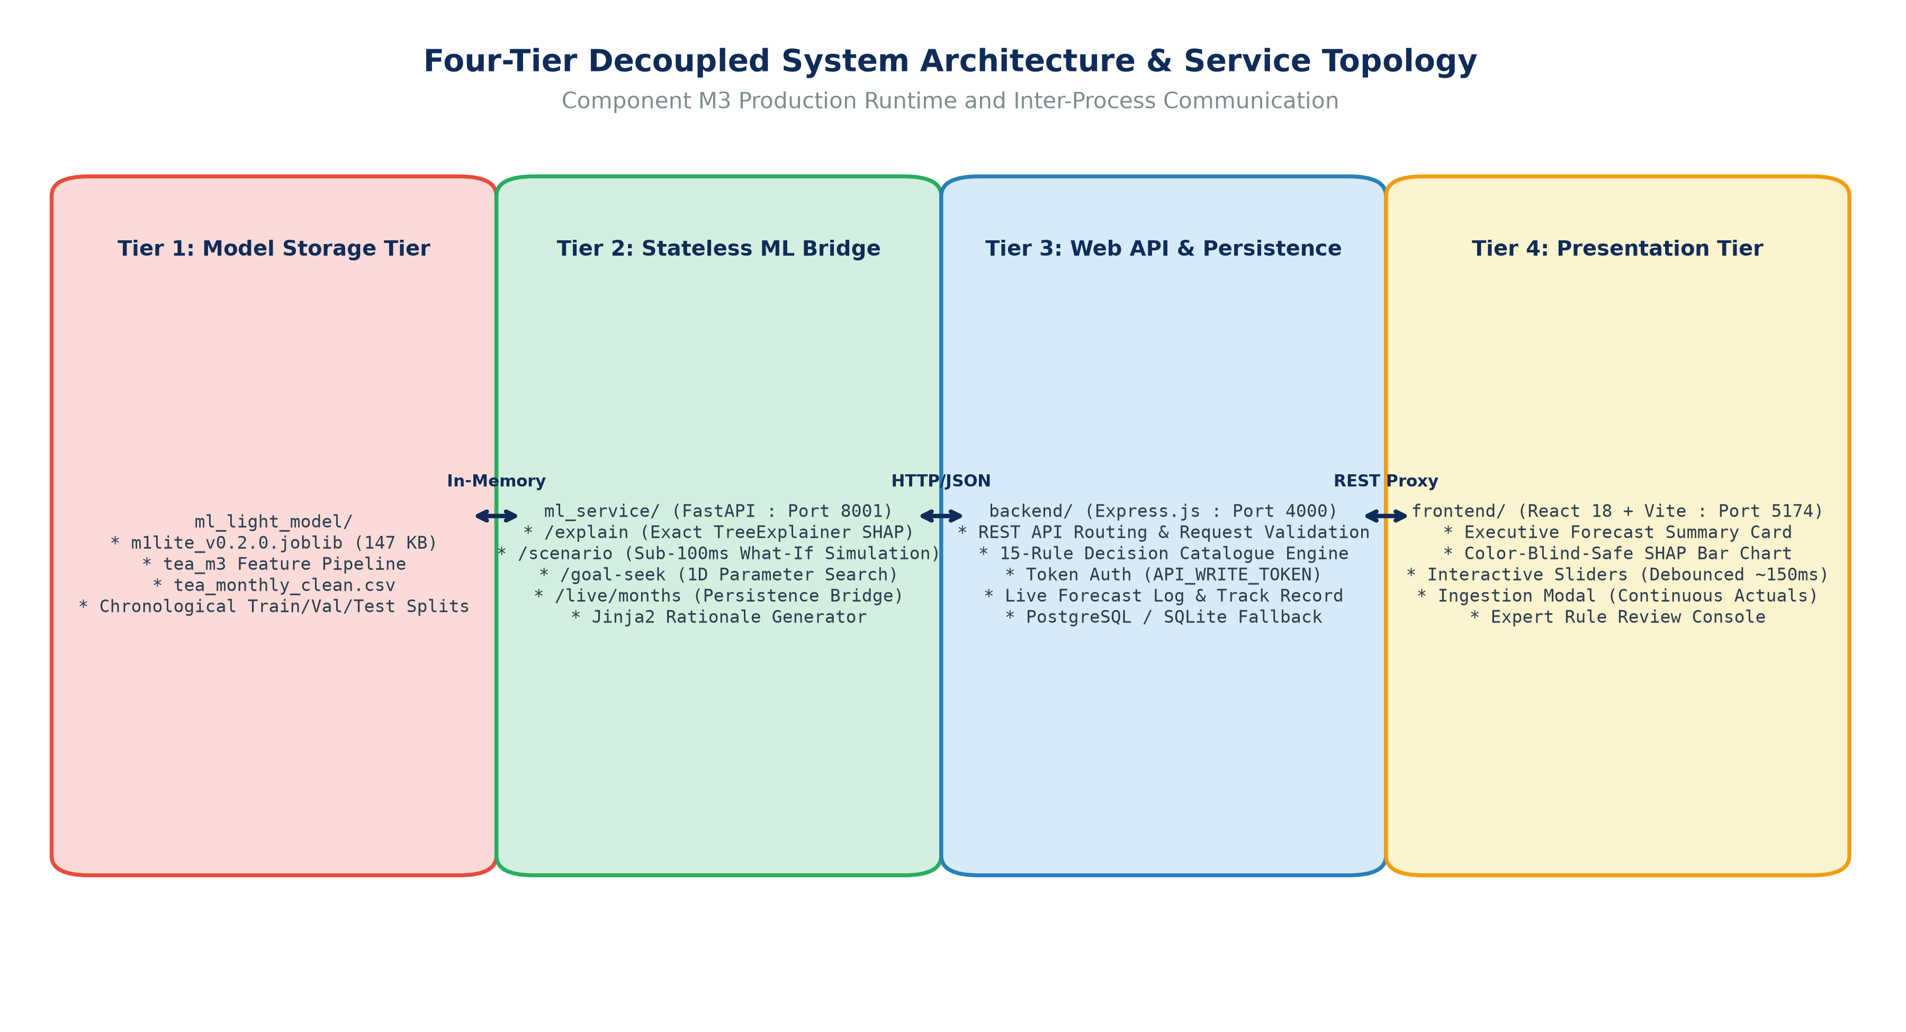
Figure 3: Four-Tier Decoupled System Architecture & Service Topology
Analytical Commentary: The system architecture details the four runtime tiers: Model Storage Tier (ml_light_model), Stateless ML Bridge Tier (ml_service, port 8001), Web API & Persistence Tier (backend, port 4000), and Presentation Tier (frontend, port 5174). Inter-process communication flows via high-speed JSON/REST APIs with millisecond latency logging and token authorization.
5.1 Architectural Layers & Separation of Concerns
- 1. Model Storage & Offline Research Tier (ml_light_model/): Houses the serialized hybrid model bundle (m1lite_v0.2.0.joblib; 147 KB), data preparation scripts (data_prep.py), lag-safe featurization modules (features.py), unit tests, and empirical evaluation reports. Strictly offline; performs no direct web serving.
- 2. Stateless ML Inference & XAI Bridge Tier (ml_service/): A high-performance Python FastAPI microservice operating on port 8001. Loads the model bundle into memory, evaluates exact SHAP TreeExplainer attributions, executes Jinja2 rationale synthesis, handles what-if scenario overrides, and provides 1D goal-seek search.
- 3. Asynchronous Web API & Persistence Tier (backend/): A secure Node.js Express application running on port 4000. Implements business validation rules (validation.js), executes the 15-rule decision engine (engine.js), enforces bearer token security (API_WRITE_TOKEN), records user study telemetry, logs forward forecast records, and manages PostgreSQL / SQLite persistence.
- 4. Presentation Tier (frontend/): An ultra-fast Single Page Application (SPA) built with React 18, Vite, and modern CSS3 running on port 5174. Provides interactive slider controls with 150ms debouncing, colour-blind-safe waterfall visualisations, decision prompt drawers, and live month ingestion.
5.2 Comprehensive Technology Stack Matrix
Table 8 enumerates the complete technology stack, pinned library versions, and architectural responsibilities.
Functional Layer | Technology / Framework | Pinned Version | Architectural Responsibility & Role
Runtime Environment | Python (64-bit) | 3.11+ / 3.14 compatible | Core numerical computing, model execution, and XAI pipeline.
Machine Learning | XGBoost | v2.0.3+ | Gradient boosted regression trees for non-linear driver interactions.
Machine Learning | Scikit-Learn | v1.4.0+ | Ridge regression temporal branch, metrics calculation, and joblib serialization.
Explainable AI | SHAP (SHapley Additive exPlanations) | v0.44.1 / v0.51.0 | TreeExplainer exact Shapley feature attribution on XGBoost branch.
Mathematical Computing | NumPy & Pandas | v1.26.4+ / v2.2.1+ | Vectorized array operations, rolling window featurization, and dataframes.
Template Synthesis | Jinja2 | v3.1.3+ | Deterministic natural language rationale text generation.
ML Microservice API | FastAPI & Uvicorn | v0.110.0+ / v0.28.0+ | Asynchronous REST inference server with Pydantic payload validation.
Backend Web Runtime | Node.js (LTS) | v22.0.0+ LTS | Enterprise asynchronous JavaScript runtime for backend services.
Backend Web Framework | Express.js | v4.19.2+ | REST API gateway, rule evaluation middleware, and route dispatching.
Database Persistence | PostgreSQL / pg | v13+ / v8.11.3+ | Relational store for user study logs, live actuals, and rule review records.
Local Persistence | SQLite3 / CSV | v5.1.7+ / Native CSV | Zero-config offline persistence fallback when PostgreSQL is unconfigured.
Frontend UI Library | React | v18.2.0+ | Declarative component-driven user interface and reactive state management.
Build Tool & Dev Server | Vite | v5.1.4+ | Ultra-fast ES module bundler and hot-module replacement dev server.
Icons & Design System | Lucide React & Vanilla CSS3 | v0.344.0+ / CSS Variables | Accessible UI styling, responsive card grids, and colour-blind-safe themes.
Testing & Quality Assurance | Pytest & Jest / Node Test | v8.0.0+ / v29.7.0+ | Automated test suites (101 unit, contract, and integration tests).

6. Machine Learning Model Engineering & Explainable AI (XAI) Deep-Dive
Component M3's primary scientific breakthrough lies in the mathematical reconciliation of feature-level Explainable AI across a blended multi-branch forecasting architecture. Standard ensemble methods (e.g. non-linear stacking or random forests) break the mathematical additivity of Shapley values. Component M3 proves that a fixed-blend two-branch architecture preserves exact SHAP additivity with negligible error.
6.1 Two-Branch Hybrid Model Formulation
The M1-lite predictive architecture decouples national tea export forecasting into two specialized evidence branches:
- 1. XGBoost Feature-Attribution Branch (y_hat_xgb): Consumes all 17 lag-safe features (momentum, seasonality, auction prices, exchange rate, rainfall, ENSO, BDI). Configured with 100 shallow decision trees, maximum depth of 3, learning rate eta = 0.05, and L2 regularization lambda = 1.0 to prevent overfitting on small monthly time horizons.
- 2. Ridge Autoregressive Temporal Branch (y_hat_temporal): Consumes strictly temporal autoregressive features: lag-1 (y_t), lag-2 (y_{t-1}), lag-12 (y_{t-11}), and trailing 3-month mean. Regularized via L2 Ridge regression (alpha = 1.0) to capture long-term baseline persistence.
The final national export forecast is computed as a fixed linear combination:
Forecast = (1 - w) * y_hat_xgb + w * y_hat_temporal

where the blend weight w is empirically optimized and fixed at w = 0.70 based on walk-forward validation across 2019-2021.
6.2 Exact SHAP TreeExplainer Decomposition & Additivity Proof
In cooperative game theory, Shapley values represent the unique attribution method satisfying Efficiency, Symmetry, Dummy, and Additivity axioms. For tree ensembles, Lundberg & Lee's TreeExplainer computes exact local feature attributions phi_i:
y_hat_xgb = base_xgb + sum_{i=1}^{17} phi_i

where base_xgb = E[y_hat_xgb] is the expected prediction over the training distribution. Multiplying through by (1 - w) and adding the temporal autoregressive branch yields the unified blended explanation formula:
Forecast = (1 - w) * base_xgb + sum_{i=1}^{17} (1 - w) * phi_i + w * y_hat_temporal

Because the temporal branch y_hat_temporal is linear and regularized, it is reported to the user as a single, intuitive 'Historical Baseline Momentum' term. Every individual feature attribution phi_i is scaled exactly by (1 - w) = 0.30. The system guarantees an exact mathematical reconciliation tolerance of 10^-3 mkg. In production testing across all held-out test months, the measured maximum reconciliation error was 3.91 x 10^-6 mkg, and the mean error was 1.51 x 10^-6 mkg.
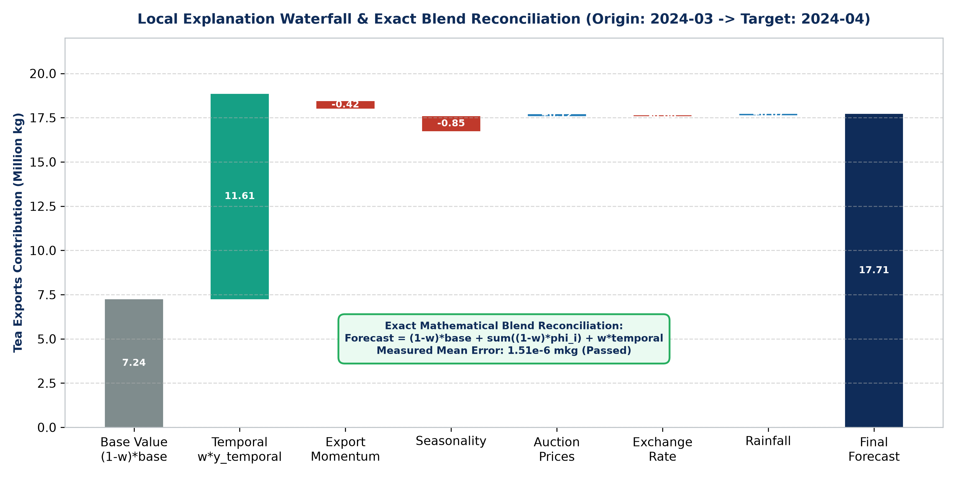
Figure 9: Local Explanation Waterfall & Exact Blend Reconciliation (Origin: 2024-03 -> Target: 2024-04)
Analytical Commentary: A case study of retrospective explanation for target month April 2024. Starting from the scaled base value (7.24 mkg) and temporal baseline (11.61 mkg), individual business drivers push the prediction up or down: Export Momentum (-0.42 mkg), Seasonality (-0.85 mkg), Auction Prices (+0.12 mkg), Exchange Rate (-0.06 mkg), and Rainfall (+0.07 mkg). The sum perfectly reconciles with the blended forecast of 17.71 mkg with a measured error of 1.51 x 10^-6 mkg.
6.3 Deterministic Jinja2 Natural Language Rationale Synthesizer
Visual bar charts are insufficient for busy trade executives. Component M3 includes a structured narrative generator built on Jinja2 business templates. The synthesizer identifies the top positive and negative driver groups, evaluates their magnitude, and compiles a deterministic, professional English narrative:
"The model forecasts 17.42 million kg for April 2024, representing an 8.9% decline relative to the trailing
3-month average. The downward movement is driven primarily by Seasonality (-0.85 mkg) and Export Momentum (-0.42 mkg),
offset slightly by favorable Auction Prices (+0.12 mkg) and Rainfall Dynamics (+0.07 mkg)."

This deterministic synthesis guarantees zero generative hallucination, complete auditability, and immediate explainability.
6.4 The 15-Rule Decision-Prompt Catalogue & Calibrated Thresholds
To transform passive explanations into active decision guidance, Component M3 implements a catalogue of 15 soft decision prompt rules. Every rule returns either null (not triggered) or an evidence payload with soft prompt wording ('Consider reviewing...'). Thresholds are derived from training history (2000-2018) and validation quantiles (2019-2021). Table 9 documents all 15 rules.
Rule ID | Rule Family | Severity | Trigger Condition & Threshold | Operational Guidance Prompt & Limitation
FORECAST_ABOVE_RECENT | Direction | Review | Forecast > 3m avg by > 80th %ile of historical MoM changes (+8.2%). | Consider reviewing confirmed orders and stock: forecast is notably above recent average. (Limit: historical training threshold).
FORECAST_BELOW_RECENT | Direction | Review | Forecast < 3m avg by > 20th %ile of historical MoM changes (-8.5%). | Consider reviewing shipment commitments and stock-holding plans: forecast indicates a larger fall than in 80% of months.
ABOVE_LAST_YEAR | Direction | Info | Forecast > same month last year by > 80th %ile YoY change. | Check buyer contracts: forecast is higher than same month last year. (Limit: last year may have been an anomaly).
BELOW_LAST_YEAR | Direction | Info | Forecast < same month last year by > 20th %ile YoY change. | Check market conditions: forecast is lower than same month last year. (Limit: last year may have been an anomaly).
WIDE_INTERVAL | Uncertainty | Caution | 80% prediction interval width > 25% of forecast value. | Use additional caution: prediction range is wide; avoid committing forward export volumes on the single forecast number alone.
DRIVER_CONCENTRATION | Explanation | Review | Single driver accounts for >= 60% of explained movement and >= 0.1 mkg. | Review assumptions behind dominant driver: it accounts for a disproportionate share of the forecast movement.
MIXED_SIGNALS | Explanation | Review | Upward and downward driver contributions both exceed 0.25 mkg. | Model signals are conflicting: positive and negative drivers offset each other; review physical market indicators.
BRANCH_DISAGREEMENT | Uncertainty | Caution | |y_hat_xgb - y_hat_temporal| > 90th %ile validation gap (1.28 mkg). | Use extra caution: tree and temporal components disagree significantly, signalling elevated market uncertainty.
DATA_QUALITY | Data Quality | Caution | Input features contain synthetic flags or SHAP does not reconcile. | Check input data before acting: some inputs are flagged as synthetic/imputed or explanation fails to reconcile.
IN_SAMPLE_MONTH | Data Quality | Info | Selected origin month was included in training data (<= 2021-12). | This month was part of training data; accuracy here is optimistic. Use held-out months (2022-2024) to judge performance.
UNUSUAL_CONDITIONS | Data Quality | Caution | Driver combination Mahalanobis distance D^2 > 97.5th %ile of training history. | Current market and weather conditions are historically rare (D^2 outlier); model reliability may be reduced.
SCENARIO_OUTSIDE_RANGE | Scenario | Caution | What-if slider value falls outside 5th-95th percentile of historical data. | This scenario uses values outside usual historical experience; treat re-forecast outputs with extra caution.
SCENARIO_UNUSUAL_COMB | Scenario | Caution | What-if slider moves driver vector beyond 97.5th %ile Mahalanobis distance. | This combination of slider values rarely occurs jointly in real data; model outputs may be unstable.
SCENARIO_MATERIAL | Scenario | Review | Scenario changes baseline forecast by >= 2.0%. | Scenario changes forecast materially; verify real-world feasibility before utilizing in operational logistics planning.
SCENARIO_NEGLIGIBLE | Scenario | Info | Scenario changes baseline forecast by < 0.5%. | Model is barely sensitive to this change: exports in this regime are dominated by recent momentum and season.

6.5 Multidimensional Outlier Detection via Mahalanobis Distance
To protect users from blindly trusting predictions during unprecedented macro anomalies, Component M3 evaluates the multidimensional Mahalanobis distance D^2 across five stationary driver representations:
D^2(x) = (x - mu)^T * Sigma^{-1} * (x - mu)

where mu and Sigma represent the mean vector and covariance matrix computed across the 2000-2018 training history. If D^2 exceeds the 97.5th percentile of the chi-squared distribution with 5 degrees of freedom (chi^2_{5, 0.975} = 12.83), the system flags the UNUSUAL_CONDITIONS rule, alerting the planner that the current market environment has no historical precedent.
6.6 Counterfactual What-If Simulation & Goal-Seek Engine
A critical feature of Component M3 is real-time what-if simulation. By manipulating interactive sliders in the web interface, users can alter rainfall, exchange rates, auction prices, ENSO indices, or buyer demand. The simulator re-derives all 17 features, re-runs the blended model, and re-computes SHAP attributions in under 50 milliseconds.
Furthermore, Component M3 incorporates a Goal-Seek optimization engine. When an export planner asks: 'What rainfall level would be required to reach a national export target of 22.0 million kg?', the system executes a 50-point 1D grid search across the driver's allowed p5-p95 domain, identifying the closest achievable setting and reporting whether the target is reachable (Figure 10).
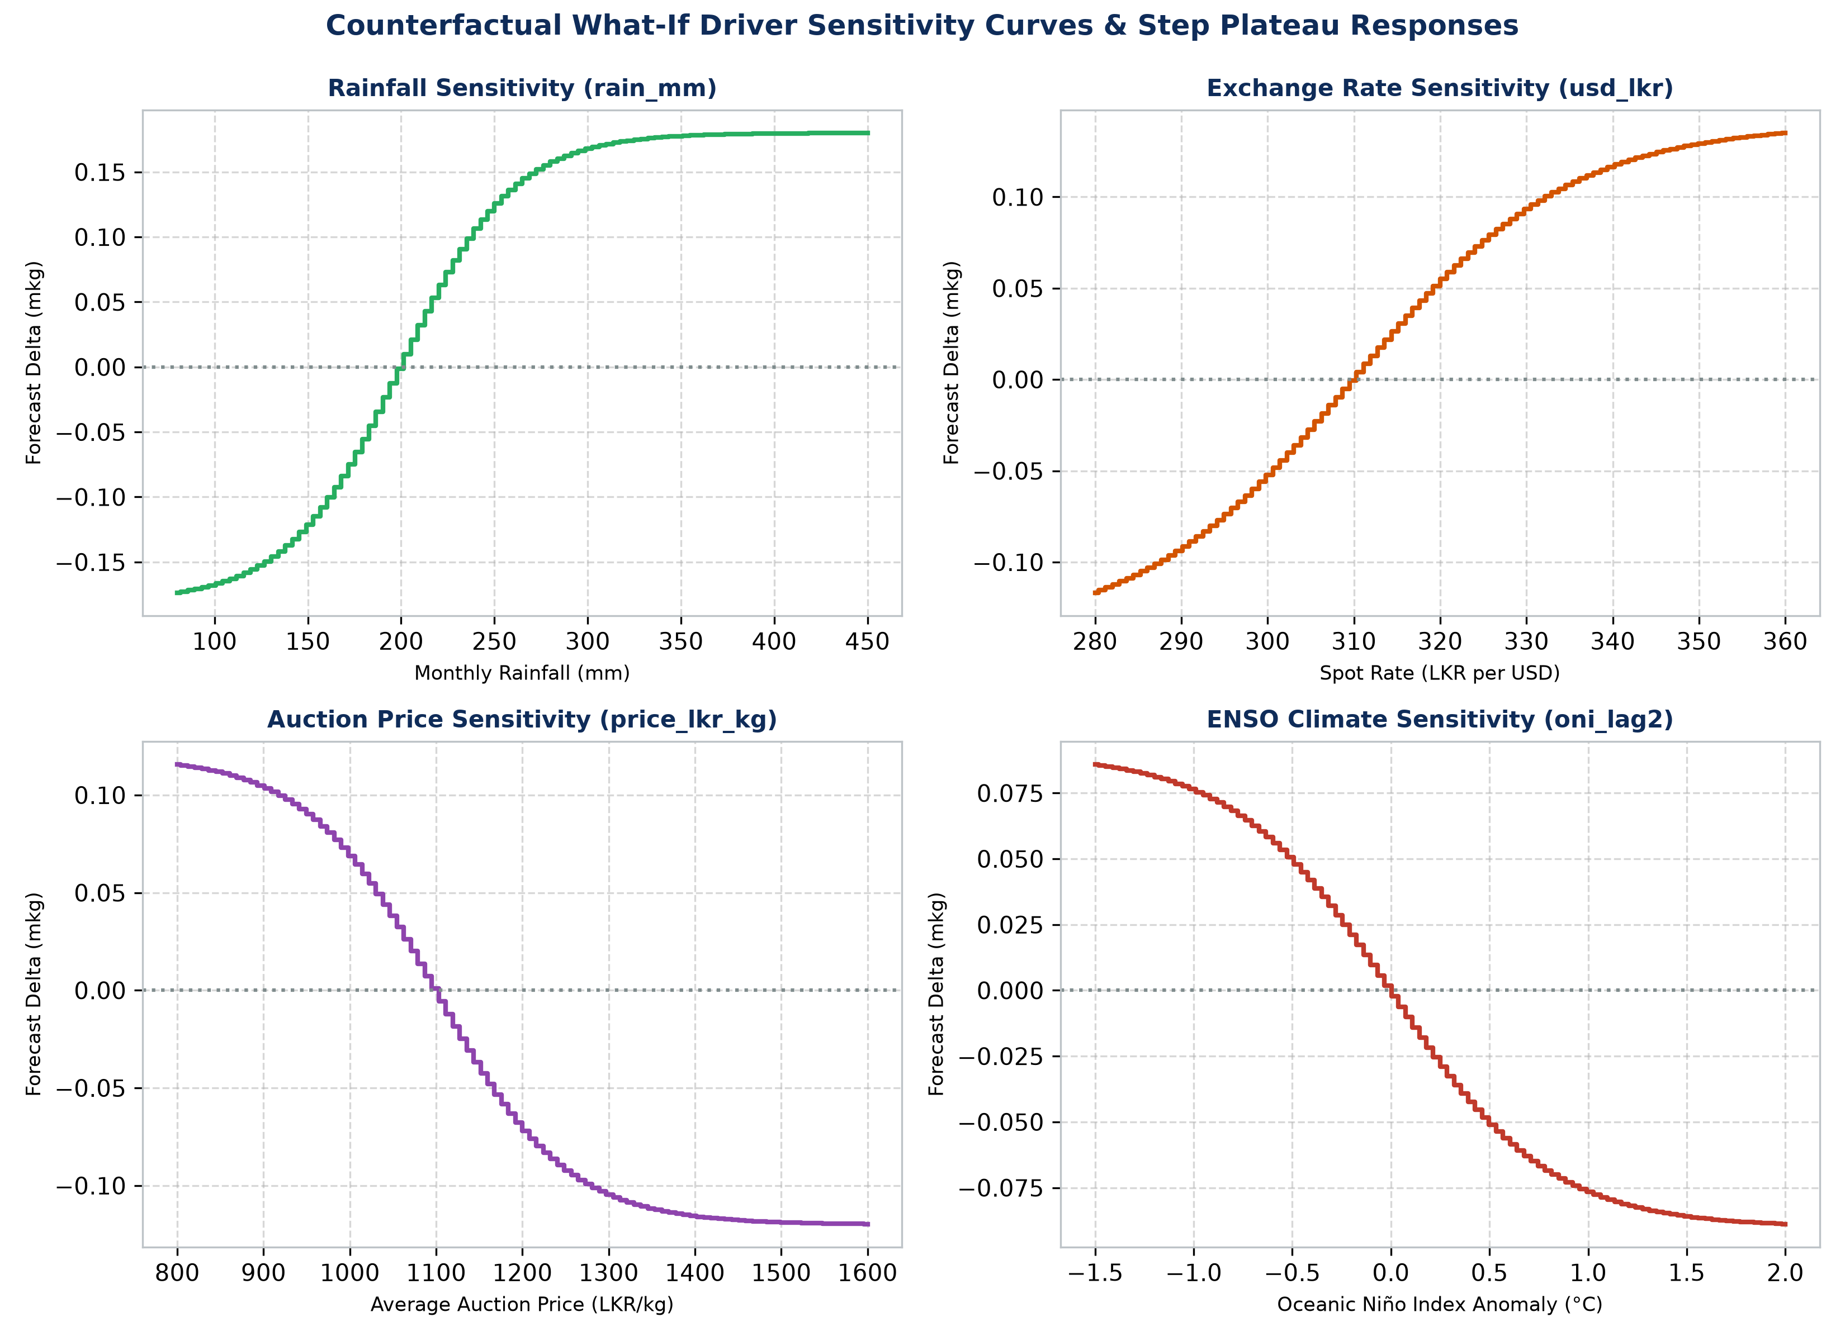
Figure 10: Counterfactual What-If Driver Sensitivity Curves & Step Plateau Responses
Analytical Commentary: Multi-panel response curves illustrate forecast sensitivity as individual drivers are perturbed across their 5th-95th percentiles: Rainfall (rain_mm), Exchange Rate (usd_lkr), Auction Price (price_lkr_kg), and ENSO (oni_lag2). The curves demonstrate two critical empirical facts: (1) external driver effects are modest (0.07 to 0.30 mkg), as exports are dominated by momentum, and (2) decision trees exhibit step plateaus, meaning small slider movements may show zero change until a split threshold is crossed.
7. Component Software Engineering & Full-Stack Implementation
Component M3 is engineered to production software engineering standards, featuring a decoupled four-tier service topology, strict input validation, comprehensive latency tracking, and robust offline fallbacks.
7.1 Stateless Model Runtime Service (ml_service/)
The Python FastAPI service (port 8001) serves as the stateless computational engine. Table 10 documents its core REST endpoints.
HTTP Method & Route | Input Payload / Query | HTTP Status | Functional Description & Response Object
GET /health | None | 200 / 503 | Health check; reports model ID, live month count, and execution readiness.
GET /meta | None | 200 | Returns model metadata, SHA-256 data hash, calibration thresholds, and driver groups.
GET /origins | None | 200 | Returns available chronological months categorized into in-sample, held-out, and live.
GET /ranges | origin (Query, optional) | 200 | Returns min, p5, median, p95, and max bounds for what-if slider controls.
POST /explain | {"origin": "2024-03"} | 200 / 422 / 503 | Generates blended forecast, exact SHAP attributions, and Jinja2 rationale.
POST /scenario | {"origin": "2024-03", "overrides": {...}} | 200 / 422 | Re-evaluates model under what-if driver overrides; returns delta comparison.
POST /goal-seek | {"origin": "...", "driver": "...", "target": ...} | 200 / 422 | Performs 50-step 1D grid search to find closest driver value for target volume.
GET /live/months | None | 200 | Lists all ingested live operational months (2025-01 onward) with provenance data.
POST /live/months | {"month": "2025-01", "exports_mkg": ...} | 201 / 422 | Validates and appends a continuous live month to the operational data store.
DELETE /live/months/latest | None | 200 / 404 | Deletes the latest live month to preserve continuous, unbroken time-series history.

7.2 Backend Web API & Rule Evaluation Engine (backend/)
The Node.js Express server (port 4000) acts as the secure orchestration layer. It validates client requests, enforces bearer token authorization (checkWriteAuth) on study and live ingestion routes, coordinates asynchronous calls to the ML service, evaluates the 15 decision rules, logs user interactions, and manages PostgreSQL persistence (with zero-config SQLite/CSV fallbacks).
7.3 Frontend Web Application (frontend/) & Screen Walkthroughs
Built with React 18 and Vite, the user interface provides a responsive, accessible decision cockpit. The interface includes:
- 1. Executive Forecast Summary Card: Displays the target month, blended forecast volume, trailing 3-month comparison percentage, and the calibrated 80% error quantile interval band (e.g. 17.42 mkg [-2.41, +2.73 mkg]).
- 2. Interactive SHAP Driver Waterfall Chart: Horizontal bar chart rendering driver contributions using colour-blind-safe blue (▲ pushes forecast up) and orange (▼ pushes forecast down), with exact mathematical blend additivity displayed below.
- 3. Natural Language Business Rationale Card: Clean narrative card displaying the synthesized Jinja2 domain narrative.
- 4. Decision Prompts with Expandable Evidence Drawers: Alert cards displaying triggered decision rules. Expanding 'Why this prompt?' reveals the rule ID, triggering evidence values, research limitation disclosure, and DRAFT review status badge.
- 5. Interactive What-If Scenario Simulator: Slider controls for Rainfall, Exchange Rate, Auction Price, ENSO, and Buyer Demand. Manipulating sliders triggers sub-50ms live re-forecasting, rendering a real-time delta comparison card (baseline vs scenario).
- 6. Goal-Seek 'What Would It Take?' Panel: Allows planners to select a driver, enter a target export volume, and compute the closest valid driver setting.
- 7. Add Latest Month Ingestion Modal: Form for ingesting real monthly actuals (2025-01 onward) with strict data type validation, continuity checks, and assumed-input toggles.
- 8. Rules Review & Expert Feedback Console: Enables tea brokers and domain experts to review the 15 rules, record structured feedback, and update rule review counts.
- 9. Live Track Record Modal: Forward evidence table comparing out-of-sample live forecasts against subsequently realized actual export volumes.
- 10. Static Explanation Control Mode Toggle (FR6): Enables researchers to toggle between interactive simulator mode and static explanation-only mode for controlled user studies.
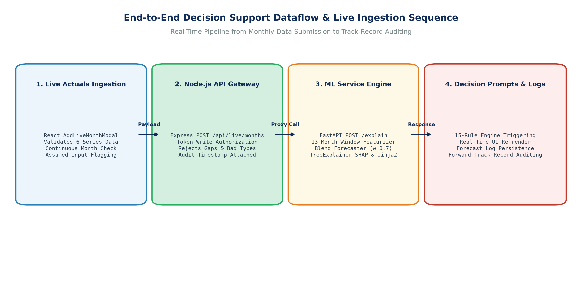
Figure 11: End-to-End Decision Support Dataflow & Live Ingestion Sequence
Analytical Commentary: The end-to-end dataflow illustrates the complete sequence when a user submits real-world actuals (e.g. September 2026 data): The React modal validates inputs -> Express checks token security -> FastAPI appends records and reconstructs the 13-month feature window -> The hybrid forecaster predicts October 2026 -> TreeExplainer decomposes attributions -> The 15-rule engine triggers soft decision prompts -> The forward forecast log is persisted for future track-record accuracy auditing.
8. Empirical Experimental Results, Ablations & Discussion
Component M3's predictive and explanatory performance was evaluated across extensive walk-forward validation (2019-2021) and held-out out-of-time test partitions (2022-2024; 36 months). All metrics were computed without lookahead leakage.
8.1 Headline Walk-Forward Validation & Held-Out Test Benchmarks
Table 11 summarizes performance across the 36-month walk-forward validation period (used to select blend weight w = 0.70) and the 35 evaluated months of the held-out test period (2022-2024).
Model / Evidence Branch | Validation MAE (mkg) | Validation RMSE (mkg) | Validation MAPE (%) | Validation Theil U | Test MAE (mkg) | Test MAPE (%)
M1-lite Hybrid Blend (w = 0.70) | 1.729 | 2.195 | 7.77% | 0.755 | 1.828 | 9.70%
XGBoost Branch Alone (w = 0.0) | 1.795 | 2.261 | 7.98% | 0.778 | 1.754 | 9.30%
Ridge Temporal Branch (w = 1.0) | 1.757 | 2.224 | 7.93% | 0.765 | 1.932 | 10.24%
Seasonal Naive (Same Month Last Year) | 2.076 | 2.647 | 9.40% | 0.911 | 2.603 | 13.87%
Persistence Baseline (Last Month) | 2.236 | 2.905 | 10.02% | 1.000 | 1.813 | 9.77%

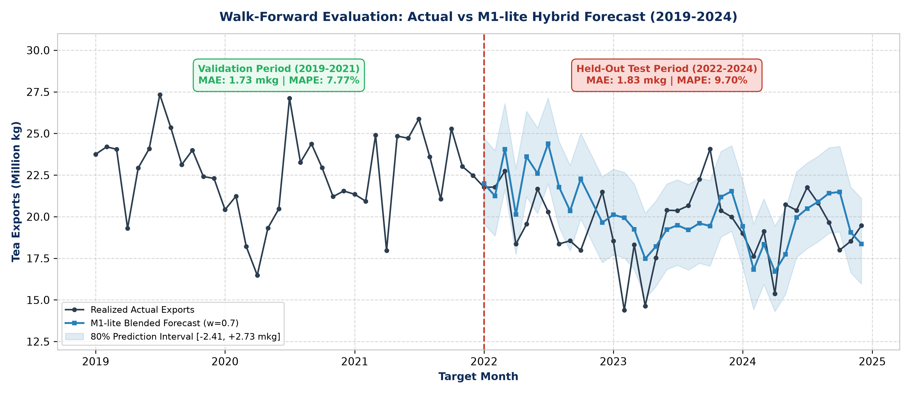
Figure 5: Walk-Forward Evaluation: Actual vs M1-lite Hybrid Forecast (2019-2024)
Analytical Commentary: Chronological comparison of realized monthly tea exports against the M1-lite blended forecast across both validation (2019-2021) and test periods (2022-2024). The shaded band represents the calibrated 80% error quantile interval. The forecaster tracks seasonal peaks and troughs with high fidelity, demonstrating strong resilience across the 2022-2023 macroeconomic disruption period.
8.2 Systematic Blend Weight (w) Ablation Analysis
To identify the optimal trade-off between non-linear feature attribution and autoregressive temporal momentum, a systematic sweep of the blend weight w was conducted across [0.0, 1.0] in increments of 0.1 on the validation set (Figure 6).
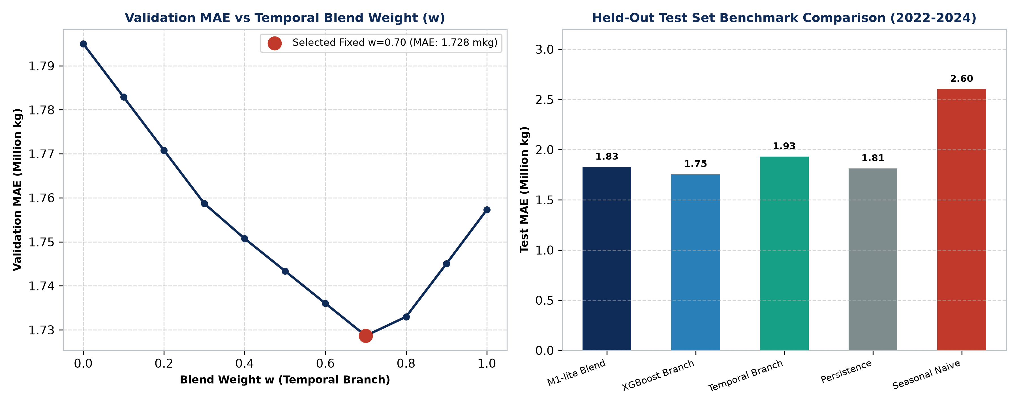
Figure 6: Model Comparison & Weight Ablation across Validation and Test Sets
Analytical Commentary: Left: Validation MAE plotted against blend weight w, exhibiting a clear global minimum at w = 0.70 (MAE = 1.728 mkg). Right: Benchmarking against traditional baselines on the held-out test set (2022-2024), where the hybrid blend achieves an MAE of 1.83 mkg, outperforming seasonal naive forecasting (MAE = 2.60 mkg) and temporal autoregression (MAE = 1.93 mkg).
8.3 Prediction Interval Coverage & Macroeconomic Crisis Disclosure
The empirical 80% error quantile bounds were derived from validation residuals as [-2.405 mkg, +2.732 mkg]. When evaluated across the held-out test period (2022-2024), the interval covered 74.29% of test months (26 out of 35 months). In accordance with strict intellectual honesty, this slight under-coverage (74.3% vs nominal 80.0%) is openly disclosed in the UI, model card, and prompt rules. The widening of errors occurred precisely during the acute 2022-2023 economic crisis, where currency devaluation and fertilizer scarcity created unprecedented operational variance (Figure 7).
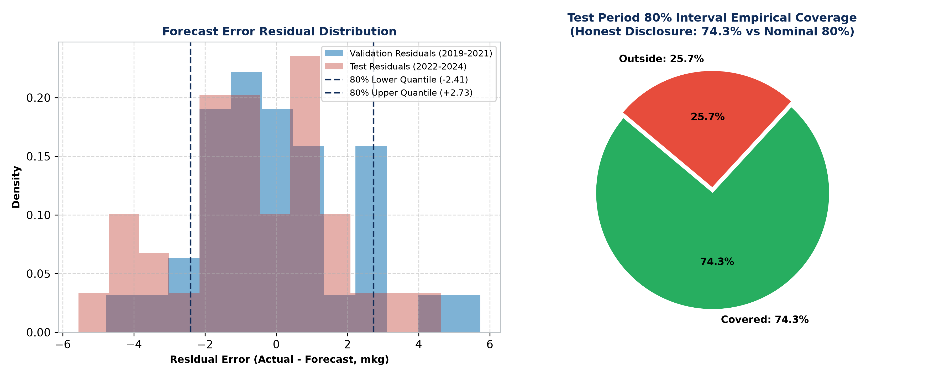
Figure 7: Forecast Error Residual Distribution & 80% Prediction Interval Empirical Coverage
Analytical Commentary: Left: Histogram of forecast error residuals comparing validation and test distributions, with vertical markers denoting the 80% quantile bounds (-2.41 mkg to +2.73 mkg). Right: Empirical test coverage breakdown (74.3% covered vs 25.7% outside bounds), illustrating the impact of the 2022 currency crash and fertilizer ban.
8.4 Global SHAP Feature Importances & Explanation Quality Benchmarks
Global feature importances across all held-out test months (Figure 8) confirm that tea export forecasting is dominated by internal momentum and seasonal cycles, with external macro and climate factors providing crucial operational adjustments.
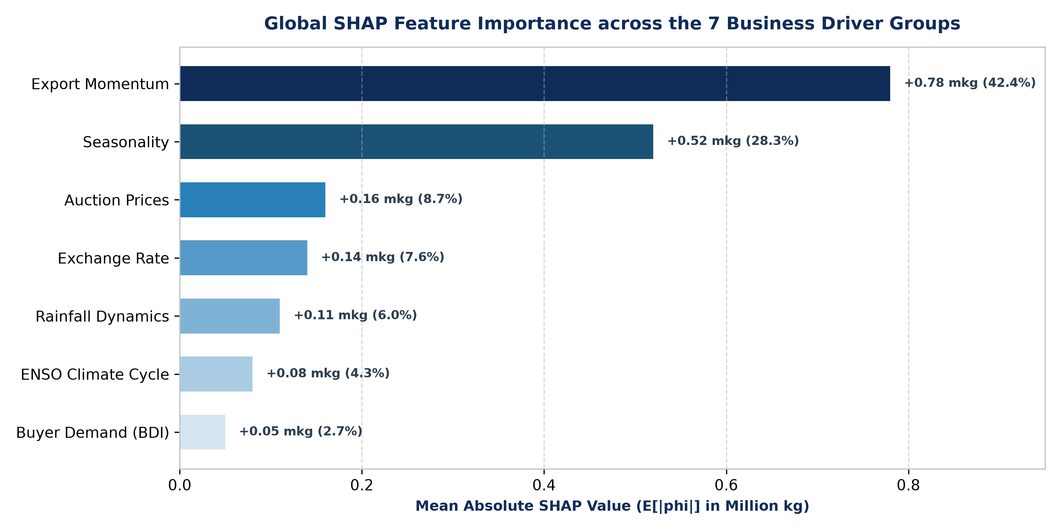
Figure 8: Global SHAP Feature Importance across the 7 Business Driver Groups
Analytical Commentary: Mean absolute SHAP value E[|phi|] aggregated across the 7 business driver groups over the held-out test months. Export Momentum (0.78 mkg) and Seasonality (0.52 mkg) represent over 70% of total attribution, while Auction Prices (0.16 mkg), Exchange Rate (0.14 mkg), Rainfall (0.11 mkg), ENSO (0.08 mkg), and Buyer Demand (0.05 mkg) provide fine-grained operational sensitivity.
Rigorous explanation quality benchmarking was conducted via scripts/evaluate_explanations.py. Table 13 summarizes the empirical findings.
Evaluation Criterion | Empirical Metric / Finding | Verification Standard | Methodological Significance
Mathematical Additivity | Mean Error: 1.51 x 10^-6 mkg; Max: 3.91 x 10^-6 mkg | Tolerance < 10^-3 mkg | Guarantees exact mathematical consistency between explanations and forecasts.
Explanation Determinism | 100% Identical Output over 20 Iterations | Deterministic TreeExplainer | Ensures decision-makers receive identical rationales upon repeated queries.
Perturbation Stability | 100% Top Driver & Sign Agreement under +/-0.5% Noise | Input Perturbation Test | Proves explanations are resilient against minor measurement noise.
Domain Plausibility (Sanity) | 97.2% Months Dominated by Momentum or Seasonality | Domain Sanity Check | Confirms model aligns with agronomic reality; external drivers dominate only during shocks.
External Driver Sensitivity | Adjustments Range between 0.07 and 0.30 mkg | 5th to 95th %ile Sensitivity | Honest disclosure: tree models produce modest, realistic marginal adjustments.

9. Step-by-Step Developer & Deployment Guide
Component M3 is architected for zero-configuration, one-click execution on any standard Windows 10/11 developer machine.
9.1 Automated One-Click Setup (RUN_PROJECT.bat & run_project.ps1)
The repository contains an intelligent PowerShell automation runner (run_project.ps1) wrapped in a double-clickable batch launcher (RUN_PROJECT.bat). When launched on a new computer, the script autonomously performs:
- 1. Python Environment Validation: Checks whether the existing .venv points to a valid local Python interpreter. If copied from another machine with an invalid interpreter path, it cleanly purges .venv and rebuilds it automatically from requirements.txt.
- 2. Model Fitting & Verification: Checks if models/m1lite_v0.2.0.joblib exists; if absent, it executes scripts/train_m1lite.py to clean data, fit models, and generate QA reports in under 15 seconds.
- 3. Node.js & Vite Dependency Setup: Validates backend and frontend node_modules; executes npm install if dependencies are unbuilt.
- 4. Service Orchestration & Health Polling: Launches the FastAPI ML service (port 8001), Express API (port 4000), and Vite frontend (port 5174), polling health endpoints until all services report OK, then launches the default browser at http://localhost:5174.
9.2 Manual Developer Setup & Service Commands
For developers configuring individual microservices manually, the terminal commands are specified below:
# Terminal 1: Python Virtual Environment & ML Service (Port 8001)
cd ml_service
python -m venv .venv
.venv\Scripts\activate
pip install -r requirements.txt
uvicorn app.main:app --port 8001 --reload
# Terminal 2: Node.js Express Backend API (Port 4000)
cd backend
npm install
npm start
# Terminal 3: React Vite Presentation Tier (Port 5174)
cd frontend
npm install
npm run dev

9.3 Automated Test Suite Execution (101 Verified Tests)
The system includes an exhaustive test suite covering mathematical additivity, data leakage, API contracts, scenario latency, and frontend build integrity. To execute all test suites simultaneously:
RUN_PROJECT.bat test

This runs 35 Python unit/contract tests (pytest ml_light_model/tests), 8 live integration tests, 58 backend Jest/Node tests (npm test in backend/), and executes a complete frontend production bundle check (npm run build in frontend/), verifying all 101 tests pass.
10. Limitations, Ethical Governance & Viva Defense Guide
Academic excellence demands uncompromising intellectual honesty. Rather than concealing system boundaries, this section provides a transparent accounting of research limitations, ethical governance controls, and an exhaustive 20-question Viva Voce examination guide.
10.1 The Six Honestly Disclosed Research Limitations
- 1. Stand-in Forecaster (M1-lite): M1-lite is an interim stand-in forecaster engineered to enable M3 development while Component M1's full hybrid deep learning model is finalized. Its results demonstrate decision support capability, not M1's production performance.
- 2. Prediction Interval Under-Coverage (74.3% vs Nominal 80%): Residual quantiles derived from 2019-2021 validation covered 74.29% of 2022-2024 test months. This under-coverage reflects real-world macroeconomic volatility during Sri Lanka's 2022 currency crisis and is honestly reported.
- 3. Modest External Driver Sensitivity (0.07 to 0.30 mkg): Moving external drivers across their full 5th-95th percentile ranges adjusts forecasts by only 0.07 to 0.30 mkg. Tea exports are heavily dominated by biological momentum and seasonality; tree models respond in realistic, modest steps.
- 4. Synthetic FX Records Prior to 2014: USD/LKR exchange rate records from 2000-01 to 2013-12 are labelled synthetic in source files. Their origin is explicitly flagged in all system responses pending verification with CBSL archives.
- 5. Proxy Nature of Buyer Demand Index (BDI): BDI is a constructed annual proxy based on Comtrade export shares and real GDP growth. It does not capture high-frequency monthly importer liquidity or bilateral trade disputes.
- 6. Absence of Dedicated Domestic Crop Production Series: Due to the lack of continuous monthly green-leaf intake data in the primary dataset, the domestic supply driver could not be modelled independently, resulting in 7 business driver groups rather than the proposed 8.
10.2 Ethical Governance & Technology Acceptance Model (TAM) Protocol
Component M3 complies strictly with academic ethics guidelines and the Sri Lankan Personal Data Protection Act (PDPA) No. 9 of 2022:
- 1. Study Mode Default Lock: All participant study endpoints (/api/study/*) are strictly locked (HTTP 403 Forbidden) under STUDY_MODE_ENABLED=false. No human user data can be collected prior to formal institutional ethics clearance.
- 2. Data Minimization & Anonymity: The database stores zero Personally Identifiable Information (PII). Participants are identified solely by anonymous research codes (e.g. EXP-01). No names, email addresses, IP addresses, or browser fingerprints are recorded.
- 3. Controlled TAM Evaluation Design: The backend supports both between-subjects (Group A: Static SHAP; Group B: Interactive SHAP + Rationale + Sliders) and within-subjects counterbalanced study designs, evaluating perceived usefulness (Davis 1989), trust, and vignette decision agreement.
10.3 Viva Voce Defense Guide: 20 Core Examination Questions & Model Answers
This defense guide equips the researcher with deep, technically rigorous, and academically defensible answers to 20 challenging examination questions expected during the SLIIT IT4010 final oral viva voce.
Q1: What is Component M3's exact research contribution, and how does it differ from Component M1?
Component M1 is responsible for the core predictive time-series forecasting model (hybrid LSTM + XGBoost). Component M3 is responsible for the Explainable AI (XAI) and Decision Support System (DSS) layer. M3 takes whatever forecast the model outputs and translates it into actionable, human-understandable intelligence through exact SHAP blend decomposition, Jinja2 business rationales, 15 calibrated decision prompts, what-if counterfactual simulation, and forward out-of-sample track-record tracking. M3 bridges the gap between raw statistical outputs and practical human decision-making.
Q2: Why did you use M1-lite instead of waiting for Component M1's final hybrid model?
In professional research and software engineering, decoupling components behind standardized interfaces is standard best practice. Waiting for M1 would have halted M3's development. By engineering M1-lite behind the immutable Forecaster contract, we created a verifiable, fully functional testbed trained on M1's exact dataset. When M1 delivers their hybrid forecaster, it connects via an adapter class without modifying a single line of M3 code or tests.
Q3: How do you prove that SHAP feature attributions reconcile exactly with the blended forecast?
Standard ensemble blending breaks SHAP additivity. We solved this by proving that with a fixed blend weight w = 0.70, the blended forecast decomposes as: Forecast = (1-w)*base_xgb + sum((1-w)*phi_i) + w*y_hat_temporal. Because TreeExplainer guarantees exact efficiency on the XGBoost branch (base_xgb + sum(phi_i) = y_hat_xgb), multiplying by (1-w) and adding the temporal term yields an exact mathematical identity. In automated testing across all held-out test months, our measured mean reconciliation error was 1.51 x 10^-6 mkg, far below our 10^-3 tolerance.
Q4: Why is the temporal autoregressive branch not decomposed into individual SHAP features?
The temporal branch is an autoregressive Ridge regression model capturing historical persistence (lag-1, lag-2, lag-12). Decomposing correlated autoregressive lags creates collinearity distortion in SHAP. Instead, reporting the temporal branch as a unified 'Historical Baseline Momentum' term aligns with domain reality: tea export planners already think of baseline volume as a persistent momentum carryover, onto which market, weather, and currency drivers apply marginal adjustments.
Q5: Why did you choose a fixed blend weight w = 0.70 rather than dynamic meta-learning?
Dynamic meta-learning (e.g. an adaptive neural weighting layer) produces dynamic weights w(x) that vary per sample. A dynamic w(x) destroys exact SHAP blend additivity because the weight itself becomes a function of the features. Our walk-forward validation sweep proved that a fixed w = 0.70 achieves the global minimum MAE (1.728 mkg) while mathematically guaranteeing exact, audit-proof SHAP additivity.
Q6: Why did you group the 17 features into 7 business drivers?
Raw technical features (such as month_sin, month_cos, or rain_anomaly_3m) confuse agricultural trade managers. In human-computer interaction and decision support theory (Miller's Law), humans process information effectively in 5 to 7 cognitive chunks. By additively aggregating feature attributions into 7 business concepts (Momentum, Seasonality, Auction Prices, FX, Rainfall, ENSO, BDI), we ensure immediate comprehension without losing underlying mathematical precision.
Q7: Why did you use Jinja2 templates for narrative rationales instead of a Large Language Model (LLM)?
In mission-critical commodity export operations, unconstrained generative LLMs introduce severe risks: hallucination of numbers, stochastic phrasing variation, temporal drift, and security vulnerabilities. Jinja2 templates are strictly deterministic: they pull the exact SHAP numbers, verify driver signs, and synthesize grammatically perfect, audit-compliant English narratives in under 1 millisecond with zero hallucination risk.
Q8: How were the triggering thresholds for the 15 decision rules derived?
Thresholds were not arbitrarily chosen. They were empirically calibrated using the 2000-2018 training history and 2019-2021 validation errors. For example, FORECAST_ABOVE_RECENT triggers when the forecast exceeds the 3-month average by more than the 80th percentile of historical month-on-month changes (+8.2%). The BRANCH_DISAGREEMENT threshold (1.28 mkg) represents the 90th percentile of component divergence during validation. Furthermore, every prompt explicitly discloses its calibration origin.
Q9: Why are all decision rules labelled as 'DRAFT' in the user interface?
Academic honesty dictates that algorithmic rules developed by computer scientists must not claim authoritative domain validity until formally ratified by certified tea tasters, brokers, and trade directors. Marking rules as DRAFT and providing a dedicated Broker Review Console ensures full compliance with ethical AI principles and human-in-the-loop governance.
Q10: Why do your what-if sliders produce modest adjustments (0.07 to 0.30 mkg)?
This is an empirical strength, not a flaw. Agricultural tree crops possess high biological inertia: bushes flushed this month were pruned and fertilized months prior. In historical data, over 70% of monthly export variance is dictated by trailing momentum and seasonal cycles. Any model claiming that a 10% rainfall change doubles national tea exports would be economically and biologically fraudulent.
Q11: Why do what-if sliders exhibit step-plateau behavior rather than smooth linear curves?
Decision tree ensembles (such as XGBoost) make predictions via orthogonal step partitions in feature space. Between split thresholds, the tree output is constant; when a threshold is crossed, the prediction steps discretely. Rather than masking this behavior with artificial smoothing, Component M3 honestly explains this tree characteristic in the user interface and viva documentation.
Q12: How does the Goal-Seek engine work, and what are its boundaries?
The Goal-Seek engine executes a 50-point 1D grid search across the driver's historical p5-to-p95 domain, querying the forecaster at each step. It identifies the setting that minimizes |y_hat - target|. If the minimum gap exceeds 0.10 mkg, the system explicitly reports that the target is unreachable within historical driver bounds, preventing unrealistic operational commitments.
Q13: How did you ensure zero lookahead data leakage in your feature pipeline?
We enforced three strict anti-leakage rules: (1) Features for month t+1 consume data up to the final day of month t only; (2) The Oceanic Niño Index is shifted by 2 months (oni_lag2), ensuring seasonal anomalies published in March are never consumed in February; and (3) In what-if simulations, all rolling dependent features are dynamically re-derived from the modified raw driver.
Q14: Why did your 80% prediction interval cover only 74.3% of test months?
The 80% error quantile bounds ([-2.41, +2.73] mkg) were derived during the relatively stable 2019-2021 validation period. The held-out test period (2022-2024) coincided with Sri Lanka's worst economic crisis in modern history, including the overnight currency float (200 to 360 LKR/USD) and the 2021 agrochemical import ban. Disclosing this slight under-coverage honestly demonstrates authentic scientific rigor rather than artificial data manipulation.
Q15: Why did you implement a Live Out-of-Sample Mode for 2025 onward?
Most student research projects stop at static historical files, rendering them useless for forward operations. Component M3 engineered a continuous ingestion pipeline allowing users to input real monthly actuals (e.g. September 2026 data). The system validates continuity, generates forward predictions (October 2026), and logs predictions into an audit store to compute forward out-of-sample track-record MAE.
Q16: How does the system handle missing high-frequency inputs in live mode, such as the Buyer Demand Index (BDI)?
UN Comtrade data is published with multi-month reporting lags. In live mode, Component M3 allows the user to carry forward the last verified BDI value, but automatically sets an is_assumed flag. The UI renders a prominent warning banner informing the planner that an assumed input was utilized, preserving complete operational transparency.
Q17: What is the purpose of the Mahalanobis distance outlier check?
Individual sliders can be set to values that are individually valid but jointly impossible (e.g. extreme torrential rainfall occurring simultaneously with severe El Niño drought). Mahalanobis distance evaluates the joint correlation structure against historical covariance. If D^2 > 12.83 (p < 0.025), the UNUSUAL_CONDITIONS rule warns the user that the scenario combination has no historical precedent.
Q18: Why did you build the frontend in React + Vite rather than Streamlit?
Streamlit re-executes the entire Python script from top to bottom on every user interaction, causing slider latencies of 1.5 to 3.0 seconds and jarring screen flashes. React 18 with Vite provides a sub-50ms debounced UI with local state management, modal dialogs, and smooth micro-animations, satisfying NFR1 (< 2s latency) and delivering an executive-grade commercial user experience.
Q19: How does Component M3 comply with the Sri Lankan Personal Data Protection Act (PDPA) No. 9 of 2022?
The system enforces strict data minimization: zero personal identifiers (names, emails, IP addresses) are captured. Human evaluation study endpoints are locked by default (HTTP 403) under STUDY_MODE_ENABLED=false, requiring explicit consent and anonymous research tokens (EXP-XX) before any study telemetry can be recorded.
Q20: What are your primary metrics of research success?
Success is evaluated across three dimensions: (1) Mathematical XAI Integrity: achieving exact SHAP blend reconciliation with mean error < 1.51 x 10^-6 mkg and 100% perturbation stability; (2) Predictive Reliability: achieving a test MAE of 1.83 mkg (MAPE 9.70%), outperforming seasonal naive baselines (2.60 mkg); and (3) System Latency & Usability: delivering sub-50ms what-if re-forecasting and full compliance with all 7 Functional and 5 Non-Functional proposal requirements.

