Simple AAC Sri Lanka — Complete User Guide (v1.1.0)
Your Comprehensive Reference Manual for Daily Communication, Customization, and Accessibility
TABLE OF CONTENTS
Chapter 1 — Getting Started with Simple AAC (Page 1) | Chapter 5 — Folders & Category Organization (Page 9)
Chapter 2 — Speaking and Sentence Composition (Page 3) | Chapter 6 — Appearance, Themes & Haptics (Page 9)
Chapter 3 — Customizing Cards & Languages (Page 5) | Chapter 7 — Safety, Board Pinning & Child Lock (Page 12)
Chapter 4 — Animated GIFs & Video Loops (Page 7) | Chapter 8 — Data Backup, Restore & Privacy (Page 12)

Chapter 1 — Getting Started with Simple AAC
Simple AAC Sri Lanka is an augmentative and alternative communication (AAC) platform engineered specifically for non-verbal children, individuals with autism (ASD), speech delays, aphasia, or stroke recovery. Built with an offline-first philosophy, Simple AAC provides instantaneous speech playback in English, Sinhala, and Tamil without requiring any internet connection or cloud subscription.

1.1 Main Interface Overview
When you launch Simple AAC, you are greeted by the clean, calming default Blue Theme designed to maximize readability and reduce sensory overstimulation. The interface consists of three primary areas:
- Top Application Bar: Houses the Pin Board security lock (left), Simple AAC title (center), and the Menu (Drawer) button (right).
- Sentence Composer Bar: Displays selected cards in sequence with immediate speech controls (Delete, Clear, Speak).
- AAC Card Grid: High-contrast visual communication cards designed for easy targeting by fine-motor challenged fingers.
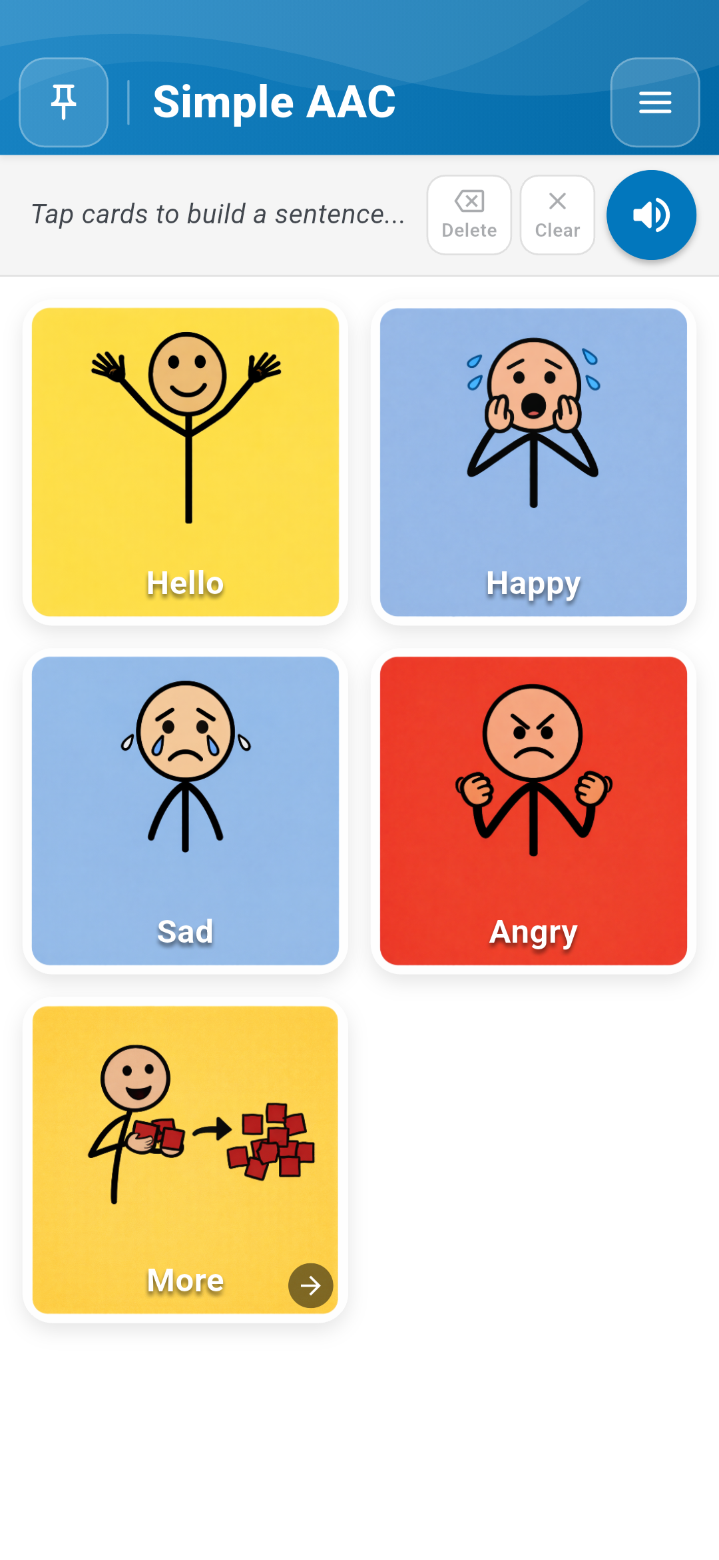
Figure 1.1: Home Screen with Blue Header & Sentence Bar | Figure 1.2: High-contrast AAC Communication Cards Grid

Chapter 2 — Speaking and Sentence Composition

2.1 Tapping to Speak
Communication begins with a single touch. Simple AAC provides immediate multi-sensory feedback:
- Instant Speech: When Tap to Speak is enabled in Settings, touching any card speaks its label immediately via offline Text-to-Speech (TTS) or custom recorded voice.
- Haptic Pop: Every touch triggers a responsive physical vibration and subtle visual pop effect, confirming selection for tactile learners.
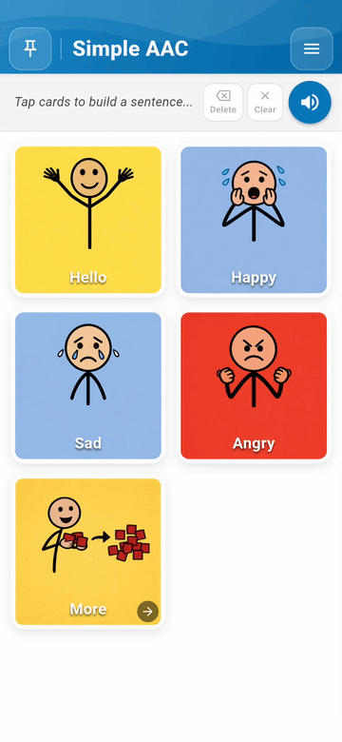 | 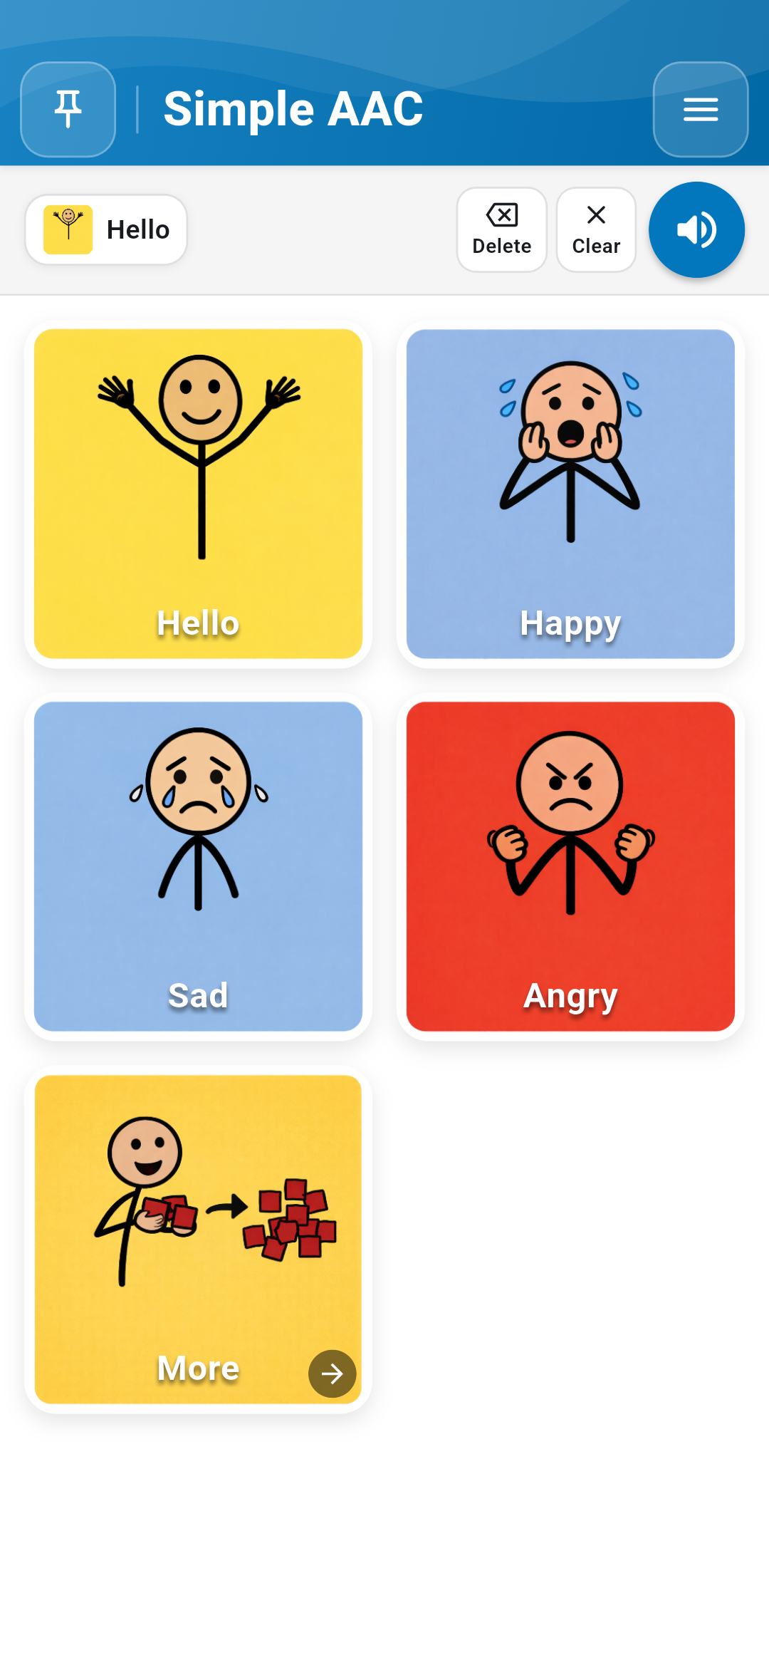
Figure 2.1: Live demonstration of tapping cards & speech | Figure 2.2: Tapping "Hello" places card on sentence bar

2.2 Constructing Multi-Word Sentences
Users can express complex thoughts by tapping cards sequentially (e.g., "Hello" + "Happy"). The Sentence Composer Bar provides three primary actions:
- Delete (Back Arrow): Removes the most recently added card from the sentence.
- Clear: Empties the entire sentence bar in a single tap.
- Speak Sentence (Speaker Button): Speaks the entire constructed sentence fluently from left to right.
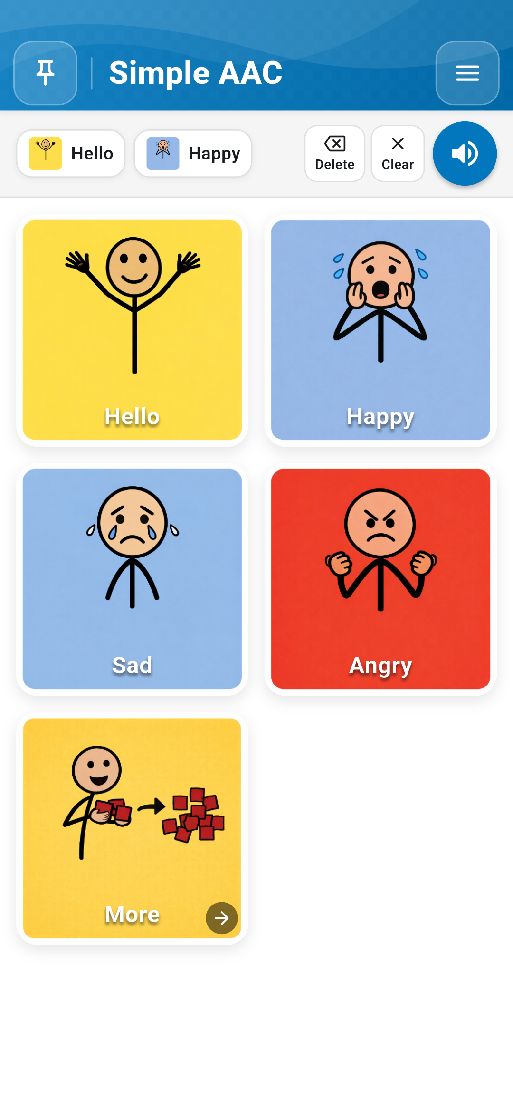
Figure 2.3: Building multi-word sentences in the Sentence Composer Bar

Chapter 3 — Customizing Cards and Multilingual Content
Every individual communicates differently. Simple AAC allows caregivers, speech therapists, and educators to fully personalize every card's imagery, labels, and audio.

3.1 Enabling Edit Mode & Card Editor
To customize cards, tap Menu (top right) -> Enable Edit Mode. Red trash-can badges appear on cards, and an Add New button displays at the top. Tapping any card opens the comprehensive Edit Card Dialog.
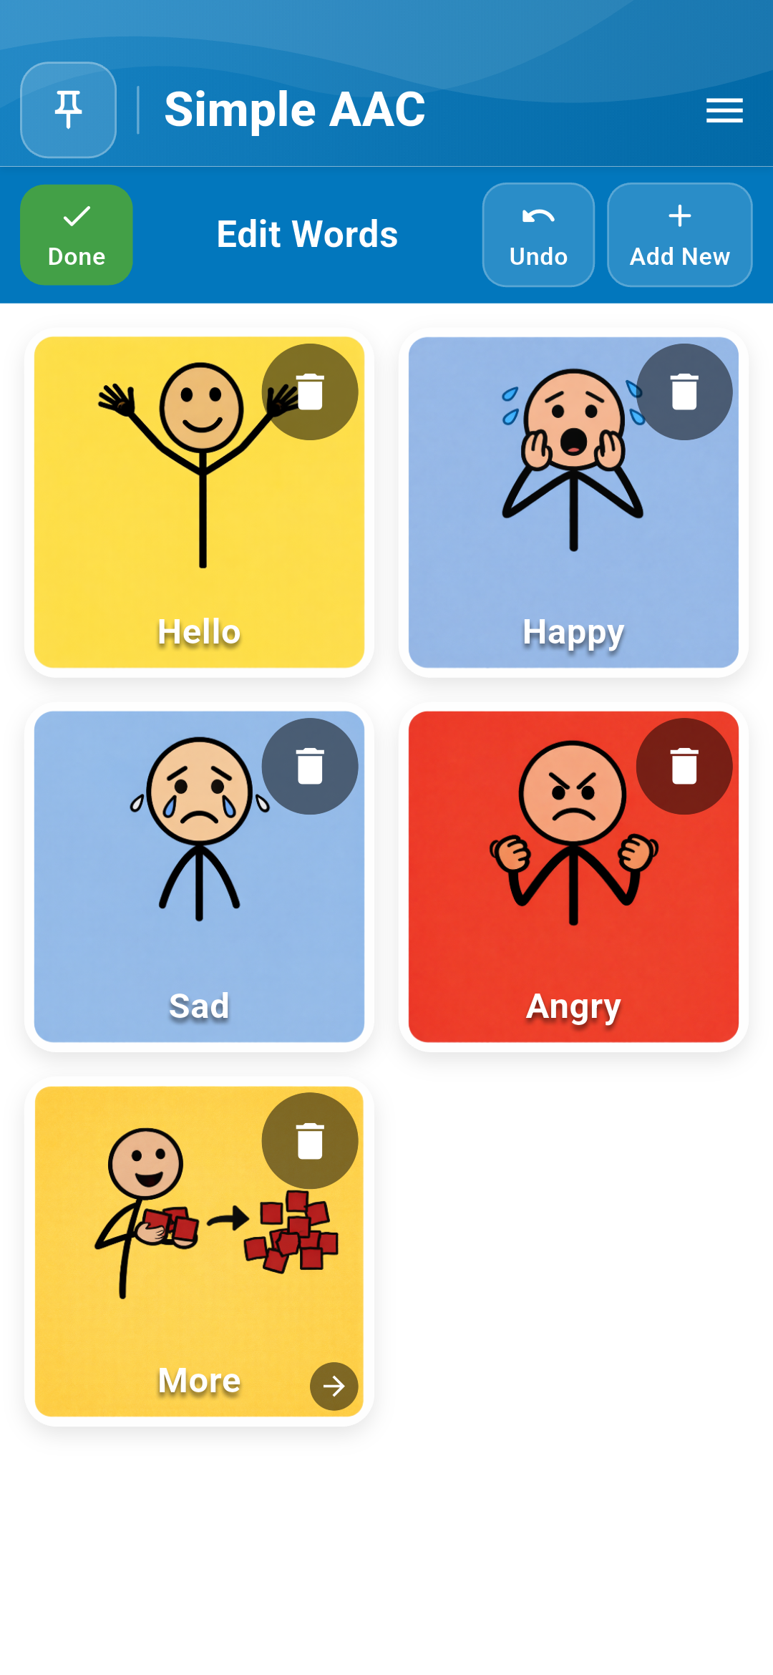 | 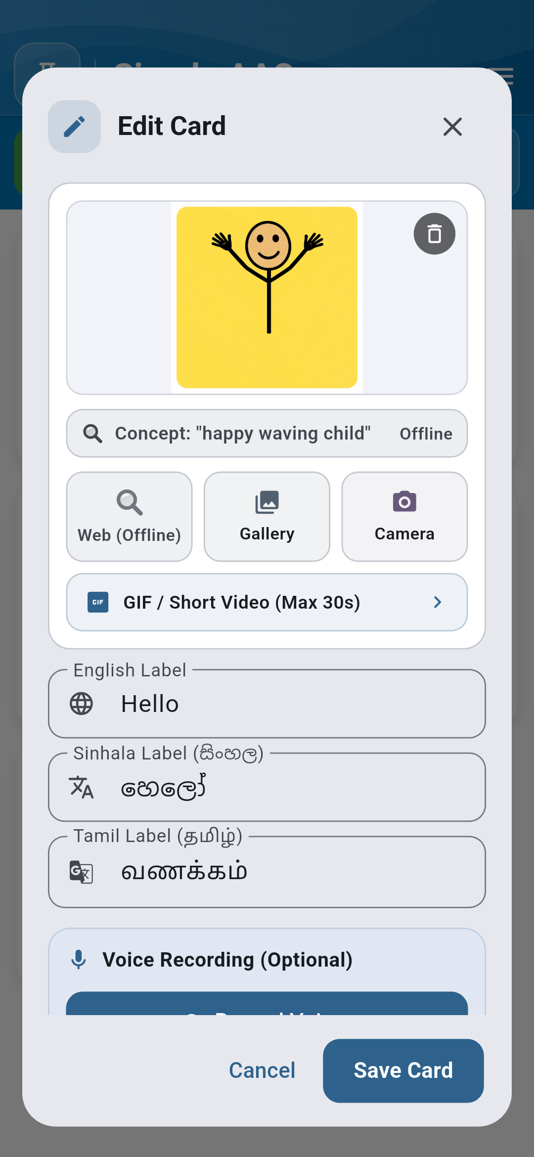
Figure 3.1: Edit Mode active with Add New button | Figure 3.2: Card Editor Dialog with customization tools

3.2 Adding Authentic Photos & Smart Search
- Camera: Capture real-world items (child's bottle, favorite toy, family members). The app requests standard Android permissions automatically.
- Gallery: Select family photos or therapy pictograms stored on the device.
- Smart Image Search: When online features are enabled, search a curated, child-safe library of concepts.
 | 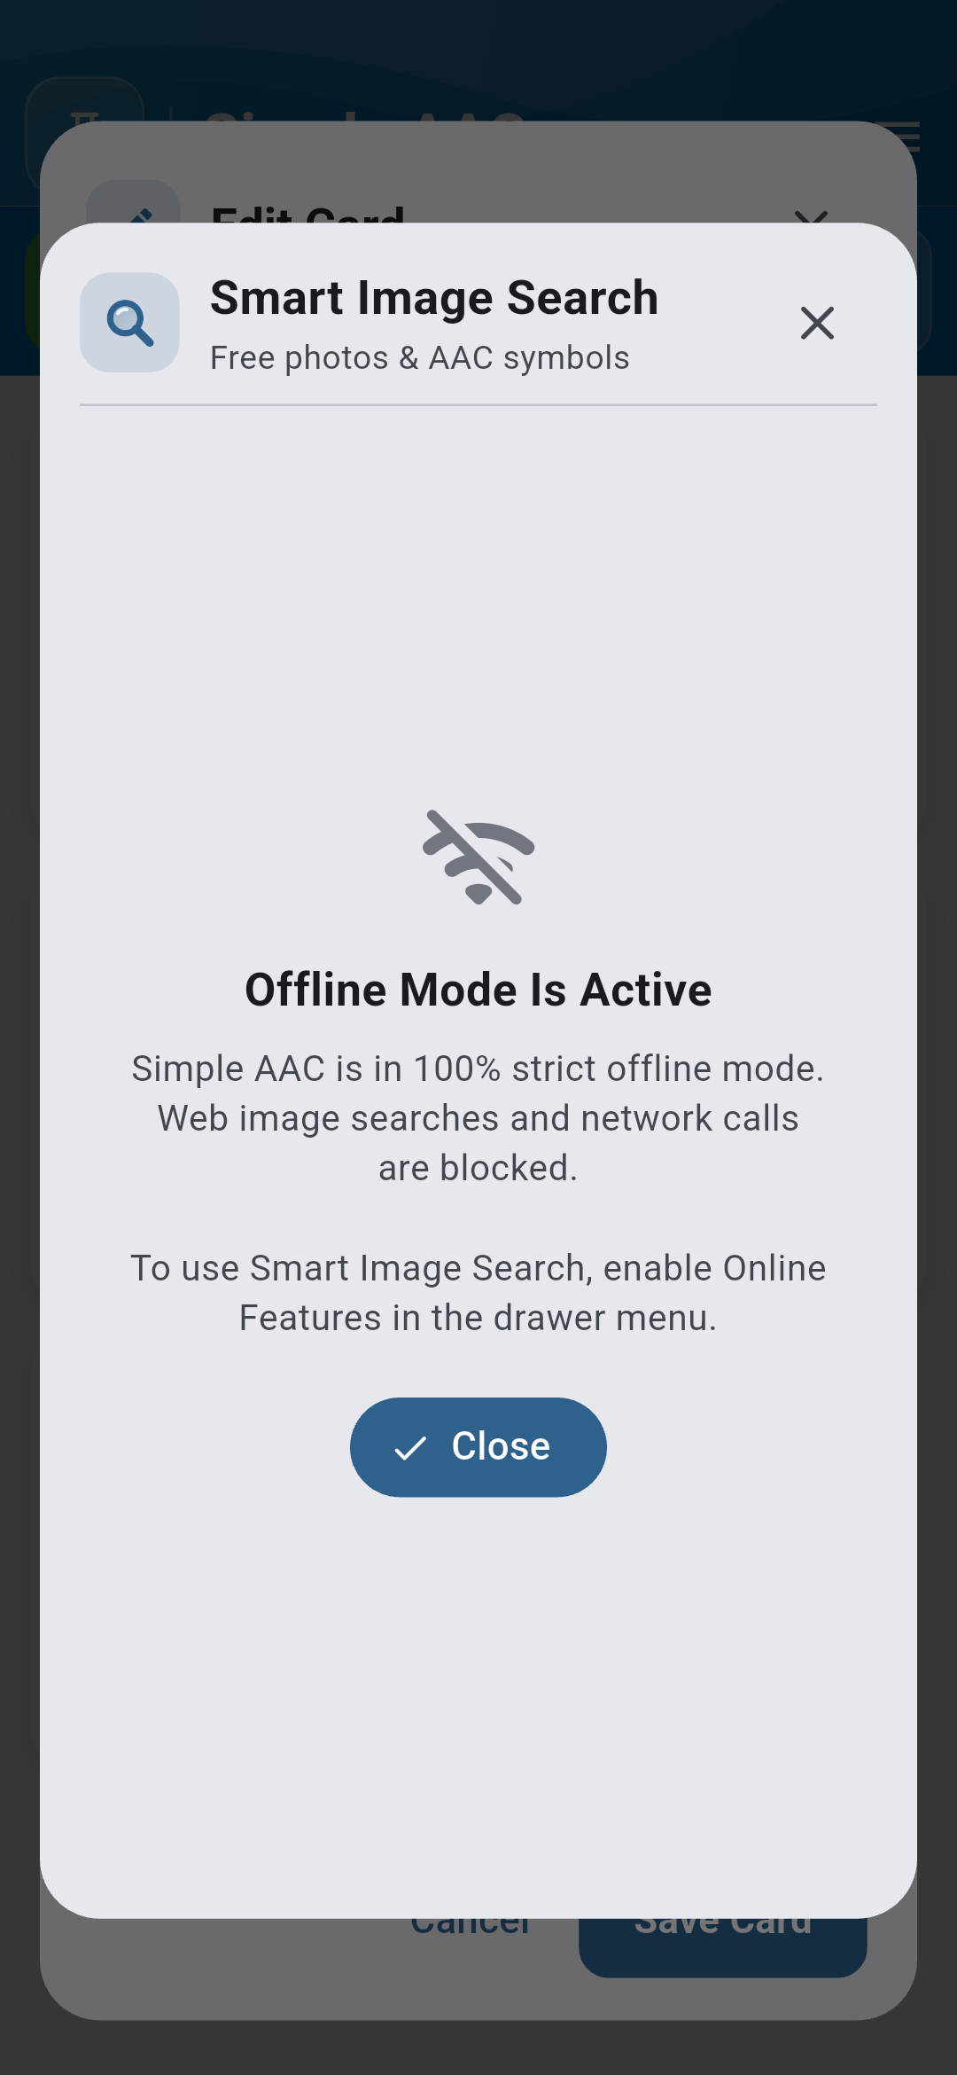
Figure 3.3: Direct Camera photo capture | Figure 3.4: Child-safe Smart Image Search

3.3 Trilingual Support & Custom Voice Recording
Simple AAC supports Sri Lanka's official languages with simultaneous trilingual labels: English (e.g., Hello), Sinhala (හෙලෝ, සතුටුයි, වතුර), and Tamil (வணக்கம், மகிழ்ச்சி, தண்ணீர்). For children who respond best to familiar family voices, caregivers can record custom audio directly in the editor, which takes precedence over synthesized speech.
Figure 3.5: Trilingual English, Sinhala & Tamil labels | Figure 3.6: High-fidelity custom voice recording

Chapter 4 — Animated GIFs and Video Loops
Visual learners and individuals with autism frequently comprehend dynamic actions (such as jumping, drinking, or washing hands) significantly better through motion than static images. Simple AAC includes a dedicated high-performance GIF engine that loops smoothly without draining battery power.
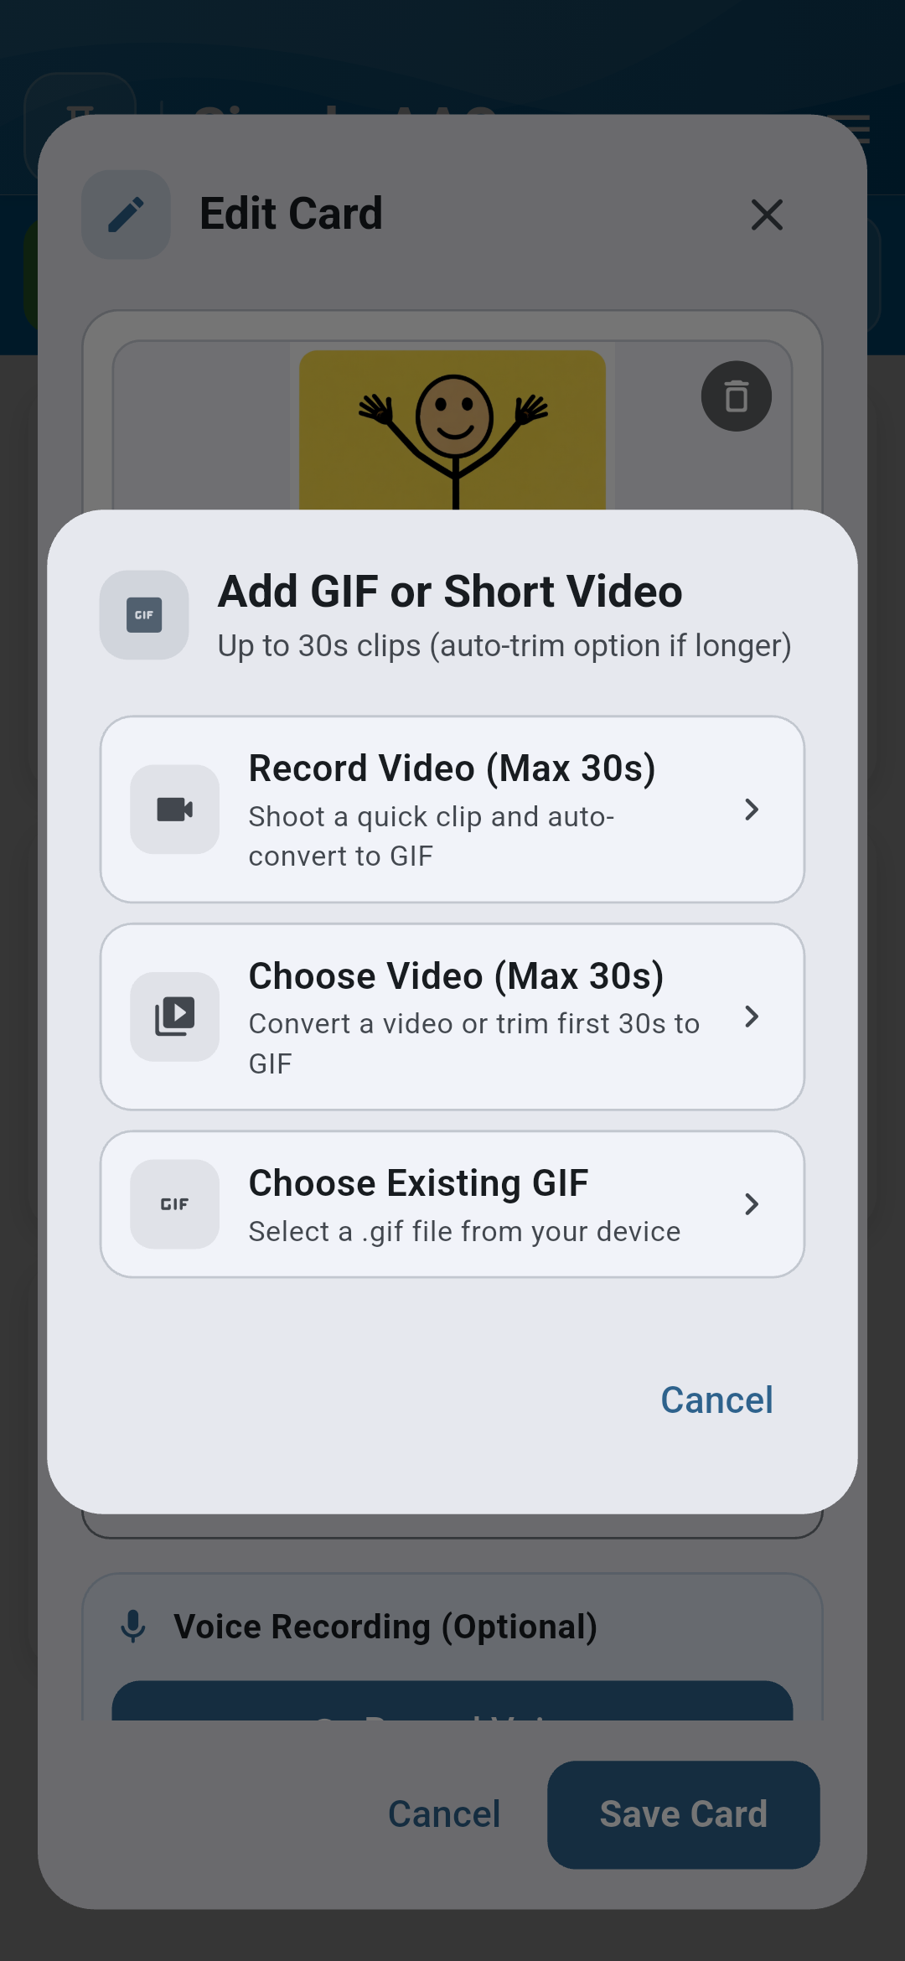
Figure 4.1: GIF import for loopable action cards | Figure 4.2: Built-in 30s video-to-GIF converter
Caregivers can record short video clips (up to 30 seconds) of actual therapies, routines, or sign language gestures, and the app automatically converts them into lightweight, battery-efficient animated loops.

Chapter 5 — Folders and Category Organization
As vocabulary expands, cards can be organized into categories such as Feelings, Food & Drink, School, and Activities. Tapping a folder card smoothly navigates into the category deck while keeping the sentence composer bar persistent at the top.
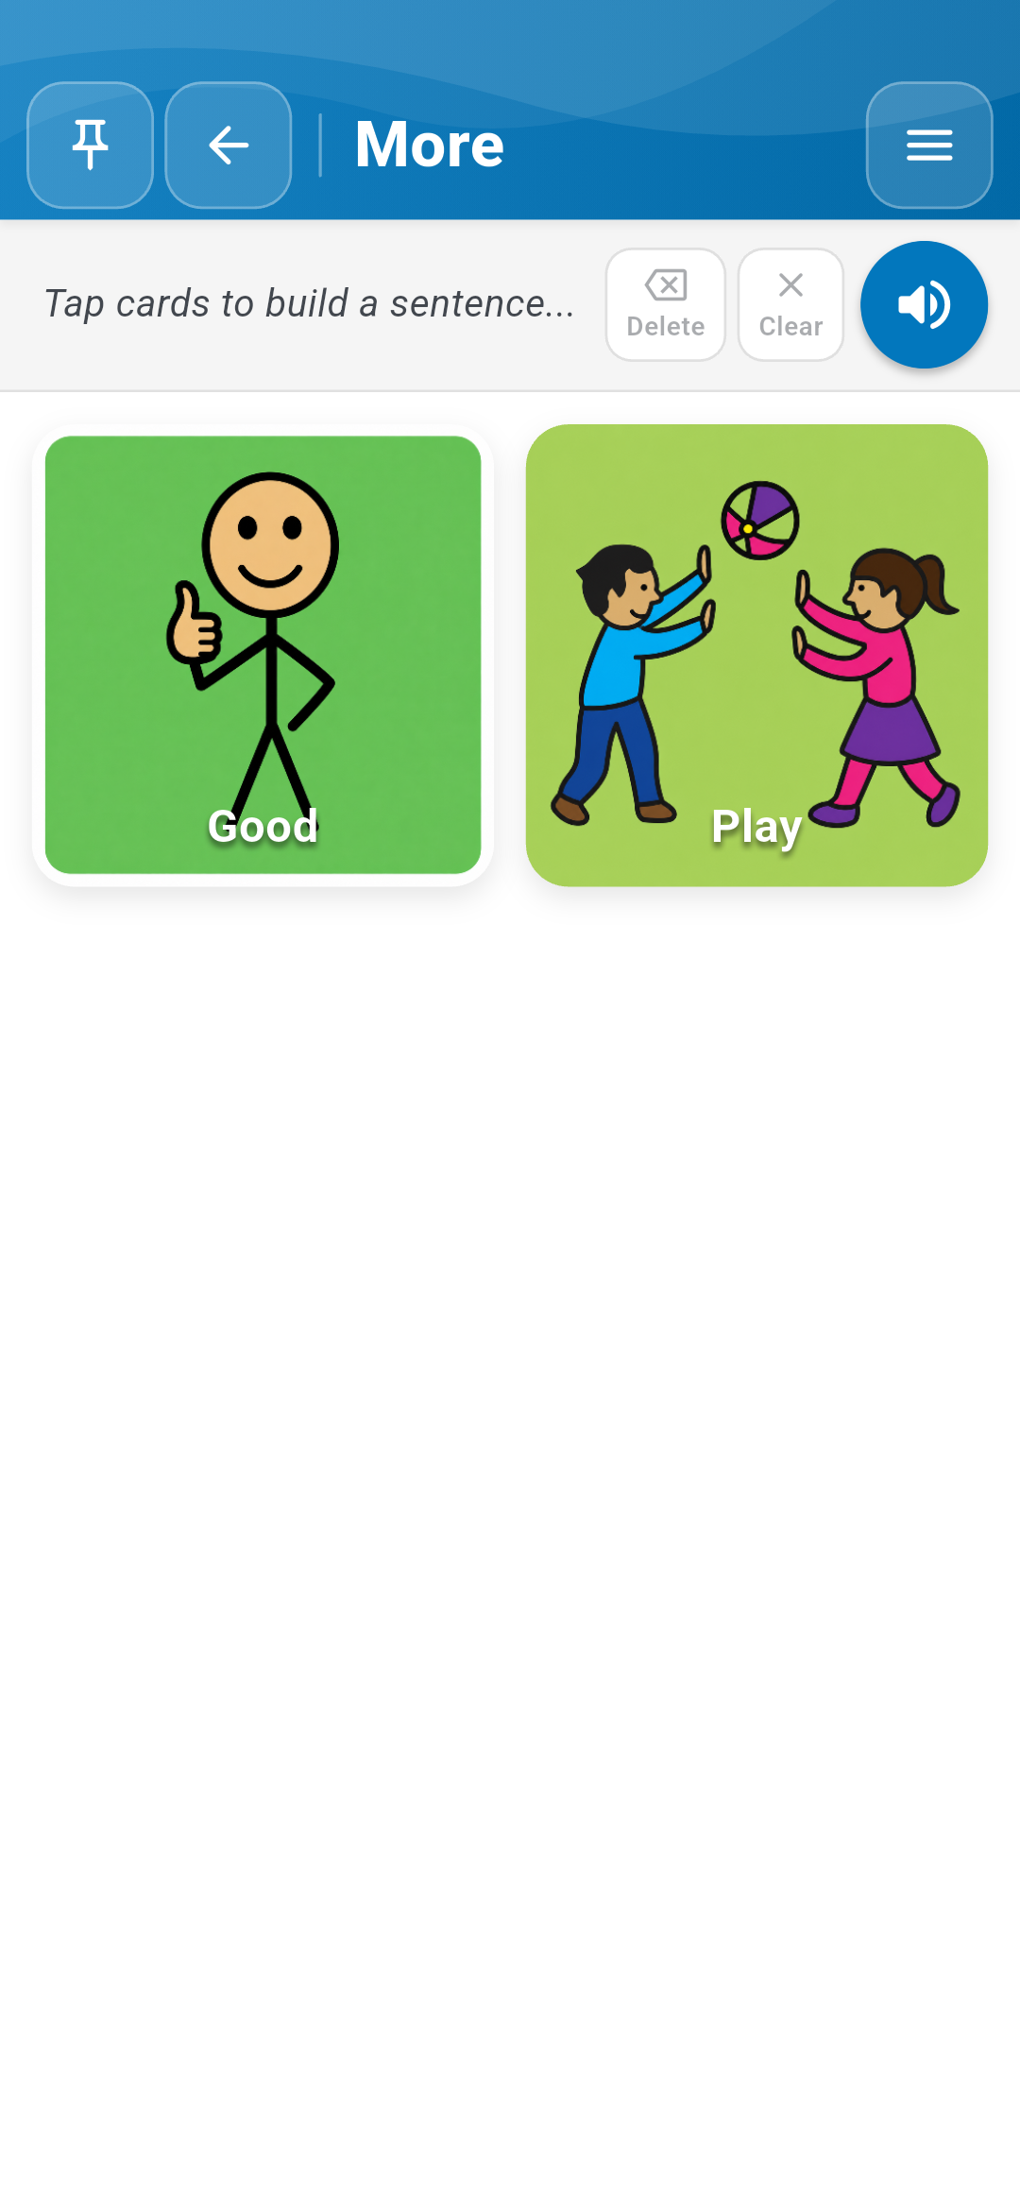
Figure 5.1: Navigating into subfolders and category decks ("More ->")

Chapter 6 — Appearance, Themes and Haptic Feedback

6.1 Settings Drawer & Live Color Customization
Access the Settings Drawer by tapping the top-right Menu button. Simple AAC v1.1.0 introduces redesigned visual Color Pickers equipped with real-time interactive preview canvases.
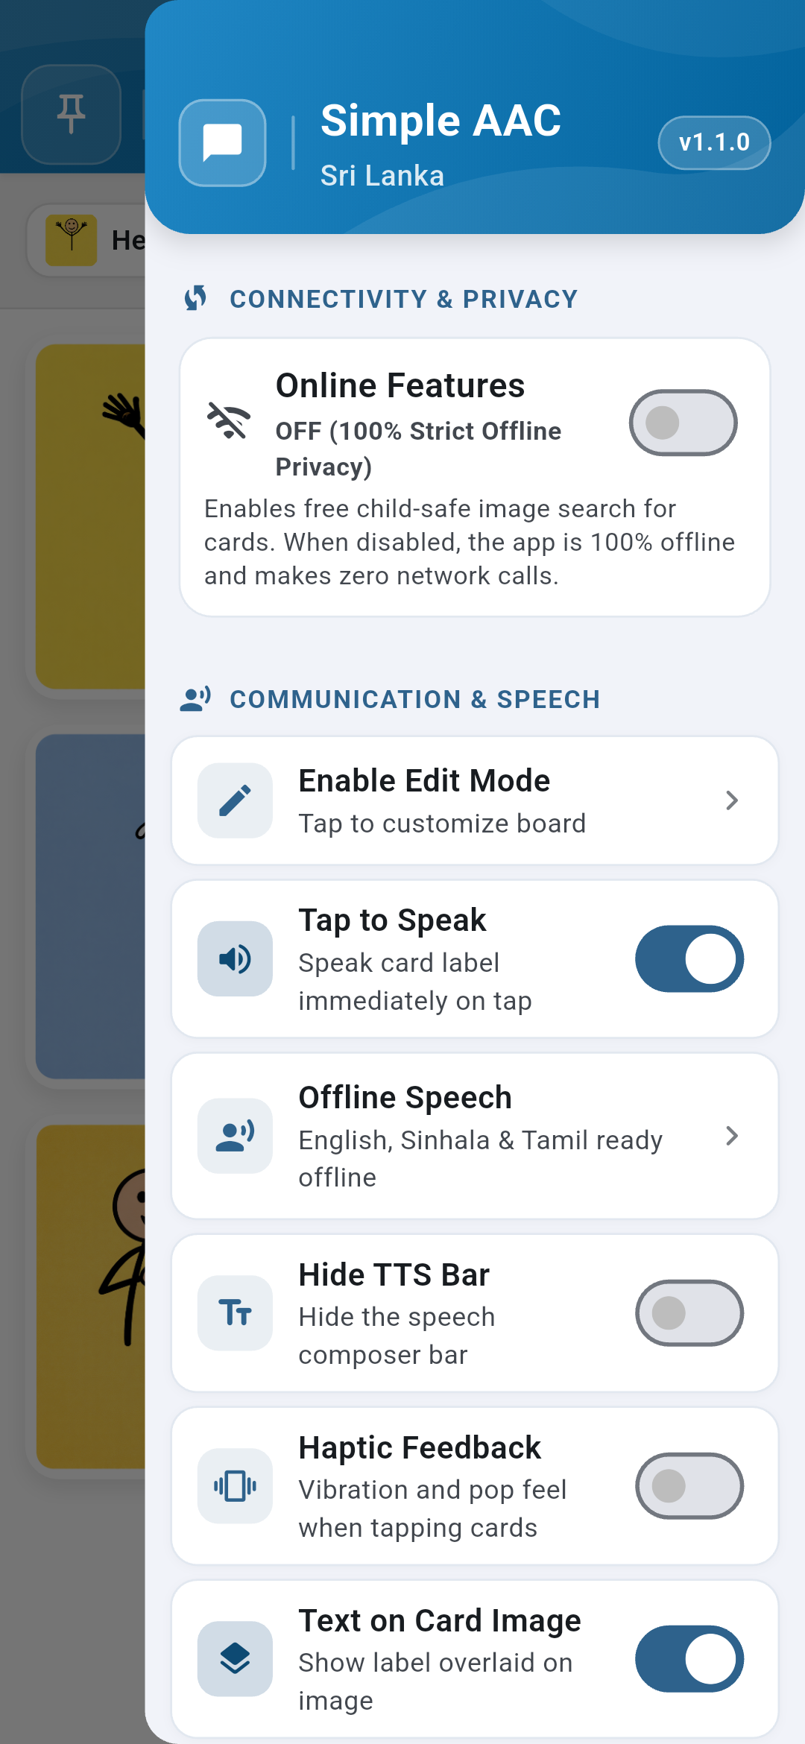 | 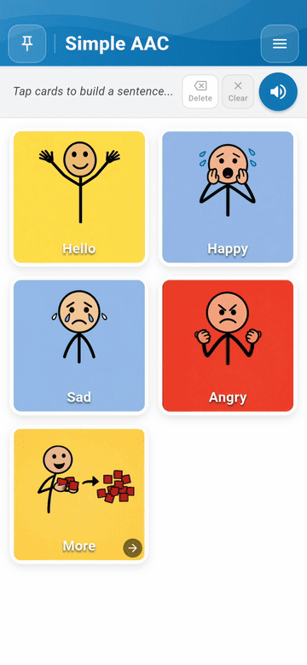
Figure 6.1: Settings Drawer with haptics toggle | Figure 6.2: Live Color Picker demonstration

6.2 Redesigned Color Pickers
Customize the primary app color, global text color, and board background with real-time contrast previews:
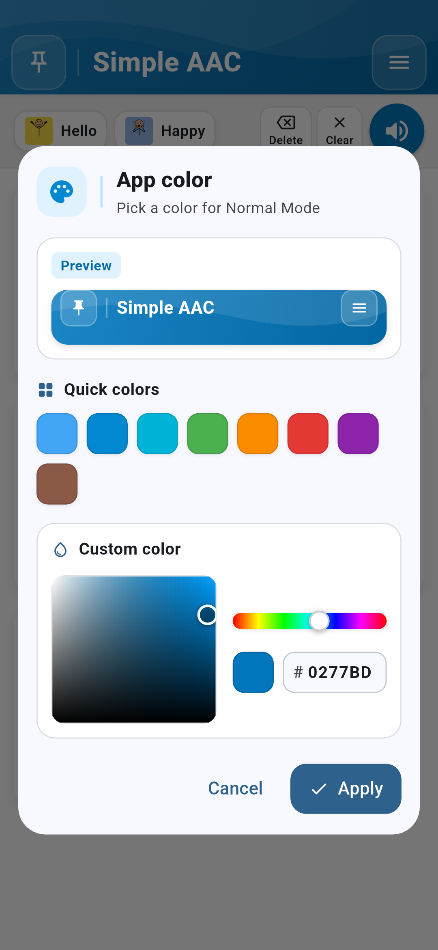 | 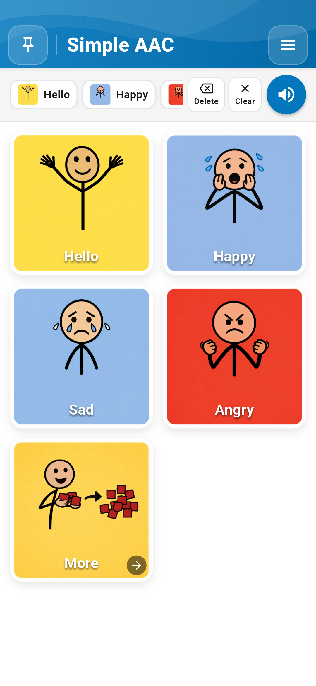
Figure 6.3: App Color Picker with mini-header | Figure 6.4: Text Color Picker with 3-card preview | Figure 6.5: Board Background Color preview

6.3 Color Vision Support & Haptic Feedback
For users with color vision deficiency, Simple AAC provides a tested Color-Blind Safe Mode exceeding WCAG AA 4.5:1 contrast standards. The Haptic Feedback switch delivers tactile reinforcement on every tap.
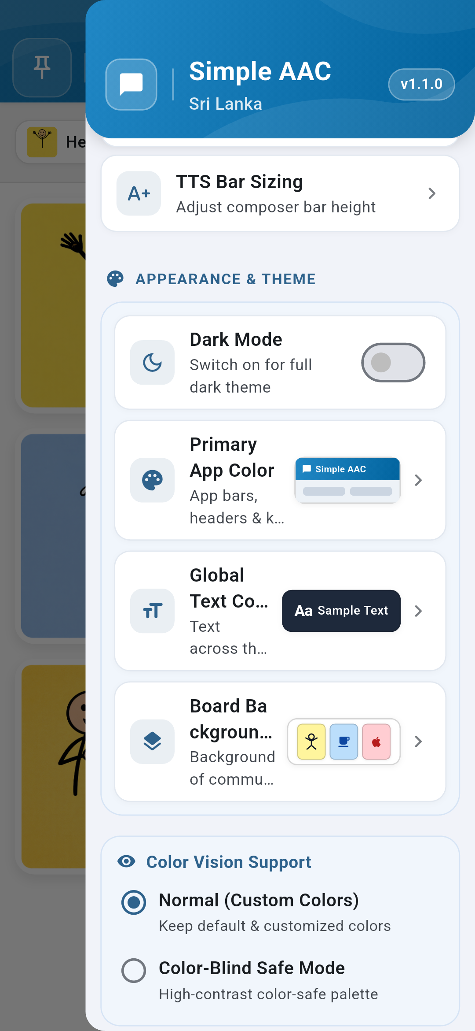
Figure 6.6: Color Vision Support and high-contrast settings

Chapter 7 — Safety, Board Pinning and Child Lock

7.1 Enabling Board Pinning with a PIN
Accidental taps or exploration can inadvertently alter settings or delete cards. Tap the Pin Board button (top left) to set a 4-digit security PIN. When locked, the Settings Drawer and Edit Mode are completely disabled, allowing users to communicate safely without risking data alteration.
 | 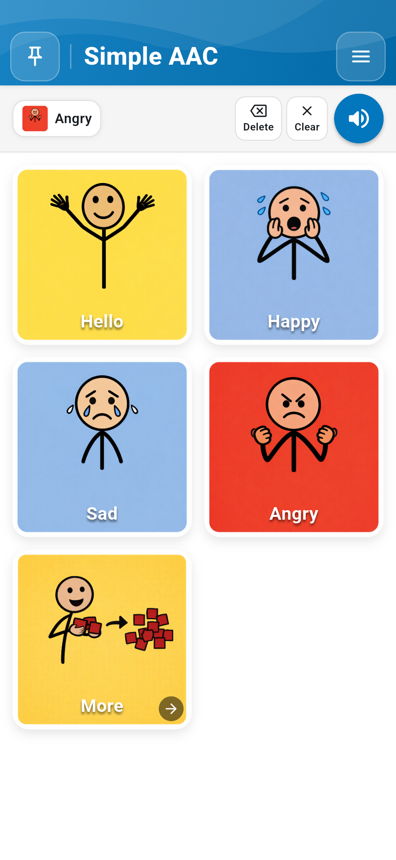
Figure 7.1: Setting up or unlocking 4-digit security PIN | Figure 7.2: Pinned board mode with disabled edit controls

Chapter 8 — Data Backup, Restore and Offline Privacy

8.1 Strict Offline Privacy Model
Simple AAC operates entirely on-device. Personal photos, voice recordings, and communication logs are never transmitted to external servers.

8.2 Exporting & Restoring Backups
- Export Backup: Packages all custom cards, photos, recordings, and settings into a single ZIP archive saved directly to your device's Downloads folder.
- Import Restore: Safely unpacks and validates any previously exported Simple AAC ZIP archive, instantly restoring your personalized vocabulary.
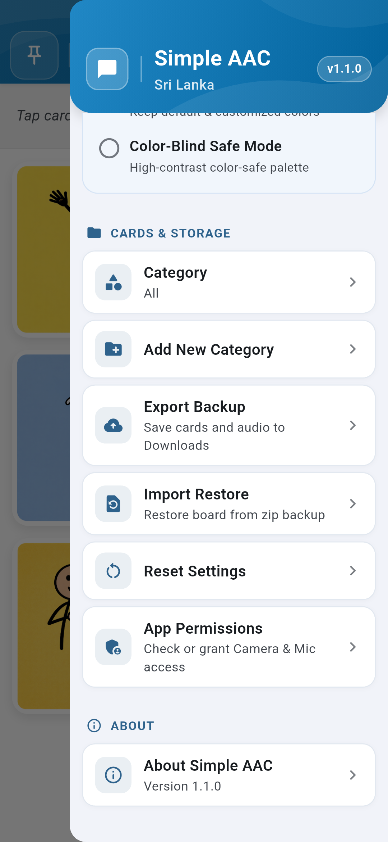 | 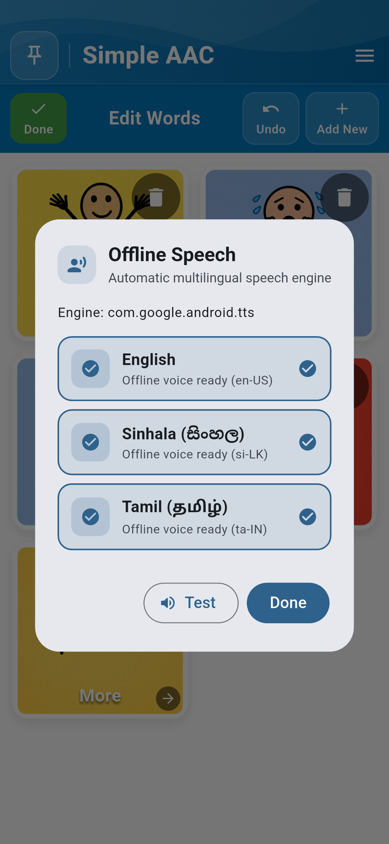
Figure 8.1: Cards & Storage section in Settings Drawer | Figure 8.2: Offline Speech (TTS) engine configuration
Note on Scalability: Simple AAC utilizes an atomic file persistence architecture (aac_cards_v1.json with automated .bak redundancy). Backups are verified safe for large datasets up to 1,000+ cards with full media integrity.
Simple AAC Sri Lanka • Version 1.1.0 • Empowering voices with dignity, independence, and reliability.

