**USER MANUAL**

**GUI FOR UNDERWATER ROBOT**

**GROUP-K**

Ashwini Jha

Devansh Shah

Amanpreet Singh

Yasasvi V Peruvemba

April 12 2019

**Introduction**

The GUI for the underwater fish robot developed by the mechanical lab of IIT Indore displays an interface for the user to activate the relays to control the robot and displays sensor data in a graphical format.

**Setting Up the Server**

We have already pre-installed all of the required dependenciesrequired to run the server.

**Step 1**

To start the server, open the folder where the server files are downloaded and copy it’s directory.

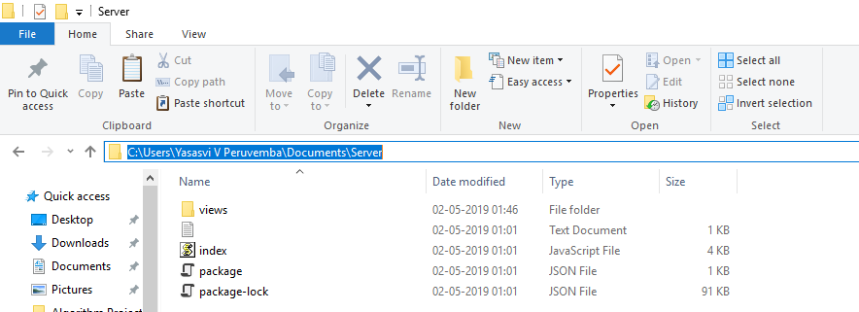

**Step 2**

Run the command line client again and type “cd *paste the path to the folder*” (eg: If the folder name is Server and it is in C:\Documents\Server, in the command line client, type “cd C:\Documents\Server”).

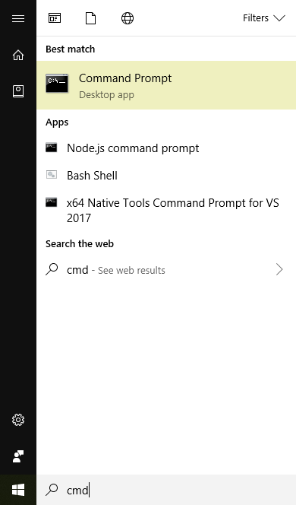

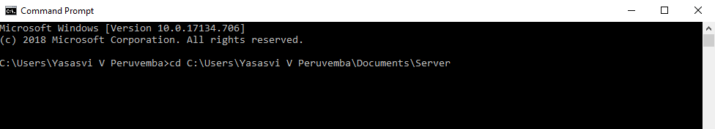

**Step 3**

After opening the path to the folder, in the command line client, type “npm start” to run the server. **Do not close the command line client in which the server is running.**

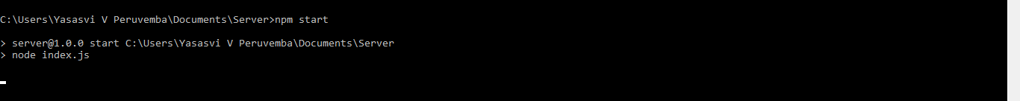

**Step 4**

Now to open up the server, open a new command line client and type “ipconfig” and copy the IP Address(The set of four numbers in front of the IPv4 Address name tag).

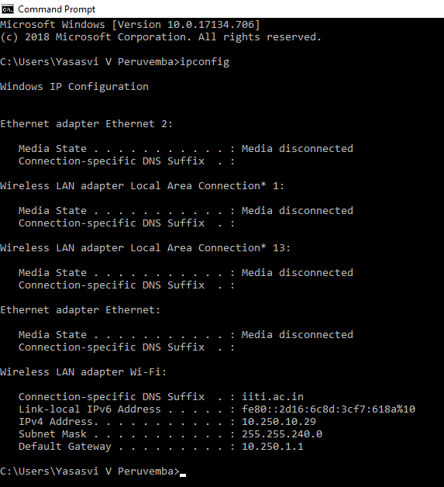

**Step 5**

Now open up any browser of your choice and paste the IP Address and concatenate “:8080” to it. This should successfully open the Login page.

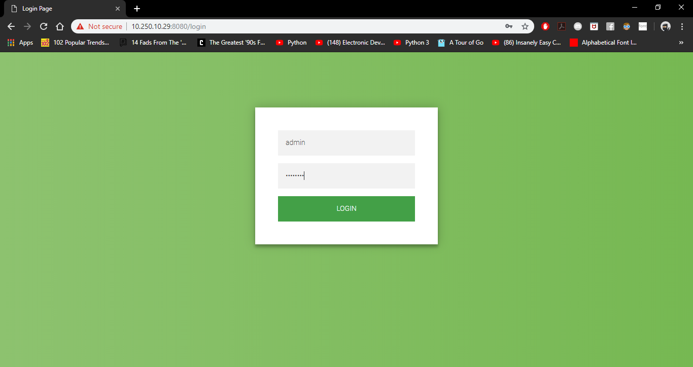

**Step 6**

If any problem occurs, from windows menu, run the Command Line Client and type “npm install” and click Enter. Then follow steps 2-5.

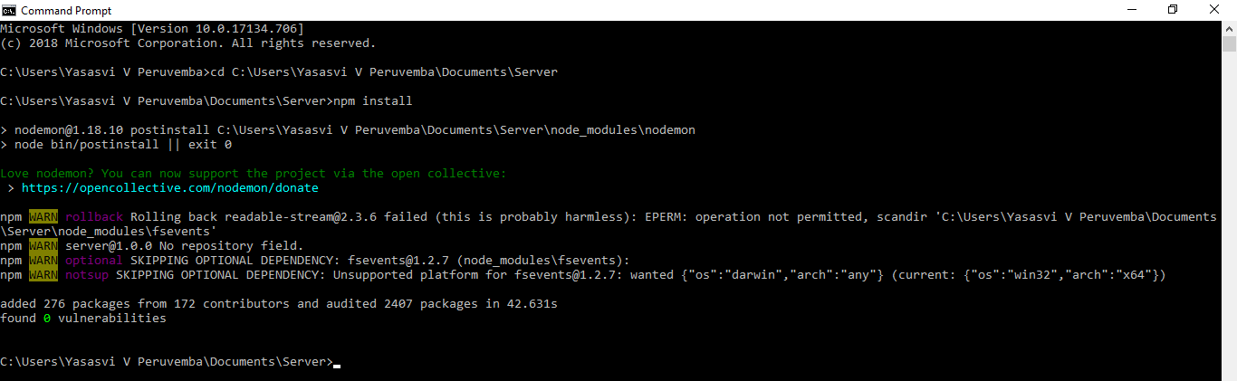

**Login**

There is a single user who has master control over the GUI for the Robot. He/She is required to login with their credentials in order to access the control interface.

In the login page, follow the given steps :

1. Username : Fill in your Username
2. Password : Fill in the Password
3. Click on Login

**Robot Control**

After logging in, the sensor data is displayed in a graph, with colour coded sensors.

There is a button to control the activation of relays.

It has a label which displays **the action that will happen when pressed**. If the label reads “SWITCH OFF” it means that clicking the button will turn off the relay and vice-versa. To exit the website, simply exit the browser and close the command line client that was running the server.