Food Delivery App - Project Report

# 1. INTRODUCTION

## 1.1 Project Overview

The Food Delivery App is a full-stack web application that connects customers, restaurant owners, and administrators on a single platform for online food ordering and restaurant management.

## 1.2 Purpose

To make food ordering faster and more convenient for customers, and to help restaurants manage their menus, orders, and operations efficiently through a digital system.

# 2. IDEATION PHASE

## 2.1 Problem Statement

Many local restaurants lack an easy-to-use digital system for receiving online orders, managing menus, and reaching more customers.

## 2.2 Empathy Map Canvas

Users: Customers, restaurant owners, admins  
Needs: Quick ordering, simple management, efficient oversight  
Pains: Long wait times, manual order tracking, operational errors

## 2.3 Brainstorming

Ideas generated include:  
- User-friendly customer UI  
- Restaurant dashboard for order & menu management  
- Admin panel for oversight  
- Payment gateway integration  
- Real-time order status updates

# 3. REQUIREMENT ANALYSIS

## 3.1 Customer Journey Map

1. Visit website → 2. Browse restaurants → 3. Add items to cart → 4. Place order → 5. Track order → 6. Review food

## 3.2 Solution Requirement

- Intuitive UI/UX for customers  
- Restaurant and admin dashboards  
- Secure login for all user types  
- Reliable backend and database  
- Scalability for multiple restaurants

## 3.3 Data Flow Diagram

User → Frontend → API → Server → Database → Response → Frontend

## 3.4 Technology Stack

- Frontend: React.js  
- Backend: Node.js, Express.js  
- Database: MongoDB  
- Styling: CSS  
- State Management: React Context API

# 4. PROJECT DESIGN

## 4.1 Problem Solution Fit

The solution directly addresses the need for an online food ordering and restaurant management system that is easy to use and scalable.

## 4.2 Proposed Solution

A web application with separate modules for customers, restaurant owners, and administrators.

## 4.3 Solution Architecture

- Frontend: React.js SPA (Single Page Application)  
- Backend: Node.js with Express REST API  
- Database: MongoDB (NoSQL)  
- Authentication: Basic login/signup (can be upgraded to JWT)

# 5. PROJECT PLANNING & SCHEDULING

## 5.1 Project Planning

Week 1: Requirement gathering, UI mockups  
Week 2: Frontend component development  
Week 3: Backend API development  
Week 4: Integration of frontend & backend  
Week 5: Testing, debugging, and deployment

# 6. FUNCTIONAL AND PERFORMANCE TESTING

## 6.1 Performance Testing

- Load tested with multiple concurrent users.  
- Verified page load times and server response times under test data.  
- Basic unit testing on backend APIs.

# 7. RESULTS

## 7.1 Output Screenshots

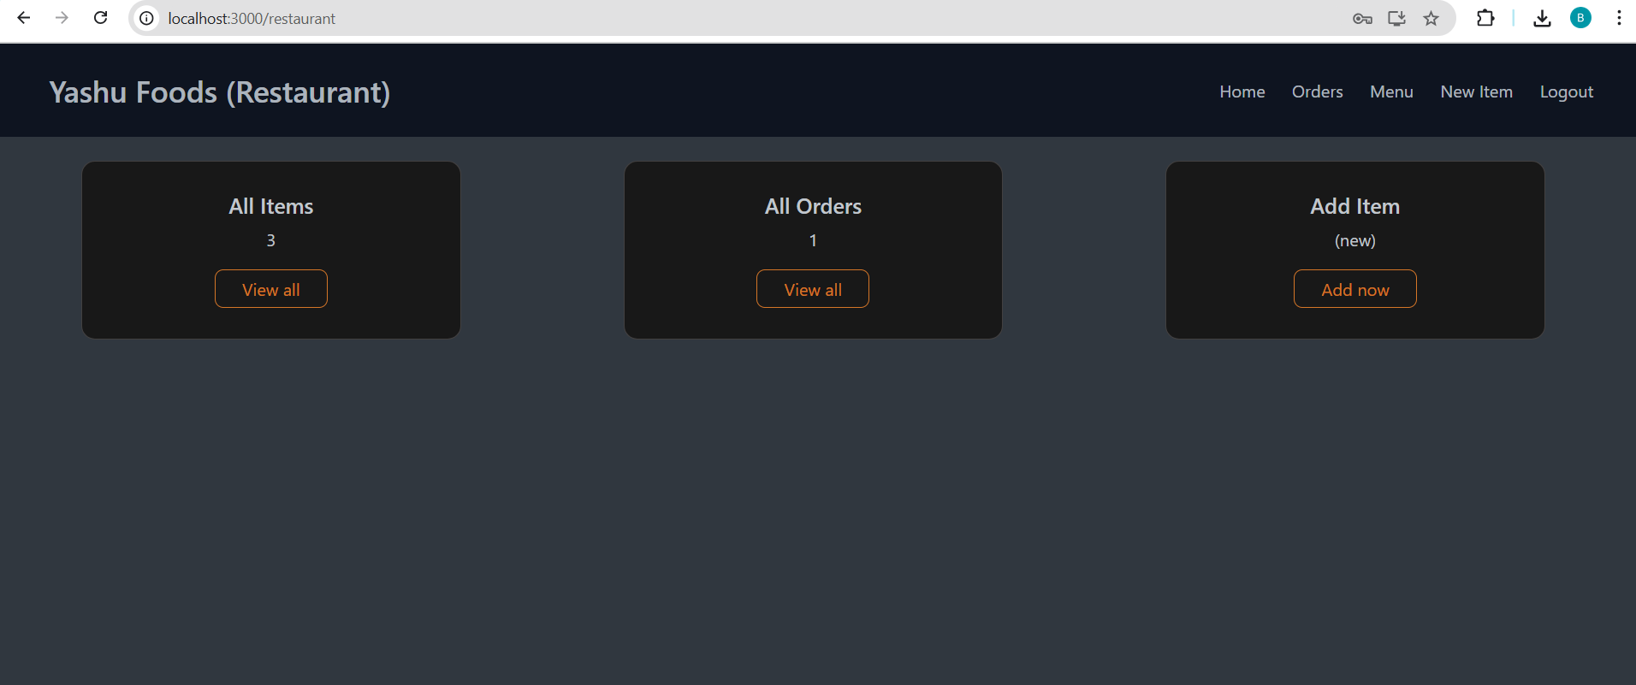

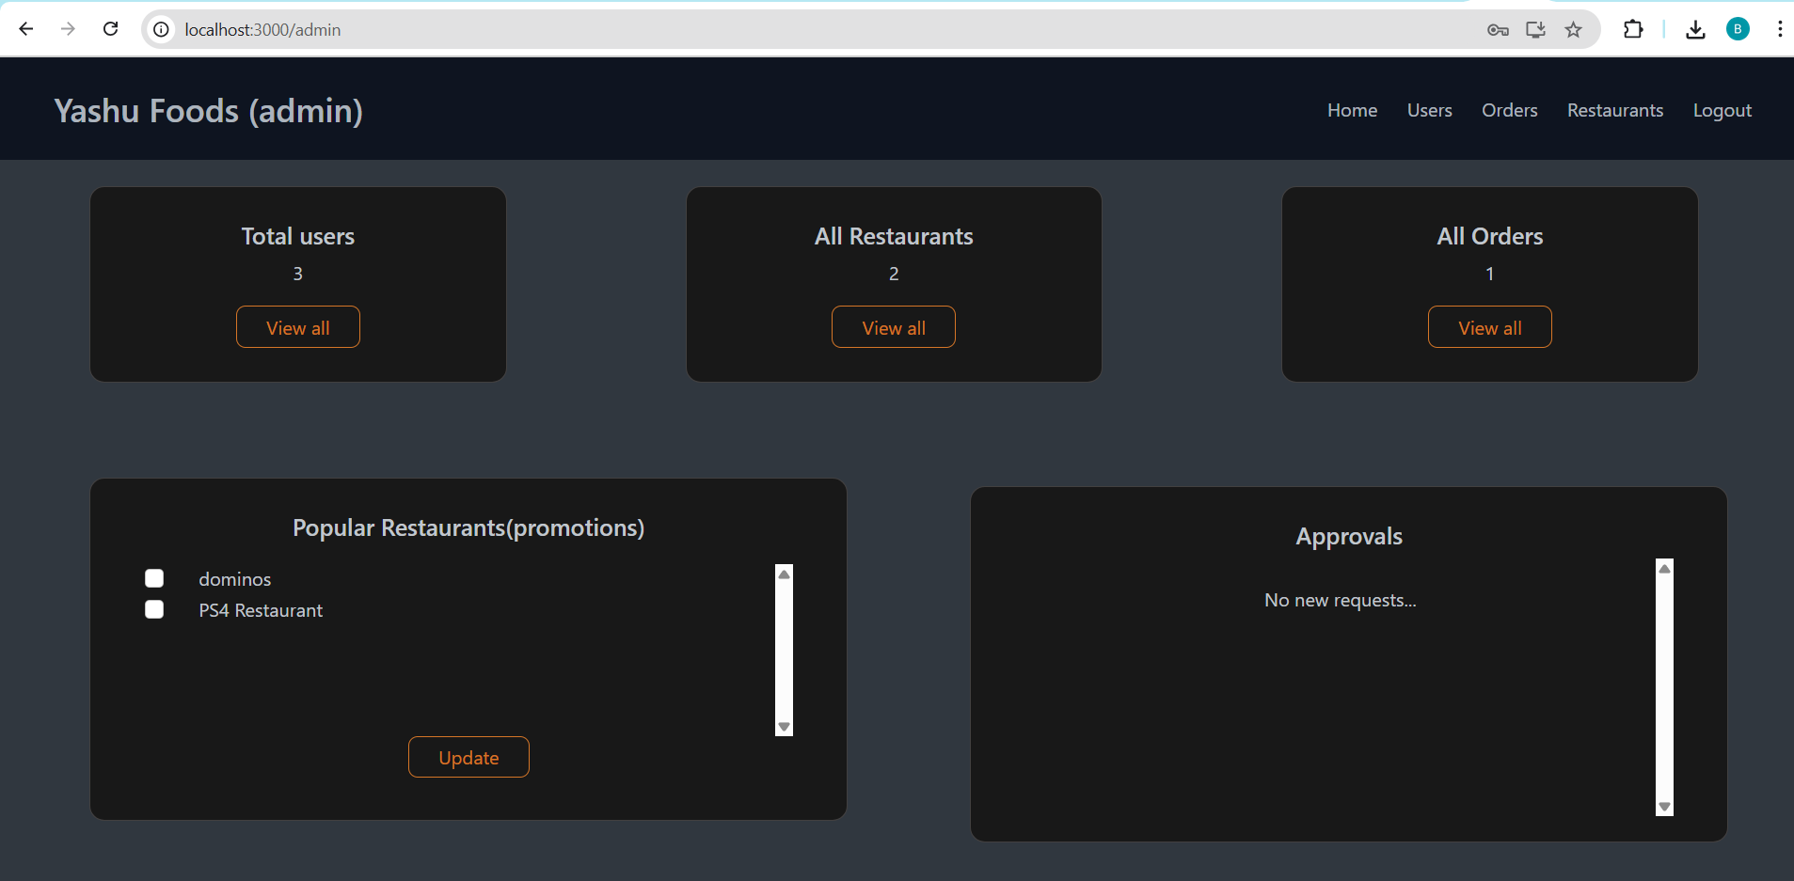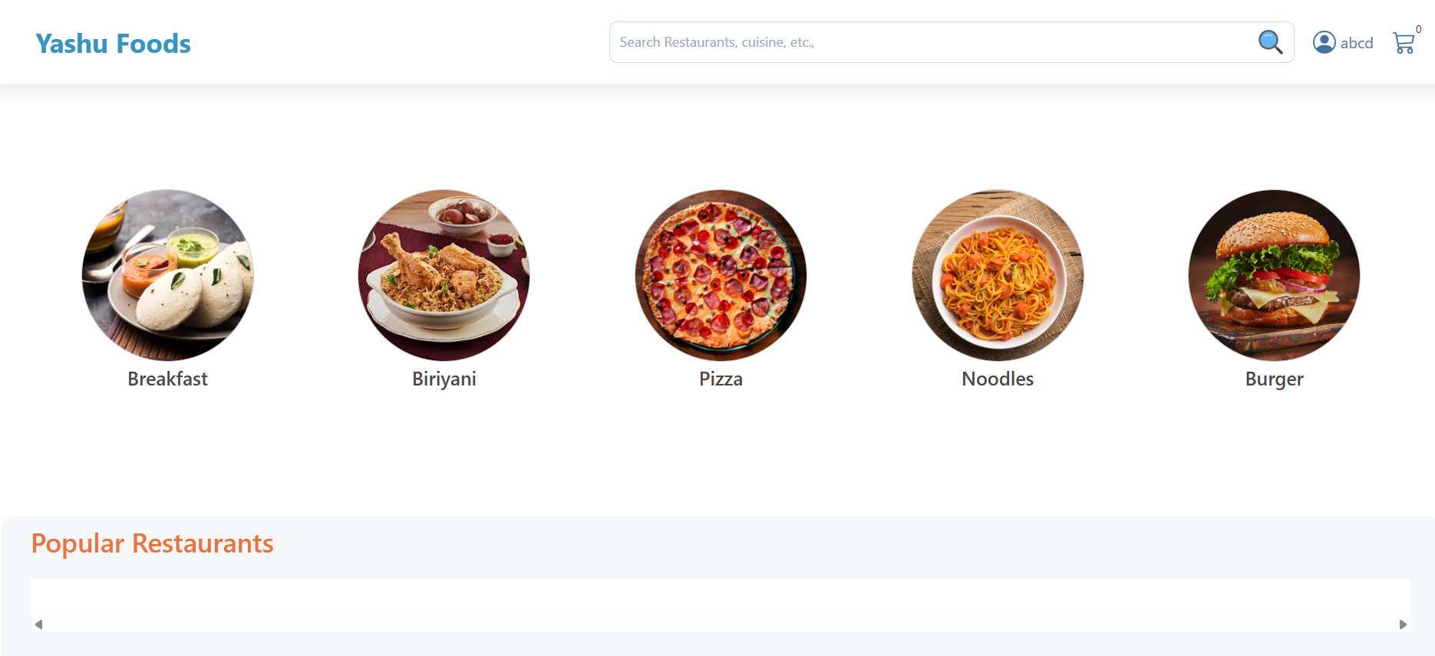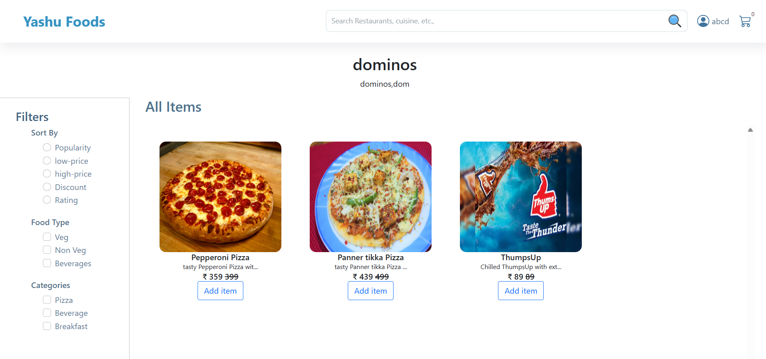

# 8. ADVANTAGES & DISADVANTAGES

Advantages:  
- Convenient for customers.  
- Increases restaurant reach.  
- Simple to manage and extend.  
  
Disadvantages:  
- Relies on stable internet.  
- No payment integration yet.  
- Limited mobile responsiveness in base version.

# 9. CONCLUSION

The Food Delivery App provides an effective way for local restaurants to go digital and reach more customers while streamlining their operations.

# 10. FUTURE SCOPE

- Add JWT authentication.  
- Add online payment gateway (Stripe/PayPal).  
- Implement order tracking for deliveries.  
- Expand to a mobile app.  
- Add analytics and reporting dashboards.

# 11. APPENDIX

## Folder Structure

delivery app/  
├── client/ # React Frontend  
│ ├── public/  
│ ├── src/  
│ │ ├── components/  
│ │ ├── context/  
│ │ ├── images/  
│ │ ├── pages/  
│ │ │ ├── admin/  
│ │ │ ├── customer/  
│ │ │ ├── restaurant/  
│ │ ├── styles/  
│ ├── package.json  
│ ├── README.md  
├── server/ # Node.js Backend  
│ ├── index.js  
│ ├── Schema.js  
│ ├── .env  
│ ├── package.json

## How to Run the Application

Run the client:  
cd client  
npm install  
npm start  
  
Run the server:  
cd server  
npm install  
node index.js

## Source Code

Add your zipped project files: delivery app.zip

## Dataset Link

Not applicable (app generates data).

## GitHub & Project Demo Link

GitHub: <https://github.com/Yasaswi-co/FoodDeliveryApp>

Demo: [React App - Personal - Microsoft​ Edge 2025-06-28 22-36-13.mp4](https://1drv.ms/v/c/f7e6ba3e521ceaf6/Ea2r0eLuMDtBlXP0_jyKmGwBVDWTjEy6Wkpy0qosmnyfYw?e=SFseuY)