DIGITAL NURTURE 5.0 DEEPSKILLING

SPRING REST JWT:
EXERCISE-2:

Question: Creating Microservices for account and loan
Solution:
Part 1: Account
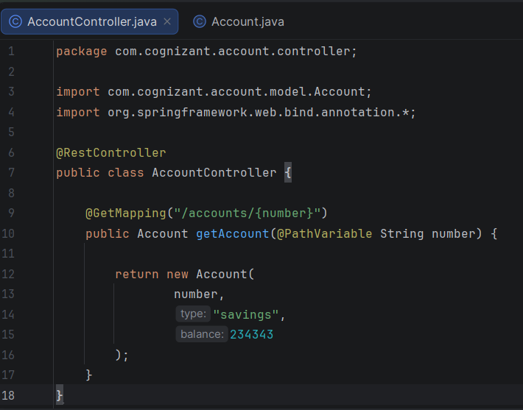
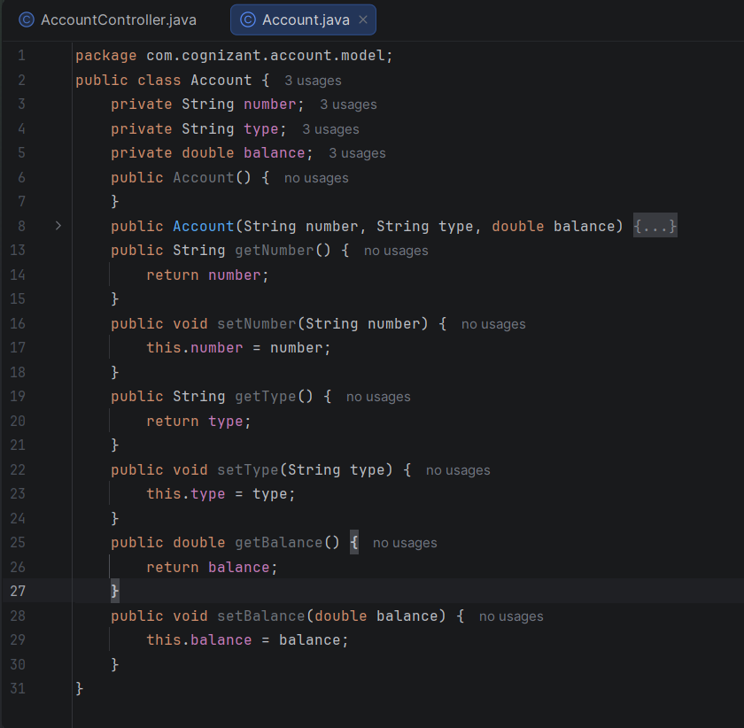
Output:
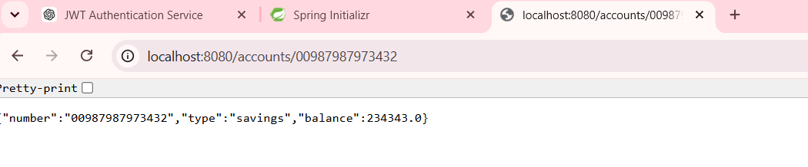

Part 2: Loan

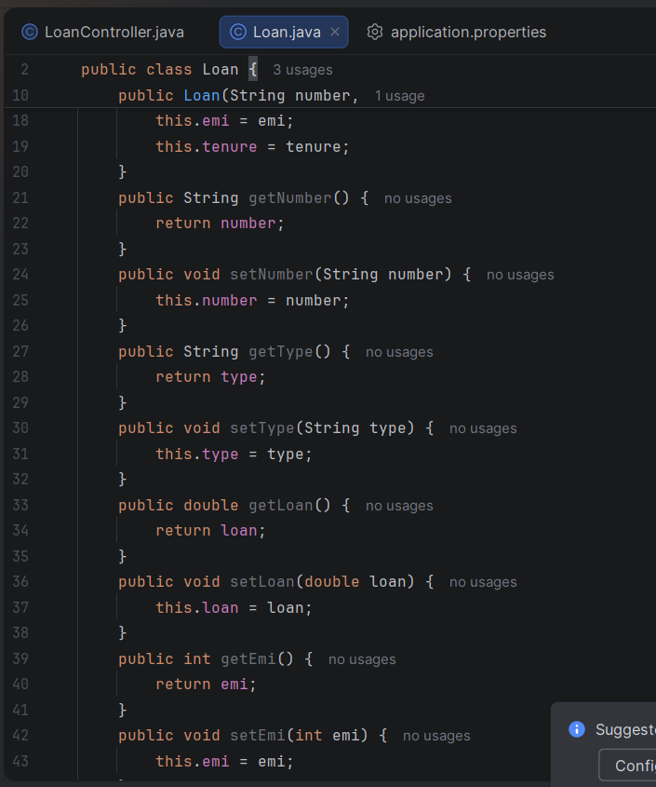
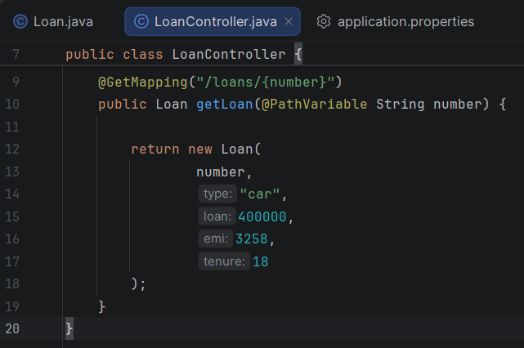
Output:
