DIGITAL NURTURE 5.0 DEEPSKILLING
HANDS-ON: 13
Question: Create a React App named “bloggerapp” in with 3 components.
- Book Details
- Blog Details
- Course Details
Implement this with as many ways possible of Conditional Rendering.
Solution:
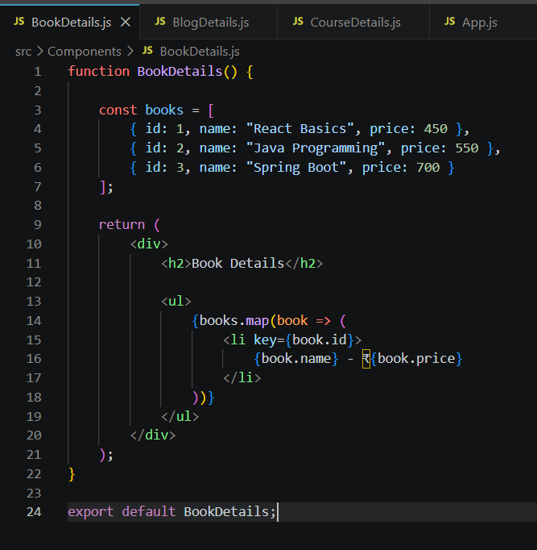
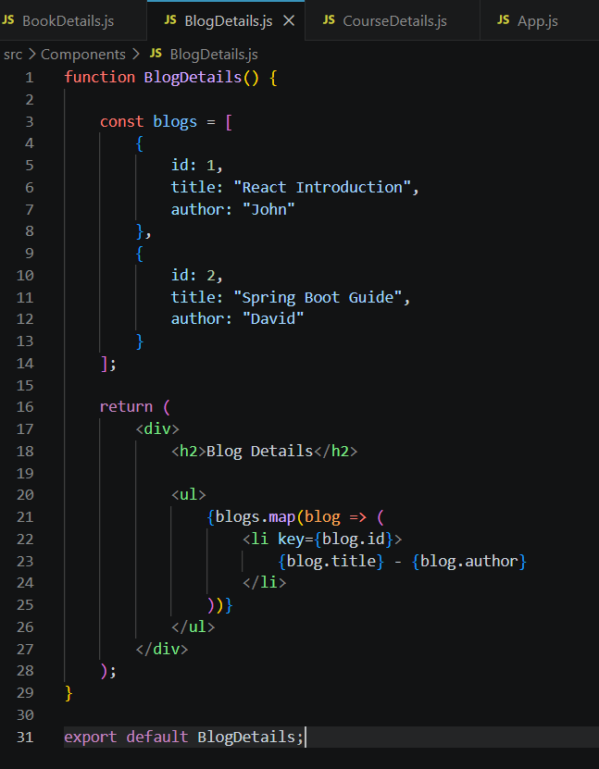
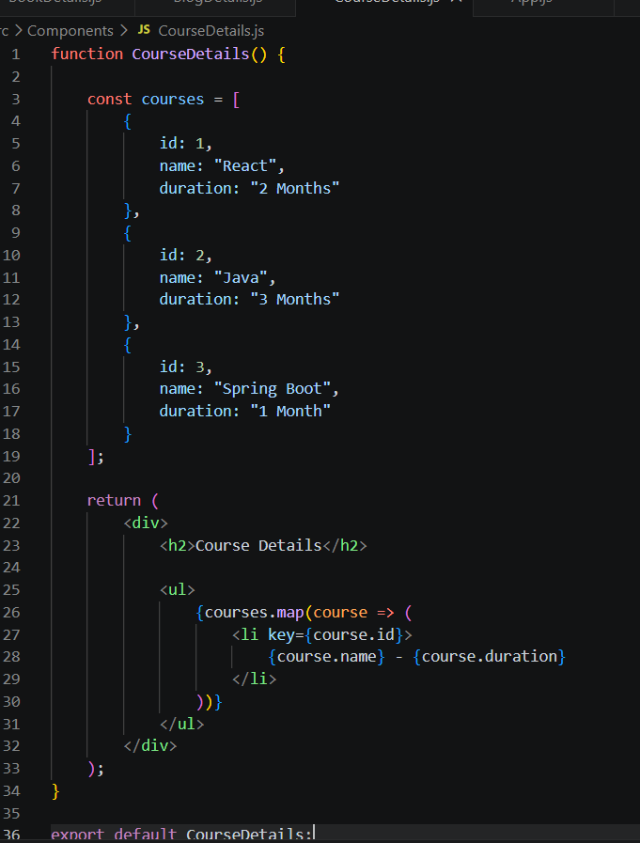
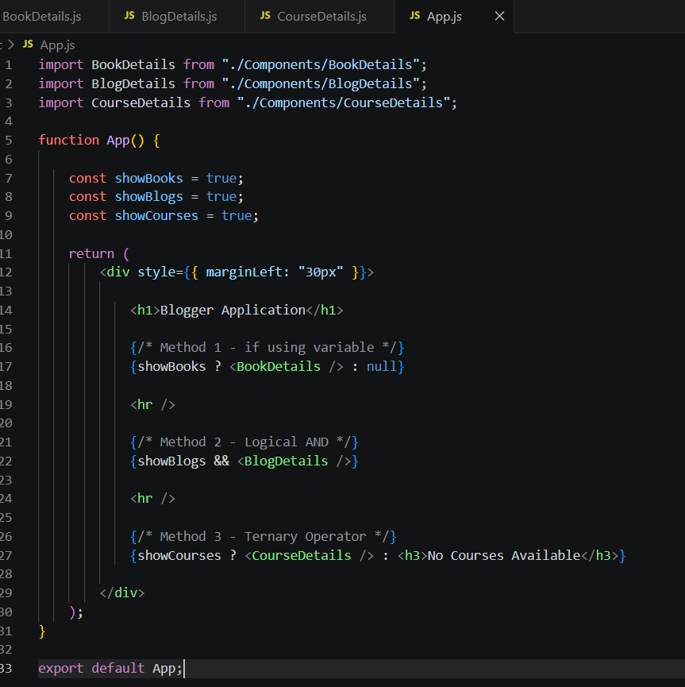

Output:

