DIGITAL NURTURE 5.0 DEEPSKILLING

JUNIT - BASIC TESTING EXERCISES:
EXERCISE-1:

Question: Setting Up JUnit
Solution:
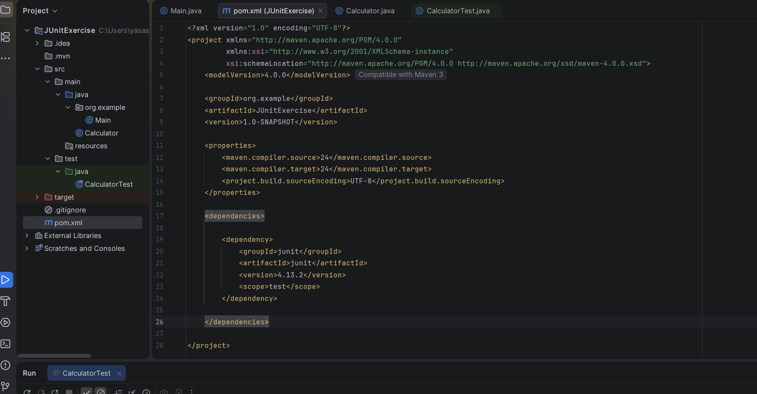
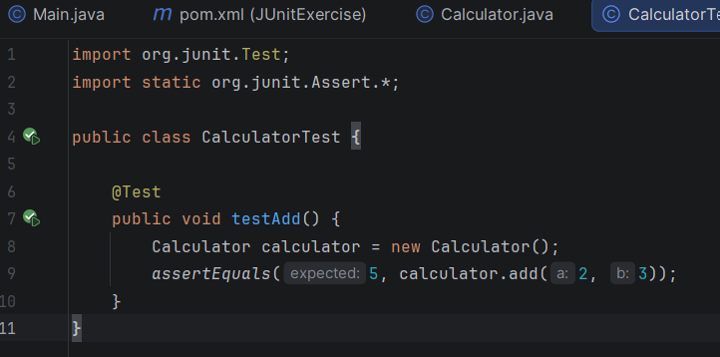
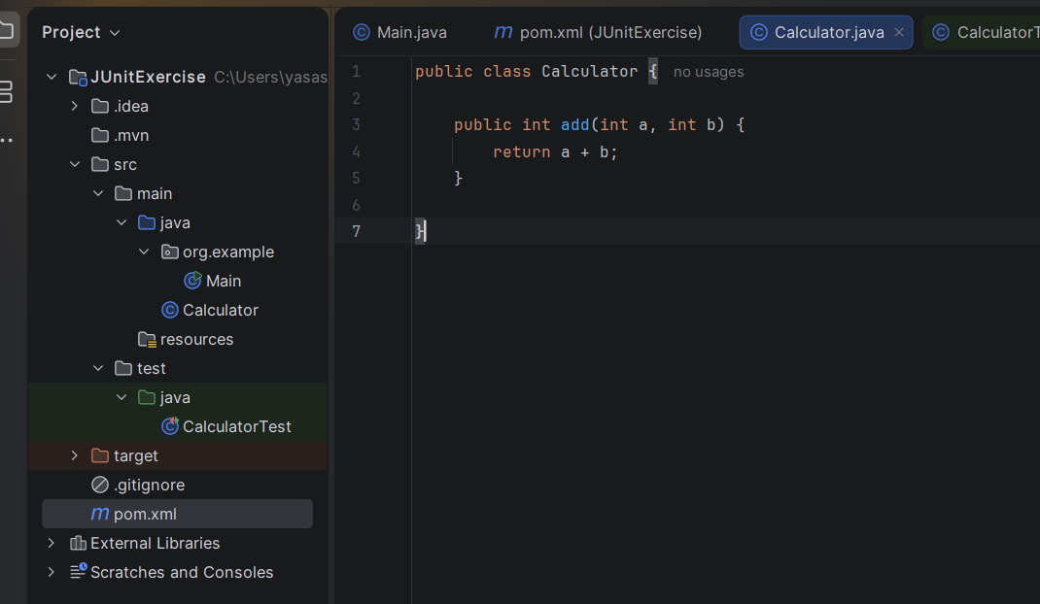

Output:
