DIGITAL NURTURE 5.0 DEEPSKILLING
HANDS-ON: 1
Question: Create a new React Application with the name “myfirstreact”, Run the application to print “welcome to the first session of React” as heading of that page.
Solution: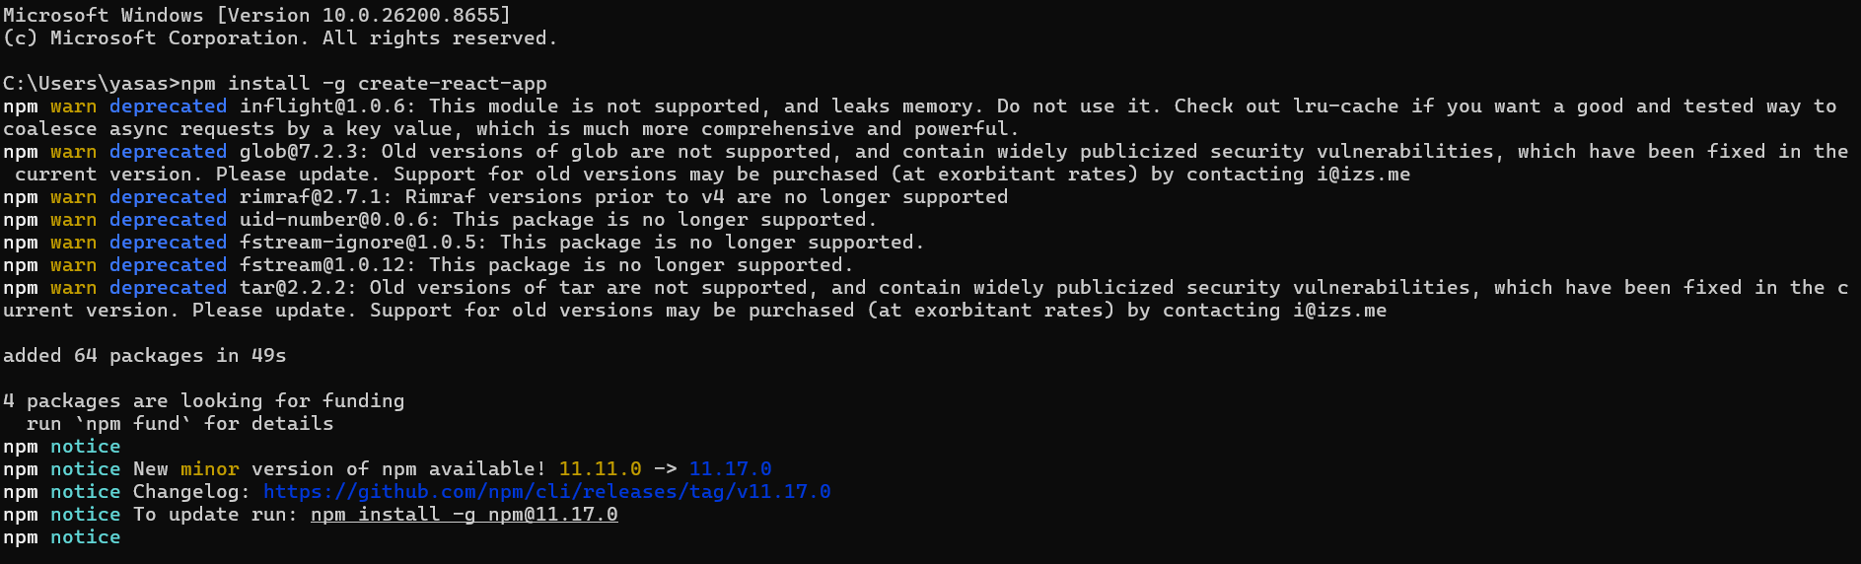
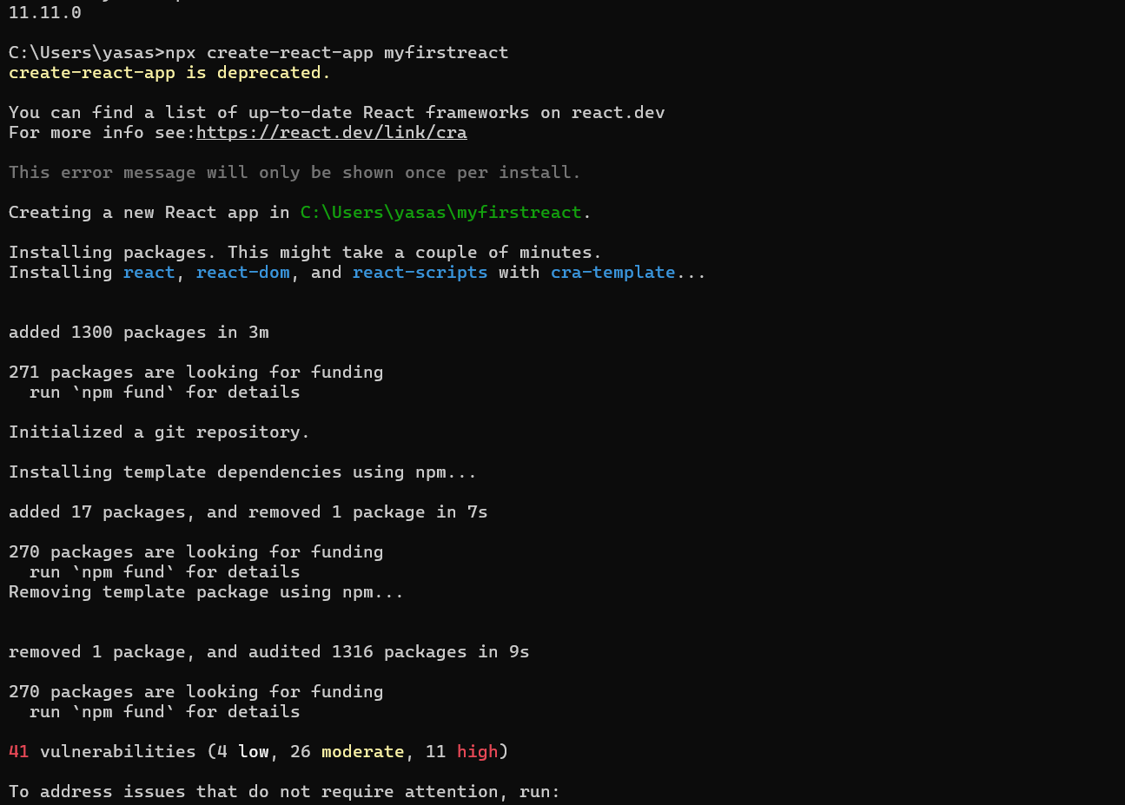
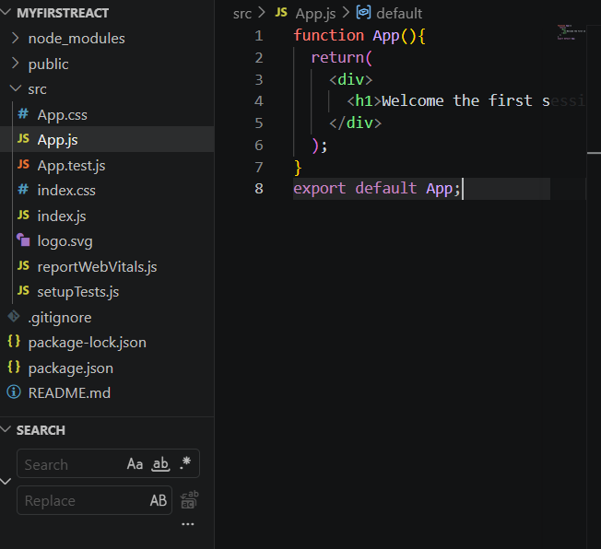
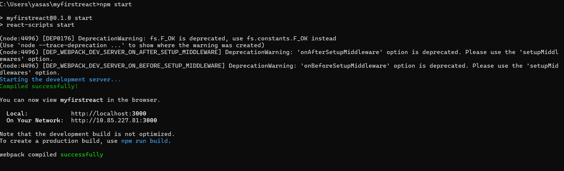

Output:
