DIGITAL NURTURE 5.0 DEEPSKILLING

SLF4J LOGGING FRAMEWORK EXERCISES:
EXERCISE-1:

Question: Logging Error Messages and Warning Levels
Solution:
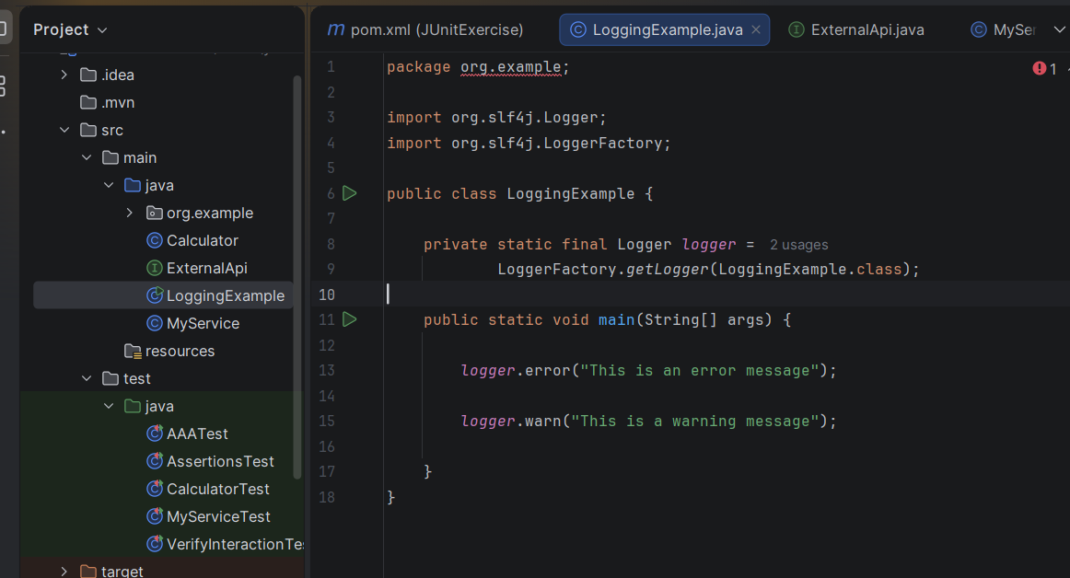

Output:
