DIGITAL NURTURE 5.0 DEEPSKILLING

JUNIT - BASIC TESTING EXERCISES:
EXERCISE-3:

Question: Assertions in JUnit
Solution:
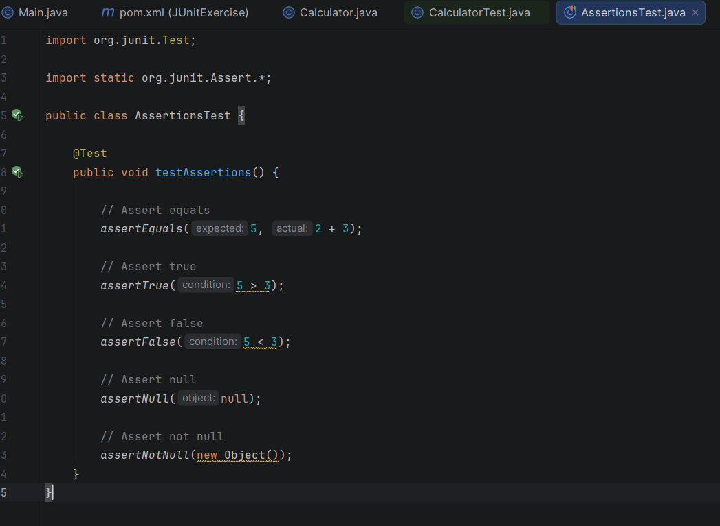

Output:
