DIGITAL NURTURE 5.0 DEEPSKILLING

ENGINEERING CONCEPTS:
ALGORITHMS_DATA STRUCTURES:
EXERCISE-7:

Question: Financial Forecasting
Solution:
FinancialForecasting.java:
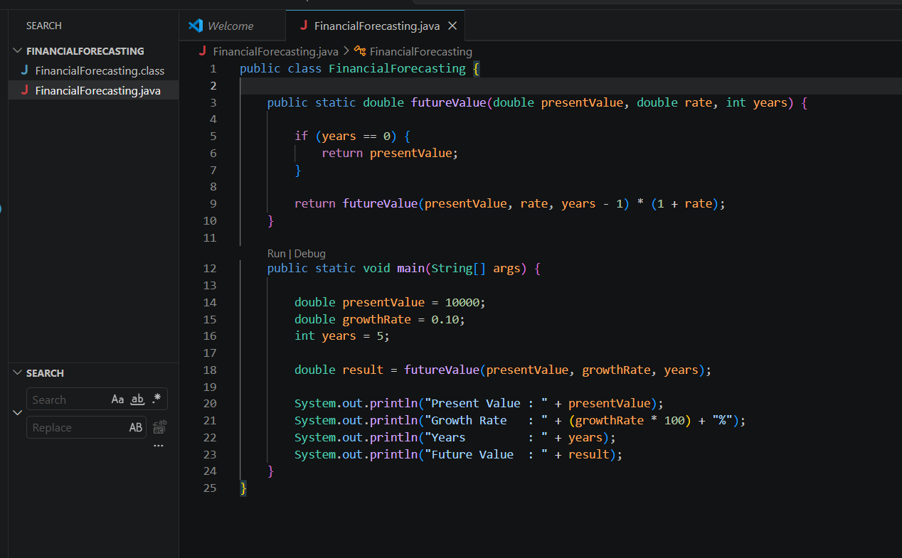

Command Prompt:
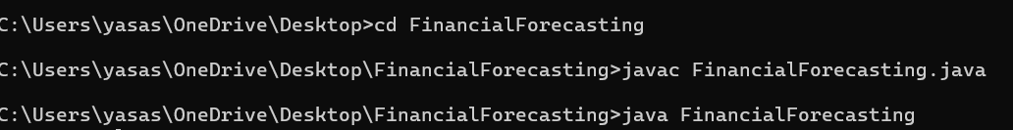
Output:
