DIGITAL NURTURE 5.0 DEEPSKILLING

MOCKITO EXERCISES:
EXERCISE-1:

Question: Mocking and Stubbing
Solution:
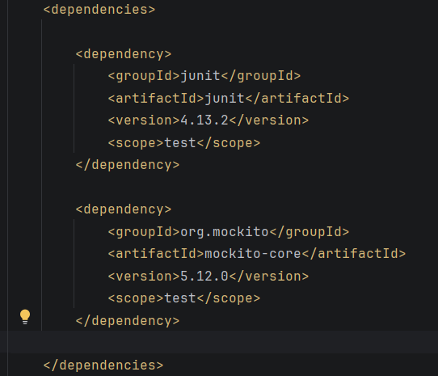
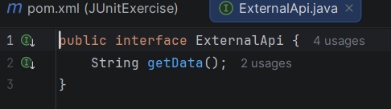
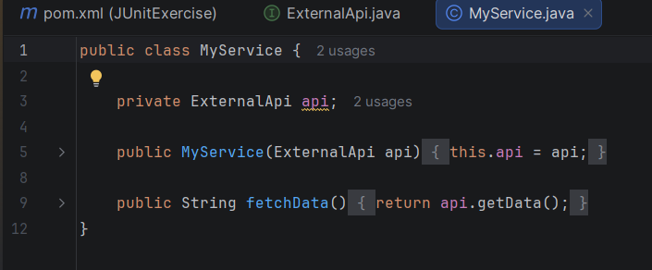
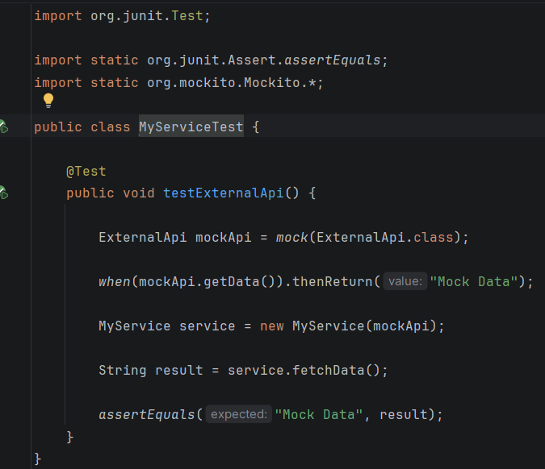

Output:


