DIGITAL NURTURE 5.0 DEEPSKILLING
HANDS-ON: 3
Question: Create a react app for Student Management Portal named scorecalculatorapp and create a function component named “CalculateScore” which will accept Name, School, Total and goal in order to calculate the average score of a student and display the same.
Solution:
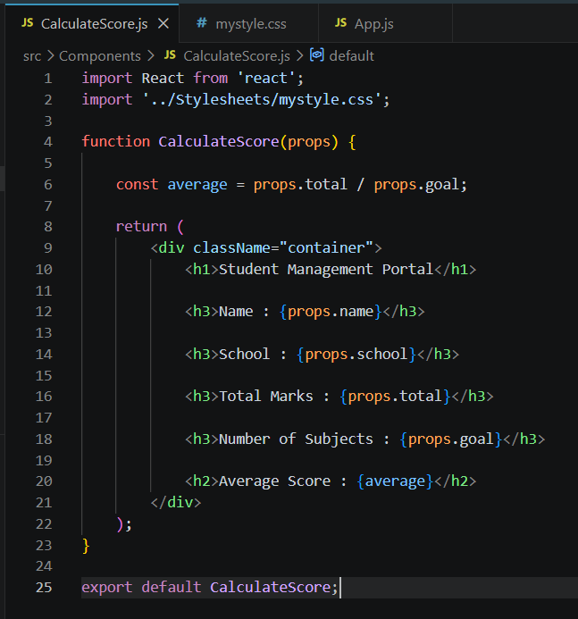

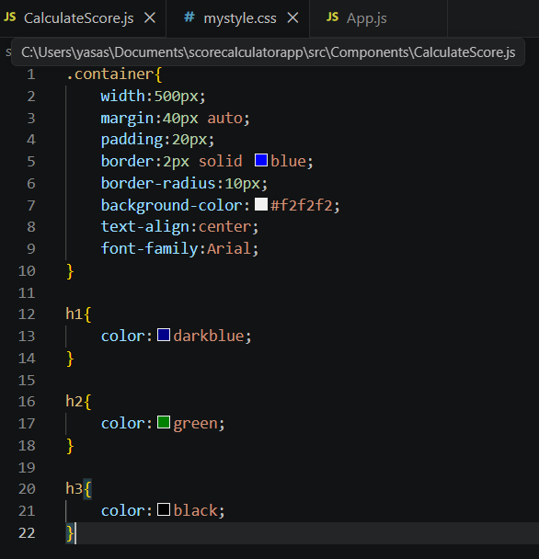

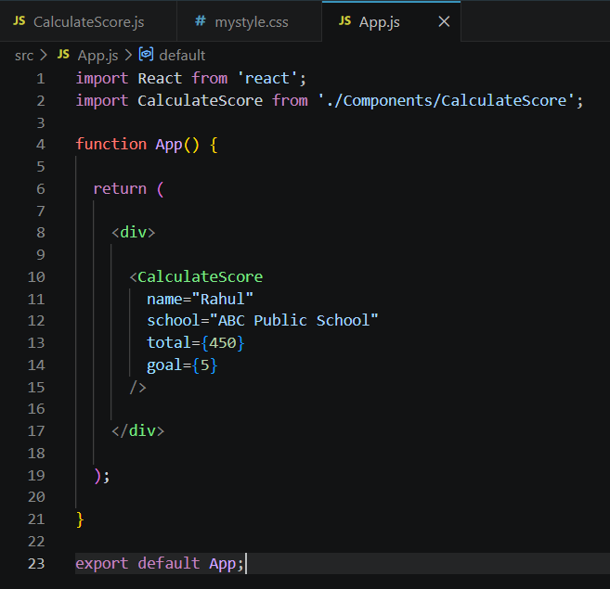
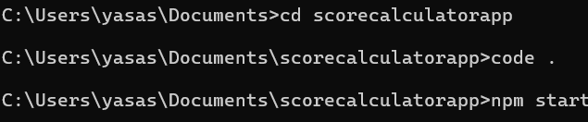

Output:
