DIGITAL NURTURE 5.0 DEEPSKILLING

SPRING REST JWT:
EXERCISE-1:

Question: Create authentication service that returns JWT
Solution:
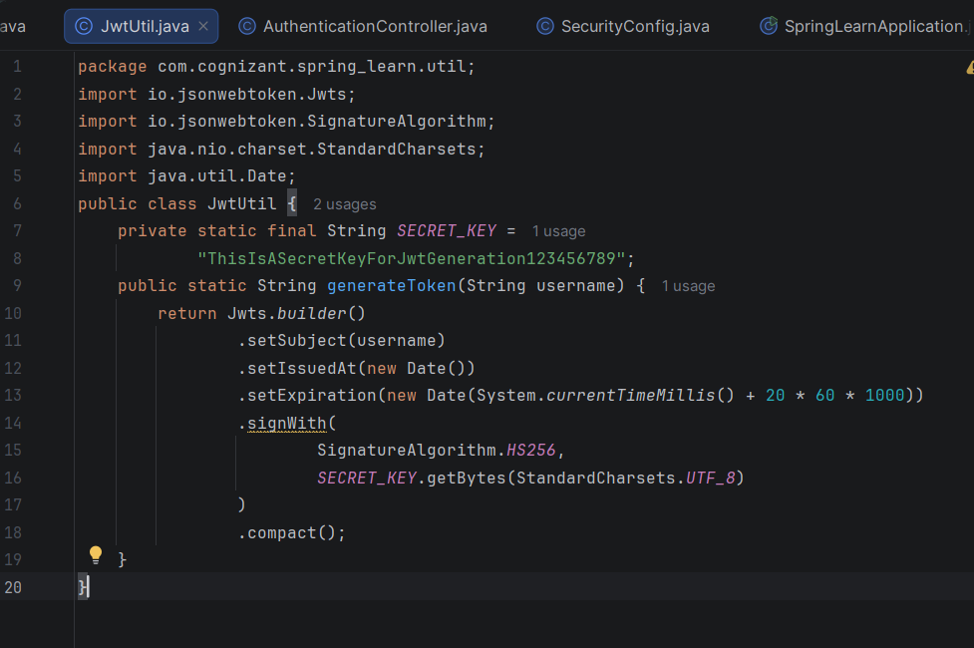

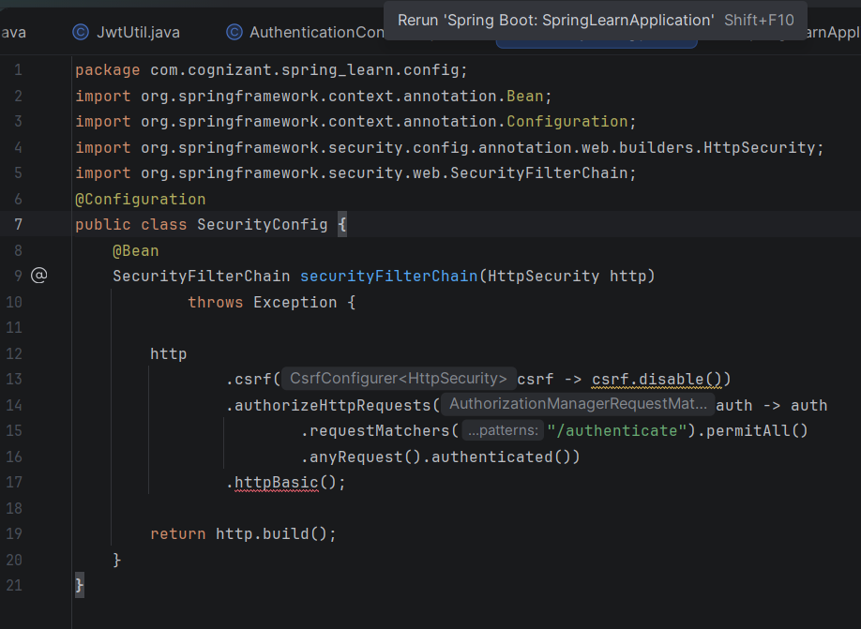
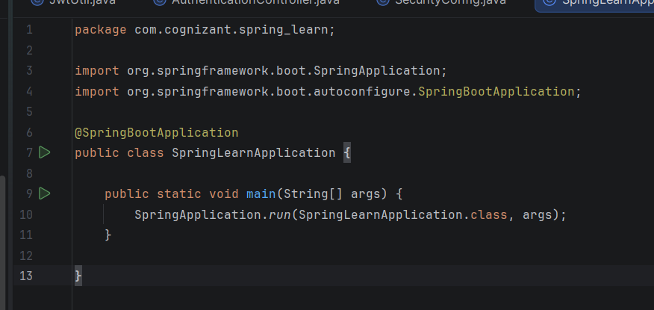

Output:
