DIGITAL NURTURE 5.0 DEEPSKILLING
HANDS-ON: 10
Question: Create a React Application named “officespacerentalapp” which uses React JSX to create elements, attributes and renders DOM to display the page.
Solution:
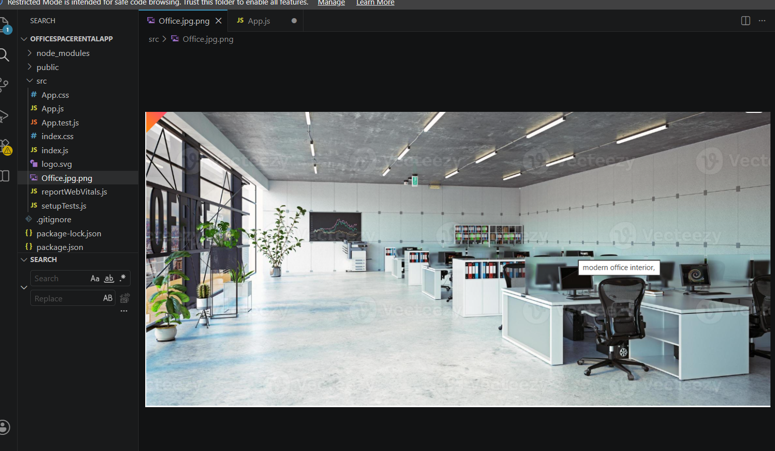
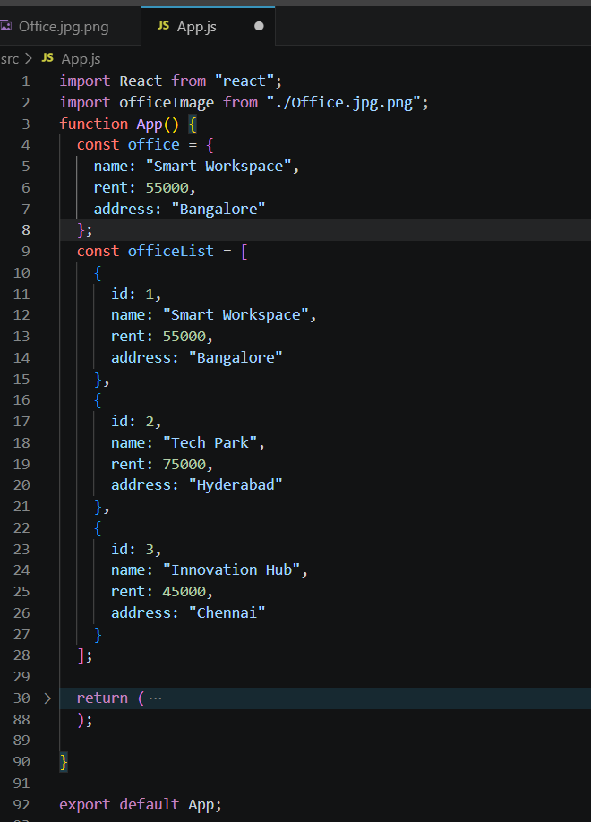

Output:
