DIGITAL NURTURE 5.0 DEEPSKILLING
HANDS-ON: 11
Question: Create a React Application “eventexamplesapp” to handle various events of the form elements in HTML.
Solution:
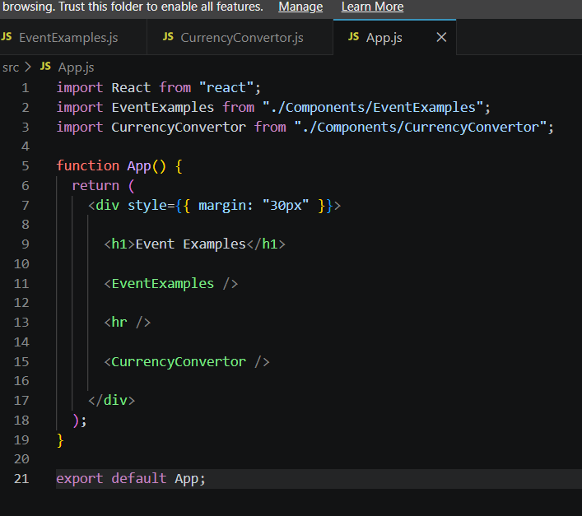
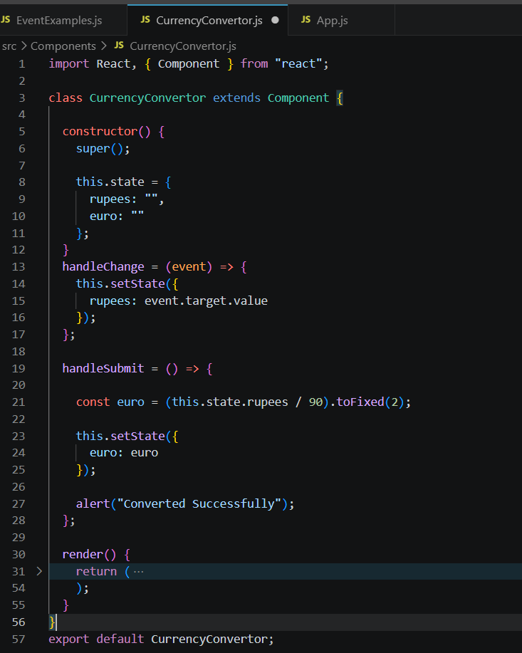
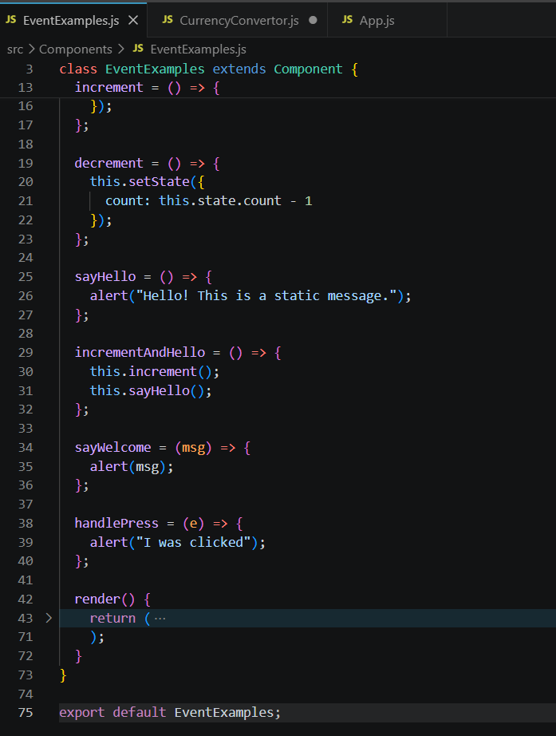

Output:
