DIGITAL NURTURE 5.0 DEEPSKILLING
HANDS-ON: 5
Question: My Academy team at Cognizant want to create a dashboard containing the details of ongoing and completed cohorts. A react application is created which displays the detail of the cohorts using react component. You are assigned the task of styling these react components.
Solution:
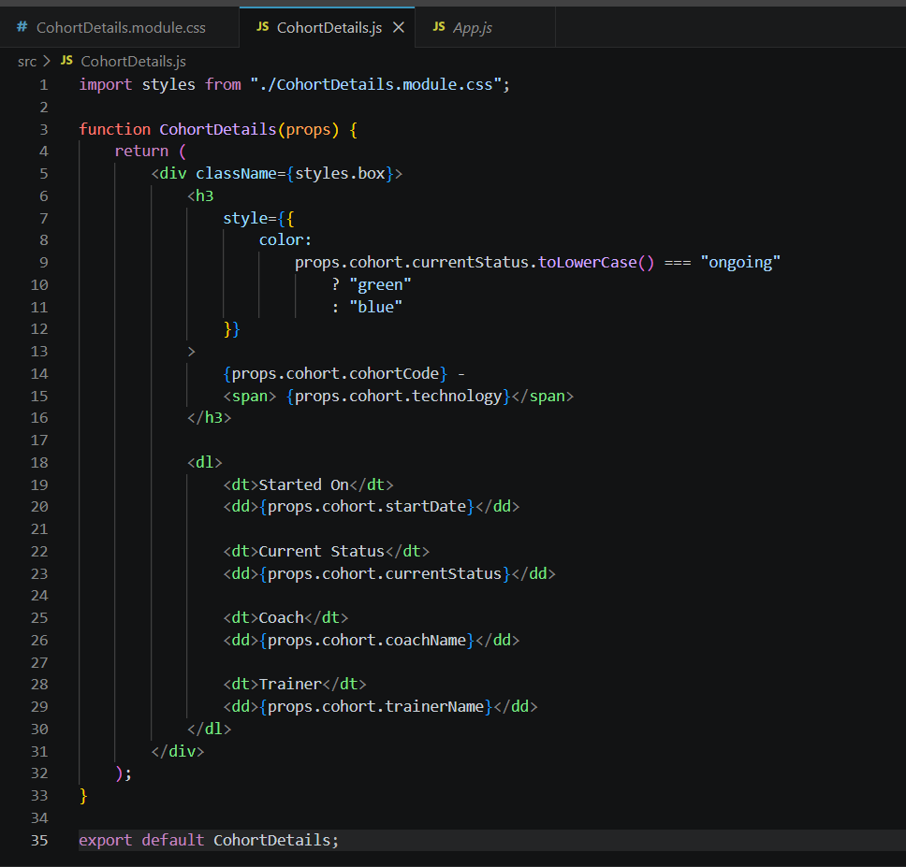
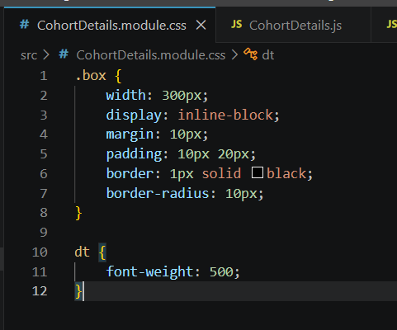
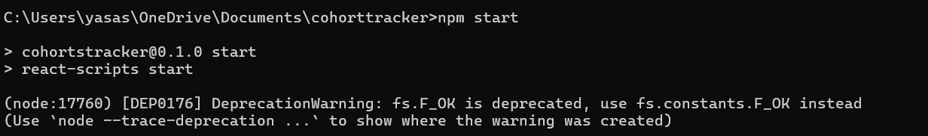
Output:

