DIGITAL NURTURE 5.0 DEEPSKILLING

SPRING REST JPA:
EXERCISE-1:

Question: Hello World RESTful Web Service
Solution:
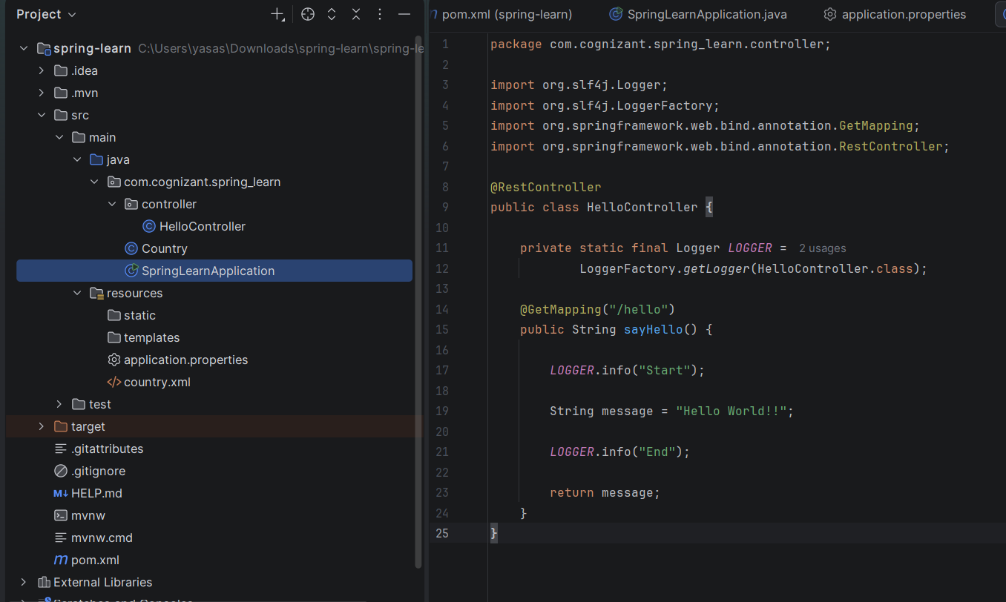
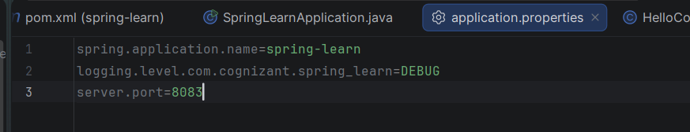

Output:
