DIGITAL NURTURE 5.0 DEEPSKILLING

PL/SQL PROGRAMMING:
EXERCISE-1:

Question: Control Structures
Solution:
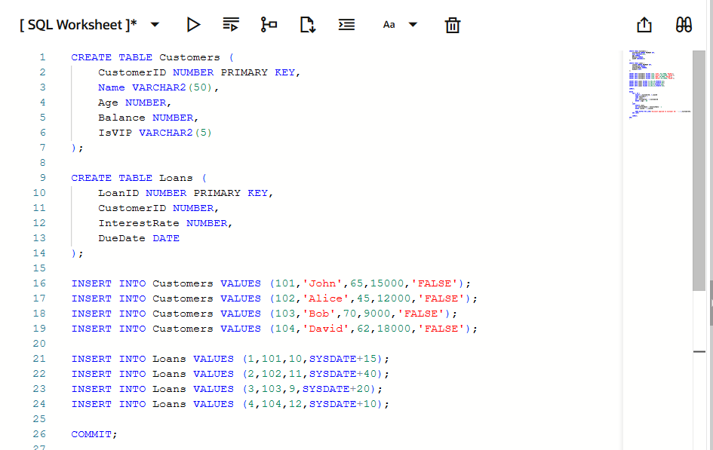
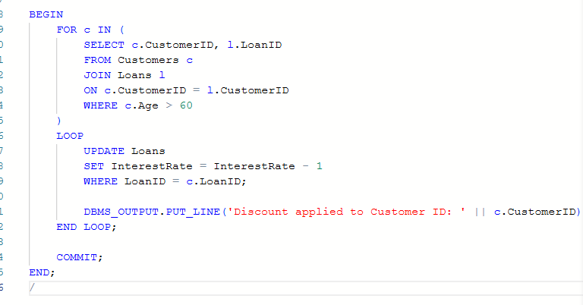
Output:
