DIGITAL NURTURE 5.0 DEEPSKILLING

SPRING REST JPA:
EXERCISE-1:

Question: Create a Spring Web Project using Maven
Solution:
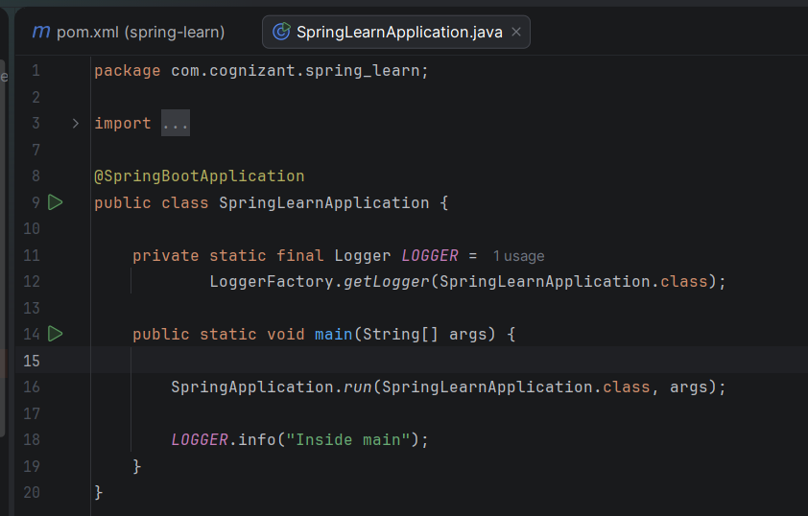

Output:
