DIGITAL NURTURE 5.0 DEEPSKILLING

JUNIT - BASIC TESTING EXERCISES:
EXERCISE-4:

Question: Arrange-Act-Assert (AAA) Pattern, Test Fixtures, Setup and Teardown Methods in JUnit
Solution:
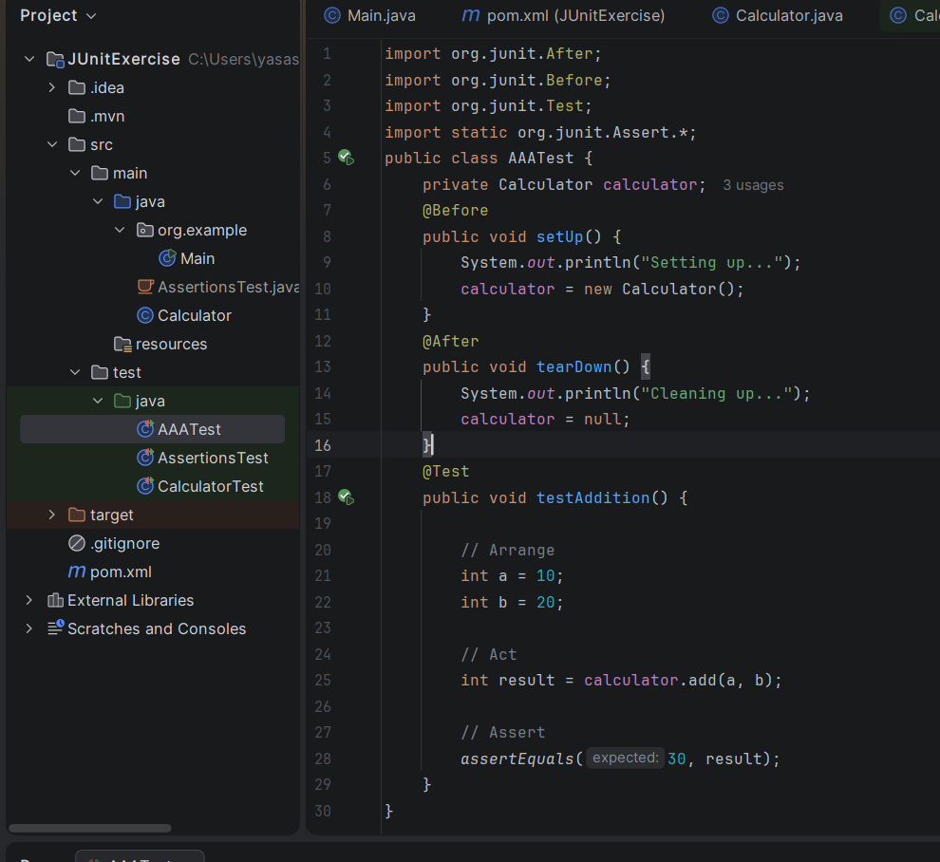

Output:
