DIGITAL NURTURE 5.0 DEEPSKILLING

MOCKITO EXERCISES:
EXERCISE-2:

Question: Verifying Interactions
Solution:
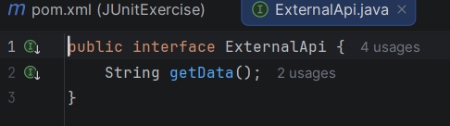
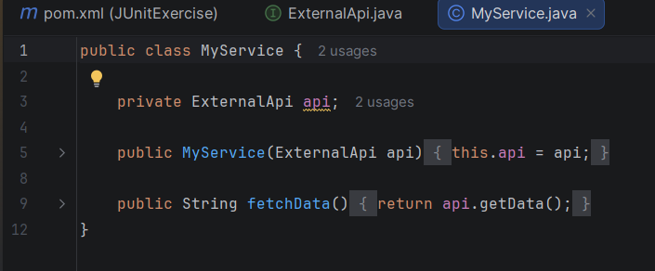
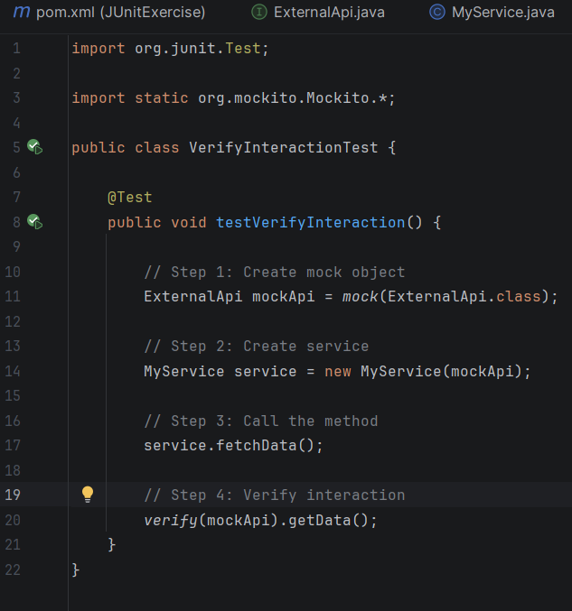

Output:
