DIGITAL NURTURE 5.0 DEEPSKILLING

SPRING REST JPA:
EXERCISE-4:

Question: Load Country from Spring Configuration XML
Solution:
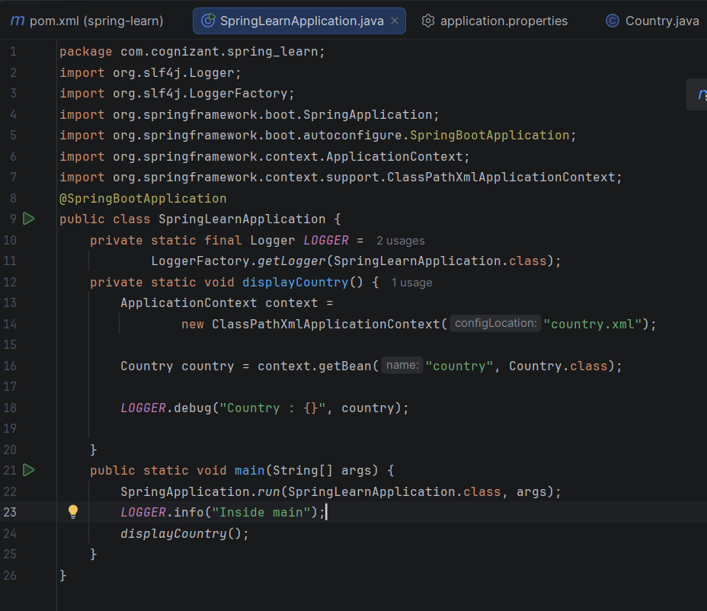
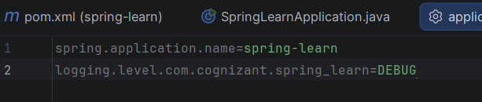
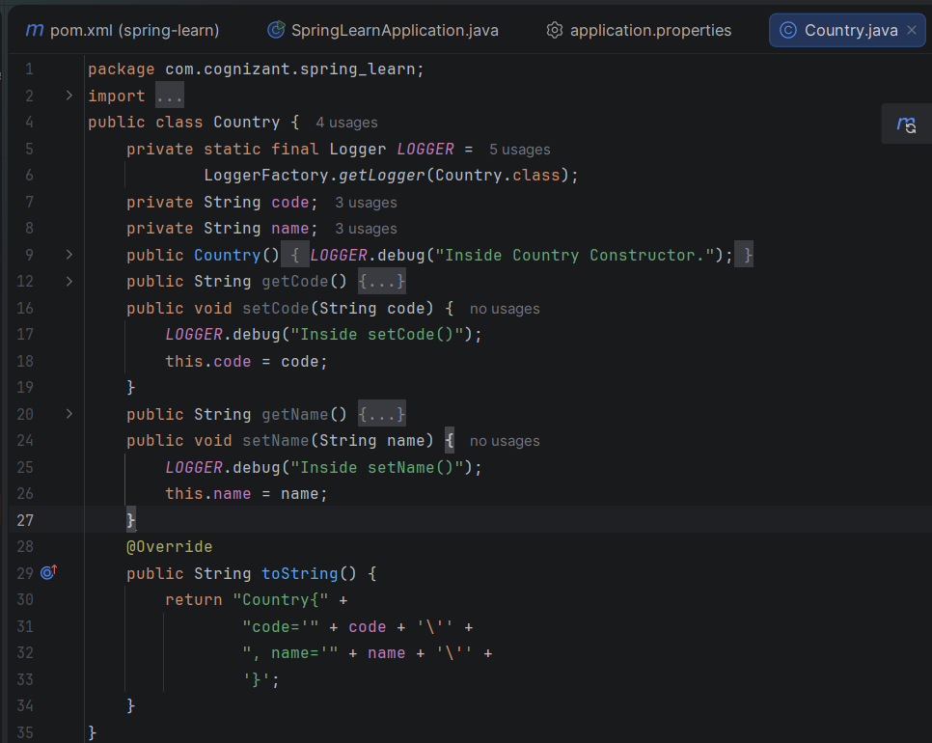

Output:
