DIGITAL NURTURE 5.0 DEEPSKILLING

ENGINEERING CONCEPTS:
DESIGN PATTERNS AND PRINCIPLES:
EXERCISE-2:

Question: Implementing the Factory Method Pattern
Solution:
Document.java:
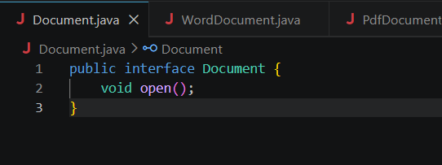
DocumentFactory.java:
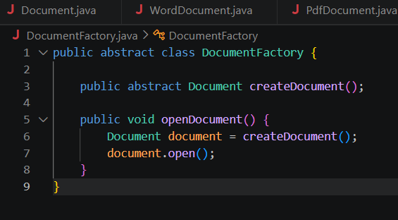

ExcelDocument.java:
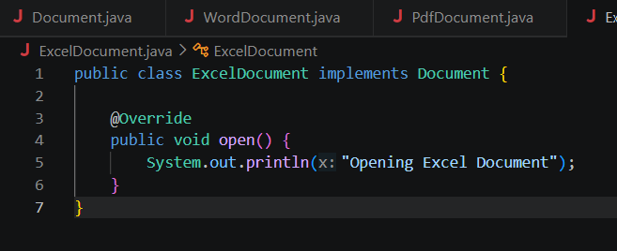
ExcelFactory.java:
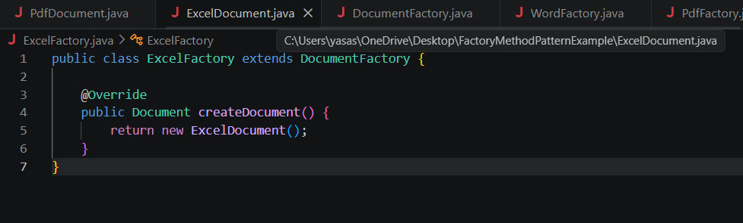
FactoryMethodTest.java:
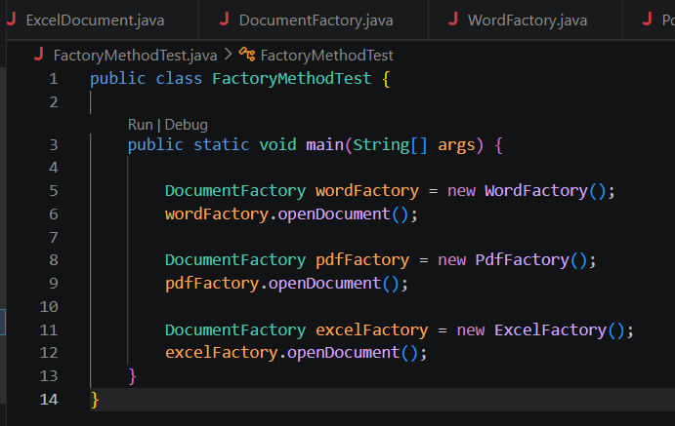

PdfDocument.java:
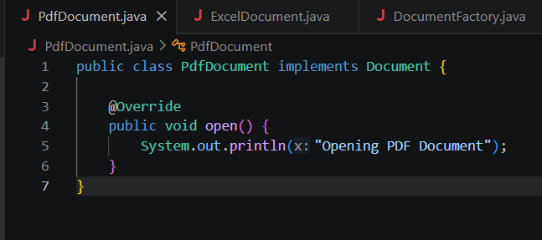
PdfFactory.java:
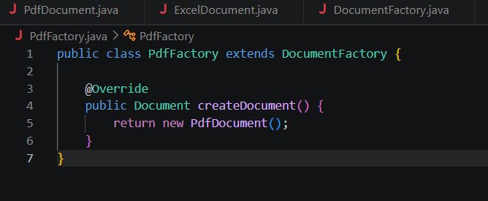
WordDocument.java:
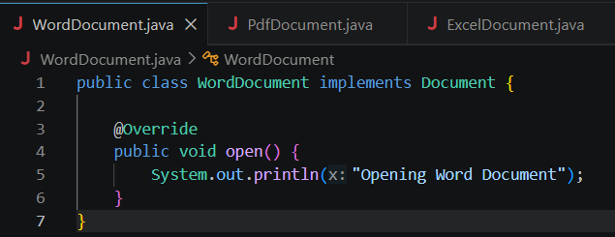

WordFactory.java:
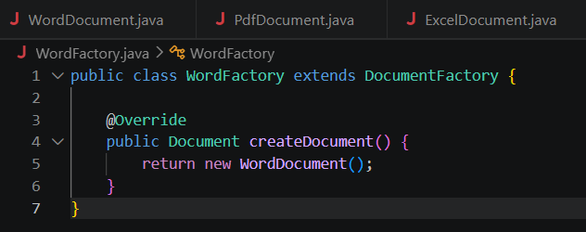
Command Prompt:
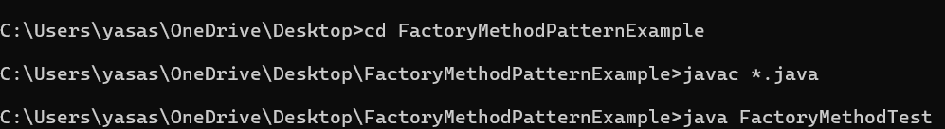
Output:
