DIGITAL NURTURE 5.0 DEEPSKILLING

SPRING REST JPA:
EXERCISE-1:

Question: REST - Get country based on country code
Solution:
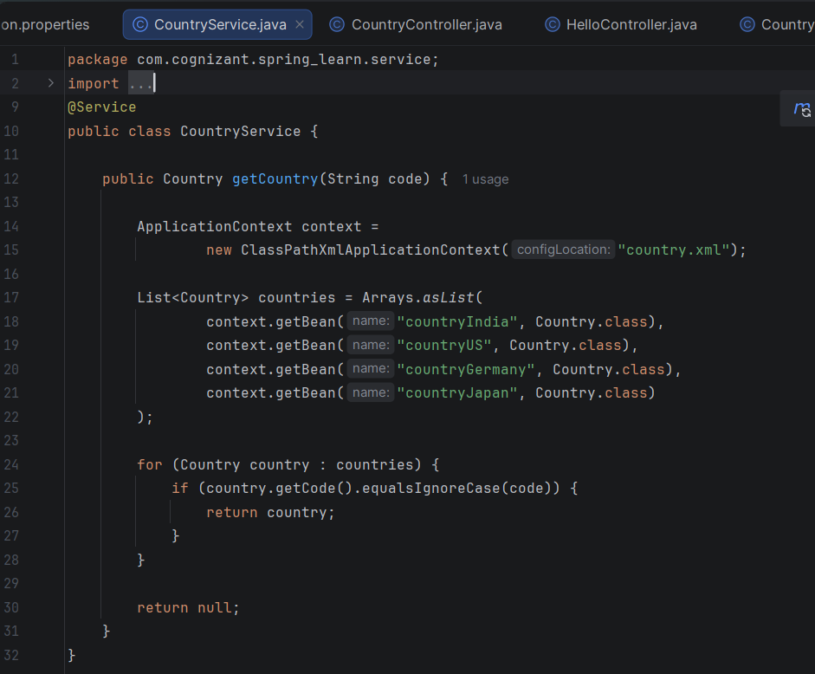

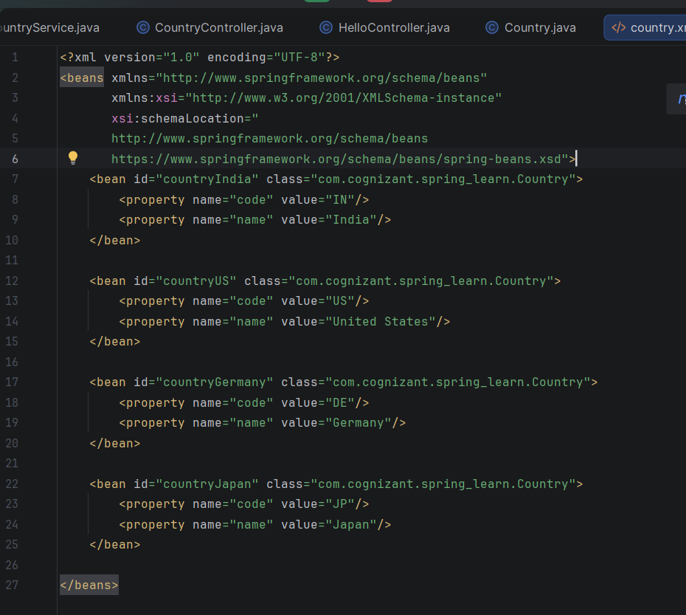
Output:
