DIGITAL NURTURE 5.0 DEEPSKILLING

ENGINEERING CONCEPTS:
ALGORITHMS_DATA STRUCTURES:
EXERCISE-2:

Question: E-commerce Platform Search Function
Solution:
Product.java:
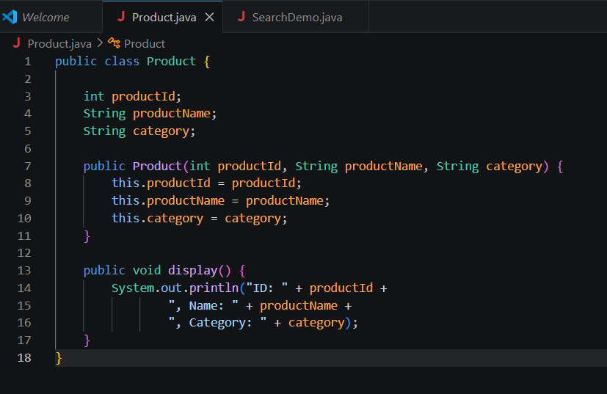

SearchDemo.java:
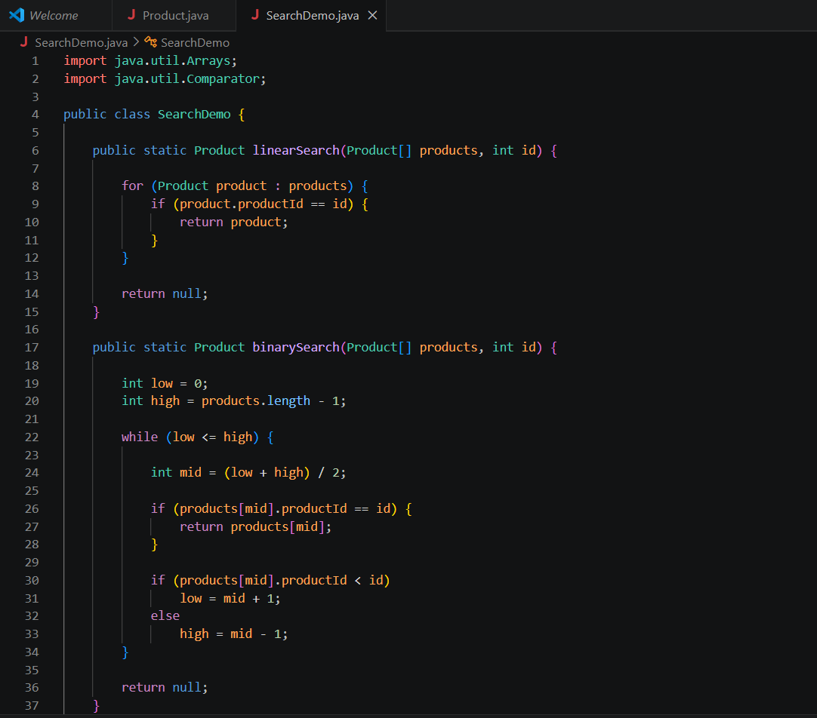
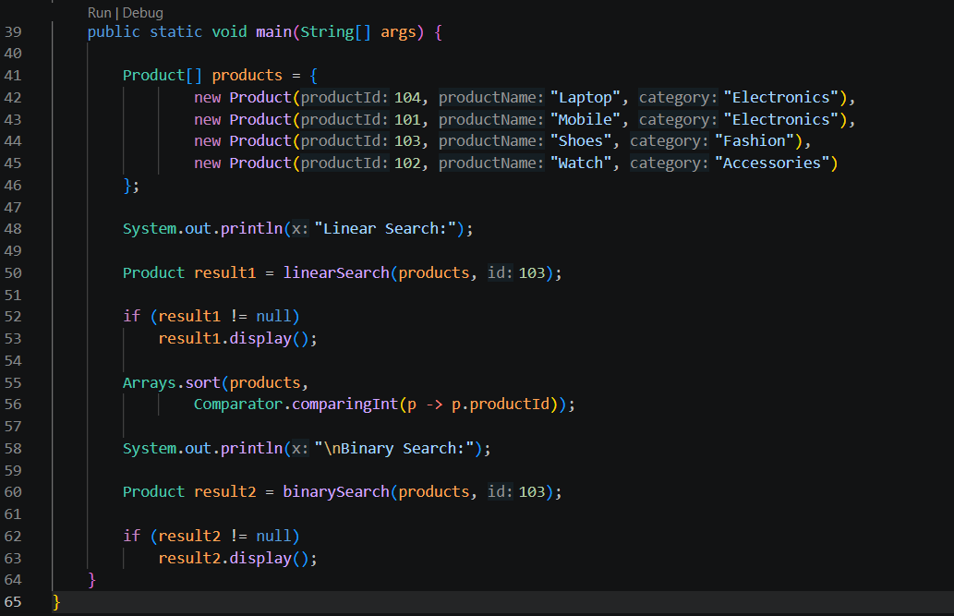

Command Prompt:
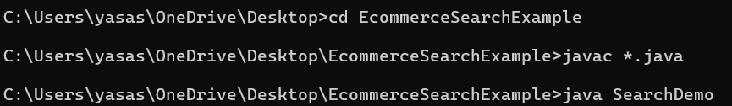
Output:
