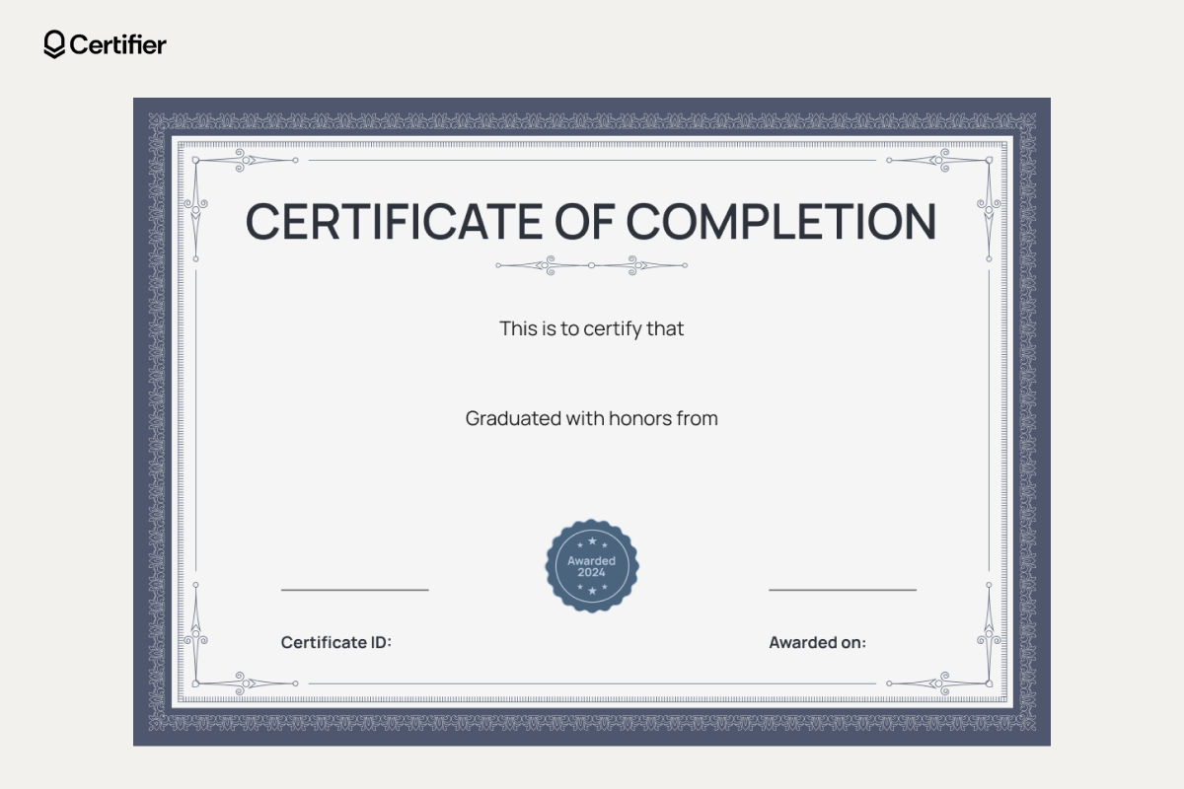
Mechanical
Arjun Verma

