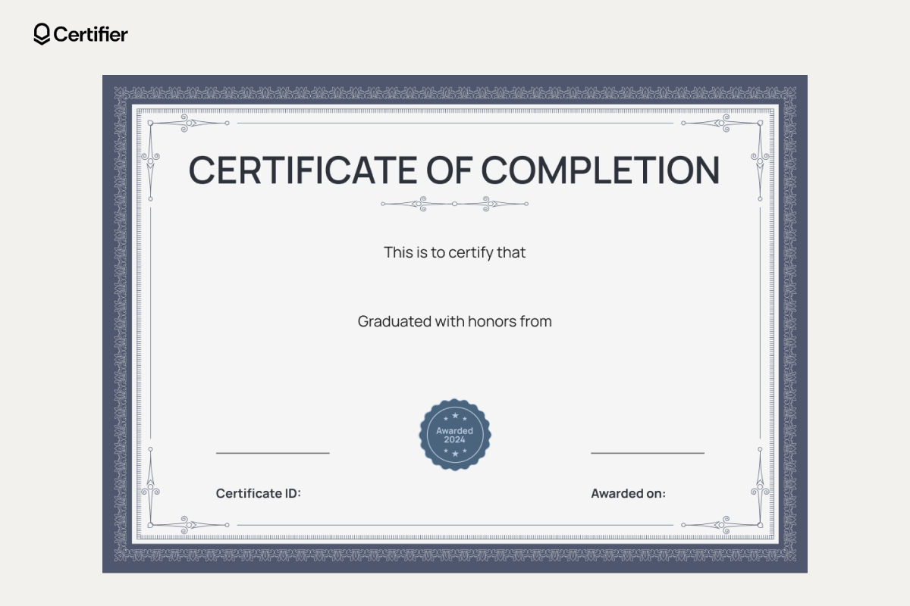
{{dept}}
{{Name}}

