6.FIBONACCI USING RECURSION

**Aim**

To write a C program that generates the Fibonacci series up to a given number of terms using **recursion**.

**Algorithm**

1. **Start**
2. Define a recursive function fibonacci(n)
   * If n == 0, return 0.
   * If n == 1, return 1.
   * Otherwise, return fibonacci(n-1) + fibonacci(n-2).
3. In main():
   * Read the number of terms n.
   * Use a loop from 0 to n-1, and call fibonacci(i) for each term.
   * Print the result.
4. **Stop**

**PROGRAM**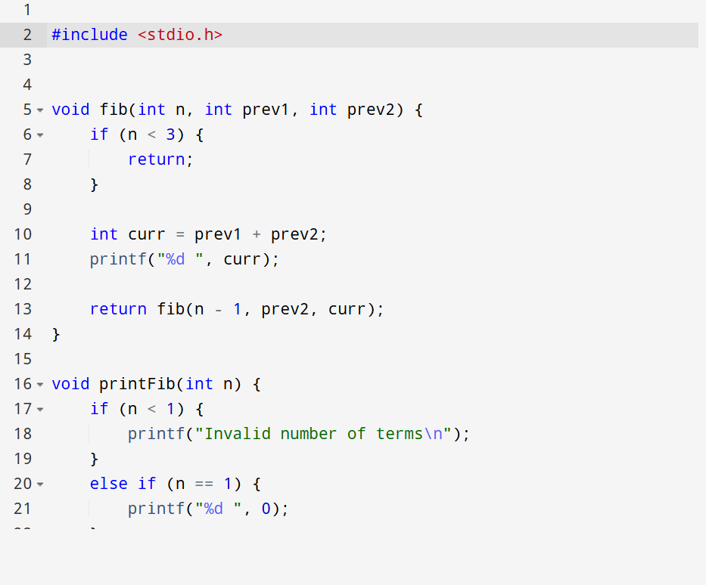

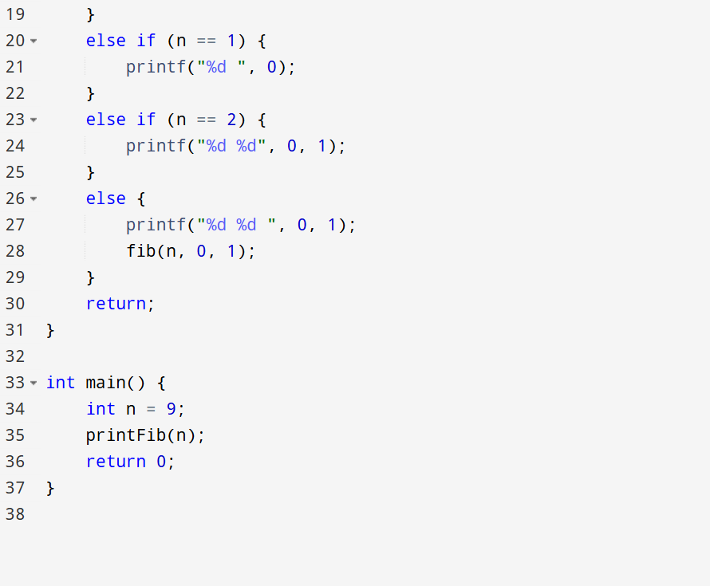

OUTPUT

O 1 1 2 3 5 8 13 21