Multilingual Named Entity Recognition,
Linking & Disambiguation
Cross-Lingual Entity Resolution across English, Hindi, Spanish, and German

1. Project Introduction
Named Entity Recognition (NER) and Entity Linking (EL) form one of the foundational pipelines in modern natural language processing, sitting at the intersection of information extraction, knowledge representation, and semantic search. While NER identifies spans of text that refer to real-world entities — people, organizations, locations — it stops short of telling us which specific entity is being referenced. A mention such as “Amazon” is structurally identified as an organization, but resolving whether it refers to the e-commerce company, the South American river, or the mythical warriors requires a second, harder step: Entity Linking and Disambiguation, which grounds each mention to a unique node in a structured knowledge base such as Wikidata.
This project builds a complete, end-to-end pipeline that performs both stages — NER and Linking/Disambiguation — as first-class, independently evaluated components, and extends the task across four widely spoken languages: English, Hindi, Spanish, and German. Rather than building four separate monolingual systems, the project uses multilingual transformer representations (XLM-R / mBERT for token classification, and LaBSE / XLM-R sentence embeddings for disambiguation) so that a single shared model architecture generalizes across languages with different scripts (Latin and Devanagari), morphologies, and resource availability.
The core technical challenge is disambiguation under cross-lingual conditions: a mention detected in Hindi text must be resolved against candidate entity descriptions that are predominantly written in English on Wikidata. This forces the system to rely on genuine cross-lingual semantic similarity — aligning meaning across languages in a shared embedding space — rather than superficial lexical overlap, which is the aspect of the project that differentiates it from typical single-language NER coursework projects.
The pipeline consists of four stages: (1) mention detection via a fine-tuned multilingual NER model trained on the WikiAnn dataset; (2) candidate generation, which queries Wikidata’s language-agnostic alias and label tables to retrieve a shortlist of plausible entities (QIDs) for each detected mention; (3) disambiguation, where each candidate is ranked against the mention’s local context using multilingual sentence embeddings, moving from a TF-IDF baseline to a bi-encoder model and optionally a cross-encoder re-ranker; and (4) linking, which outputs the final resolved Wikidata QID with a confidence score, including a NIL/unlinkable fallback for mentions that have no valid knowledge-base entry.
The project is evaluated with two distinct, comparable metrics reported per language: NER F1-score (precision/recall over entity spans and types) and Linking Accuracy (correctness of the final entity resolution against gold-standard Wikidata QIDs, using benchmarks such as WikiAnn for NER and Mewsli-9 / Wikipedia-hyperlink-derived weak labels for linking). The resulting four-language comparison table is the project’s central deliverable, and is expected to surface a meaningful, explainable performance gradient — with high-resource languages (English, Spanish, German) outperforming the comparatively lower-resource Hindi — giving the project a genuine analytical narrative rather than a single flat accuracy number.
Beyond the evaluation tables, the project includes a lightweight interactive demo (React) where a user pastes text in any of the four supported languages and receives highlighted entity spans, each linked to its resolved Wikidata page. This makes the system’s output tangible and demonstrable, both for an academic project defense and as a portfolio artifact for technical interviews, where it illustrates practical competence in transformer fine-tuning, retrieval-based candidate generation, embedding-based semantic ranking, and multilingual evaluation methodology — skills directly relevant to applied AI/ML, search, and knowledge-graph engineering roles.

2. Pipeline & Flowchart
End-to-End Pipeline Overview
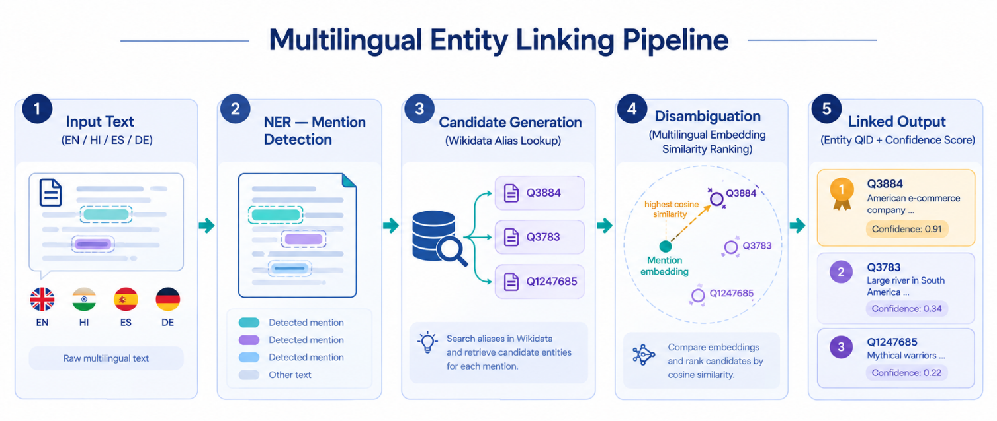
Disambiguation Stage Detail
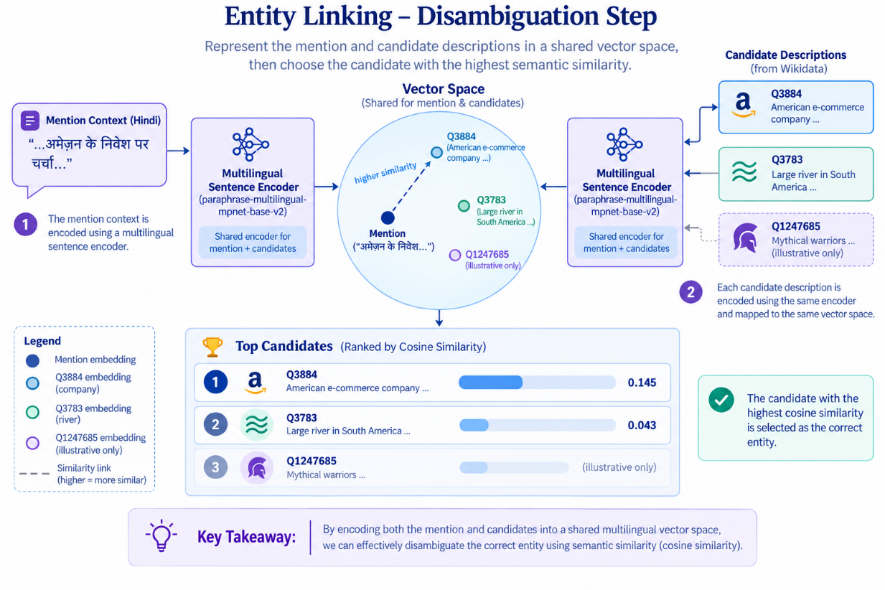
System Architecture Diagram

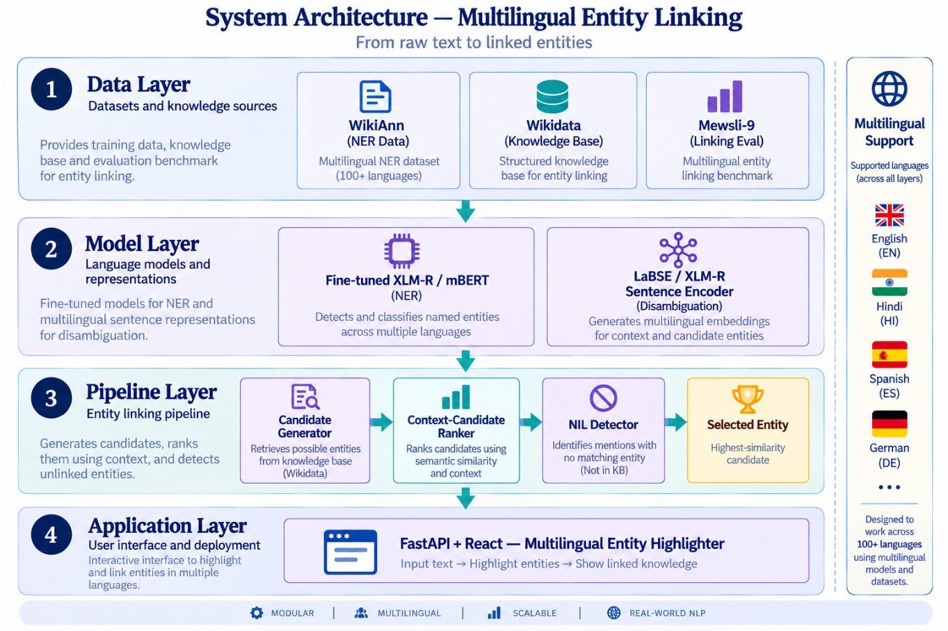

3. Hardware & Software Requirements
Minimum and recommended environment for training, evaluation, and running the demo application. All components are available on free tiers (Google Colab free GPU, HuggingFace Hub, Wikidata public endpoints).
Category | Component | Minimum Requirement | Recommended
Hardware | GPU | None (CPU-only, small models) | 1x NVIDIA T4 / equivalent (Colab free tier)
Hardware | RAM | 8 GB | 16 GB+
Hardware | Storage | 10 GB free (datasets + checkpoints) | 25 GB+ (multiple model checkpoints)
Hardware | Internet | Required (Wikidata SPARQL, HF Hub downloads) | Stable broadband connection
Software | OS | Windows / Linux / macOS | Linux or WSL2 (Windows)
Software | Python | 3.9+ | 3.10 / 3.11
Software | Core ML libraries | transformers, datasets, torch | + sentence-transformers, accelerate
Software | NER base model | bert-base-multilingual-cased (mBERT) | xlm-roberta-base / xlm-roberta-large
Software | Embedding model | distiluse-base-multilingual | LaBSE / xlm-r-large sentence-transformer
Software | Knowledge base access | Wikidata public SPARQL endpoint | Local Wikidata JSON dump (offline, faster)
Software | Experiment tracking | Manual logs / CSV | Weights & Biases (free tier) or MLflow
Software | Demo framework | Streamlit or Gradio (free, local) | Streamlit Community Cloud (free hosting)
Software | Dev environment | Jupyter Notebook / VS Code | Google Colab (free GPU) + VS Code

4. Dataset, Model & Hyperparameters
Datasets and model configuration used across the four target languages: English (EN), Hindi (HI), Spanish (ES), German (DE).
Component | Detail | Value / Source
Dataset — NER | Source | WikiAnn (via HuggingFace ‘datasets’), splits for EN, HI, ES, DE
Dataset — NER | Labels | PER, ORG, LOC (IOB2 tagging scheme)
Dataset — Linking (eval) | Source | Mewsli-9 (multilingual) + Wikipedia hyperlink weak labels
Dataset — Linking (eval) | Knowledge Base | Wikidata (QIDs, multilingual labels & aliases)
Dataset split | Train / Val / Test | 80% / 10% / 10% per language
Model — NER | Base architecture | XLM-RoBERTa-base (270M params) or mBERT-base
Model — NER | Fine-tuning head | Token classification (linear + softmax over IOB2 tags)
Model — Disambiguation | Base architecture | LaBSE / XLM-R sentence-transformer (bi-encoder)
Model — Disambiguation | Similarity metric | Cosine similarity, top-k candidate re-ranking
Hyperparameter | Learning rate | 2e-5 (NER fine-tuning)
Hyperparameter | Batch size | 16 (train), 32 (eval)
Hyperparameter | Epochs | 3–5 (early stopping on validation F1)
Hyperparameter | Max sequence length | 128 tokens
Hyperparameter | Optimizer | AdamW, weight decay 0.01
Hyperparameter | Warmup ratio | 0.06 of total training steps
Hyperparameter | Candidate shortlist size (k) | 10 candidates per mention
Hyperparameter | NIL threshold | Cosine similarity < 0.4 → unlinkable

5. Deviations from the Original Proposal (What Actually Changed)
The proposal above was written before implementation began. Building and live-testing the system surfaced several places where the original plan didn't hold up, and better options were found through direct experimentation. This section documents what actually changed, and why, rather than silently updating the numbers above. A more detailed, evidence-backed account of the final round of testing (accuracy numbers, specific bugs found and fixed, and one experiment that was initially reported as working and later corrected) is kept separately in docs/LATE_STAGE_FINDINGS.md.
Area | Proposed | Actual (and why)
Demo framework | Streamlit or Gradio | FastAPI backend + React frontend. Streamlit was explicitly ruled out early in development in favor of a real client/server split with a custom UI.
NER model at inference time | Fine-tune XLM-RoBERTa-base / mBERT on WikiAnn and use that fine-tune directly | The project's own WikiAnn fine-tune was trained and scored well in-domain (EN 0.839 / HI 0.890 / ES 0.914 / DE 0.883 F1) but failed badly on casual, unpunctuated, real-world-style text (WikiAnn is Wikipedia-only, third-person, always punctuated). The running demo instead uses a pretrained checkpoint (Davlan/xlm-roberta-base-ner-hrl) trained on broader data, which generalizes far better out-of-domain. The original fine-tune is kept in the repo but is not what the demo runs.
Disambiguation embedding model | LaBSE (recommended) or distiluse-base-multilingual (minimum) | Tested head-to-head against sentence-transformers/paraphrase-multilingual-mpnet-base-v2. LaBSE is tuned for translation-pair retrieval, not semantic similarity ranking, and scored measurably worse on this task's disambiguation cases. mpnet was adopted instead.
NIL threshold | Cosine similarity < 0.4 -> unlinkable | Lowered to 0.1 after live testing showed correct links from the adopted embedding model routinely scoring well under 0.4, which was producing false NILs on correct matches.
Knowledge base access | Wikidata public SPARQL endpoint (minimum) or a local offline Wikidata JSON dump (recommended, for speed) | Neither alone was practical: the public SPARQL endpoint rate-limits aggressively during outages (observed "1 request/minute" throttling), and a full offline dump was out of scope. The actual system uses a small local parquet cache built from ~50 hand-picked seed QIDs (configs/seed_entities.yaml) for fast, reliable lookups on common entities, falling back to live wbsearchentities/wbgetentities calls (with retry/backoff) for anything not in the cache.
Candidate ranking signal | Cosine similarity only, top-k re-ranking | Added a small popularity tiebreak (Wikidata sitelink count, log-scaled) blended into ranking order only -- not into the displayed confidence score -- to favor the more notable of two same-named entities on close ties.
Preprocessing | Not specified | Added a truecasing step before NER (English-only) to recover capitalization on lowercase/casual input, since capitalization is the strongest signal these NER models use for proper nouns. Restricted to fully-lowercase input after it was found to wrongly re-capitalize already well-formed sentences and produce spurious entity fragments (see docs/LATE_STAGE_FINDINGS.md).
Context translation | Not specified | Added and tested an experimental step translating non-English context to English before disambiguation, on the hypothesis that the embedding model is more discriminative in English. Tested against real pipeline data: it does not reliably fix the case it targeted (Hindi गुजरात, Gujarat vs. Gujarati) -- kept in the pipeline as a harmless, gracefully-degrading step, not presented as a confirmed fix. Full writeup, including a correction of an earlier incorrect claim, in docs/LATE_STAGE_FINDINGS.md.
Linking evaluation set | Mewsli-9 (multilingual) + Wikipedia hyperlink weak labels | Mewsli-9 was not integrated. Linking accuracy is instead measured against a hand-authored gold set of 142 sentences across the four languages (mention + context + gold QID), built from the same verified seed QIDs used for the KB cache to avoid mislabeling. Swapping in Mewsli-9 remains a natural next step for a larger, production-scale evaluation.

Measured results (vs. the proposal's projected gradient)
The proposal projected a "meaningful, explainable performance gradient" with high-resource languages outperforming Hindi. What was actually measured, end-to-end against the real pipeline and the 142-example gold set, is a different pattern: English and Hindi were the strongest (91.9% and 88.6% linking accuracy), while Spanish and German trailed at 80.0% and 77.1-80.0% (rechecked twice to rule out rate-limit noise; the gap held steady). The proposal's assumption that resource level alone would predict the ranking did not hold; the actual cause of the ES/DE gap has not yet been root-caused. NER F1 on WikiAnn's own test set for the project's fine-tuned model (not what the demo runs at inference) was EN 0.839, HI 0.890, ES 0.914, DE 0.883. Full breakdown and methodology in docs/LATE_STAGE_FINDINGS.md.

