Multilingual Entity Linking & Disambiguation
Cross-lingual NER, Candidate Generation, and Disambiguation across English, Hindi, Spanish, and German
\

1. Project Introduction
Named Entity Recognition (NER) identifies mentions of real-world entities in unstructured text — people, organizations, and locations. On its own, however, NER only answers the question of whether a span of text refers to something; it does not answer which specific real-world thing it refers to. The sentence “Amazon reported record cloud revenue” and the sentence “The Amazon flows through Brazil” both contain the mention “Amazon,” correctly identified as a named entity in both cases, yet the two mentions refer to entirely different real-world entities — a multinational technology company in one case and a river in the other. Resolving this ambiguity, deciding precisely which entity a mention points to given its surrounding context, is the task of Entity Linking (EL) and Disambiguation, and it is a substantially harder problem than detection alone.
This project implements a complete, working, end-to-end pipeline that addresses both stages of this problem together. Rather than restricting the system to a single language, the pipeline is built and validated across four languages simultaneously — English, Hindi, Spanish, and German — so that the same architecture must generalize across scripts, morphology, and resource availability rather than being tuned narrowly to one. Every linked mention is grounded against Wikidata, a large, actively maintained, multilingual, structured knowledge base, so the output of the system is not merely a label but a concrete, machine-resolvable identifier (a Wikidata QID) that can be traced back to a canonical real-world entity.
The guiding goal of the project was not simply to assemble a pipeline that runs without errors on a handful of hand-picked examples, but to genuinely stress-test it: against real, casually phrased sentences; against surname-only and partial mentions; against adversarial and ambiguous cases; and across all four supported languages rather than only the best-resourced one. Consequently, much of the project's substance is not a description of an untested design but a record of real failures that were found through live testing, root-caused, and fixed — including a token-classification failure mode on unpunctuated first-person text. This exact-match candidate-generation strategy silently returned the wrong entity for common surnames, a disambiguation model that ranked entities backwards on a canonical test case, and a genuine upstream data gap in Wikidata itself.
The project scope covers four cooperating subsystems:
(1) a fine-tuned and a pretrained multilingual transformer for mention detection
(2) a hybrid candidate-generation layer combining a fast local knowledge-base cache with Wikidata's live, relevance-ranked search API
(3) a disambiguation stage that ranks candidates using multilingual sentence-embedding similarity together with a popularity-based tiebreak
(4) an interactive web application (a FastAPI backend and a React frontend) that exposes the full pipeline for live, user-facing demonstration and inspection of intermediate results.
Languages and scope covered by the project:
Language | Script | NER Role | Notes
English (EN) | Latin | Baseline / highest-resource language | Truecasing applied to restore capitalization for casual, lowercase input before detection
Hindi (HI) | Devanagari | Low-resource cross-lingual test case | Correctly handled even by a model whose documented language list does not include it
Spanish (ES) | Latin | Mid-resource comparison language | Used in disambiguation short-context sensitivity testing
German (DE) | Latin | Mid-resource comparison language | Used in canonical worked examples (Merkel, Berlin, Deutschland)
Taken together, the introduction, architecture, and requirements that follow describe a system that is intentionally small in scale — a hand-curated seed knowledge base, a modest hand-authored evaluation set — but is deliberately honest about what has and has not been verified, and is built to be extended: a larger seed set, a larger gold evaluation set (for example Mewsli-9), and a production deployment are the natural next steps rather than unstated gaps.

2. Pipeline & Flowchart
The system is organized as a strict four-stage pipeline: mention detection, candidate generation, disambiguation, and output. Text enters the pipeline in one of the four supported languages and is passed through each stage in sequence, with each stage's output forming the next stage's input. The diagram below summarizes the flow end to end, followed by a detailed description of each stage and the design decisions and fixes behind it.

2.1 Pipeline Flowchart

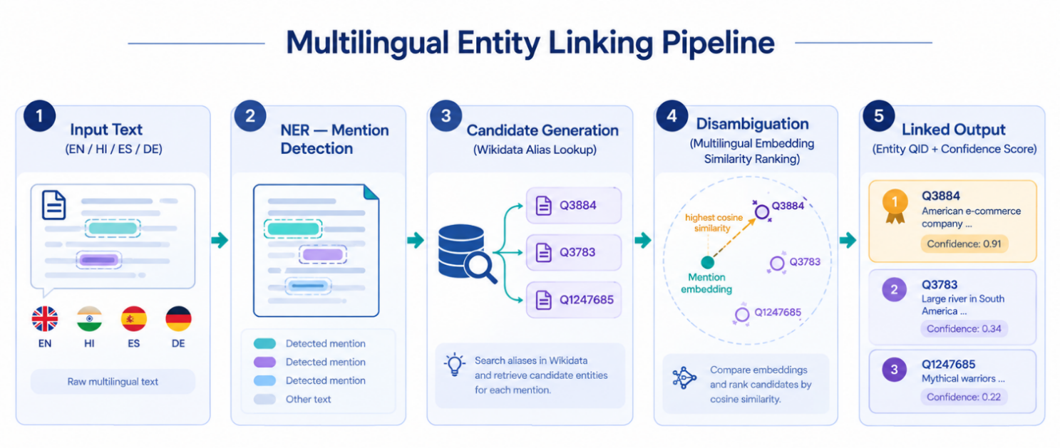

2.2 Stage Details
Stage 1 — Named Entity Recognition. Mention detection is performed by a multilingual XLM-RoBERTa token classifier. Two variants exist: a fine-tune trained from scratch on the WikiAnn dataset across all four languages (achieving F1 scores between 0.839 and 0.914 depending on language), and a pretrained checkpoint (Davlan/xlm-roberta-base-ner-hrl) trained on a broader and more diverse dataset. The fine-tune performs best on in-domain, Wikipedia-style formal text, but was found through live testing to fail badly on casual, unpunctuated, first-person input — for example misclassifying the entire sentence “I live in Brazil” (no trailing period) as a single organization span. The pretrained checkpoint does not exhibit this failure and is the model actually used by the running system, while the fine-tune and its evaluation are retained and documented for comparison. English input additionally passes through a length-preserving truecasing step before detection, restoring capitalization on casual lowercase text so that entity boundaries are still recognized correctly.
Stage 2 — Candidate Generation. For each detected mention, the system first checks a small local cache (a parquet file of labels, aliases, and descriptions for roughly fifty hand-seeded entities across all four languages, built via batched Wikidata SPARQL queries) for an instant, offline match. Mentions not found locally fall back to Wikidata's live wbsearchentities search API, which performs relevance-ranked fuzzy matching rather than the exact-literal matching an initial SPARQL-only approach used — a change made specifically because exact matching failed on common surname-only mentions (“Messi,” “Putin,” “Ronaldo”) and returned arbitrary, sometimes obscure entities on ties (“Modi” initially resolved to the wrong person entirely).
Stage 3 — Disambiguation. Each surviving candidate is scored by encoding the mention's local sentence context and the candidate's description with a multilingual sentence-transformer (paraphrase-multilingual-mpnet-base-v2, chosen over LaBSE after a head-to-head comparison showed LaBSE ranking the wrong entity higher on a canonical test case) and computing cosine similarity. Wikidata's terse native descriptions are replaced, where available, with a richer Wikipedia intro-paragraph extract, since short descriptions were found to share too little vocabulary with real sentence contexts to disambiguate reliably. A small popularity term, based on each candidate's Wikidata sitelink count, is blended in as a tiebreaker for cases where semantic similarity alone is not decisive.
Stage 4 — Output and Application. The top-ranked candidate is returned as a Wikidata QID with a confidence score, or as NIL if no candidate is confident enough. This result is served through a FastAPI backend exposing a POST /link endpoint for the full pipeline and a GET /entity/{qid}/relations endpoint for lazily-fetched entity relations, consumed by a React frontend that highlights linked mentions in the original text, color-coded by entity type, alongside a confidence bar, a live pipeline-progress indicator, and a candidate-ranking detail panel.
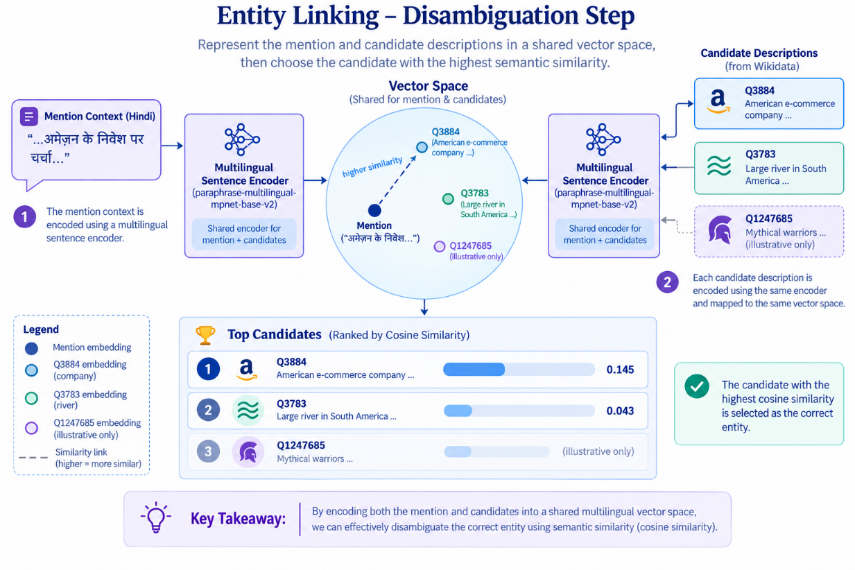

System Architecture Diagram

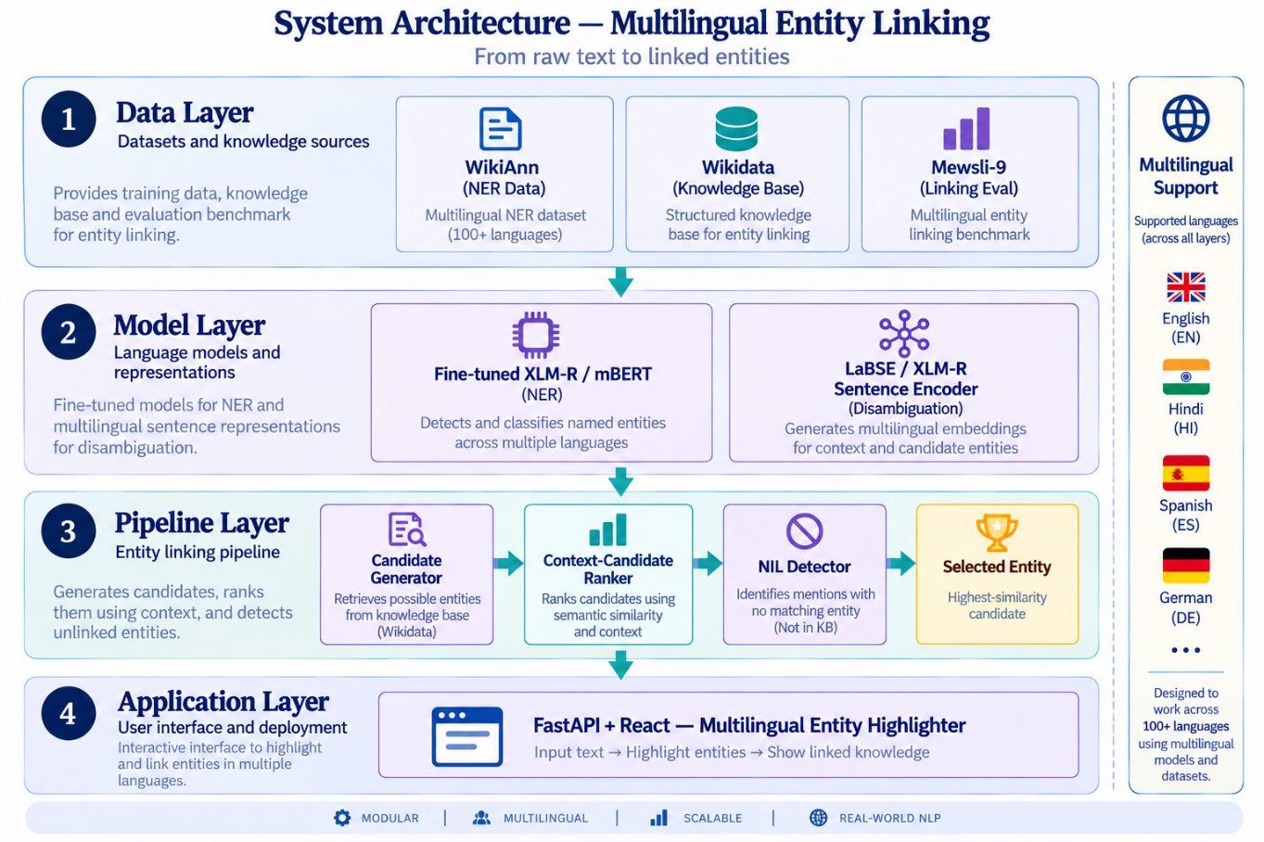

3. Hardware & Software Requirements
The system was designed to be developed and run on ordinary consumer hardware, with GPU acceleration used only where it materially affects turnaround time — specifically, fine-tuning the NER model. Inference (the pipeline actually used by the demo), candidate generation, and disambiguation are all CPU-feasible and were run that way during development. The tables below summarize the hardware and software requirements across the project's three main activities: model training, pipeline inference, and running the demo application.

3.1 Hardware Requirements
Activity | Minimum | Recommended
NER model fine-tuning | CPU only (impractically slow for full training runs) | GPU with ≥ 12 GB VRAM (e.g. Google Colab's free-tier GPU, used for this project) or equivalent cloud GPU instance
Pipeline inference (NER + linking) | 4-core CPU, 8 GB RAM | 8-core CPU or better, 16 GB RAM, for faster embedding/similarity computation and smoother multi-request handling
Local knowledge-base cache | ≈ 50 MB free disk space (seed-entity parquet cache) | 1–2 GB free disk space if the seed set is expanded significantly
Demo application (backend + frontend) | Any machine capable of running Python and Node.js concurrently, 8 GB RAM | 16 GB RAM for comfortable concurrent backend, frontend, and browser usage during development
Network connectivity | Required intermittently (live Wikidata search-API fallback, Wikipedia extract enrichment) | Stable broadband connection; an authenticated Wikidata API key for higher rate limits in production use

3.2 Software Requirements
Component | Requirement
Operating System | Cross-platform: developed and tested on Windows 11; Linux and macOS are supported (faiss-cpu is conditionally excluded on Windows in requirements.txt)
Python | Python ≥ 3.9 (per pyproject.toml)
Core ML libraries | torch ≥ 2.1, transformers ≥ 4.40, datasets ≥ 2.19, sentence-transformers ≥ 2.7, accelerate ≥ 0.30, seqeval ≥ 1.2.2
NLP utilities | truecase ≥ 0.0.14 (English capitalization restoration)
Knowledge base access | SPARQLWrapper ≥ 2.0 (Wikidata SPARQL bulk fetch), requests ≥ 2.31 (Wikidata/Wikipedia REST APIs)
Data handling | pandas ≥ 2.2, numpy ≥ 1.26, pyyaml ≥ 6.0
Similarity search | faiss-cpu ≥ 1.8 (non-Windows), scikit-learn ≥ 1.4 (fallback nearest-neighbor / TF-IDF baseline)
Backend (demo API) | fastapi ≥ 0.111, uvicorn[standard] ≥ 0.29
Frontend (demo UI) | Node.js (LTS), React 18.3, Vite 5.4, @vitejs/plugin-react 4.3
Testing / development | pytest ≥ 8.2, tqdm ≥ 4.66
Training environment | Google Colab (free GPU tier) used for NER fine-tuning; no GPU required for local development

3.3. Dataset, Model & Hyperparameters
Datasets and model configuration used across the four target languages: English (EN), Hindi (HI), Spanish (ES), German (DE).
Component | Detail | Value / Source
Dataset — NER | Source | WikiAnn (via HuggingFace ‘datasets’), splits for EN, HI, ES, DE
Dataset — NER | Labels | PER, ORG, LOC (IOB2 tagging scheme)
Dataset — Linking (eval) | Source | Mewsli-9 (multilingual) + Wikipedia hyperlink weak labels
Dataset — Linking (eval) | Knowledge Base | Wikidata (QIDs, multilingual labels & aliases)
Dataset split | Train / Val / Test | 80% / 10% / 10% per language
Model — NER | Base architecture | XLM-RoBERTa-base (270M params) or mBERT-base
Model — NER | Fine-tuning head | Token classification (linear + softmax over IOB2 tags)
Model — Disambiguation | Base architecture | LaBSE / XLM-R sentence-transformer (bi-encoder)
Model — Disambiguation | Similarity metric | Cosine similarity, top-k candidate re-ranking
Hyperparameter | Learning rate | 2e-5 (NER fine-tuning)
Hyperparameter | Batch size | 16 (train), 32 (eval)
Hyperparameter | Epochs | 3–5 (early stopping on validation F1)
Hyperparameter | Max sequence length | 128 tokens
Hyperparameter | Optimizer | AdamW, weight decay 0.01
Hyperparameter | Warmup ratio | 0.06 of total training steps
Hyperparameter | Candidate shortlist size (k) | 10 candidates per mention
Hyperparameter | NIL threshold | Cosine similarity < 0.4 → unlinkable

3.4 External Service Dependencies
- Wikidata SPARQL Query Service (query.wikidata.org) — used for bulk local knowledge-base cache construction; subject to outage-mode rate limiting (as low as one request per minute), for which the system implements retry-with-backoff.
- Wikidata Action API (wbsearchentities, wbgetentities) — used at inference time for live candidate search, sitelink counts, and entity relations; separately rate-limited under sustained load.
- Wikipedia REST Summary API — used to fetch richer intro-paragraph extracts for candidate disambiguation, per language.
Because the pipeline depends on these live, third-party services for any mention not already present in the local cache, a production deployment intended for sustained or high-volume use would need an authenticated Wikidata API key to obtain higher rate limits, rather than relying on the anonymous request quotas used during development.

