Smart Agriculture Monitoring System using IoT
1. Title of the Project
Design and Implementation of an IoT-Based Smart Agriculture Monitoring System
2. Problem Statement
Traditional irrigation systems often rely on manual observation or fixed schedules, which can lead to over-irrigation or under-irrigation. This results in water wastage, crop stress, and reduced agricultural productivity.
3. Objective of the Project
- To Monitor soil moisture, temperature, and humidity
- To Reduce water wastage
- To Design a low-cost IoT solution

4. Scope of the Project
- Suitable for small and medium farms
- Extendable to automation and cloud monitoring

5. System Overview
The system uses sensors deployed in the field to collect environmental and soil data. An ESP32 microcontroller processes this data and applies intelligent decision logic at the edge level. Based on the conditions, alerts related to irrigation are generated.
6. Tools Used
6.1.Hardware Components
- ESP32
- DHT22
- Soil Moisture Sensor
6.2.Software Requirements
- Arduino IDE,
- DHT Library
- Wokwi Simulator

7.Hardawre Setup
Hardware implementation of Smart Agriculture Monitoring System
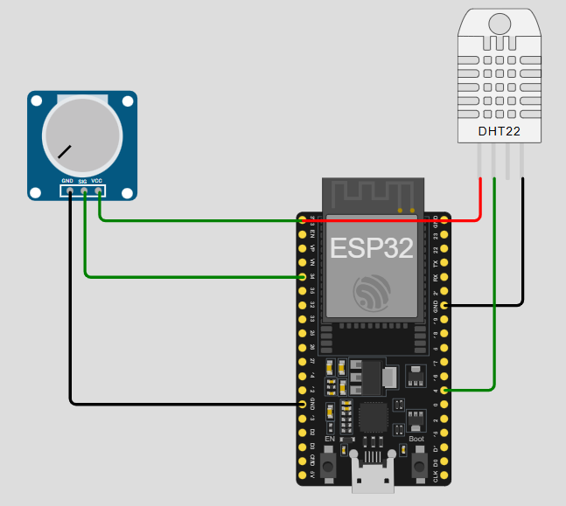
8. System Architecture
9. Data Flow Explanation
1. Soil moisture sensor sends analog signal to ESP32 ADC pin
2. DHT22 sends digital temperature and humidity data
3. ESP32 processes raw data and converts it into meaningful values
4. Decision logic evaluates conditions
5. Alert or normal status is generated

10. Sample Output
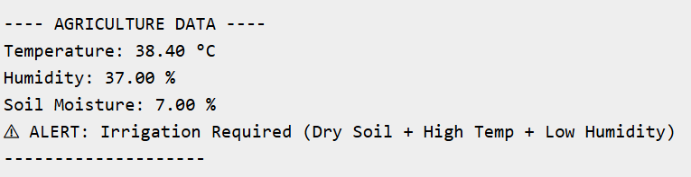
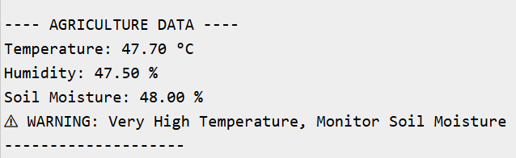
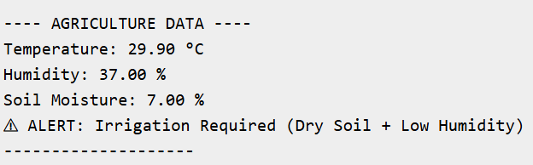
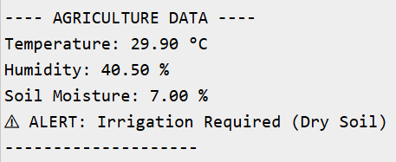
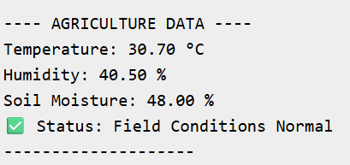
11. Advantages
- Low cost and easy to deploy
- Scalable and upgradable
- Real-time monitoring
12. Conclusion
The project demonstrates a practical IoT-based smart agriculture monitoring system.

