ECE 6372- ADVANCED HARDWARE DESIGN

A Modern Women Security System with ESP-32 and GSM Module

# ABSTRTACT

A portable self-defense device which can be carried anywhere. The device contains a camera, GPS module, and an alarm system. All these modules are interfaces together and a single switch control is given for all the modules. As when a panic switch is pressed the camera will capture the image of the culprit, send the current geographic location with the image to http web server and simultaneously to a trusted person with the help of application and generating alarm. The image and the geographic location can be accessed anytime to deal with the culprit. All of these modules are to be fitted together.

# INTRODUCTION

America is the tenth most dangerous place for women to live, according to a recent survey. Women are concerned about the safety every time they go out. One aspect of these causes of crime, among many, is the inability of the law-abiding and or feeble citizen to grab attention for themselves when attacked. Society from the relative anonymity preset in the society and fact that many people are strangers to each other. This device is to overcome and to help women or as a matter of fact anybody to fight back while any kind of misbehavior. In this device we have introduced a camera to capture the image, GPS module

to know the location, an alarm to grab attention, no matter if it’s a crowded place or an isolated place.

Today various strategies are followed by people to avoid being a victim. For example, remaining in a well-lit and crowded area. And or being in front of a camera where if attacked they would be having prof against the fugitive. All these strategies are limited to only few places and for a limited time, because it is not always possible to do so. There are lot of devices available in market and their major shortcoming is that the device relies on only sound and visual signal to attract attention, but it does not record any information of the evildoer. Whereas this invention has the capability to record the face of the evildoer, save the geographic location and generate audio and visual signal to gain attention of others.

# SYSTEM ARCHITECTURE

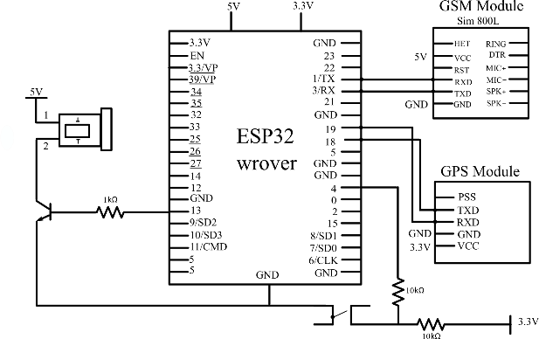

Fig.1: System architecture of women security system

# DESIGN DETAILS

## ESP32

ESP32 is a single 2.4 GHz Wi-Fi chip designed with the TSMC low-power 40 nm technology. It is designed to achieve the best power and RF performance, showing robustness, versatility and reliability in a wide variety of applications and power scenarios. ESP32 is designed for mobile, wearable electronics, and Internet-of-Things (IoT) applications. It features all the state-of-the-art characteristics of low-power chips, including fine-grained clock gating, multiple power modes, and dynamic power scaling. For instance, in a low-power IoT sensor hub application scenario, ESP32 is woken up periodically only when a specified condition is detected. Low-duty cycle is used to minimize the amount of energy that the chip expends. The output of the power amplifier is also adjustable, thus contributing to an optimal trade-off between communication range, data rate and power consumption.

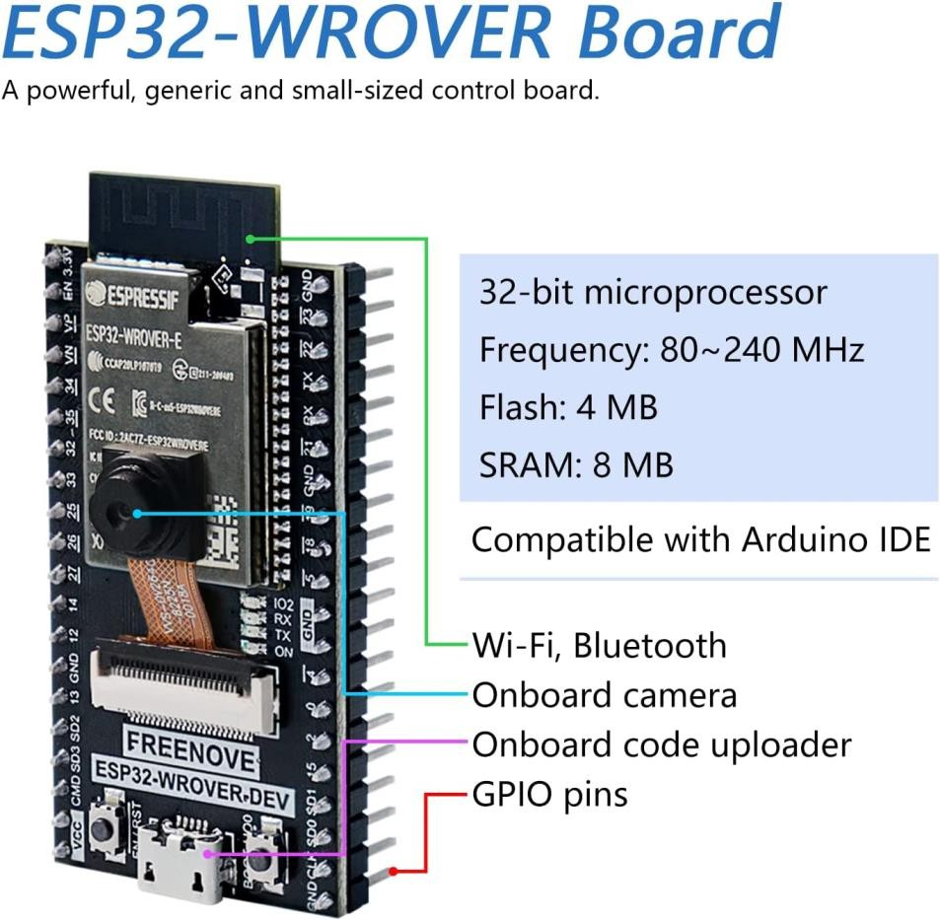

Fig.2: ESP32 wrover board

The ESP32 will be interfaced with GPS module, buzzer, and camera module. There are total 39 GPIO (General Purpose Input/output Pin). In which 34 to 39 pins can be used as input pin only. It has 3 power pins Micro USB, 3.3V supply, ground pin. The Micro USB

is used to power the microcontroller, the 3.3V will regulate power to microcontroller and other components on board, the ground pin is used to keep components safe. Enable pin is used to reset the microcontroller. There are 12-bit 18 channel of analog pins ADC1_0 to ADC1_5 and ADC2_0 to ADC2_9 used to measure analog voltage; it is a 12-bit 18 channel ADC. There are two channels of 8 bits for digital to analog conversion pin, DAC1 and DAC2. All GPIO pins act as PWM. GPIO21 and GPIO22 are used as I2C communication. The board has Tensillica Xtensa LX6 microprocessor. It has maximum operating frequency of 240 MHZ. It has SRAM of 520 KB and RAM of 448 KB. The microcontroller has 3 UART - UART1 is USB port, UART0 and UART2 is for receiving and transmitting data. The microcontroller have integrated Wi-Fi of 802.11 b/g/n. The 3.3V and ground pin of microcontrollers is connected to common power supply. The microcontroller will be interfaced with buzzer, the buzzer has two pins one for input signal and another one is for ground. The ground pin of buzzer will be connected to ground pin of microcontroller. The input pin of buzzer will be connected to the 13 pin of the microcontroller. The 13 pin of microcontroller act as the output pin. The buzzer pin 13 will be low as soon the switch is on it will become high and alarm will be generated for particular time period along with the LED which will be used as indicator for the people around the victim. The GPS module neo-6m has 4 pins- Vin, GND, TXN, RXN. The voltage and ground pin will be connected. Transmitting pin will be connected to D18 pin of microcontroller for transmitting location data to the microcontroller. The GPS module have antenna to communicate with the satellite. Once the satellite is located and locked by the antenna the GPS module will indicate it by blinking LED which is placed in in module. After GPS is locked the coordinate of longitude and latitude will be given to the module and it will transfer data through transmitting pin to microcontroller and the coordinates will be shown.

## GPS MODULE

The Global Positioning System (GPS) is a satellite-based navigation system that provides location and time information. The system is freely accessible to anyone with a GPS receiver and unobstructed line of sight to at least four of GPS satellites. A GPS receiver calculates its position by precisely timing the signals sent by GPS satellites. GPS is nowadays widely used and has become an integral part of smart phones.

GPS modules contain tiny processors and antennas that directly receive data sent by satellites through dedicated RF frequencies. From there, it’ll receive timestamp from each visible satellites, along with other pieces of data. The GPS module has four pins Vcc ,GND, RXD, TXD. The Vcc pin of GPS is connected to 3.3V of ESP32 . The GND is GND of the GPS module. The RXD is connected to the 19 the pin of the ESP 32. TXD is connected to the 18 pin of ESP32. The detailed connections are shown in system architecture.

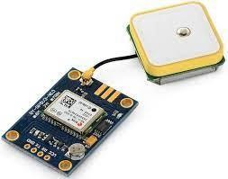

Fig.3: GPS module

## GSM/GPRS BREAKOUT BOARD

Mini GSM / GPRS breakout board is based on SIM800L module, supports quad-band GSM/GPRS network, available for GPRS and SMS message data remote transmission. The board features compact size and low current consumption. With power saving technique, the current consumption is as low as 1mA in sleep mode.

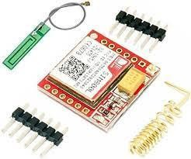

Fig.4: GSM module

It communicates with microcontroller via UART port, supports command including 3GPP TS 27.007, 27.005 and SIMCOM-enhanced AT Commands. TTL serial port for serial port, can be linked directly to the microcontroller. The VCC, TXD, RXD, GND pins are used. The Vcc is connected to 5v of ESP32. The GND of GSM is connected to GND of ESP32. The TXD pin is RXD of ESP 32 and The RXD of GSM is connected TXD of ESP32. The detailed connections are shown in system architecture.

## ARDUINO IDE

The Arduino IDE is an open-source software, which is used to write and upload code to the Arduino boards. The IDE application is suitable for different operating systems such as Windows, Mac OS X, and Linux. It supports the programming languages C and C++. Here, IDE stands for Integrated Development Environment.

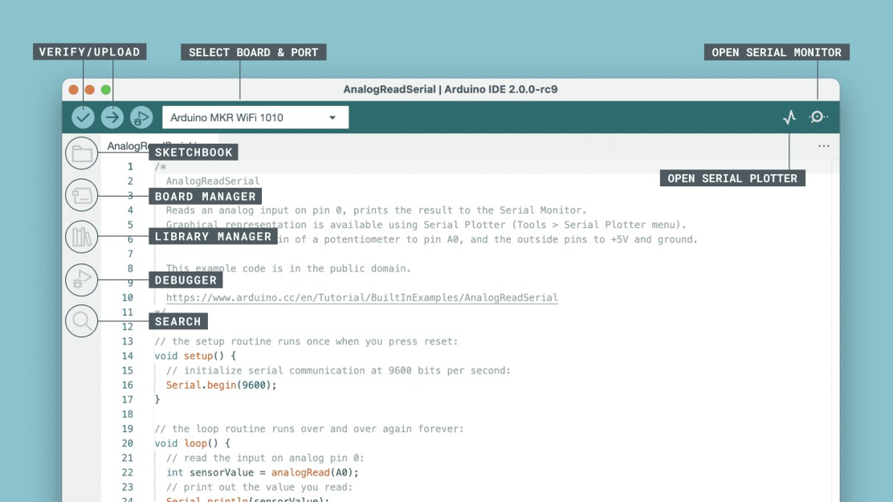

Fig.5: Ardunio IDE

Programs written using Arduino Software (IDE) are called sketches. These sketches are written in the text editor and are saved with the file extension. ino. The editor has features for cutting/pasting and for searching/replacing text. The message area gives feedback while saving and exporting and also displays errors. The console displays text output by the Arduino Software (IDE), including complete error messages and other information. The bottom righthand corner of the window displays the configured board and serial port. The toolbar buttons allow you to verify and upload programs, create, open, and save sketches, and open the serial monitor.

## ANDROID STUDIO

Android Studio is the official integrated development environment ([IDE](https://www.techtarget.com/searchsoftwarequality/definition/integrated-development-environment)) for Android application development. It is based on the [IntelliJ IDEA](https://www.theserverside.com/definition/IntellJ-IDEA), a [Java](https://www.theserverside.com/definition/Java) integrated development environment for software, and incorporates its code editing and developer tools. To support application development within the Android operating system, Android Studio uses a

Gradle-based build system, emulator, code templates, and [Github](https://www.techtarget.com/searchitoperations/definition/GitHub) integration. Every project in Android Studio has one or more modalities with source code and resource files. These modalities include Android app modules, Library modules, and Google App Engine modules.

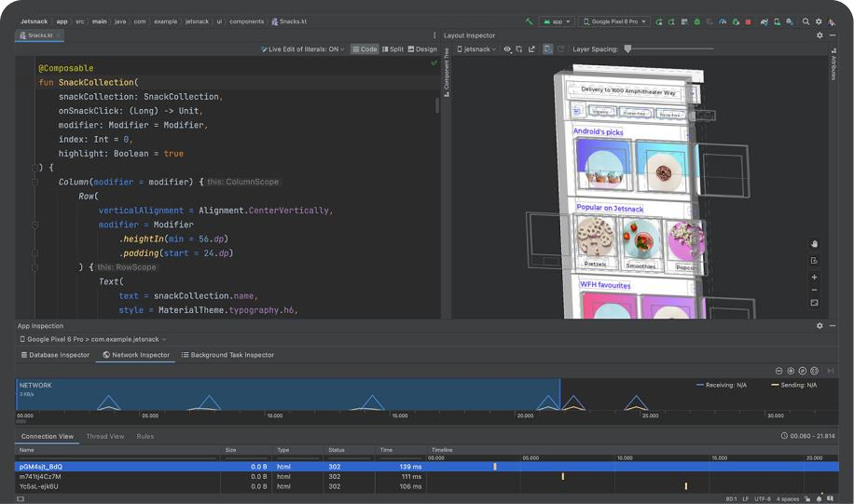

Fig.6: Android studio

Android Studio uses an Instant Push feature to push code and resource changes to a running application. A code editor assists the developer with writing code and offering code completion, refraction, and analysis. Applications built in Android Studio are then compiled into the [APK format](https://www.techtarget.com/whatis/definition/APK-file-Android-Package-Kit-file-format) for submission to the Google Play Store. The software was first announced at Google I/O in May 2013, and the first stable build was released in December 2014. Android Studio is available for Mac, Windows, and Linux desktop platforms. It replaced Eclipse Android Development Tools (ADT) as the primary IDE for Android application development. Android Studio and the Software Development Kit can be downloaded [directly from Google](https://developer.android.com/studio/).

# PROTOTYPING AND DEMONSTRATION

The hardware parts consists mainly of which will be discussed in this methodology section accordingly. We have used microcontroller - ESP32. The ESP32 is used to control the camera, Wi-Fi and buzzer. The main software part i.e. programing both the

microcontroller is done in Arduino IDE. The hardware part predominantly comprises of the camera module, buzzer, LED and inbuilt Wi-Fi module.

This project, on the whole, is based on three stages: software implementation, hardware development, and testing. The hardware part is the most laborious part of achieving the ambitions of this project. Based on the work proposed, several steps must be followed. The first step is study and design, where the work starts with the literature survey on the basics of personal security systems. After finishing the study process, the design is done. Lastly, all the modules and circuits have been assembled and constructed and the hardware is established for real application testing. Then a combination of both software and hardware obtained. Finally, a well-organized hardware obtained for the women security system. We are showing project working pictures below.

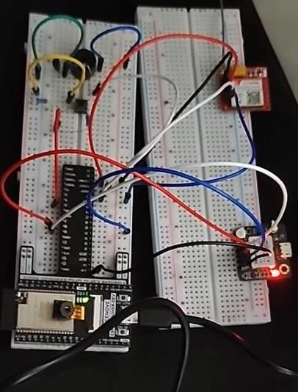

Fig.7: Connections and integration of all modules to ESP32 wrover board

Fig7 shows the connections and integration of all modules to ESP32 wrover board. Fig 8 shows obtained latitude and longitude from the GPS module.

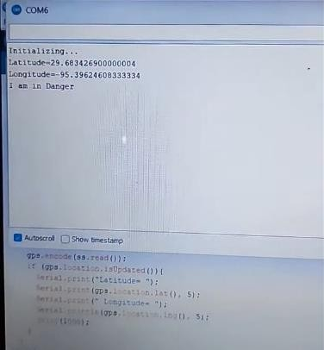

Fig.8: Latitude and longitude from the GPS module

Fig 9 is the working of the android app that sends the location of the victim to the trusted contacts.

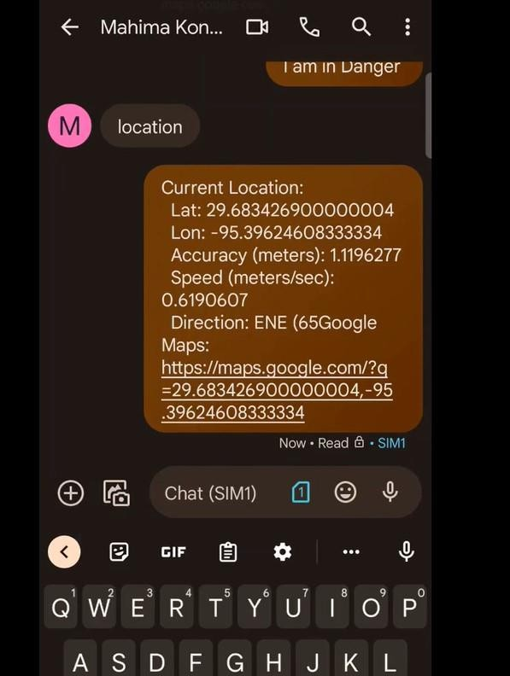

Fig.9: Location of the victim to the trusted contacts.

Fig 10 shows the working of the camera module sending the suspect’s picture to the http web server with the obtained server address.

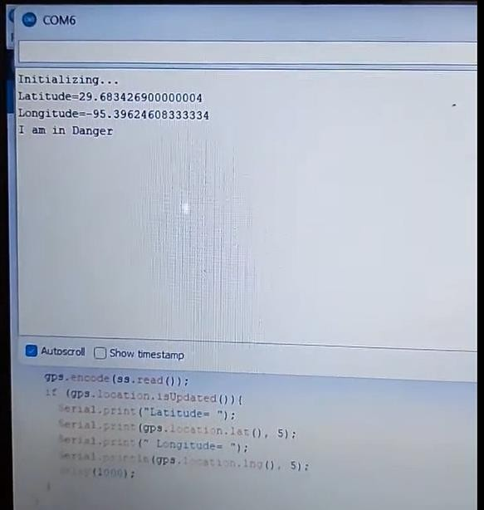

Fig.10: Working of the camera module

# CONCLUSION

A portable self-defense device with a camera, GPS module, and alarm system is developed. The culprit image is captured and sent to http web server, simultaneously generating an alarm with the help of a buzzer. A mobile application is developed using Android studio to share the location to the trusted contacts. This setup is specially built for the security of the women.