**Step 1:**

* Run WebForms.py file.

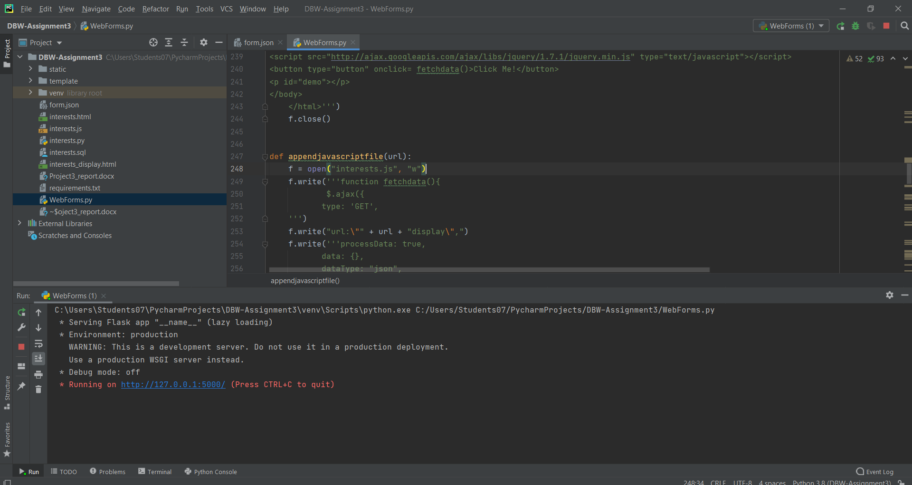

* Click on the generated url, <http://127.0.0.1:5000/> and then input the json file name as command line argument.

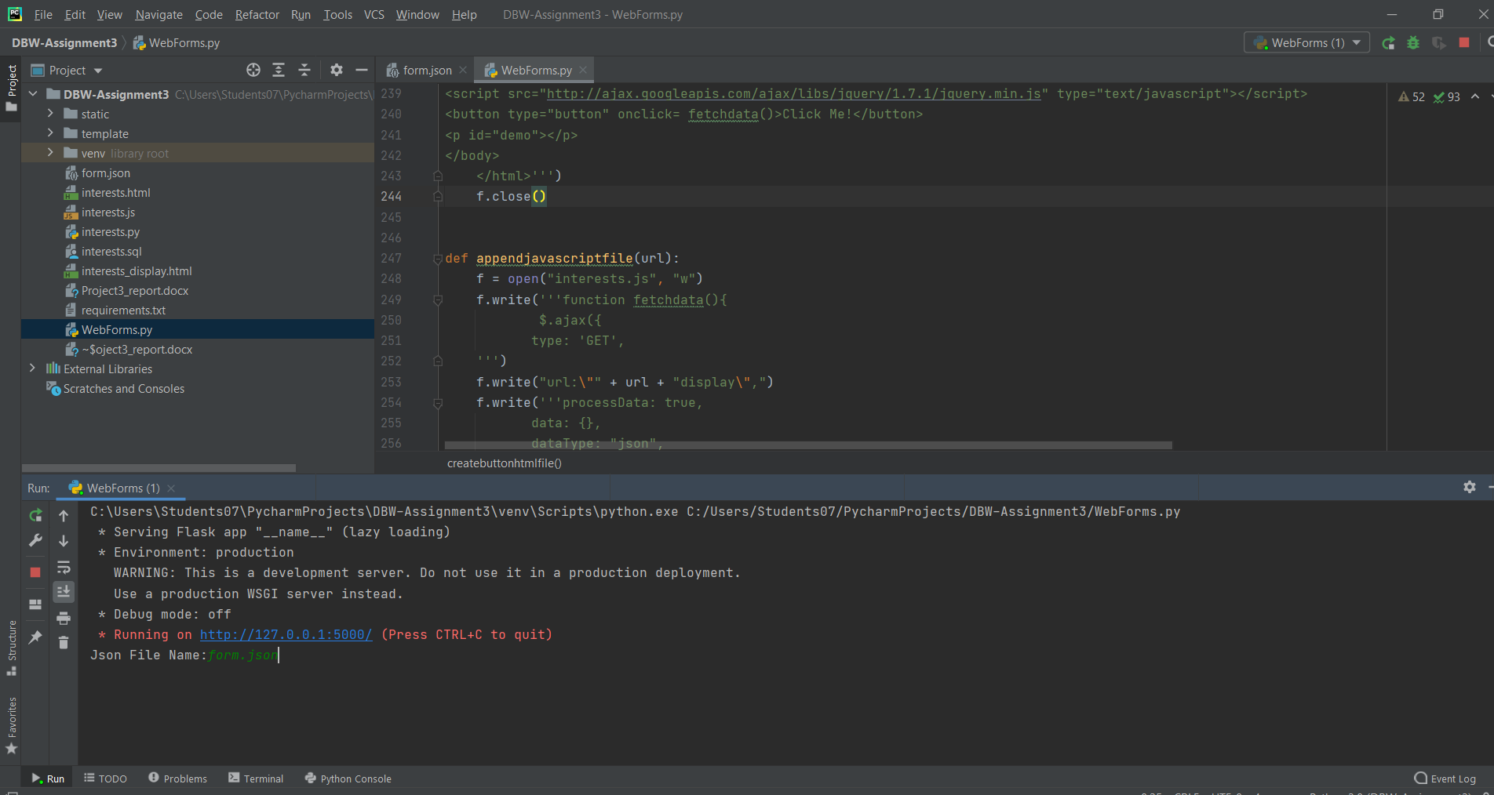

**Interests.html, interests.js, interests.sql, interests.py, interests_display.html files** are generated.

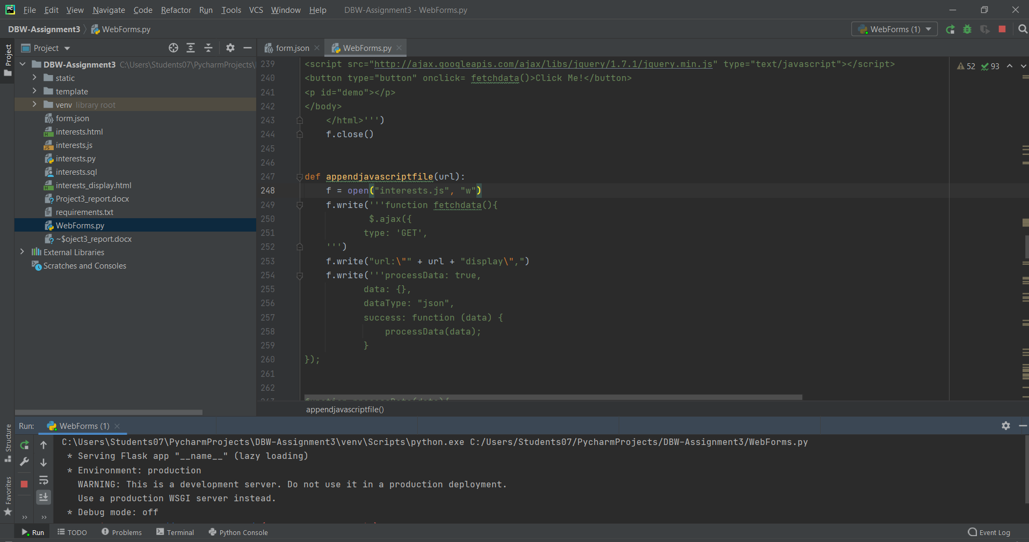

**Step 2:**

* Create a new user and database using the following commands on Mysql terminal:

**CREATE USER 'raj'@'localhost' IDENTIFIED BY 'r123';**

**GRANT ALL PRIVILEGES ON *.* TO 'raj'@'localhost';**

**FLUSH PRIVILEGES;**

**CREATE DATABASE raj;**

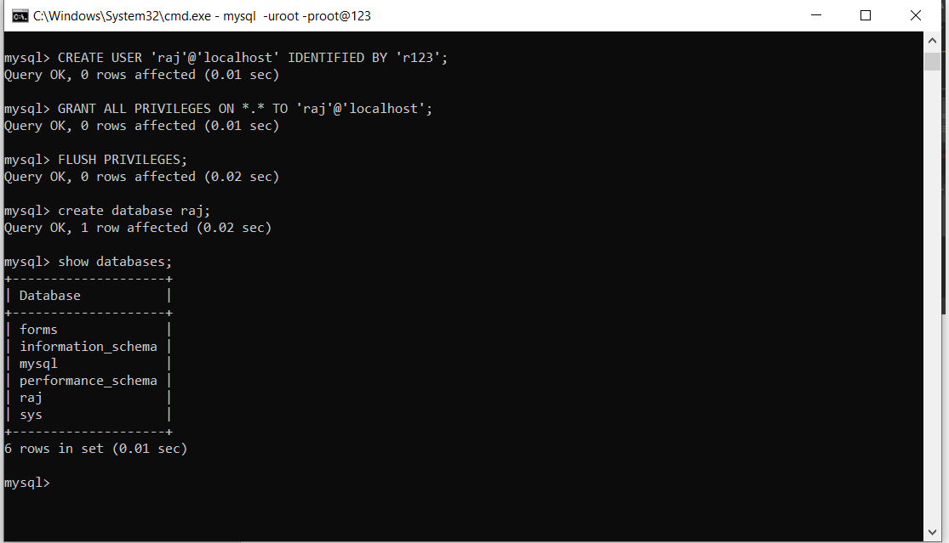

**Step 3:**

* Move the interests.sql file into MySQL/bin and run the following commands in MySQL terminal:

**USE raj;**

**SOURCE interests.sql;**

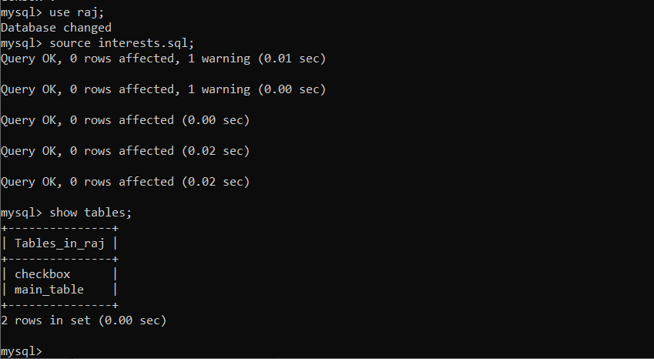

**Step 4:**

* Terminate WebForms.py file and then run interests.py

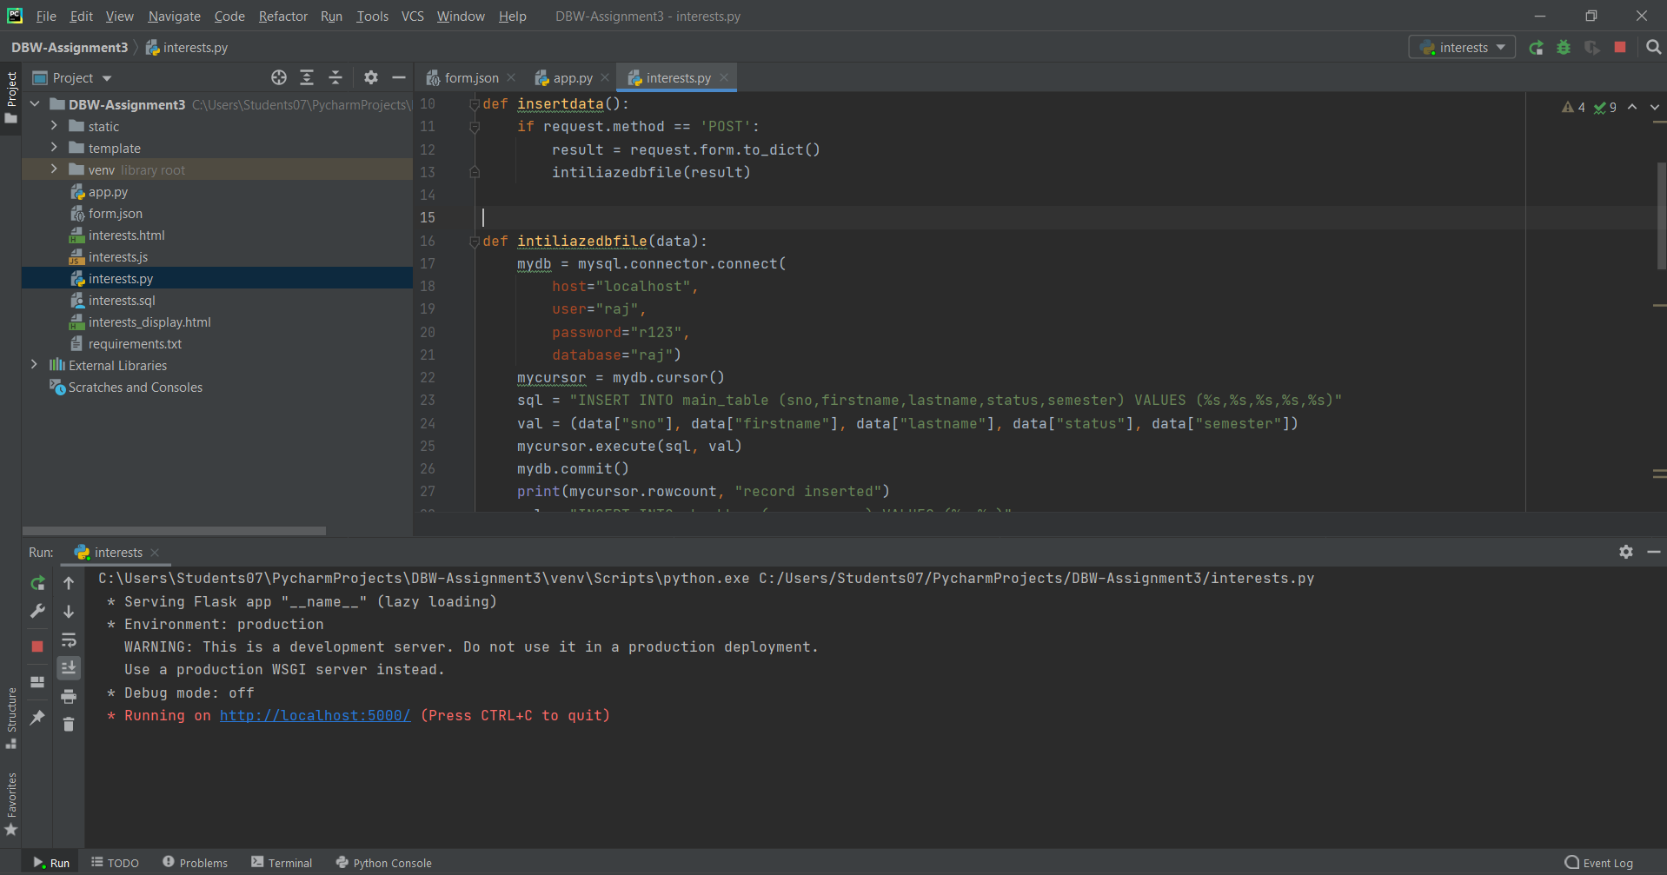

**Step 5:**

* Open interests.html file in chrome browser.

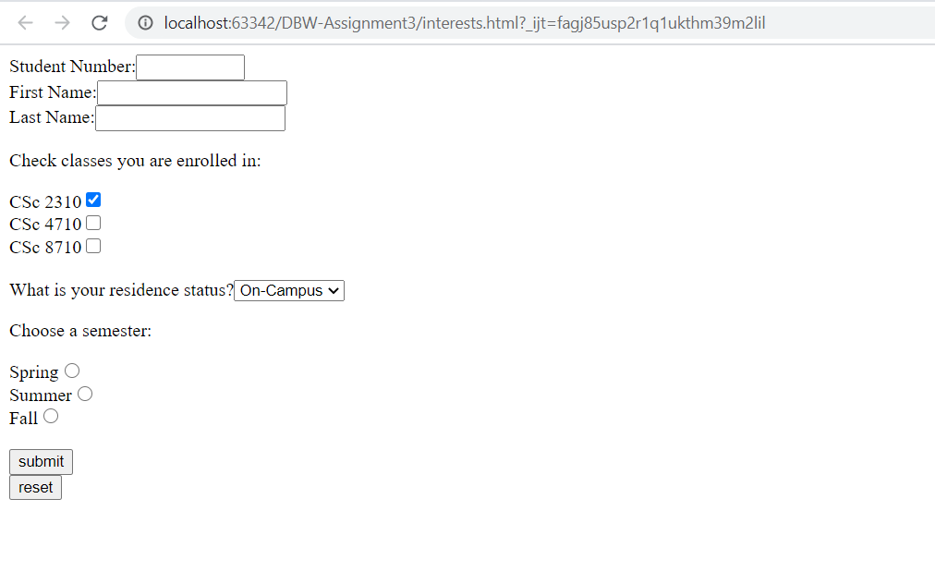

* Fill the form as below:

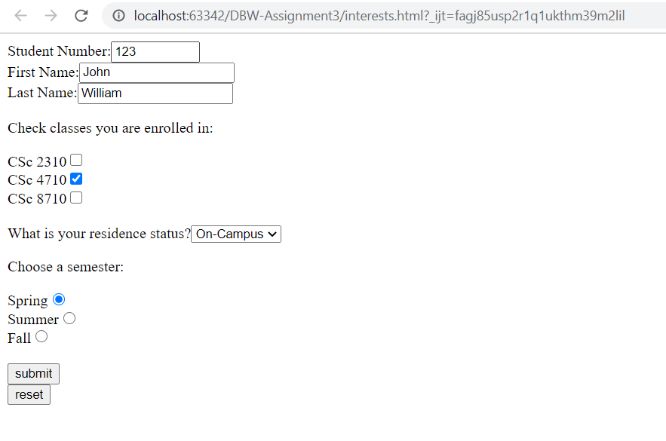

* Submit the form multple times to insert further records into the database tables

**Step 6:**

* Open interests_display.html in chrome browser and hit “Click Me” button.

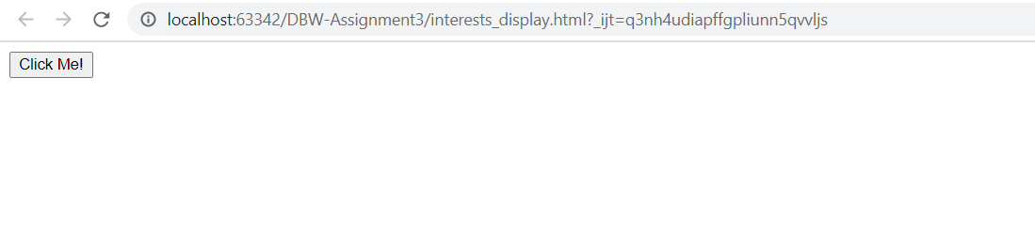

* All the inserted records are displayed as shown in the below screenshot:

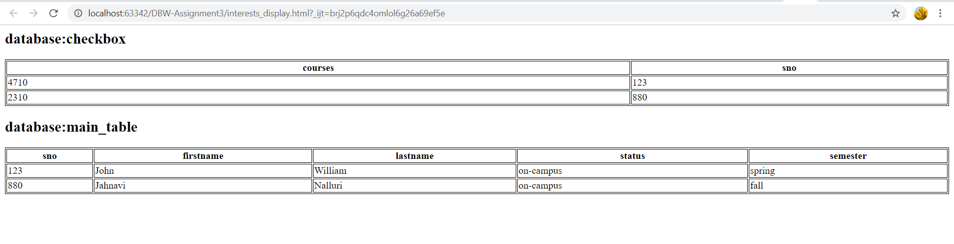

Below are the screenshots for Java script validations:

1. When Student Number is given a string value

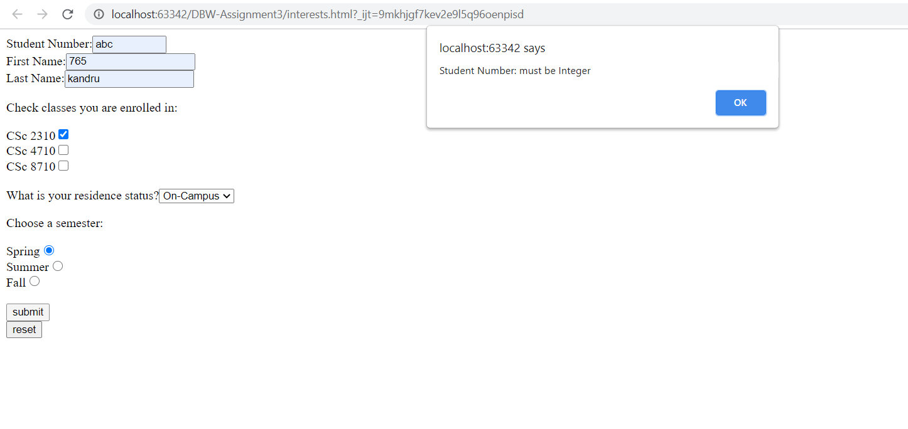

1. When First Name is given a integer value

