**Multi Factor Authuntication:**

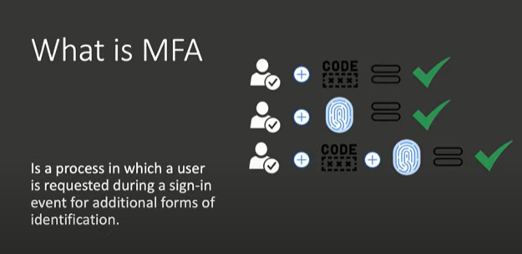

User name

password

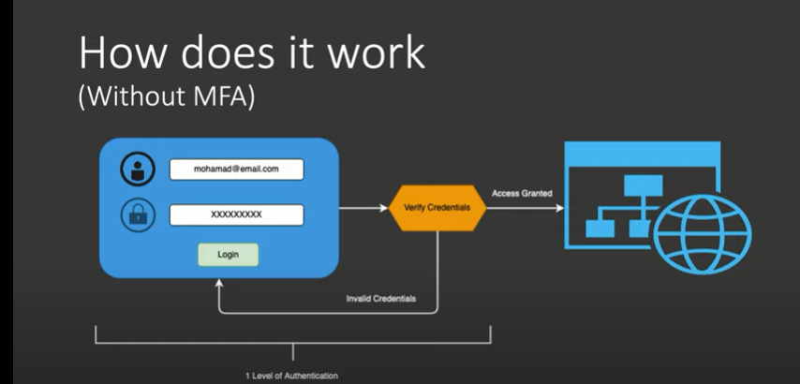

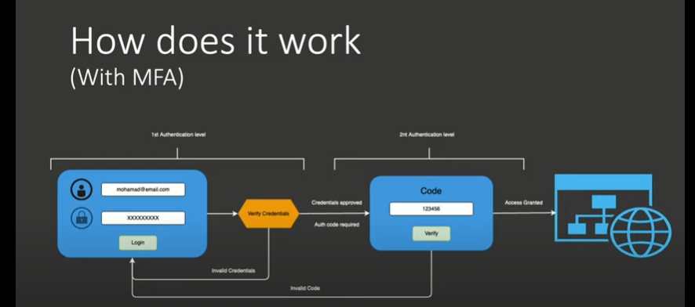

One time code(from phone)

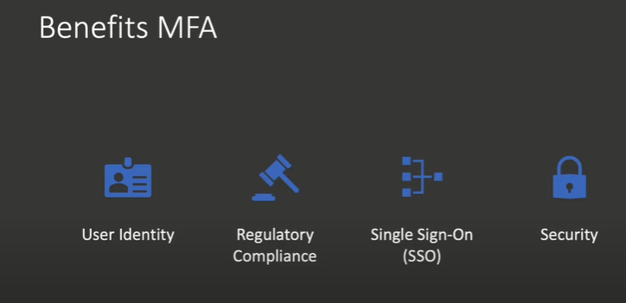

Single Sigin various sigin

Registration--->two factor authuntication---> QR code---> scan with authuntication app

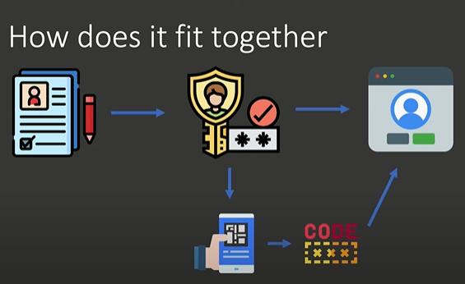

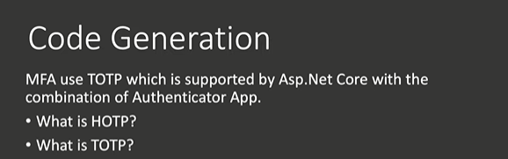

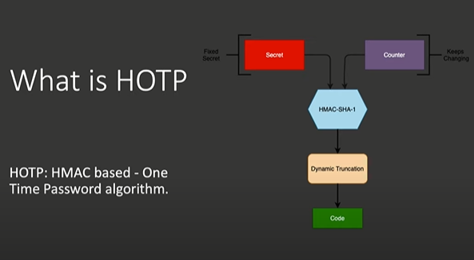

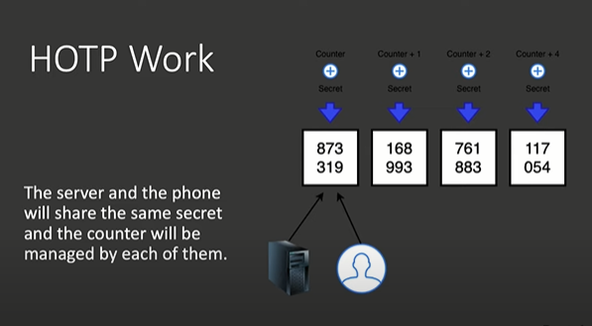

After QR code scan it is know to server and phone.

Every time counter is incremented by one

**What if we doesnt use the code:(counter is not increamented):**

Counter on the server and counter on the mobile phone is updated automatically(with auto factor authentication)<-------------disadvantage

**Part-1:**

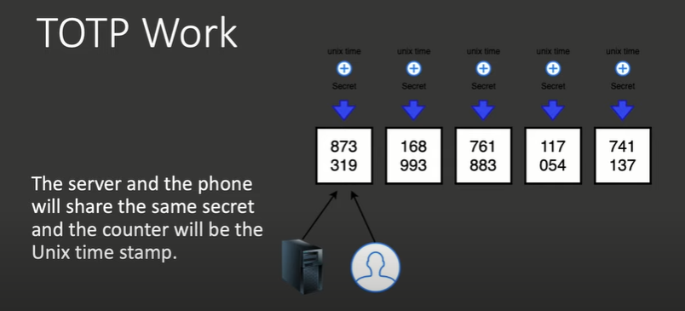

Gap b/w is 30sec

hMAC or H1

Server matches the Authuntication time in the phone

**Time frame entering by both the devices**

**(all devices doesnt have same time frame):**

Time frame with two along with login

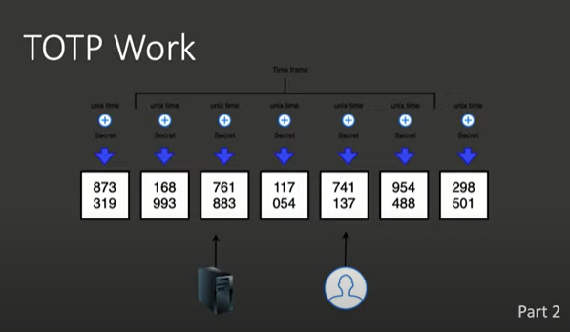

If server is not in that time frame it will wait to come to that time frame,

If that doesnt work it will **2 factor authuntication**

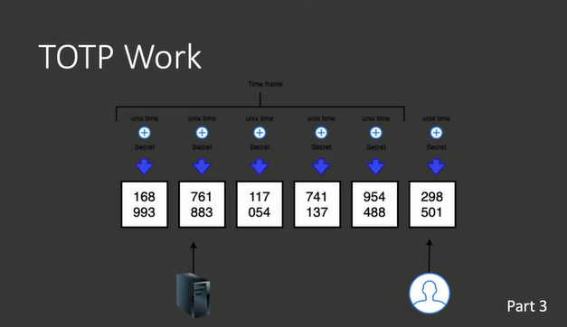

HMAC-SHA1:

Secret --->server+mobile phone+counter=based on unix time

HMAC uses underline hash function generate secret code 160 bits or 20 bits long

TOTP: 8char long,

OUTPUT(HMAC func):should trucked in chits(160 bits or 20 bits long)

Trunction :Dyanamic truncation(numeric 10*5)

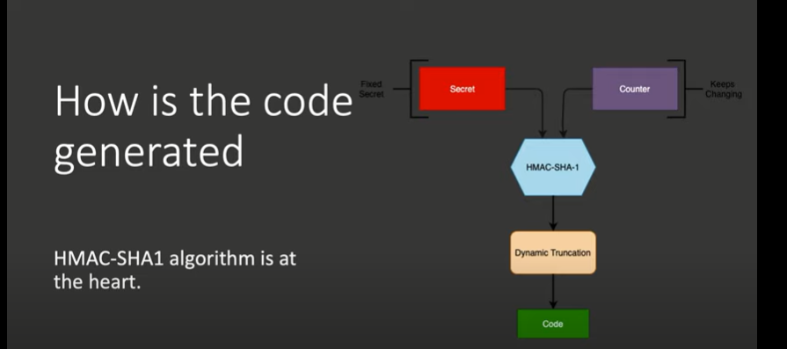

Automatically populated from mobile device

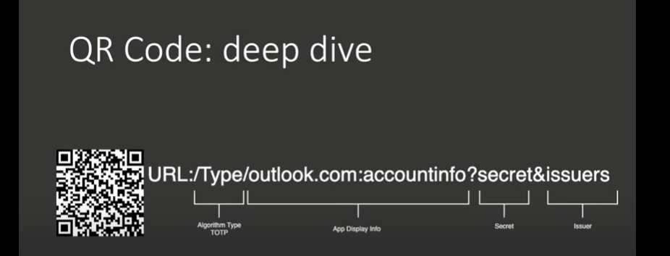

New application in command:

dotnet new mvc -n "authun" -au individual

Dotnet build

Dotnet run

Register---> conform email

Login--->click on mail

Two factor authuntication

**https://localhost:7281/Identity/Account/Manage/EnableAuthenticator**

Idenity is class library

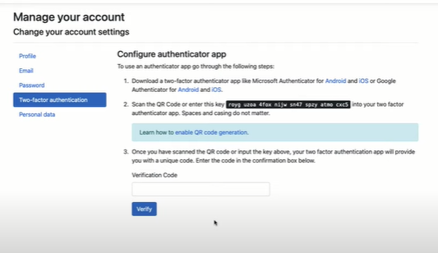

Enable rasar page:

Startup.cs

Add razors to startup



Install this two packages:



1.

dotnet tool install --global dotnet-aspnet-codegenerator --version 2.2.0

2.

dotnet tool install --global dotnet-ef --version 6.0.3

3.

