**Department of IT and Computer Science**

**Pak-Austria Fachhochschule: Institute of Applied Sciences and Technology, Haripur, Pakistan**

**COMP-201L Data Structures and Algorithms Lab**

**Lab Report: 01**

**Class: Computer Science**

**Name: Yaseen Ejaz Ahmed**

**Registration No.: B20F0283CS014**

**Semester: Third**

**Submission Date: 21 October 2021**

**Submitted to: Dr. Rafi Ullah**

**Instructor Signature**

**Lab No. 1**

**C++ Review**

**Objectives:**

* To Review the basic concepts of C++.
* To Review Arrays, how to declare, initialize and access 2D and 3D arrays Implement  
  Arrays in C++.

**Tools/Software Required:**

C++ Compiler

**Introduction:**

Basic concepts of C++, Arrays, declaration, initialize and access 2D and 3D arrays.

**Lab Tasks:**

**Lab Task 01:**

You’re given with marks of 10 students in Mathematics, write a program to determine the grade  
of each student.  
80, 72, 93, 87, 90, 55, 66, 74, 69, 56

Assume:  
Grade is A if score is equal and greater than 90  
Grade is B+ if score is less than 90 and greater than 81  
Grade is B if score is less than 82 and greater than 71  
Grade is C if score is less than 72 and greater than 66  
Grade is D if score is less than 66 and greater than 59  
Grade is F if score is less than 60.

**Code:**

#include <iostream>

using namespace std;

void Marks(int*);

**int main()**

{

int a[10] = {80, 72, 93, 87, 90, 55, 66, 74, 69, 56};

Marks(a);

delete[] a;

}

**void Marks(int a[])**

{

for(int i=0;i<10;i++)

{

cout<<”\nStudent “<<i+1<<” : “<<a[i]<<”\t”;

if(a[i]>=90)

cout<<’A’;

else if(a[i]<90 && a[i]>=81)

cout<<”B+”;

else if(a[i]<82 && a[i]>=71)

cout<<’B’;

else if(a[i]<72 && a[i]>=66)

cout<<’C’;

else if(a[i]<66 && a[i]>=60)

cout<<’D’;

else if(a[i]<60)

cout<<’F’;

}

}

**Output:**

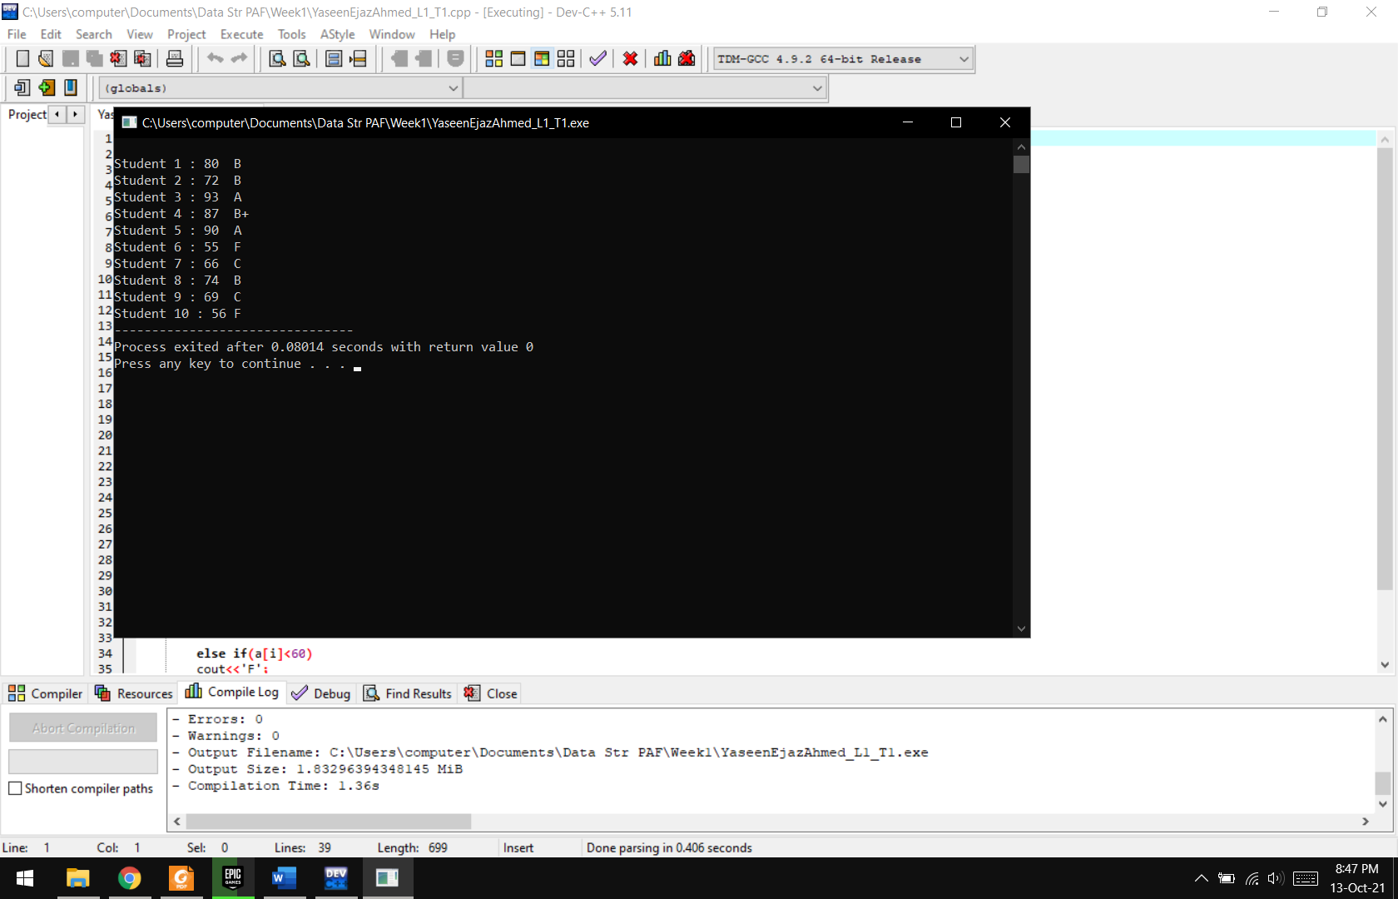

**Lab Task 02:**

Write a program to ask user to enter 5 floating numbers and find the maximum and minimum of all by calling min() and max() functions

**Code:**

#include <iostream>

using namespace std;

**float min(float a[],int size)**

{

float min=a[0];

for(int i=0;i<size;i++)

{

if(min>a[i])

min=a[i];

}

return min;

}

**float max(float a[],int size)**

{

float max=a[0];

for(int i=0;i<size;i++)

{

if(max<a[i])

max=a[i];

}

return max;

}

**int main()**

{

float a[5];

cout<<”Enter 5 numbers :\n”;

for(int i=0;i<5;i++)

{

cout<<”Enter Number “<<i+1<<” : “;

cin>>a[i];

}

cout<<”\nThe minimum number is “<<min(a,5);

cout<<”\nThe maximum number is “<<max(a,5);

delete[] a;

}

**Output:**

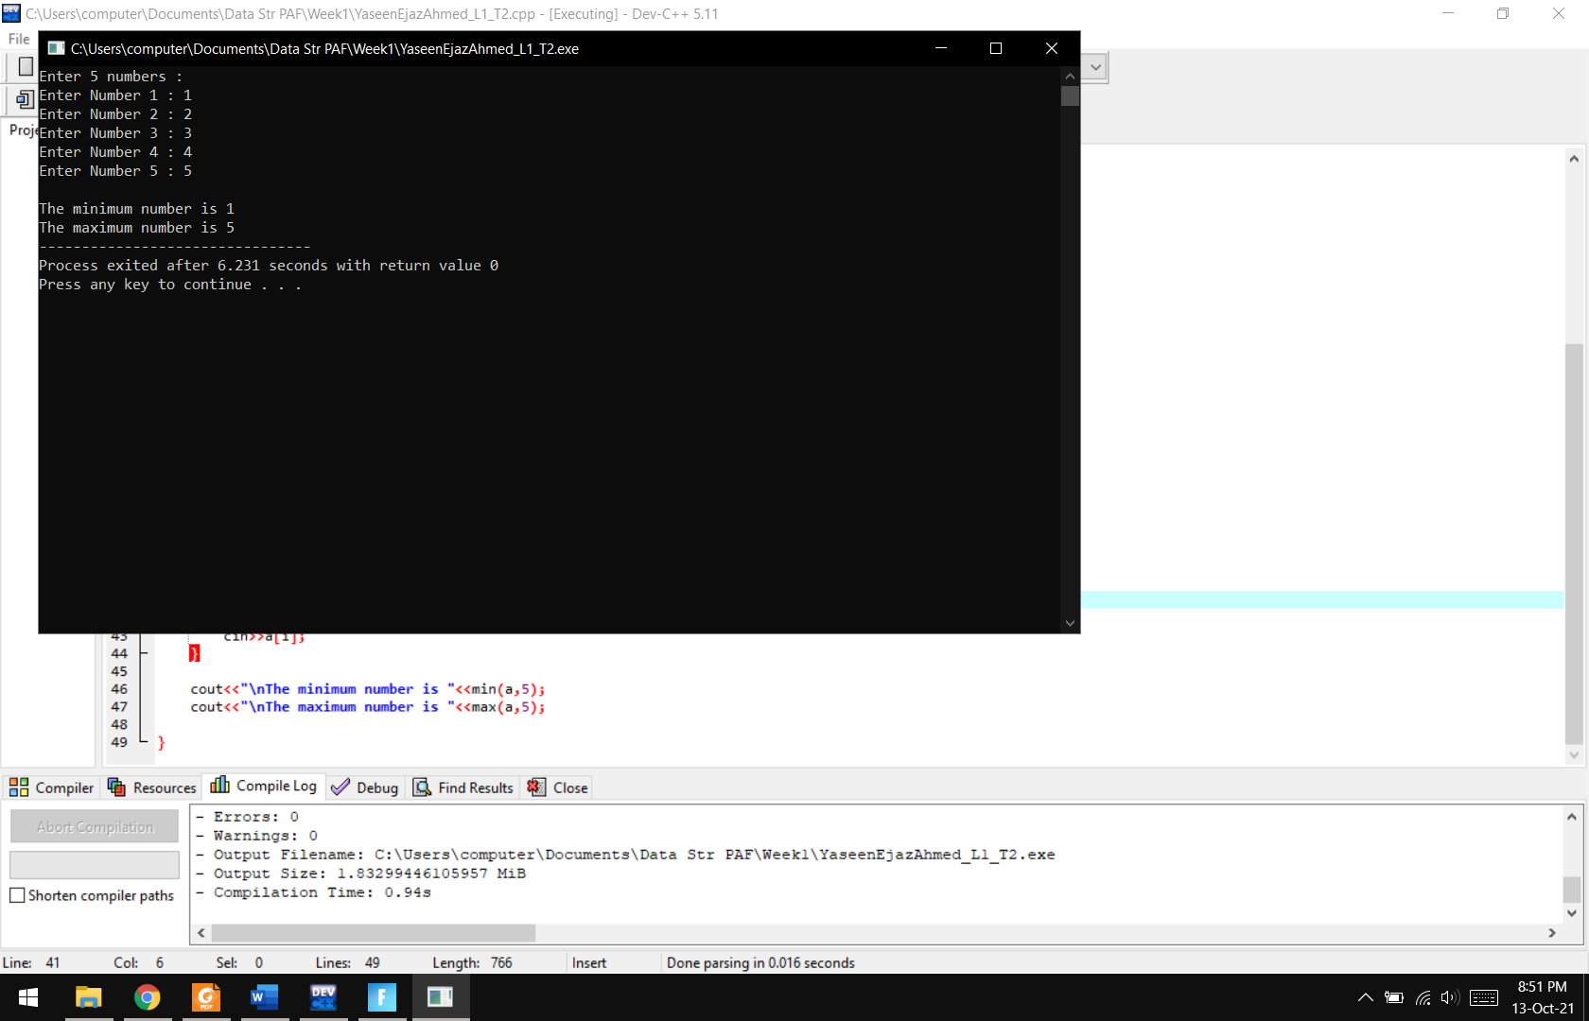

**Lab Task 03:**

Write a program that shows following output

**Code:**

#include <iostream>

using namespace std;

**void PrintHistogram(int a[],int size)**

{

int temp;

cout<<”\nElement\tValue\tHistogram\n”;

for(int i=0;i<10;i++)

{

cout<<i<<”\t”<<a[i]<<”\t”;

temp=a[i];

for(int i=1;i<=temp;i++)

cout<<”*”;

cout<<endl;

}

}

**int main()**

{

int size=10;

int a[size];

cout<<”Please enter 10 integers :\n”;

for(int i=0;i<size;i++)

{

cout<<”Enter Number “<<i+1<<” : “;

cin>>a[i];

}

PrintHistogram(a,size);

delete[] a;

}

**Output:**

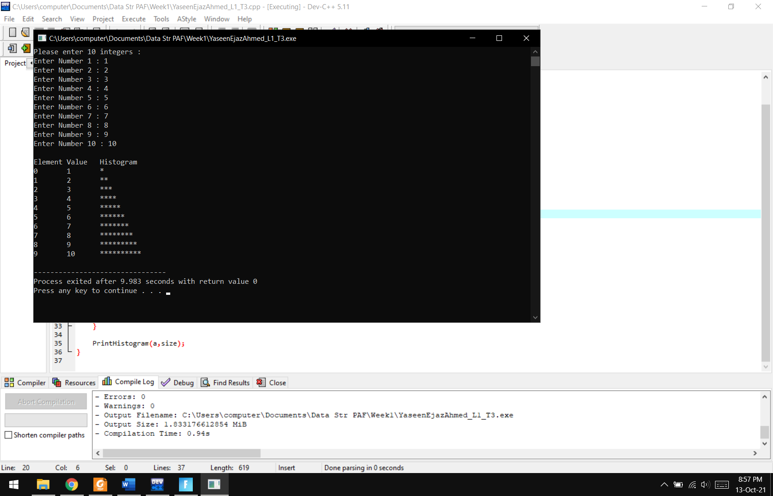

**Lab Task 04:**

Write a program that will print multi-subscripted array as shown below using function printArray().

**Code:**

#include <iostream>

using namespace std;

**void PrintArray(int *a,int rows,int col)**

{

cout<<”\n\nMatrix form\n”;

for(int i=0;i<rows;i++)

{

for(int j=0;j<col;j++)

{

cout<<*((a+i*col)+j)<<”\t”;

}

cout<<endl;

}

}

**int main()**

{

int rows,col;

cout<<”Enter the rows of the matrix : “;

cin>>rows;

cout<<”Enter the columns of the matrix : “;

cin>>col;

int a[rows][col];

for(int i=0;i<rows;i++)

{

cout<<”\nRow “<<i+1<<” :\n”;

for(int j=0;j<col;j++)

{

cout<<”Column “<<j+1<<” : “;

cin>>a[i][j];

}

}

PrintArray(*a,rows,col);

delete[] a;

}

**Output:**

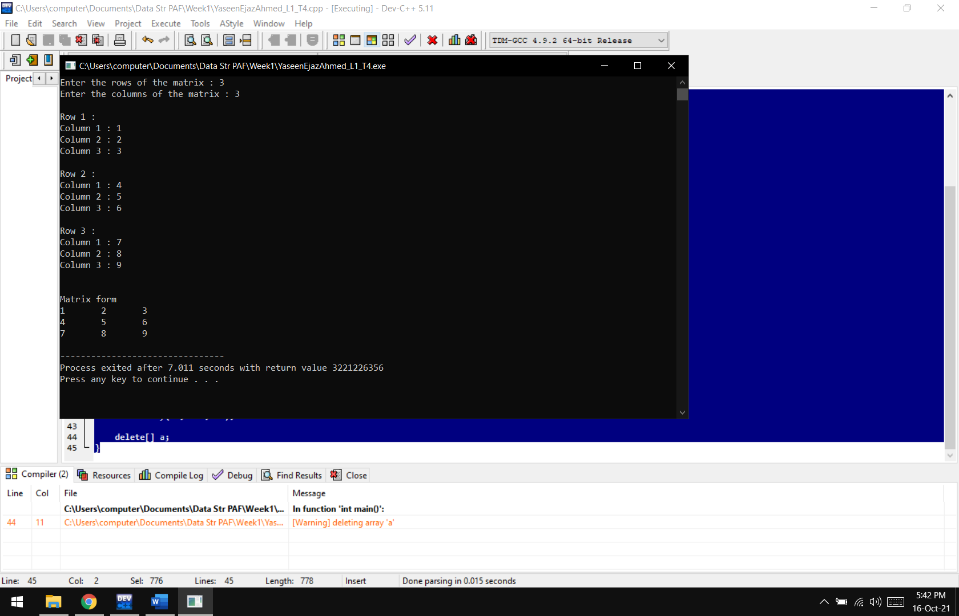

**Results & Observations:**

In this lab, we have learnt the basics of arrays and multi-dimensional arrays. We can use arrays to hold values of the same data type. We can modify values and use these values for different purposes as well.