**Department of IT and Computer Science**

**Pak-Austria Fachhochschule: Institute of Applied Sciences and Technology, Haripur, Pakistan**

**COMP-201L Data Structures and Algorithms Lab**

**Lab Report: 02**

**Class: Computer Science**

**Name: Yaseen Ejaz Ahmed**

**Registration No.: B20F0283CS014**

**Semester: Third**

**Submission Date:**

**Submitted to: Dr. Rafi Ullah**

**__________________**

**Instructor Signature**

**Lab No.2**

Structures & Pointers Using C++

**Objectives:**

* To Revise the concepts of structures & pointers using C++.
* To Implement structures and pointers in C++

**Tools/Software Required:**

Dev C++ Compiler

**Introduction:**

Structure is a collection of variables of different data types under a single name. It is  
similar to a class in that, both holds a collection of data of different data types. We use pointers to point to different addresses and to access the values stored in them.

**Lab Tasks:**

**Lab Task 01:** Write a program to swap two values by passing pointers as argument to the function.

**Code:**

#include <iostream>

using namespace std;

**SwapValues(int *p,int *q)**

{

int *temp;

temp=p;

p=q;

q=temp;

cout<<"\n\nAfter Swapping :\na = "<<*p<<"\t"<<"\nb = "<<*q;

delete p;

delete q;

p=q=NULL;

}

**int main()**

{

int a,b;

cout<<"Enter the first value : ";

cin>>a;

cout<<"Enter the second value : ";

cin>>b;

int *aptr=&a;

int *bptr=&b;

cout<<"\nBefore Swapping :\na = "<<*aptr<<"\t"<<"\nb = "<<*bptr;

SwapValues(aptr,bptr);

delete aptr;

delete bptr;

aptr=bptr=NULL;

}

**Output:**

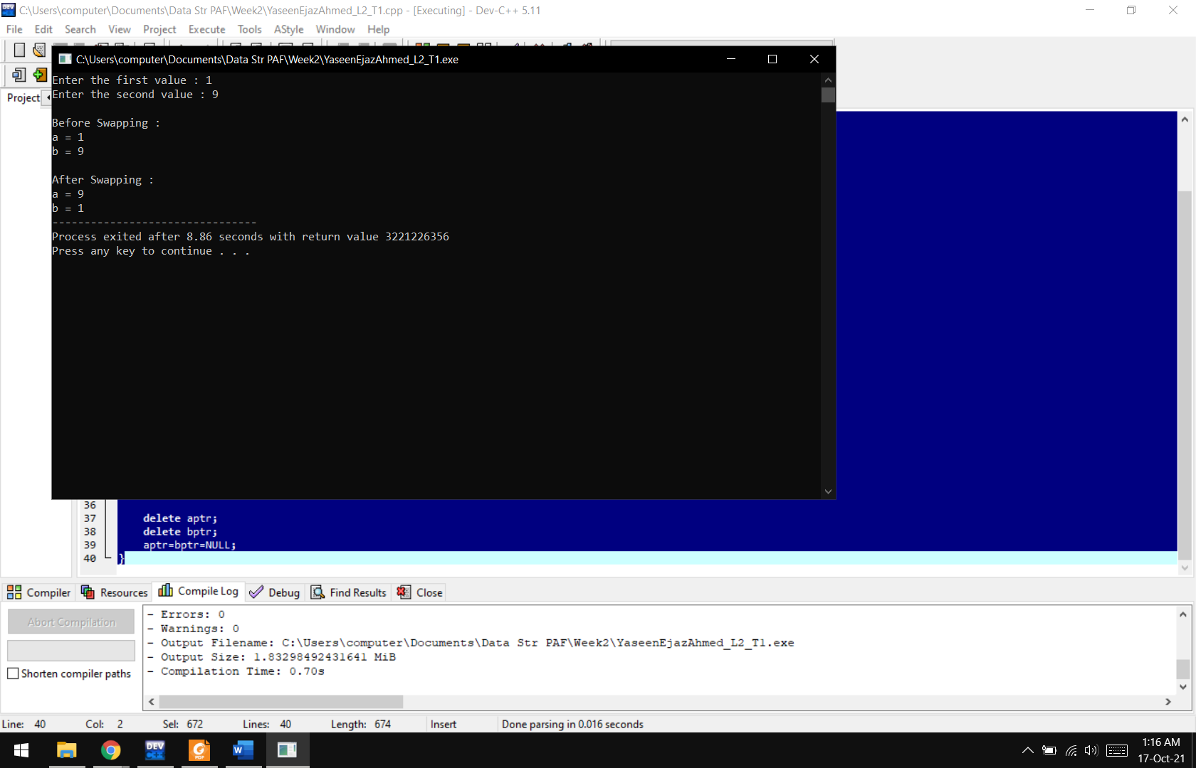

**Lab Task 02:** Write a program to convert Fahrenheit temperature to Celsius degrees by passing pointers as arguments to the function. The formula for the conversion is:

c = ( f-32) *5 .0/9.0.

**Code:**

#include <iostream>

using namespace std;

**float ConvertToCelsius(float *fp)**

{

float c;

float *cp=&c;

c = (5.0/9.0) * (*fp-32);

return *cp;

}

**int main()**

{

float f;

cout<<"Enter the temperature in Farenheit : ";

cin>>f;

float *fp=&f;

cout<<"\nThe temperature in Celsius is "<<ConvertToCelsius(fp)<<"C";

delete fp;

fp=NULL;

}

**Output:**

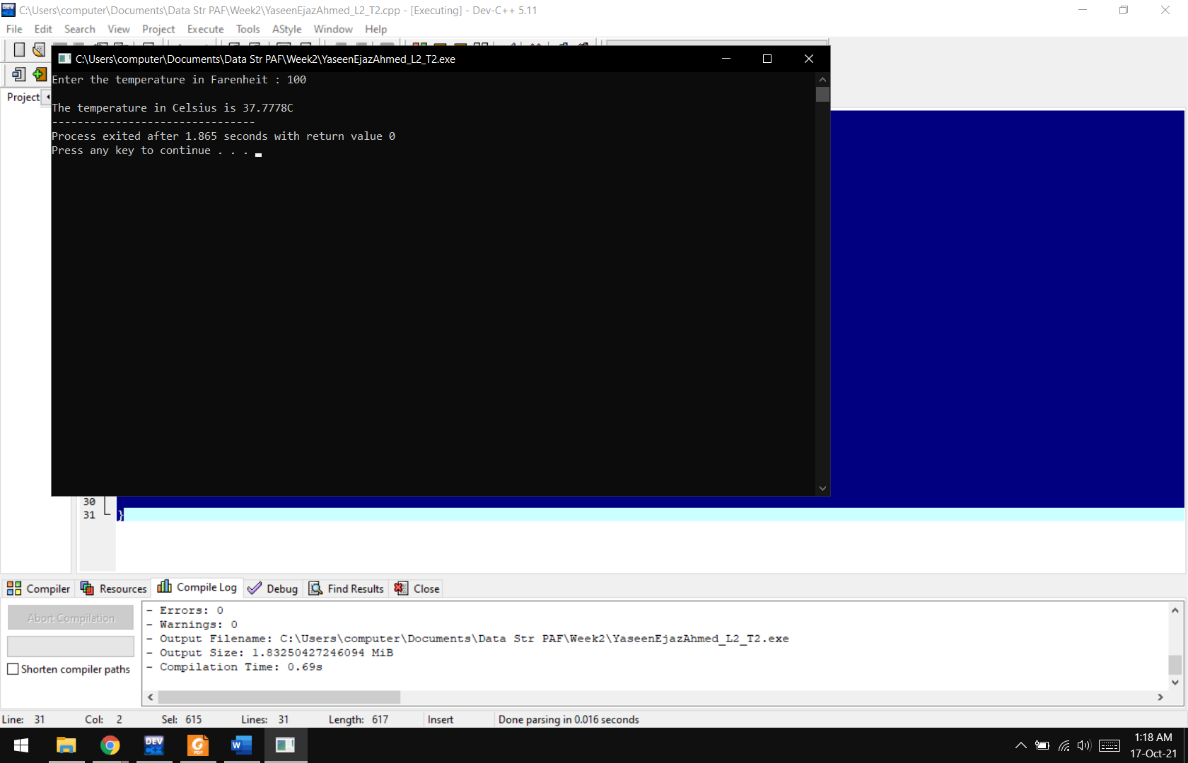

**Lab Task 03:** Create a structure(student) is which should contain name, roll and marks as its data member. Then, create a structure variable(s). Then take data (name, roll and marks) from user and store it in data members of structure variables. Display the data Entered by the user.

**Code:**

#include <iostream>

using namespace std;

**struct student**

{

string Name;

string RollNo;

float Marks;

};

**int main()**

{

student S;

cout<<"Enter Student Information\nName : ";

cin>>S.Name;

cout<<"Roll Number : ";

cin>>S.RollNo;

cout<<"Marks : ";

cin>>S.Marks;

cout<<"\n\nName :"<<S.Name<<"\nRoll Number : "<<S.RollNo<<"\nMarks : "<<S.Marks;

}

**Output:**

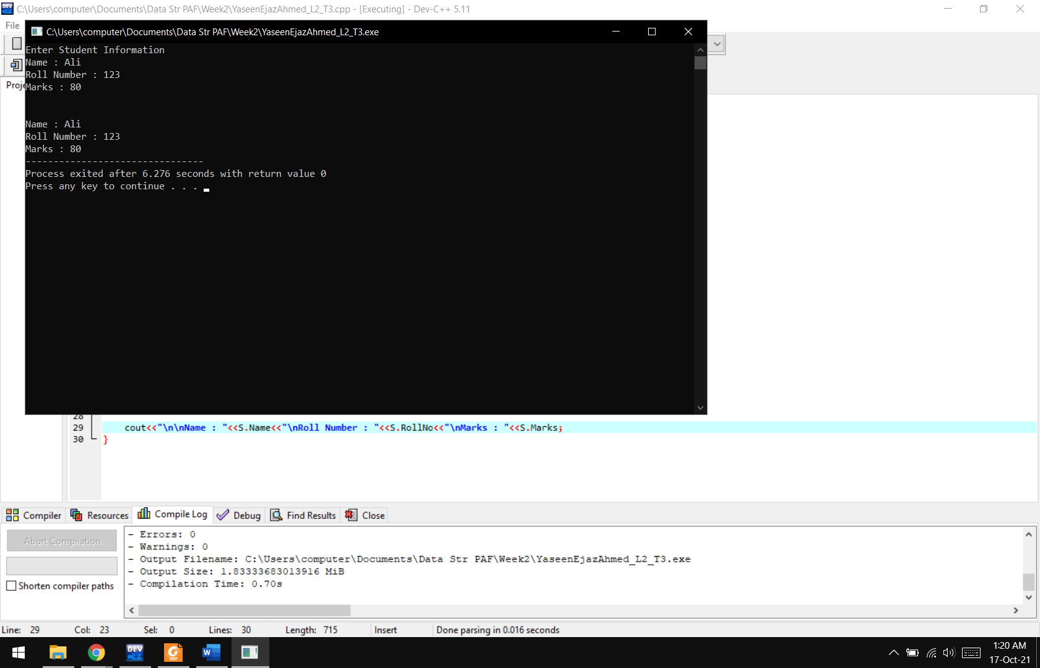

**Lab Task 04:** Declare a structure to represent a complex number (a number having a real part and imaginary part). Write C++ functions to add, subtract, multiply and divide two complex numbers. (Comment each line with information about it)

**Code:**

#include <iostream>

using namespace std;

**struct complex**

{

double real1;

double img1;

double real2;

double img2;

}c;

**void Add()**

{

cout<<"\n\nAddition : ";

if(c.img1+c.img2>=0)

cout<<c.real1+c.real2<<"+"<<c.img1+c.img2<<"i";

else

cout<<c.real1+c.real2<<c.img1+c.img2<<"i";

}

**void Sub()**

{

cout<<"\n\nSubtraction : ";

if(c.img1+c.img2>=0)

cout<<c.real1-c.real2<<c.img1-c.img2<<"i";

else

cout<<c.real1-c.real2<<"+"<<c.img1-c.img2<<"i";

}

**void Mul()**

{

cout<<"\n\nMultiplication : ";

cout<<c.real1*c.real2<<" + ("<<c.real1*c.img2<<"i) + ("<<c.img1*c.real2<<"i) + ("<<c.img1*c.img2<<"i^2)\n";

cout<<c.real1*c.real2<<" + ("<<(c.real1*c.img2)+ (c.img1*c.real2)<<"i) + ("<<c.img1*c.img2<<"i^2)";

}

**void Div()**

{

cout<<"\n\nDivision : ";

cout<<c.real1<<"+("<<c.img1<<"i) / "<<c.real2<<"+("<<c.img2<<"i)";

}

**int main()**

{

cout<<"First Equation :\nEnter Real Part : ";

cin>>c.real1;

cout<<"Enter Imaginary Part : ";

cin>>c.img1;

cout<<"\nSecond Equation :\nEnter Real Part : ";

cin>>c.real2;

cout<<"Enter Imaginary Part : ";

cin>>c.img2;

cout<<"\nFirst Equation : ";

if(c.img1>=0)

cout<<c.real1<<"+"<<c.img1<<"i";

else

cout<<c.real1<<c.img1<<"i";

cout<<"\nSecond Equation : ";

if(c.img2>=0)

cout<<c.real2<<"+"<<c.img2<<"i";

else

cout<<c.real2<<c.img2<<"i";

Add();

Sub();

Mul();

Div();

}

**Output:**

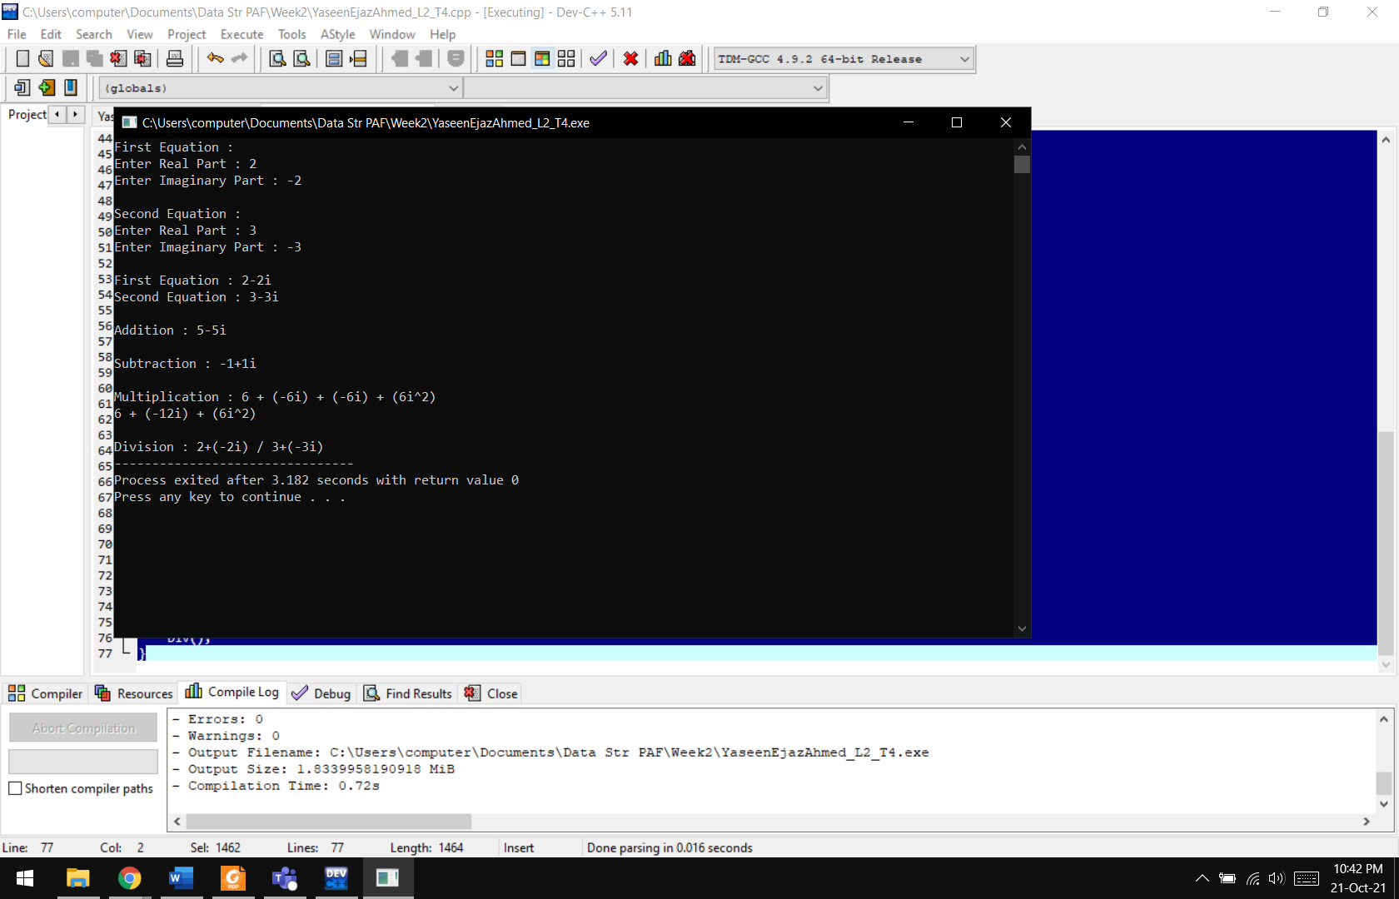

**Lab Task 05:** Construct a structure to compute time difference of two time periods. The time periods should be entered by the user. (Comment each line with information about it)   
Hint* use functions and pointers to struct the structure.

**Code:**

#include <iostream>

using namespace std;

**struct Time**

{

int SHour;

int FHour;

int SMin;

int FMin;

};

**int main()**

{

Time t;

int hour, minute;

cout<<"Starting Time\n\n";

do

{

cout<<"Enter the Hour : ";

cin>>t.SHour;

}

while(t.SHour<0 || t.SHour > 23);

do

{

cout<<"Enter the Minutes : ";

cin>>t.SMin;

}

while(t.SMin<0 || t.SMin > 59);

cout<<"\nEnding Time\n\n";

do

{

cout<<"Enter the Hour : ";

cin>>t.FHour;

}

while(t.FHour<0 || t.FHour > 23);

do

{

cout<<"Enter the Minutes : ";

cin>>t.FMin;

}

while(t.FMin<0 || t.FMin > 59);

minute = t.FMin - t.SMin;

hour = t.FHour - t.SHour;

if(minute<0)

{

minute = minute + 60;

hour--;

}

if(hour<0)

{

hour = hour + 24;

}

cout<<"\nTime Difference : \n"<<hour<<" : "<<minute;

}

**Output:**

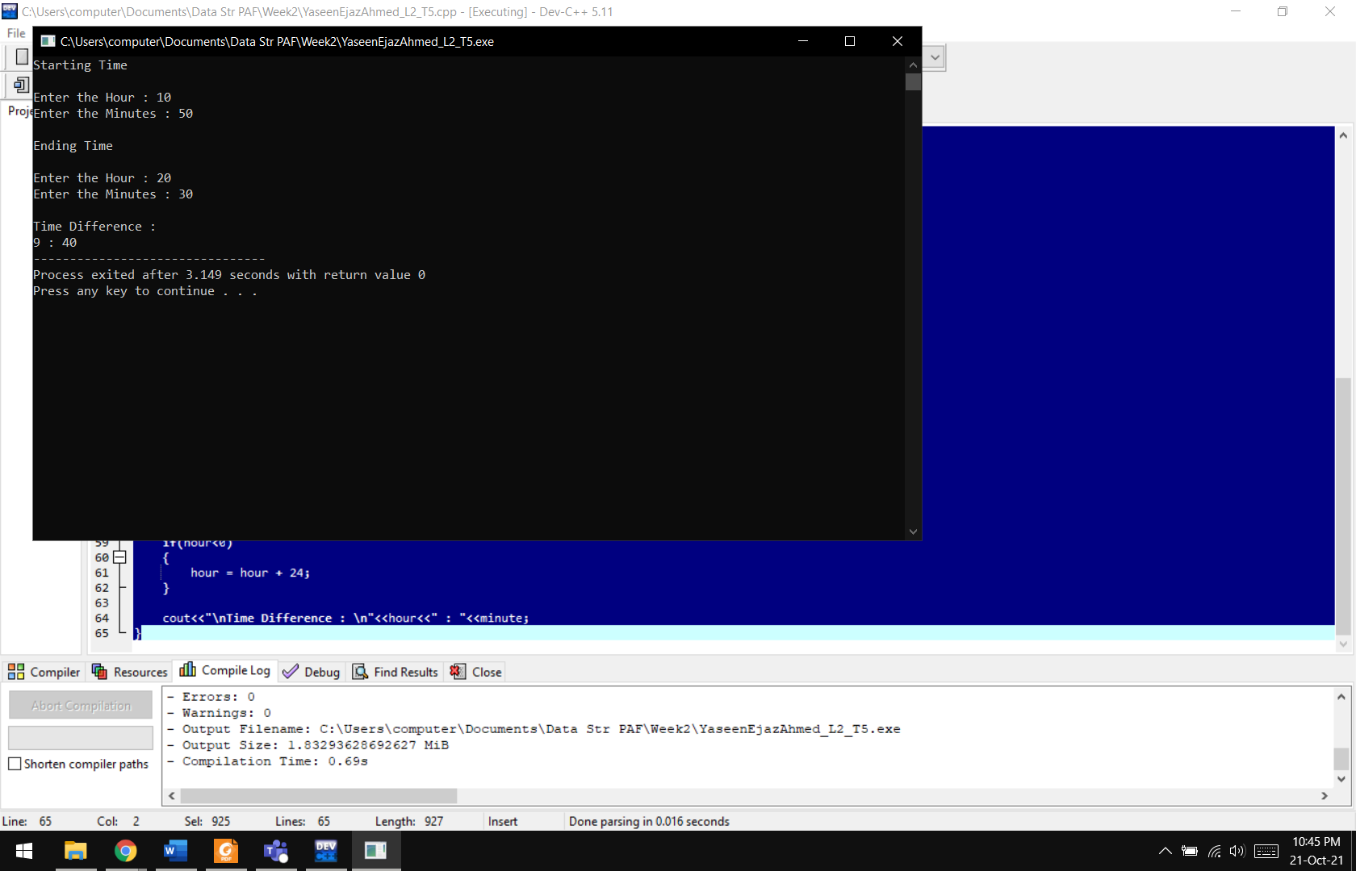

**Results & Observations:**

In this lab, we have learnt the basics of structures and pointers. We can use structures for holding many types of data with a single handle and we can also use reusability of code in these cases.