**Department of IT and Computer Science**

**Pak-Austria Fachhochschule: Institute of Applied Sciences and Technology, Haripur, Pakistan**

**COMP-201L Data Structures and Algorithms Lab**

**Lab Report 05**

**Class: Computer Science**

**Name: Yaseen Ejaz Ahmed**

**Registration No.: B20F0283CS014**

**Semester: Third**

**Submission Date:**

**Submitted to: Engr. Rafi Ullah**

**__________________**

**Instructor Signature**

**Lab No. 5**

**Sorting Algorithms: Quick, Merge & insertions Sort**

**Objectives:**

To understand & implement the working of sorting algorithms using arrays in C++

**Tools/Software Required:**

C++ Compiler

**Introduction:**

**SORTING:**It is often necessary to arrange the elements in an array in numerical order from highest to lowest values i.e.; from ascending to descending and vice versa. If an array contains string values or alphabetical order, then arrays need to be sorted. The process of sorting an array requires the exchanging of values. While this seems to be a simple process, a computer must be careful that no values are lost during this exchange.

**Lab Tasks:**

**Lab Task 01:** Writing a function to sort array elements using insertion sort**.**

[1,8,4,6,0,3,5,2,7,9]

**Code:**

#include <iostream>

using namespace std;

**InsertionSort(int a[],int n)**

{

int key;

int i,j;

for(i=1;i<n;i++)

{

key =a[i];

j=i-1;

while(j>=0 && a[j]>key)

{

a[j+1] = a[j];

j--;

}

a[j+1]=key;

}

cout<<"\n\nSorted Array :\n";

for(int i=0;i<n;i++)

{

cout<<a[i]<<"\t";

}

}

**int main()**

{

int n=10;

int a[n]={1,8,4,6,0,3,5,2,7,9};

cout<<"Original Array :\n";

for(int i=0;i<n;i++)

{

cout<<a[i]<<"\t";

}

InsertionSort(a,n);

}

**Output:**

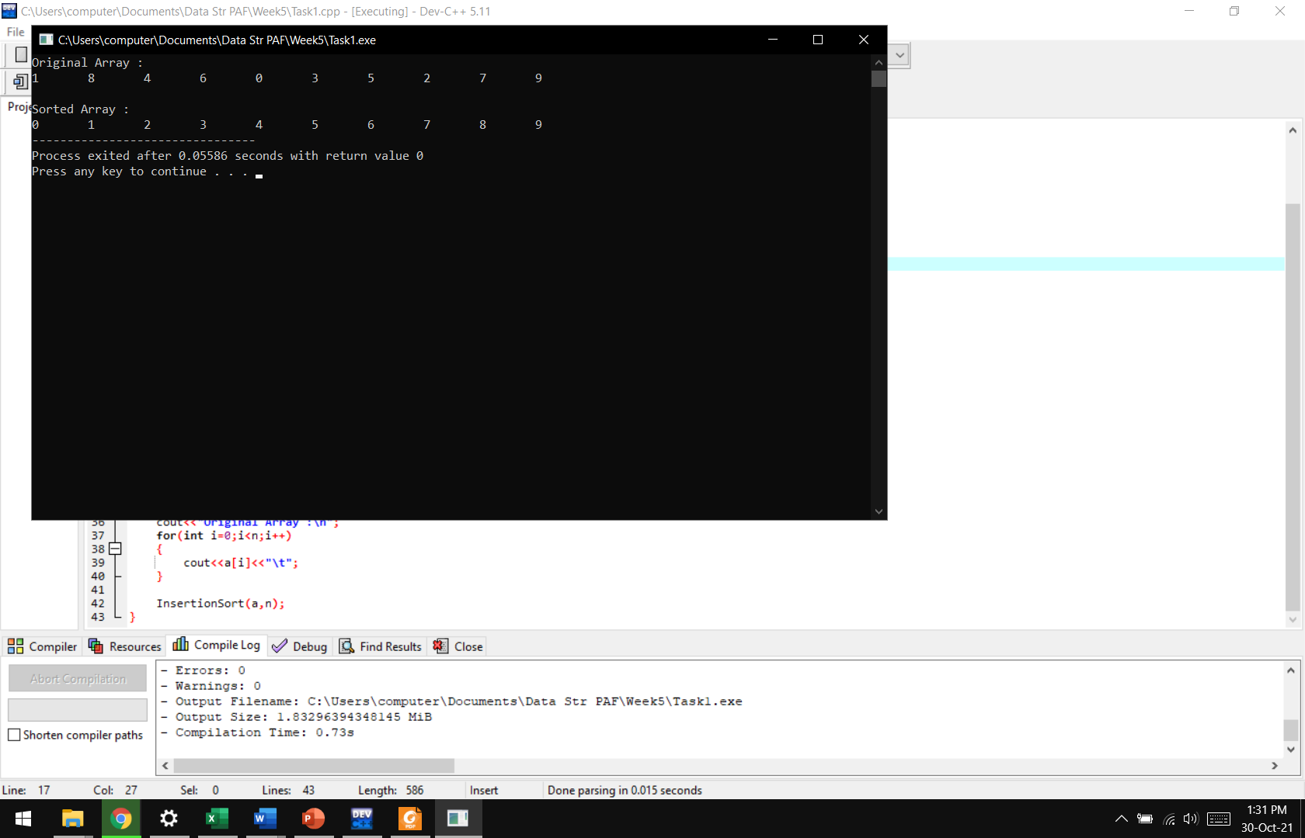

**Lab Task 02:** Write a code to sort the following arrays using Quick sort method.

[10, 34, 45, 33, 23, 47, 31, 23, 45, 69, 2, 56,7,67, 88, 42]

**Code:**

#include <iostream> //yaseen ejaz ahmed B20F0283CS014

using namespace std;

**void swapping(int* a,int* b)**

{

int temp=*a;

*a=*b;

*b=temp;

}

**int partition(int a[],int l,int h)**

{

int pivot = a[h]; // pivot

int i=(l-1);

for (int j=l; j<=h-1;j++)

{

if (a[j]<pivot)

{

i++;

swapping(&a[i],&a[j]);

}

}

swapping(&a[i+1],&a[h]);

return (i+1);

}

**void quickSort(int a[],int low,int high)**

{

if (low<high)

{

int pi=partition(a,low,high);

quickSort(a,low,pi-1);

quickSort(a,pi+1,high);

}

}

**void Show(int a[],int size)**

{

int i;

for (i=0;i<size;i++)

cout<<a[i]<<"\t";

}

**int main()**

{

int a[] = {10, 34, 45, 33, 23, 47, 31, 23, 45, 69, 2, 56,7,67, 88, 42};

int size = sizeof(a)/sizeof(a[0]);

cout << "\nThe array is\n";

Show(a,size);

quickSort(a,0,size-1);

cout<<"\n\nSorted array:\n";

Show(a,size);

}

**Output:**

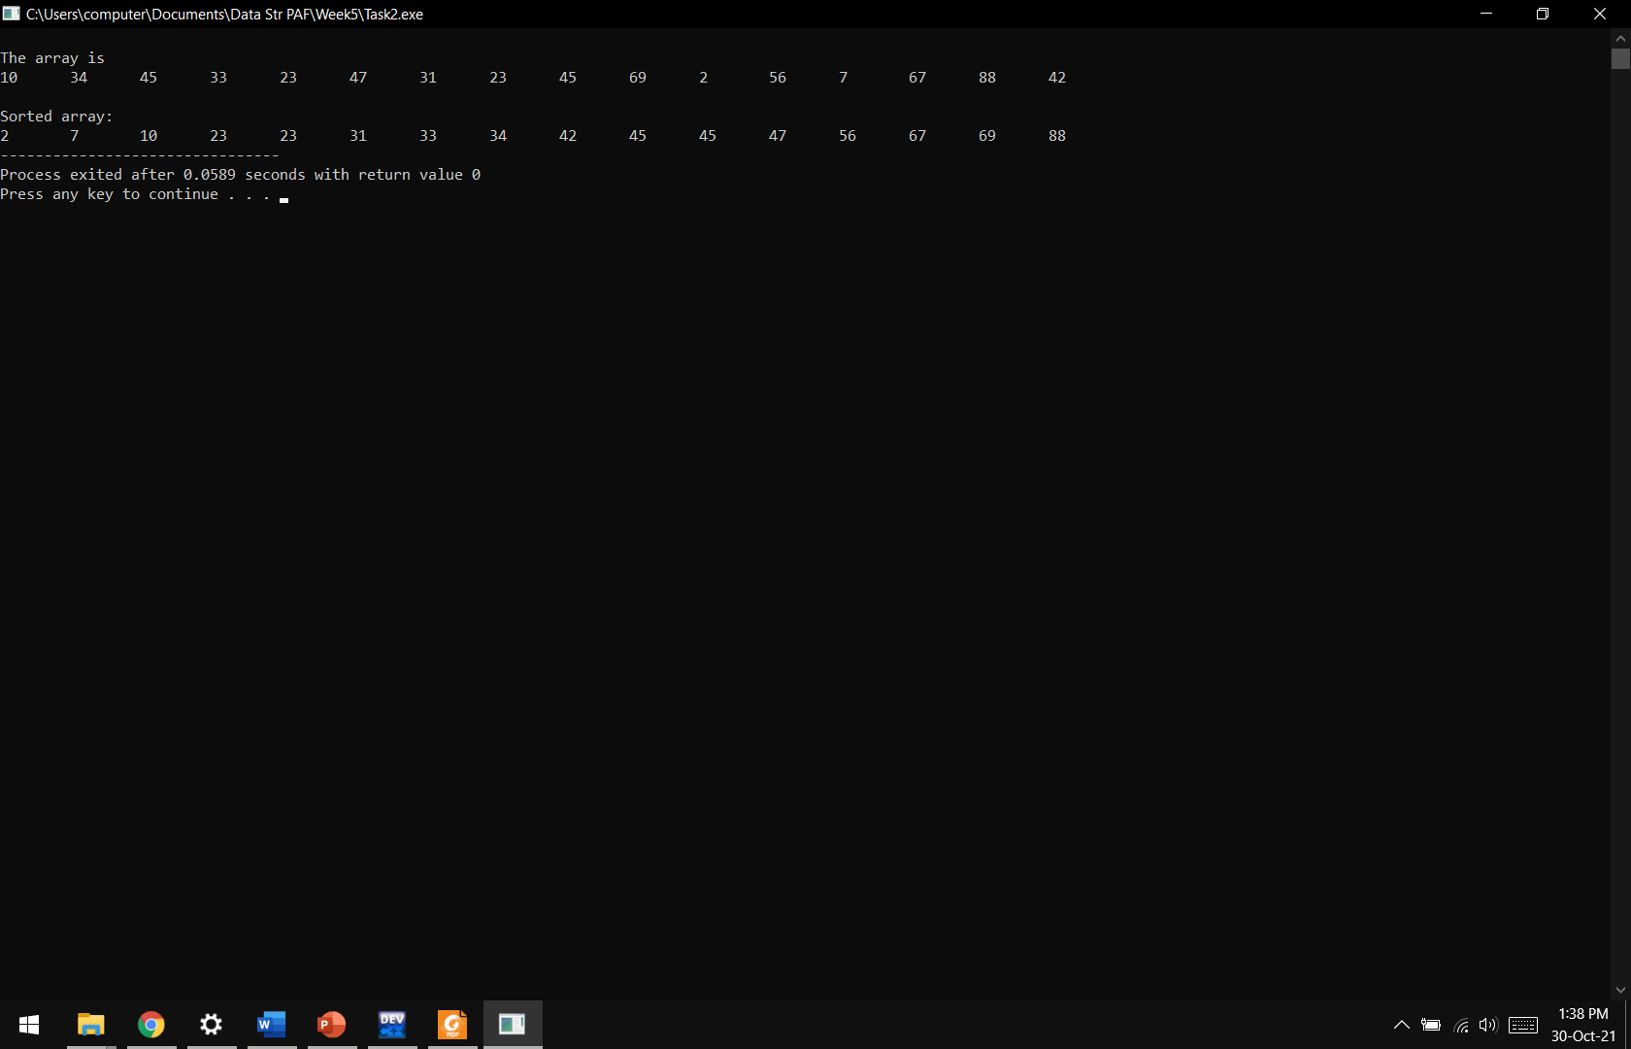

**Lab Task 03:** Write a code to sort the following arrays using Merge sort method**.**

[10, 34, 33, 22, 77, 98, 2, 56, 7, 55, 56, 67, 88, 42]

**Code:**

#include <iostream>

using namespace std;

**void Merge(int array[],int const left,int const mid,int const right)**

{

int const subArrayOne=mid -left+1;

int const subArrayTwo=right-mid;

int *leftArray = new int[subArrayOne];

int *rightArray = new int[subArrayTwo];

for (int i=0; i<subArrayOne;i++)

leftArray[i]=array[left+i];

for (int j=0; j<subArrayTwo;j++)

rightArray[j]=array[mid+1+j];

int indexOfSubArrayOne=0;

int indexOfSubArrayTwo=0;

int indexOfMergedArray=left;

while (indexOfSubArrayOne<subArrayOne && indexOfSubArrayTwo<subArrayTwo) {

if (leftArray[indexOfSubArrayOne]<=rightArray[indexOfSubArrayTwo]) {

array[indexOfMergedArray]=leftArray[indexOfSubArrayOne];

indexOfSubArrayOne++;

}

else {

array[indexOfMergedArray]=rightArray[indexOfSubArrayTwo];

indexOfSubArrayTwo++;

}

indexOfMergedArray++;

}

while (indexOfSubArrayOne < subArrayOne) {

array[indexOfMergedArray]=leftArray[indexOfSubArrayOne];

indexOfSubArrayOne++;

indexOfMergedArray++;

}

while (indexOfSubArrayTwo < subArrayTwo) {

array[indexOfMergedArray]=rightArray[indexOfSubArrayTwo];

indexOfSubArrayTwo++;

indexOfMergedArray++;

}

}

**void Merge(int array[],int const begin,int const end)**

{

if (begin>=end)

return;

int mid=begin+(end-begin)/2;

Merge(array,begin,mid);

Merge(array,mid+1,end);

Merge(array,begin,mid,end);

}

**void Show(int a[],int size)**

{

for (int i=0; i<size;i++)

cout<<a[i]<<"\t";

}

**int main()**

{

int a[]={10, 34, 33, 22, 77, 98, 2, 56, 7, 55, 56, 67, 88, 42};

int size = sizeof(a)/sizeof(a[0]);

cout << "\nThe array is\n";

Show(a,size);

Merge(a,0,size-1);

cout << "\n\nSorted array is \n";

Show(a, size);

}

**Output:**

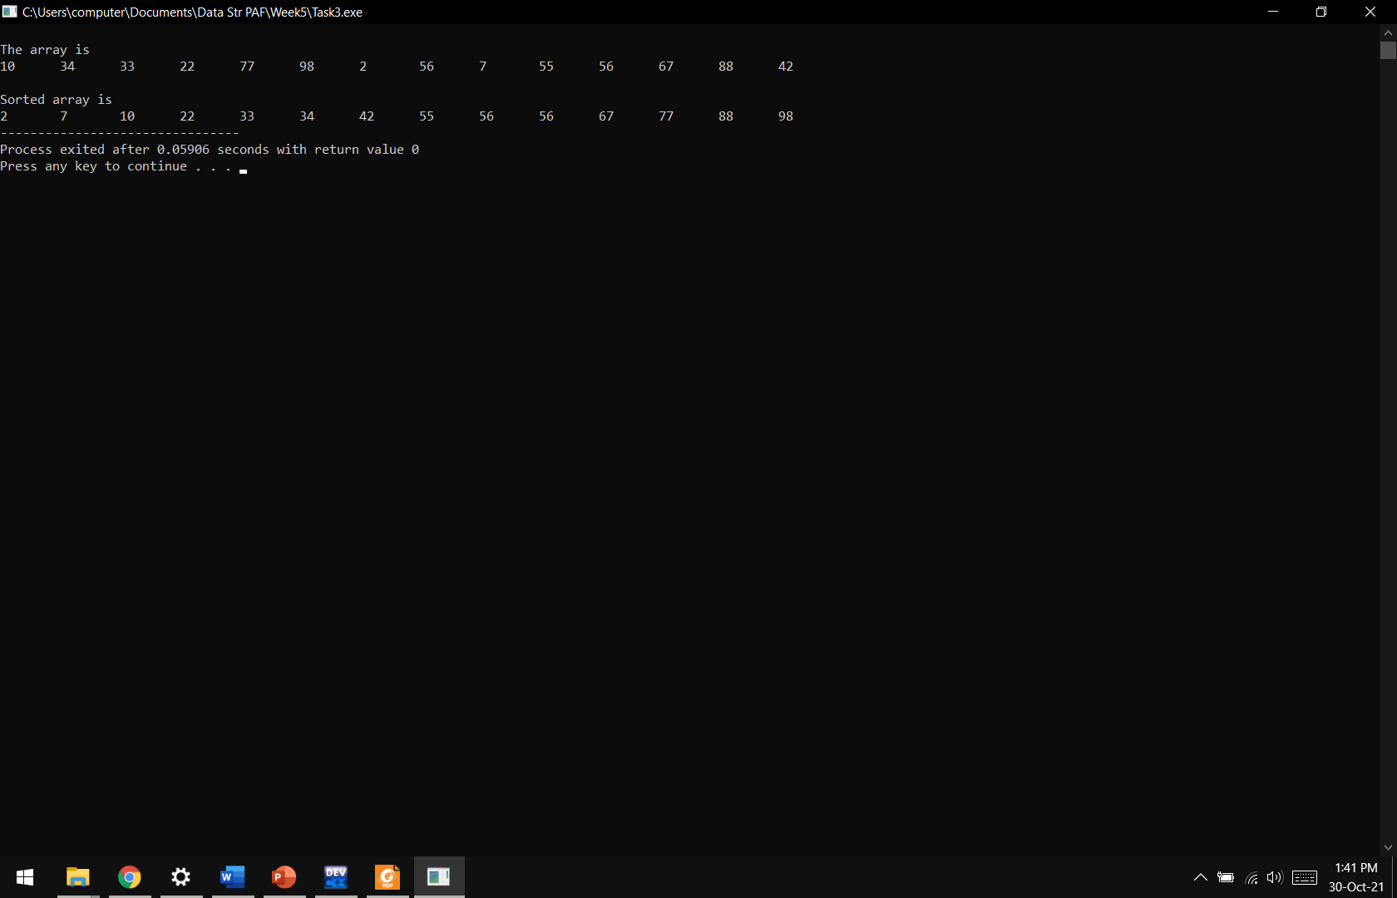

**Lab Task 04:** Write a code to sort the following arrays using Insertion sort method**.**

[12, 31, 41, 37, 49, 45, 69, 2, 56,76,67, 98, 52]

**Code:**

#include <iostream>

using namespace std;

**void InsertionSort(int a[],int n)**

{

int key;

int i,j;

for(i=1;i<n;i++)

{

key =a[i];

j=i-1;

while(j>=0 && a[j]>key)

{

a[j+1] = a[j];

j--;

}

a[j+1]=key;

}

cout<<"\n\nSorted Array :\n";

for(int i=0;i<n;i++)

{

cout<<a[i]<<"\t";

}

}

**int main()**

{

int n=13;

int a[n]={12, 31, 41, 37, 49, 45, 69, 2, 56,76,67, 98, 52};

cout<<"Original Array :\n";

for(int i=0;i<n;i++)

{

cout<<a[i]<<"\t";

}

InsertionSort(a,n);

}

**Output:**

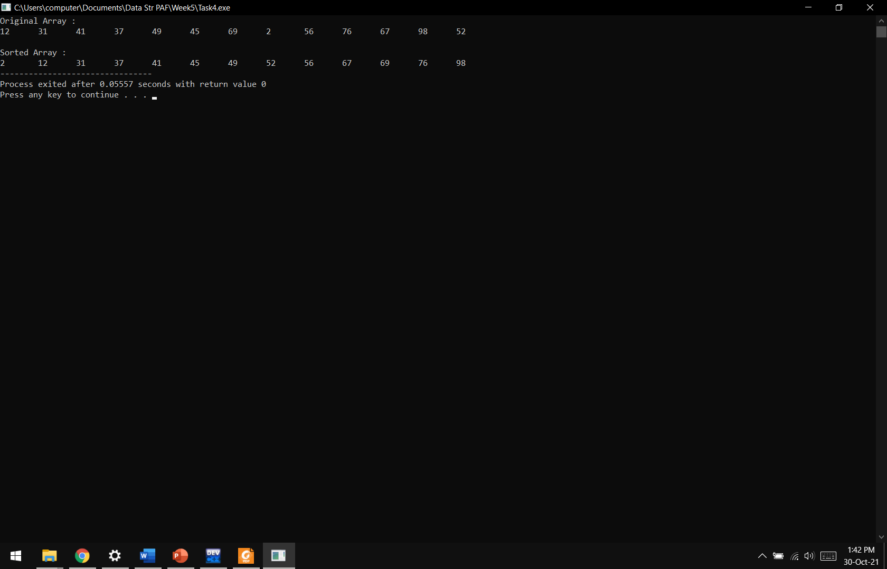

**Results & Observations:**

In this lab we have learnt about different sorting algorithms. We can use different types of these sorting algorithms for different data. Some types of sorting may be better than others depending on the data and time complexity.