Tamper-Evident Logging System

Nowadays technology is pacing at an extremely fast rate. Every day new solutions , apps, programs, systems, workflows, and technology are made.
In this chaos of tech, there are security measures which we also need to implement so that threat actors don’t cause unnecessary damage. We need to make sure that the CIA triad( Confidentiality, integrity, availability) is implemented and non-repudiation is maintained.
To achieve this, we use logs
Logs are basically the timestamp, or we can say the written proof of a person doing a thing or a work which we cant deny later.
Let’s take an example:
When we are in school or college our teachers take our attendance either in a notebook or in the school/college portal proving that we were present in the lecture on that date/ day. This is what logs and logging systems are.
The attendance is our logs and the school portal where the attendance is stored and managed is called logging system.
In digital world we need loggings system because internet is a dangerous place if not used ethically.
Threat actors can break systems and if there are no logging system then they can easily tamper with the systems and never get caught because there will be no proof of incident ever occurring.

Logging system logs each and everything, if you even add a full stop that is also logged.
Logs are a big concern and very important in the tech world. If there is no security or safety measures build in to the logging system that can be catastrophic.
Lets understand this with an example:
Lets say I work in a company and there is a threat actor inside our organization or just a normal threat actor.
Now they might have a grudge against me and they want to frame me for something wrong and unethical conduct.
If they somehow get access to the logging system and there is no security measure in the logging system.
They tamper with the logs that belong to me and frame me for leaking sensitive information of the company. Since there is no security measure in the logging system everyone will believe that I did it as the tampered logs prove that accusation.
To solve this problem we use a Tamper-Evident Logging system which creates a cryptographic chain between the logs using SHA-256 Hashing algorithm. This system is build in Python using libraries hashlib for SHA-256 hashing and SQLite for storing data in databases. This system provides integrity to logging system, so if anyone tampers with the logs an alert will be generated.

System Design

The core logic that this system uses is that I visualize each log as a node which has attributes like event_type, description, timestamp, prev_hash and event_hash.
These nodes are then connected to each other in form of a chain. The next node’s (log’s) event_hash value will be calculated using attributes event_type, description, timestamp and prev_hash.

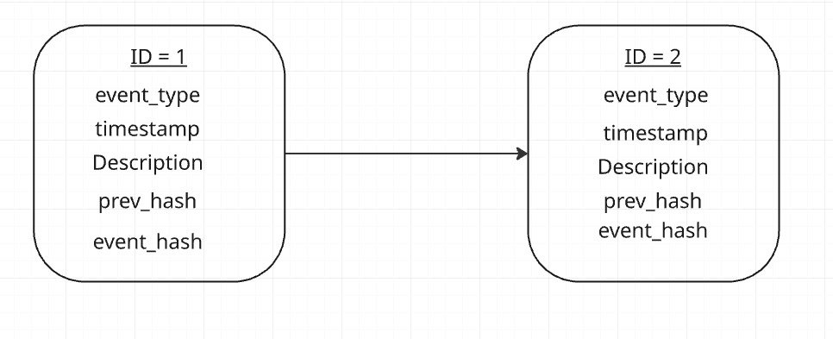
We use prev_hash because since the next nodes hash value is dependent on the previous node and next node also stores the hash of prev node, and if someone alters a particular node’s(logs’s) data, that nodes hash value will be different than the hash in the next node in the chain. This difference in hashes generates a alert and proves that the logs have been tampered with.
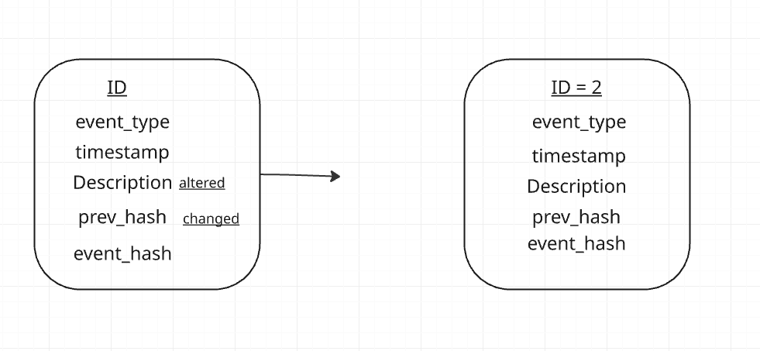

At the beginning of the system when there is only one node or log we store “0” * 64 in the prev_hash (this is also known as genesis block) because there is no prev hash value.
The logs which are entered are stored in the database what has the following attributes:
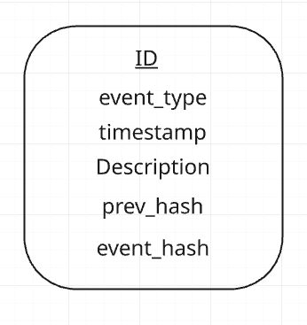

- ID : It is the row identifier. It auto increments as we add entries to the database. It also act as a primary key in database.
- Event Type: it shows what type of event took place eg. LOGIN, EDIT, LOGOUT etc.
- Timestamp: The time and date when the event took place.
- Description: It shows a human readable short summary of what the event actually is.
- Prev_hash: it stores the hash of previous log. It is used to generate the hash of current log.
- Event_hash: it stores the current logs hash.

3. Implementation Details

3.1 connect_db()
This function creates the connection to the SQLite database. If the database file logs.db does not exist at the time of running the program, SQLite automatically creates it. The function also creates the logs table with all six required columns if it does not already exist. This ensures the system is ready to accept log entries immediately on startup. SQLite was chosen over a JSON file because it is more scalable, handles large numbers of entries efficiently, and is harder to casually edit by hand compared to a plain text JSON file.

3.2 hash_function()
This function takes four inputs — timestamp, event_type, description, and prev_hash and generates a 64-character hexadecimal hash string using the SHA-256 algorithm. Inside the function, all four fields are concatenated into a single string. That string is then encoded into bytes and passed into hashlib.sha256(). The hexdigest() method is called to produce the final hexadecimal representation of the hash.
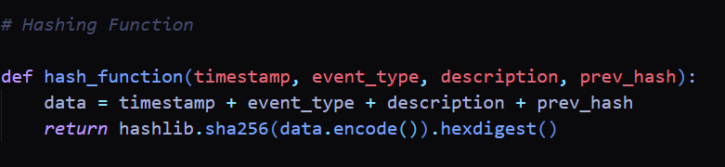
SHA-256 was chosen because it is a one-way cryptographic function — you cannot reverse a hash back to the original data. Even a single character change in the input produces a completely different hash output. This property is what makes the tamper detection reliable.

3.3 get_last_hash()
This function retrieves the hash value of the most recently added log entry from the database. It runs the SQL query SELECT entry_hash FROM logs ORDER BY id DESC LIMIT 1 to fetch only the last row. This hash is then passed as the prev_hash into the next log entry that is being added, forming the chain link between the two nodes.
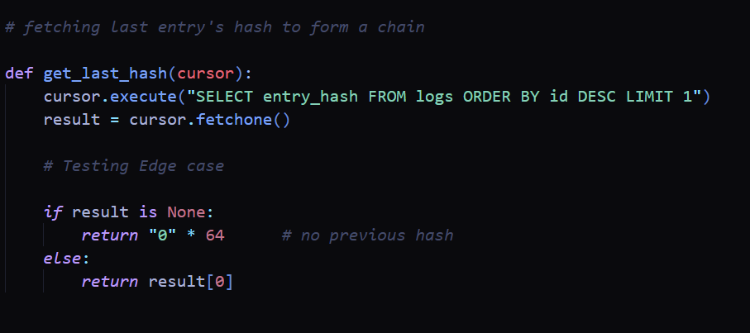
An important edge case is handled here when the table is completely empty and there are no previous entries, fetchone() returns None. In this case the function returns a string of 64 zeros, which becomes the genesis block prev_hash for the very first entry in the system.

3.4 event_add()
This function handles the complete process of adding a new log entry. The steps are as follows:
- The current timestamp is captured using datetime.now().isoformat()
- The user is prompted to input the event type and a description of the event
- get_last_hash() is called to retrieve the previous entry's hash
- hash_function() is called with all four values to generate the current entry's hash
- A parameterized SQL INSERT query is executed to store all six values into the database
- conn.commit() saves the transaction
Parameterized queries are used intentionally to prevent SQL injection attacks, which is especially important in a security-focused system.

3.5 chain_verification()
This is the most important function in the system. It retrieves all log entries ordered by ID and performs two independent checks on each entry:
Check 1: Hash Mismatch Detection (Modification):
For each entry, the hash is recomputed from scratch using the stored timestamp, event_type, description, and prev_hash values. This recomputed hash is then compared against the stored entry_hash. If they do not match, it means the content of that entry was modified after it was written. The system immediately flags this as a HASH MISMATCH and marks the log as tampered.
Check 2: Chain Linkage Detection (Deletion and Reordering):
For each entry, the stored prev_hash is compared against the entry_hash of the previous row in the database. For the first entry, the expected prev_hash is always 64 zeros (genesis block). If the stored prev_hash does not match the expected value, it means an entry was either deleted or reordered. The system flags this as CHAIN BROKEN.
After checking all entries, a final verdict is printed. If any entry failed either check, the system reports INTEGRITY CHECK FAILED. If all entries passed, it reports INTEGRITY CHECK PASSED LOG IS CLEAN.

3.6 simulate_tamper()
This function is included for demonstration purposes. It takes an entry ID as input from the user and directly overwrites that entry's description with the string 'Modified data. Threat actor modified this log' using an SQL UPDATE query. Critically, the entry_hash is NOT updated after this change. This simulates exactly what an attacker would do change the data but leave the hash intact. When chain_verification() is run afterwards, the hash mismatch is immediately detected.
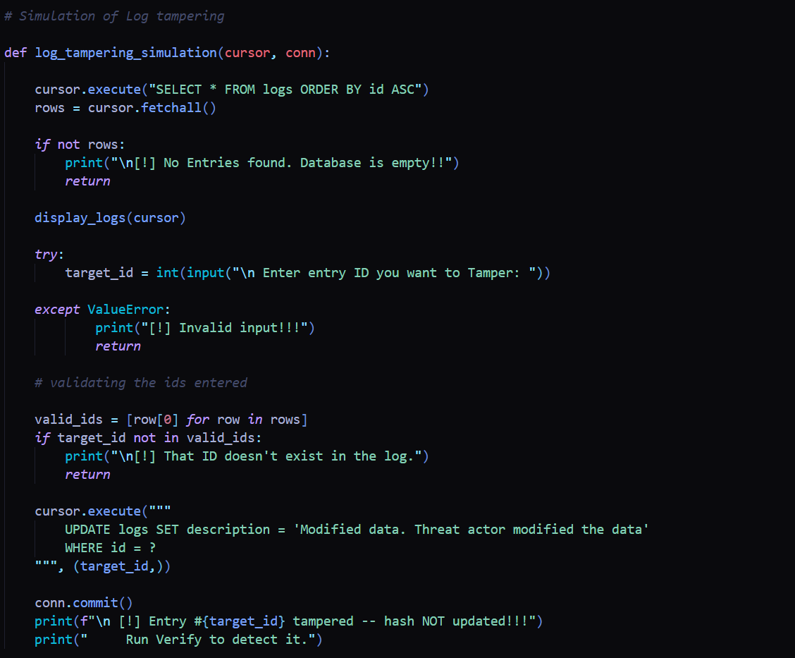

3.7 simulate_deletion()
This function deletes the second entry from the database to simulate a deletion attack. It specifically targets the second row (OFFSET 1) so that the chain break occurs in the middle of the log, which is the most realistic attack scenario. After deletion, running chain_verification() will detect the CHAIN BROKEN error at the entry that previously followed the deleted one, because its prev_hash now points to a hash that no longer exists in sequence.
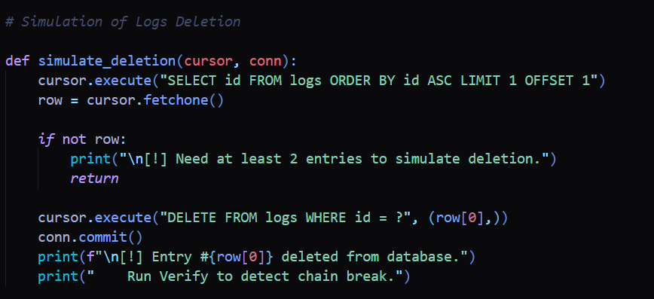

3.8 simulate_reorder()
This function allows the user to select two entry IDs and swaps their description fields. It simulates a scenario where an attacker tries to rearrange events to change the story of what happened. After the swap, the stored entry_hash values no longer match the recomputed hashes because the description content has changed. chain_verification() detects this as a HASH MISMATCH on both affected entries.
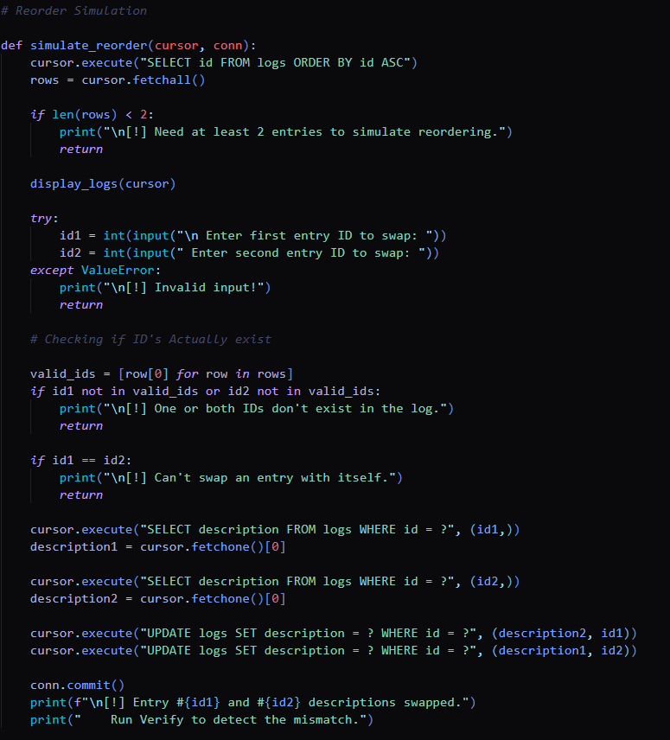

4. Results and Analysis
The system was tested against all three attack scenarios. In each case the system correctly identified the tampering and generated the appropriate alert.

4.1 Clean Chain Verification
After adding several log entries covering events such as LOGIN, FILE_ACCESS, TRANSACTION, and LOGOUT, the chain_verification() function was run. Every entry passed both checks and the system reported INTEGRITY CHECK PASSED LOG IS CLEAN. This confirms that the chaining and hashing logic works correctly under normal conditions.

4.2 Modification Detection
The simulate_tamper() function was used to overwrite the description of entry number 2 without updating its hash. When chain_verification() was run again, it immediately identified entry 2 with a HASH MISMATCH error, correctly pinpointing the exact entry that was modified and reporting INTEGRITY CHECK FAILED.

4.3 Deletion Detection
The simulate_deletion() function removed the second entry from the database. When chain_verification() was run, it detected a CHAIN BROKEN error at the entry that followed the deleted one. The system correctly identified that the prev_hash of that entry did not match the entry_hash of its new predecessor, proving that an entry had been removed from the chain.

4.4 Reorder Detection
The simulate_reorder() function swapped the descriptions of two entries. When chain_verification() was run, both affected entries were flagged with HASH MISMATCH errors. The system correctly identified that the content of those entries had been changed, even though their position in the database remained the same.
In all three scenarios the system performed exactly as designed. Every type of tampering was detected and the exact entry or entries involved were identified.

5. Limitations and Future Improvements
While the system successfully fulfills all the requirements of this task, there are some limitations that are important to acknowledge:
Manual Log Entry:
Currently all log entries must be entered manually by the user. There is no automated integration with actual system events such as file system changes, login events, or network activity. In a real production environment, the logging system would be connected directly to the operating system or application to capture events automatically.
No Log Normalization:
Different operating systems and applications produce logs in different formats. Windows Event Logs, Linux syslog, and application-level logs all have different structures. This system does not perform log normalization all entries follow a fixed format defined by the system itself. A future improvement would include a normalization layer that converts logs from different sources into a standard structure before chaining them, making the system compatible with enterprise SIEM pipelines.
Vulnerability to Full Database Access:
An attacker who has complete access to the database file could theoretically recompute all hashes from scratch after tampering. A production-grade solution would use HMAC (Hash-based Message Authentication Code) with a secret key stored in a separate secure location. This would make it impossible to recompute valid hashes without access to that key.
Plaintext Log Storage:
Log contents are stored as plaintext in the database. A more secure implementation would encrypt the log contents using AES-256 encryption to protect sensitive event data from unauthorized reading.
Local Storage Only:
The database is stored on the local machine. In a real system, logs should be forwarded to a remote append-only storage server as soon as they are created, so that even a compromised local machine cannot destroy the log history.

6. Conclusion
This project successfully implements a tamper-evident logging system that provides cryptographic integrity to a log chain. By using SHA-256 hashing to link each log entry to the previous one, the system can reliably detect three types of tampering modification of an existing entry, deletion of an entry, and reordering of entries. All three scenarios were tested and the system performed correctly in each case.
The core concept behind this system is the same principle used in blockchain technology a chain where each block is mathematically dependent on all the blocks before it. This makes silent tampering impossible. Any change to any part of the chain, no matter how small, is immediately visible during verification.
From a real-world perspective, this type of system is critical for maintaining accountability in organizations. It ensures non-repudiation once an event is logged and the chain is established, no one can deny that the event occurred or alter the record without detection.
Future improvements would include HMAC-based authentication to protect against full database access attacks, AES-256 encryption of log contents, log normalization to support multiple input sources, automated event capture from the operating system, and remote append-only storage for production deployments.

7. References
- Python Software Foundation. (2024). hashlib Secure hashes and message digests. https://docs.python.org/3/library/hashlib.html
- Python Software Foundation. (2024). sqlite3 DB-API 2.0 interface for SQLite databases. https://docs.python.org/3/library/sqlite3.html
- National Institute of Standards and Technology. (2015). FIPS PUB 180-4: Secure Hash Standard (SHS). https://csrc.nist.gov/publications/detail/fips/180/4/final
- World Bank ID4D. (2023). Tamper-proof logs. https://id4d.worldbank.org/guide/tamper-proof-logs
- Crosby, S.A., Wallach, D.S. (2009). Efficient Data Structures for Tamper-Evident Logging. USENIX Security Symposium.

