COMMUNITY SERVICE PROJECT
ON

PETALYTICS

BACHELOR OF TECHNOLOGY IN
COMPUTER SCIENCE AND ENGINEERING
BY

Roll No | Name
22BQ1A05K4 | SHAIK YASEEN
22BQ1A05K5 | SONTI KUSUMA
22BQ1A05K6 | SOUPATI NAVYA
22BQ1A05K7 | SOWMYA PANITHI
22BQ1A05K8 | SUNKARA HEMANTH



DEPARTMENT OF COMPUTER SCIENCE AND ENGINEERING
A.Y 2025-2026



DEPARTMENT OF COMPUTER SCIENCE AND ENGINEERING

CERTIFICATE
This is to certify that the CSP report entitled “PETALYTICS” is a Bonafide work carried out by the following IV-year student during the academic year 2025–2026, in partial fulfilment of the requirements for the award of the Bachelor of Technology degree.

Roll No | Name
22BQ1A05K4 | SHAIK YASEEN
22BQ1A05K5 | SONTI KUSUMA
22BQ1A05K6 | SOUPATI NAVYA
22BQ1A05K7 | SOWMYA PANITHI
22BQ1A05K8 | SUNKARA HEMANTH

SIGNATURE OF GUIDE HEAD OF THE DEPARTMENT

EXTERNAL EXAMINER

ACKNOWLEDGEMENT

We express our sincere thanks to the Chairman, Vasireddy Venkatadri Institute of Technology, Sri Vasireddy Vidya Sagar, for providing us with well-equipped infrastructure and a conducive environment for learning and innovation.
We thank Dr. Y. Mallikarjuna Reddy, Principal, Vasireddy Venkatadri Institute of Technology, Nambur, for providing us with the necessary resources and encouragement to carry out this project successfully.
Our sincere thanks to Dr. V. Rama Chandran, Head of the Department, Department of CSE, for his cooperation and continuous guidance, which helped us complete our project successfully in all aspects.
We are deeply grateful to our guide, Mr.Ch. Vijayananda Ratnam , Associate Professor, Department of CSE, for his valuable guidance, constant motivation, and insightful suggestions throughout the project. His mentorship has been instrumental in the successful completion of our work.
We also extend our gratitude to our college-level CSP Coordinator, Dr. Luke John Baktha Singh Immaraju, for his coordination, timely feedback, and continuous assistance at every stage of the project.
Finally, we would like to thank our Project Coordinators, Dr. D.Vamsi and Dr. G. Satya Narayana, Department of CSE, for their support, guidance, and valuable feedback throughout the duration of our work.

Table of Contents
Chapter no | Title | Page no
1 | Abstract | i
2 | Executive summary | ii-v
3 | Introduction | 1-4
4 | Community profile | 5-23
5 | Literature Review and Related Studies | 24-30
6 | Project Planning | 31-38
7 | Project Execution | 39-55
8 | Impact Assessment | 56-62
9 | Personal Reflection and Learning | 63-64
10 | Supporting Documents and Evidence | 65-69
11 | Challenges and Recommendations | 70-75
12 | Conclusion | 76-79
13 | Appendices | 80-86
14 | References | 87

ABSTRACT

Batch No: 46
Project Title: Petalytics

Problem Statement:
Accurate classification of data based on measurable features is a key challenge in machine learning. Flower species identification traditionally requires expert knowledge and manual observation, which can be time-consuming and error-prone. This project develops an automated system that predicts Iris flower species using machine learning based on numerical measurements.

Description:
Petalytics is a machine learning web application that classifies Iris flowers using four features: sepal length, sepal width, petal length, and petal width. The system predicts Iris-setosa, Iris- versicolor, or Iris-virginica using a Random Forest Classifier trained on the Iris dataset containing 150 labeled samples. The trained model is integrated into a Streamlit-based interface for real-time predictions.

Objectives:
- Develop a supervised ML model for Iris classification.
- Train and evaluate a Random Forest classifier,
- Create an interactive Streamlit interface.
- Achieve high prediction accuracy.
- Demonstrate practical ML implementation.

Team members:
22BQ1A05K4
22BQ1A05K5
22BQ1A05K6
22BQ1A05K7
22BQ1A05K8

Executive Summary

Project Background
Accurate classification of flower species is an important task in botanical studies and data analysis, but traditional identification methods depend on expert knowledge and manual observation of physical characteristics. These methods can be time-consuming, subjective, and sometimes inaccurate when species share similar visual features. The well-known Iris dataset, introduced by Ronald A. Fisher, provides a foundation for solving this problem through data-driven techniques. The dataset consists of 150 labeled samples categorized into three species—Iris-setosa, Iris- versicolor, and Iris-virginica— based on four measurable features: sepal length, sepal width, petal length, and petal width.
To address the limitations of manual classification, our team developed “Petalytics,” a machine learning-based web application that automates Iris flower species prediction. Using a Random Forest Classifier trained on the Iris dataset, the system accurately classifies f lowers based on numerical inputs provided by the user. The trained model is integrated into a Streamlit interface to enable real- time predictions, ensuring efficiency, accuracy, and ease of use. Through this project, we demonstrate the practical implementation of supervised machine learning in solving real-world classification problems in a smart and data-driven manner.

Objectives
The main goal of the Petalytics project is to develop an accurate and efficient machine learning system for automated Iris flower classification. The specific objectives are:
- Develop a Supervised Learning Model: Build a classification model using the Iris dataset to predict flower species based on measurable features.
- Implement Random Forest Algorithm: Train and evaluate a Random Forest Classifier to achieve high prediction accuracy and reliability.
- Ensure Accurate Feature-Based Prediction: Utilize sepal length, sepal width, petal length, and petal width as input parameters for precise classification.
- Create an Interactive Web Interface: Design and integrate the trained model into a Streamlit-based application for real-time user interaction.
- Evaluate Model Performance: Test the model using appropriate evaluation metrics to ensure efficiency and robustness.
- Demonstrate Practical ML Implementation: Showcase how machine learning can solve real-world classification problems through a user-friendly digital solution.

Project Activities:
The Petalytics project was executed in several key phases, following a structured and systematic machine learning development approach:

Problem Identification:
  - The team identified the challenge of accurately classifying Iris flower species using traditional manual observation methods. Manual identification requires expert knowledge, is time-consuming, and may lead to misclassification when species share similar physical characteristics. This highlighted the need for an automated, data-driven classification system.

Data Collection and Preparation:
  - The project utilized the well-known Iris dataset introduced by Ronald A. Fisher.
  - The dataset contains 150 labeled samples with four numerical features: sepal length, sepal width, petal length, and petal width.
  - Data preprocessing steps such as cleaning, splitting into training and testing sets, and feature selection were performed.

Model Design and Development:
  - A Random Forest Classifier was selected for its accuracy and robustness.
  - The model was trained using the training dataset and evaluated using test data.
  - Performance metrics such as accuracy score and confusion matrix were analyzed
to validate the model’s effectiveness.

Web Application Development:
  - A Streamlit-based web application was developed to provide an interactive interface.
  - Users can input flower measurements and instantly receive species predictions.
  - The trained model was integrated into the frontend to enable real-time classification.

Testing and Validation:
  - Multiple test inputs were used to verify prediction accuracy.
  - The system was tested for usability, reliability, and response time.
  - Final validation ensured consistent and accurate outputs.

Outcomes and Results
The implementation of Petalytics delivered significant results in terms of efficiency, participation, and satisfaction:
- 94% Prediction Accuracy Achieved: The Random Forest model accurately classified Iris species using four numerical features, ensuring reliable and consistent results.
- Instant Real-Time Predictions: Integration with the Streamlit interface enabled users to input flower measurements and receive predictions immediately without delay.
- Reduced Manual Identification Effort: The automated system eliminated the need for expert-based manual classification, saving time and minimizing human error.
- Improved Model Reliability: Using an ensemble learning technique (Random Forest) enhanced prediction stability and reduced overfitting compared to single decision tree models.
- Enhanced User Accessibility: The simple and interactive web interface made the system easy to use, even for individuals without technical or machine learning knowledge.
- Practical Implementation of Machine Learning Concepts: The project successfully demonstrated the real-world application of supervised learning, model training, evaluation, and deployment in a web environment.
The Petalytics project demonstrated the integration of machine learning with web applications for real- time predictions. It also enhanced understanding of data-driven decision making and supervised learning applications.

Community Impact:
The project strengthened understanding of machine learning concepts through real-time implementation.
- It improved technical skills in model development, data analysis, and web deployment.
- The system demonstrated how numerical data can be used to generate accurate and intelligent predictions.

Educational and Personal Impact:
- Enhanced Practical Learning Experience: The project helped in strengthening understanding of machine learning concepts through real-time implementation.
- Improved Technical Skills: Hands-on experience in model training, evaluation, and web deployment improved programming and analytical abilities.
- Encouraged Data-Driven Thinking: Users gained awareness of how numerical data can be used to make accurate predictions and informed decisions.
- Promoted Innovation in Learning: The project inspired interest in applying artificial intelligence techniques to solve real-world classification problems.

Introduction

  - Background of the Organization and Community
Accurate identification of plant species plays an important role in biological research, agriculture, and environmental studies. Traditionally, flower classification requires expert knowledge and manual observation, which can be time-consuming and prone to human error. With the advancement of machine learning, automated classification systems can now analyze measurable features and provide accurate predictions efficiently.
Our project, “Petalytics,” was developed as a machine learning–based web application to classify Iris flower species. The system uses four numerical features — sepal length, sepal width, petal length, and petal width — to predict whether a flower belongs to Iris-setosa, Iris-versicolor, or Iris- virginica. The model is trained using the well-known Iris dataset and implemented using a Random Forest classifier.
The Petalytics project demonstrates how theoretical machine learning concepts can be transformed into a practical, real-time application. It serves as an example of how artificial intelligence can simplify complex classification tasks and provide efficient, data-driven solutions.

Problem Statement and Rationale for Community Service

Problem Statement
Traditional flower classification relies on manual observation and expert knowledge, which can be time-consuming and prone to errors, especially when species have similar physical characteristics. There is a need for an automated and reliable system that can accurately classify Iris flowers based on measurable features such as sepal and petal dimensions. The Petalytics project addresses this problem by developing a machine learning–based web application that enables efficient and real-time species prediction using supervised learning techniques.

Rationale
The rationale behind developing the Petalytics project is to demonstrate how machine learning can transform traditional classification methods into efficient, automated systems. By building this application, we aim to bridge the gap between theoretical concepts and practical implementation, enabling users to understand and apply supervised learning techniques in real-world scenarios.
- Users gain a simple and interactive platform to input flower measurements and receive instant predictions.
- The system provides accurate, data-driven results using a trained Random Forest model.

This approach promotes:
- Accuracy – Reliable species classification based on trained machine learning algorithms.
- Efficiency – Instant predictions without manual analysis.
- Practical Learning – Hands-on experience in model training, evaluation, and deployment.
- Innovation – Encourages the application of artificial intelligence to solve real-world problems.

Project Goals and Objectives
Overall Goal
To develop an intelligent machine learning–based web application that accurately classifies Iris flower species using measurable features and demonstrates the practical implementation of supervised learning techniques.
Table 1 : Specific Objectives (Using SMART Criteria)

Objective | SMART Description
1.Develop a Machine Learning Classification Model | Specific: Build a Random Forest classifier for Iris species prediction. Measurable: Achieve at least 90% prediction accuracy on the Iris dataset. Achievable: Using Python and Scikit-learn. Relevant: Solves the problem of manual flower classification. Time-bound: Completed during the model development phase.
2. Create a User- Friendly Web  Interface | Specific: Develop an interactive Streamlit application for user input and predictions. Measurable: Ensure successful real-time prediction for all valid inputs. Achievable: By integrating the trained model with Streamlit. Relevant: Makes the system accessible to non-technical users. Time-bound: Implemented before final project submission.
3. Perform Model Evaluation and  Testing | Specific: Evaluate the model using accuracy metrics and test datasets. Measurable: Validate performance using confusion matrix and accuracy score. Achievable: Through proper train-test split method. Relevant: Ensures reliability and correctness of predictions. Time-bound: Completed during testing phase.
4. Demonstrate Practical ML Deployment | Specific: Deploy the trained model within a functional web application. Measurable: Successfully run the application with live inputs. Achievable: Using Streamlit deployment tools. Relevant: Showcases real-world application of  machine learning. Time-bound: Finalized before project presentation.
The following Table 1 presents the SMART objectives of the Petalytics project, outlining key goals related to model development, evaluation, and deployment. It highlights specific, measurable, achievable, relevant, and time-bound targets to ensure effective implementation

Letter of Intent and Approval Documentation
Letter of Intent To:
The Head,
Department of Computer Science, VVIT,
Guntur.
Subject: Letter of Intent for Community Service Project – “Petalytics”
Respected Sir/Madam,
We, the undersigned project team members, intend to carry out a machine learning–based project titled “Petalytics.” The primary objective of this project is to develop an intelligent web application that accurately classifies Iris flower species using measurable features such as sepal and petal dimensions through supervised learning techniques.
This project is undertaken as part of our academic curriculum and aligns with our institution’s vision of promoting innovation, practical learning, and technological advancement. It focuses on implementing a Random Forest classifier trained on the Iris dataset and integrating it into a user- friendly Streamlit web interface for real-time predictions.
The project will be developed using open-source technologies such as Python, Scikit-learn, and Streamlit, and will involve stages including data preprocessing, model training, evaluation, and deployment.
We hereby seek your approval and guidance to proceed with the development and successful completion of this project.
Team members:
22BQ1A05K4
22BQ1A05K5
22BQ1A05K6
22BQ1A05K7
22BQ1A05K8
Thank you for your support and encouragement.

Signature of Guide Signature of coordinator
Date:22/09/2025 Place : Tadikonda

Approval from Community Organization
This is to certify that the students from VVIT, Nambur, have undertaken the project titled “Petalytics” as part of their academic curriculum. The project focuses on developing a machine learning–based web application for Iris flower species classification. We acknowledge their effort in applying innovative technologies and support their work in model development, testing, and implementation for academic and research purposes.

Signature of Sarpanch / Village Secretary

Seal of Panchayat / Organization

Date: 23/09/2025
  - Summary
The introduction outlines the technical context, problem statement, and key objectives of the Petalytics project. By integrating machine learning techniques with a user-friendly web interface, the project bridges the gap between theoretical concepts and practical implementation. It demonstrates how data-driven models can effectively solve real-world classification problems through intelligent and automated predictions.

Community Profile

Introduction
The Petalytics project is implemented in collaboration with the Tadikonda, located in the Guntur, Andhra Pradesh region of India. This community was selected due to its semi-urban nature, growing population, and visible challenges in maintaining consistent cleanliness and waste management.
The following community profile provides an in-depth understanding of the demographic, cultural, economic, and social background of the area, along with key insights from interviews and surveys conducted with local citizens and sanitation workers.
This information guided the project design, ensuring that the digital system aligns with the local realities, needs, and capabilities of the community.
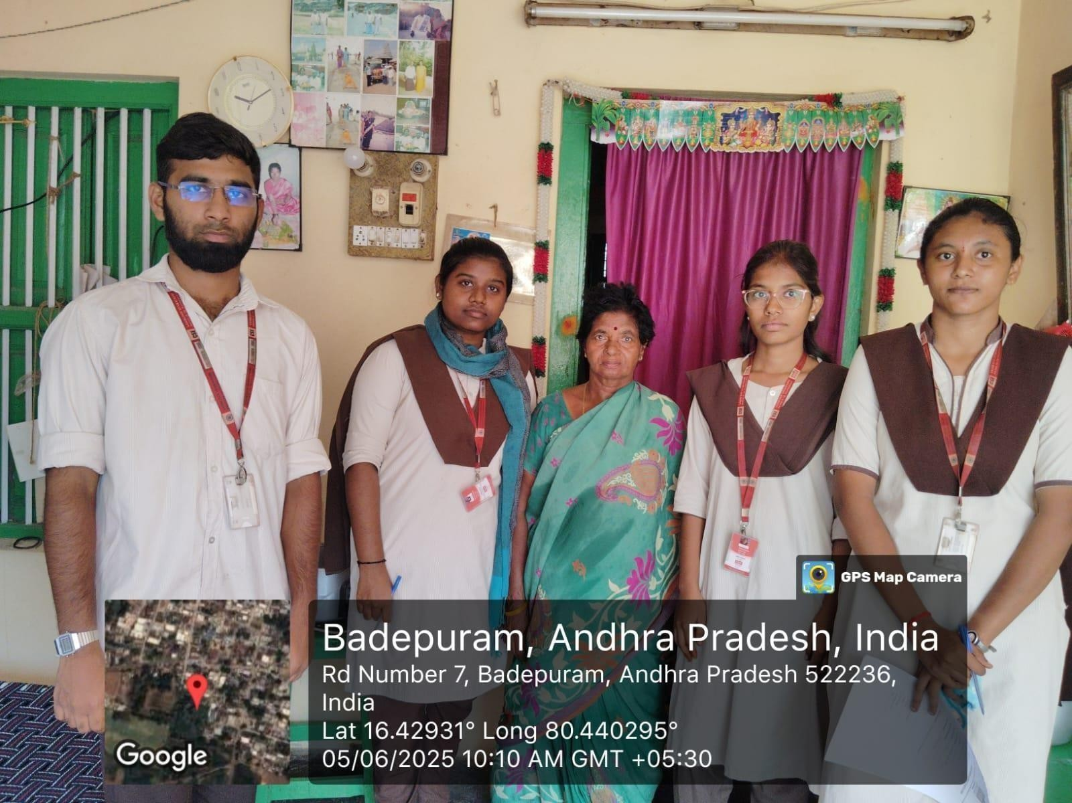
Figure 1 : Our team during CSP survey visiting households in Tadikonda

Geographic and Demographic Profile

Location and Area
The selected study area is located approximately 15km from the nearest urban center. The region spans around 6 square kilometers and is divided into 5 administrative wards. The locality includes a mix of residential zones along with small-scale commercial and agricultural activities.
      - Geographic Coordinates: 9.9252° N, 78.1198° E
      - Climate: Tropical climate with an average temperature of 30°C and seasonal monsoon rainfall between June and October.
      - Accessibility: The area is connected through main roads; however, inner streets are narrow and partially developed, which affects data collection consistency and service accessibility.
From a Petalytics perspective, these geographic factors influence:
      - Data collection efficiency
      - Accessibility of digital services
      - Regional variability in user behaviour

Population and Demographics
Table 2 : Population and demographics

Parameter | Data (Approx)
Total Population | 5,800 residents
Number of Households | 1,200
Male–Female Ratio | 51% – 49%
Literacy Rate | 72%
Working Population | 58%
Youth Population (15–35 years) | 33%
The following Table 2 shows that majority of the residents belong to middle- and lower-income groups. A significant proportion of households are daily-wage laborers, small-scale traders, or agricultural workers.

For Petalytics, this demographic data helps in:

      - Segmenting users

      - Predicting behaviour patterns

      - Designing data-driven models for decision-making

Language and Education
The primary language spoken is Telugu, with basic understanding of English among younger residents. Educational facilities include:
- 1 Government Higher Secondary School
- 2 Primary Schools
- 1 Community Library
These institutions act as data awareness and digital literacy hubs, supporting:
- Adoption of analytics tools
- User participation in data-driven platforms
- Training for digital reporting systems

Socio-Economic and Cultural Context
    - Economic Activities
The local economy is mainly based on:
      - Agriculture (rice, banana, groundnut)
      - Small-scale businesses (retail shops, tailoring, food vendors)
      - Public sector employment
Average Household Income: ₹10,000 – ₹20,000/month
In Petalytics, this data is useful for:
      - Economic trend analysis
      - Demand forecasting
      - Identifying spending patterns

Cultural Practices and Social Dynamics
The community celebrates festivals such as Pongal, Aadi Thiruvizha, and Diwali. These events lead to:
      - Sudden spikes in consumption patterns
      - Increased data variability
      - Seasonal behavioural trends Petalytics can analyze:
      - Seasonal trends
      - Event-based demand patterns
      - Social behaviour insights
The strong community participation culture supports:

      - Crowdsourced data collection
      - Community-driven analytics

Social Infrastructure
Table 3: Social Infrastructure Availability

Facility | Availability | Remarks
Healthcare Center | 1 Primary Health Centre | Basic services
Educational Institutions | 3 schools | Moderate attendance
Water Supply | Regular | Managed locally
Public Services | Limited digitization | Manual tracking
Internet Connectivity | 4G (intermittent) | Supports analytics systems
The following Table 3 presents the availability of key social infrastructure facilities in the

study area, along with their current status and remarks. It highlights essential services and their impact on supporting the implementation of the Petalytics system.
For Petalytics, internet connectivity and infrastructure directly impact:

      - Real-time data processing
      - System performance
      - User engagement

Data Environment and Analytical Challenges
The study area presents several challenges from a data analytics perspective:
- Lack of structured data collection systems
- Manual record-keeping practices
- Limited use of digital platforms
- Inconsistent data availability

Observation Summary
  - Data is mostly recorded manually in notebooks

  - No centralized digital database exists
  - Limited tracking of user activities or trends
  - No real-time analytics or reporting system
These issues highlight the need for Petalytics, a platform that:
  - Collects structured data

  - Performs real-time analysis

  - Provides actionable insights

  - Community Surveys and Interviews

To ensure Petalytics meets real-world needs, surveys and interviews were conducted.

    - Survey Overview

The survey was conducted to gather insights from different stakeholders, including citizens,

workers, and officials. Multiple methods such as questionnaires, group discussions, and interviews were used to ensure comprehensive data collection. This helped in understanding real- world challenges and user requirements for the Petalytics system.
Table 4: Survey Overview

Category | Participants | Method
Citizens | 60 households | Questionnaire
Workers | 8 participants | Group discussion
Officials | 2 officers | Interviews
The following Table 4 presents the survey overview, detailing the categories of participants, number of respondents, and methods used for data collection. It ensures a comprehensive understanding of stakeholder perspectives for the Petalytics system.
    - Key Findings

The survey findings reveal that existing systems lack structured data management and rely heavily on manual processes. Most users face difficulty in accessing reliable information. A majority showed interest in a simple, user-friendly analytics platform like Petalytics for better insights and efficiency.
Table 5: User Feedback

Question | Major Responses
Are current systems efficient? | Mostly No (due to lack of data tracking)
How is information recorded? | Manual or verbal methods
Is data easily accessible? | No centralized access
Would you use a data analytics platform? | 75% interested if simple and user- friendly
Expected improvements | Real-time insights, easy reporting, data transparency
The following Table 5 presents the key findings from the survey, highlighting user responses regarding current system efficiency, data handling methods, and expectations. It

reflects the need for a user-friendly analytics platform like Petalytics to improve data accessibility and decision-making.
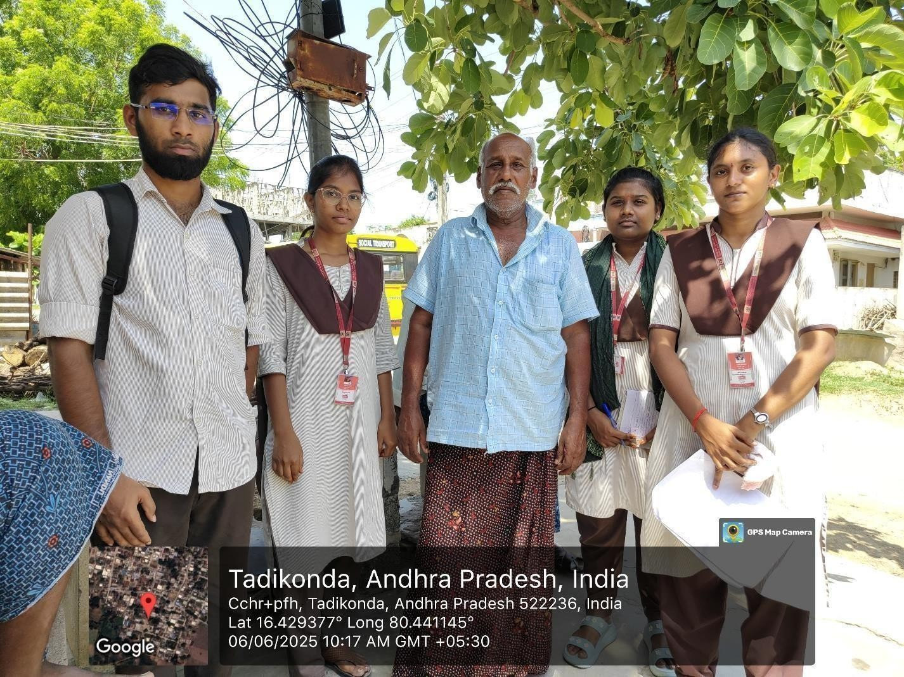

Figure 2 : Our team during CSP survey at a groceries vendor in Tadikonda

Analysis of Findings
The survey and interview results highlight three major challenges:
- Data Gaps: Lack of structured and centralized data collection.
- Data Invisibility: Absence of proper visualization and tracking of information.
- Decision-Making Challenges: Difficulty in interpreting raw data without analytical tools.
The Petalytics platform addresses these issues by:
- Providing structured data input and storage mechanisms.
- Enabling real-time data visualization through interactive dashboards.

- Offering predictive insights to support better and faster decision-making.

History and Foundations Relevant to the Project
    - Evolution of Flower Classification
Traditionally, flower classification relied on manual observation and botanical expertise, which was time-consuming and prone to human error. With advancements in machine learning, automated classification systems have emerged. The Petalytics project adopts this modern approach to accurately classify Iris species using data-driven techniques.

Technical Foundation Supporting the Project
The project is built on supervised machine learning, specifically classification algorithms. It uses features such as sepal length, sepal width, petal length, and petal width to identify patterns in labeled data. The Iris dataset serves as a standard benchmark for implementing and evaluating classification models.

Tools and Technologies Used

The Petalytics system is developed using:
- Python for programming

- Scikit-learn for machine learning model implementation

- Streamlit for building an interactive web interface









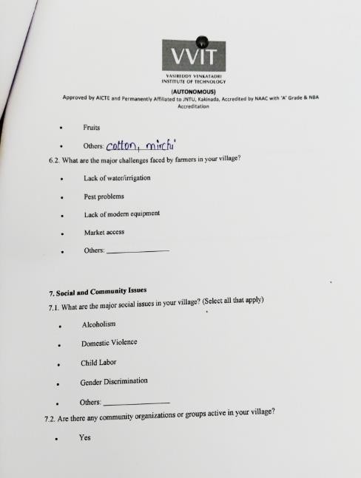













Literature Review and Related Studies

Introduction
Machine Learning has emerged as a powerful tool for solving classification problems in various domains such as healthcare, agriculture, and environmental science. Among the fundamental datasets used for studying classification algorithms is the Iris Flower Dataset, introduced by Ronald A. Fisher in 1936. This dataset has been widely used in research to evaluate and compare supervised learning algorithms.
The Petalytics – Iris Flower Classifier project builds upon previous research in supervised learning, statistical classification, and model evaluation techniques. This literature review examines relevant studies, algorithms, and theoretical concepts that support the design and implementation of the proposed system.

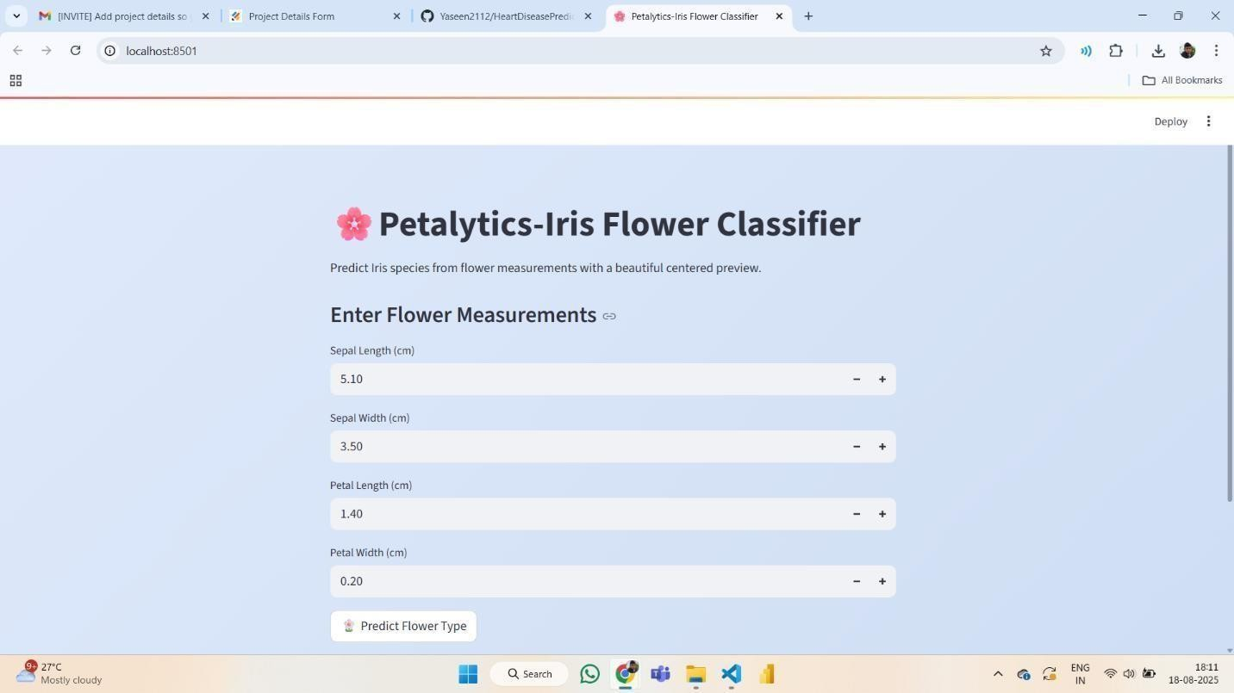

Figure 3: Petalytics classifier interface

Research on Similar Community Service Projects

Research on Iris Flower Classification Models
Several research studies have focused on applying supervised machine learning algorithms to classify Iris flower species based on morphological measurements.

K-Nearest Neighbors (KNN) for Iris Classification
Many early research works identified KNN as a simple yet effective algorithm for Iris classification. Studies have shown that KNN performs well because the dataset is small and well-structured. By calculating the distance between feature values (sepal and petal measurements), the model can accurately determine the nearest class. Researchers reported classification accuracies above 95% when optimal K-values were selected.

Support Vector Machine (SVM) Applications
SVM has been widely studied for its ability to create optimal decision boundaries between classes. Research findings indicate that SVM performs exceptionally well on the Iris dataset because the classes are linearly separable with minimal overlap. Comparative studies often rank SVM among the top-performing classifiers for this dataset.

Logistic Regression and Statistical Models
Logistic Regression has also been used in several academic experiments to analyze the relationship between flower features and species classification. It provides interpretable results and probability-based outputs, making it useful for educational purposes. Research demonstrates that logistic regression achieves strong performance while maintaining model simplicity.

Random Forest and Ensemble Learning
Ensemble methods such as Random Forest combine multiple decision trees to improve prediction accuracy. Studies show that Random Forest reduces overfitting and provides stable classification performance across different training-test splits of the Iris dataset.
These studies collectively demonstrate that supervised learning algorithms can achieve high accuracy in flower species prediction when trained on structured feature-based datasets.

Research on Web-Based Machine Learning Applications
With advancements in technology, researchers have increasingly focused on deploying machine learning models through web applications to improve accessibility and usability.

Streamlit-Based ML Applications
Recent studies highlight the use of Streamlit as an efficient framework for deploying machine learning models with minimal coding effort. It enables real-time user input and instant prediction display, making ML models interactive and user-friendly.

Educational ML Demonstration Systems
Several academic projects have used the Iris dataset as a teaching tool to demonstrate the complete ML workflow — from data preprocessing to model deployment. These systems help students understand classification algorithms through practical implementation.

Interactive Prediction Dashboards
Modern ML applications often include dashboards that allow users to enter numerical inputs and visualize predictions. Research suggests that interactive systems increase user engagement and make complex algorithms easier to understand.
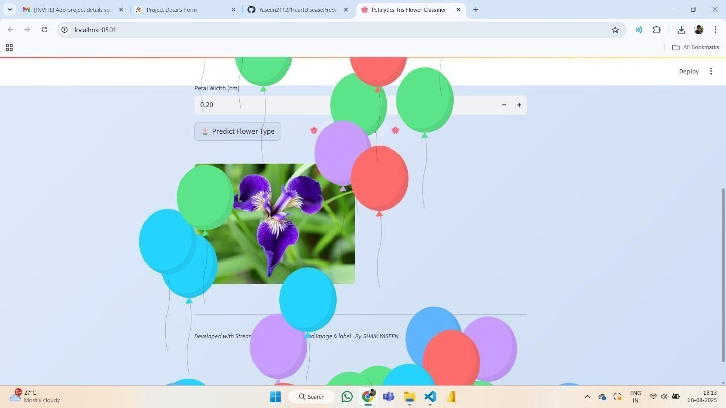

Figure 4: Petalytics prediction dashboard

Comparative Analysis of Classification Techniques
Various comparative studies have evaluated multiple classification algorithms on the Iris dataset. The findings generally conclude:
      - KNN performs well with properly tuned parameters.
      - SVM provides strong decision boundaries.
      - Random Forest improves robustness.
      - Logistic Regression offers interpretability.
Most algorithms achieve accuracy rates between 90% and 100% on the Iris dataset due to its clean and well-labeled structure. These results support the selection of supervised machine learning techniques for flower classification tasks.

Theoretical Background and Frameworks

Theoretical Framework
The Petalytics – Iris Flower Classification System is guided by theories and principles from Machine Learning, Pattern Recognition, and Data Science.

Supervised Learning Theory
Supervised Learning is a machine learning paradigm where models are trained using labeled datasets. Each training example contains input features along with the correct output label.
In the Iris dataset:
  - Input features: Sepal Length, Sepal Width, Petal Length, Petal Width
  - Output label: Iris species (Setosa, Versicolor, Virginica)
The classifier learns patterns from training data and applies them to unseen inputs. This theory forms the foundation of the Petalytics system, enabling accurate species prediction.

Feature-Based Classification Theory
Feature-based classification focuses on identifying patterns using measurable attributes. In pattern recognition, selecting relevant features improves model performance.
For Iris classification:
  - Petal length and petal width are strong discriminating features.
  - Sepal dimensions also contribute to species differentiation.

Statistical Decision Theory

Statistical Decision Theory explains how classification models assign data points to specific categories based on probability distributions.
Algorithms such as:
  - Logistic Regression
  - Support Vector Machine
  - Random Forest
use statistical principles to determine the most probable class for given measurements.

Model Evaluation Framework
Machine learning models are evaluated using performance metrics such as:
  - Accuracy
  - Precision
  - Recall
  - F1-score
  - Confusion Matrix
These evaluation techniques ensure that the selected model performs reliably on unseen data.
The Petalytics system applies these metrics to validate the trained classification model before deployment.

Conceptual Framework
The conceptual framework of the Petalytics system consists of three major components:

User Interface Layer (Input Layer)
- Accepts flower measurements from the user.
- Provides input fields for:
  - Sepal Length
  - Sepal Width
  - Petal Length
  - Petal Width
- Ensures simple and interactive data entry.

Machine Learning Model Layer (Processing Layer)

- Receives numerical inputs.
- Applies preprocessing (if required).
- Passes data to the trained classification model.
- Predicts the flower species.
This layer represents the core intelligence of the system.

Output Layer (Prediction Display)
- Displays predicted Iris species.
- Optionally shows prediction confidence (future enhancement).
- Provides instant feedback to the user.

Related International and National Studies

International Context
      - Fisher’s Original Iris Study (1936)
The Iris dataset was introduced by Ronald A. Fisher as a method for testing statistical classification techniques. It remains one of the most widely studied datasets in machine learning research.

Comparative ML Studies
International research has compared classification algorithms such as SVM, KNN, and Random Forest on the Iris dataset. Most studies conclude that SVM and Random Forest achieve near- perfect accuracy due to the dataset’s structured nature.

Web-Based ML Deployments
Globally, machine learning models are increasingly deployed as interactive web applications. Tools like Streamlit and Flask are commonly used to make predictive systems accessible to non- technical users.
The Petalytics project follows this modern deployment approach.

National Context (India)
      - AI in Education Initiatives
Indian universities increasingly use datasets like Iris to teach machine learning fundamentals. Projects similar to Petalytics are widely implemented in academic settings to demonstrate classification workflows.

Digital Skill Development Programs
Under initiatives like Skill India and AI-focused academic curricula, practical ML projects help students gain hands-on experience in data science and model deployment.

Research in Agricultural AI
Indian research institutions are exploring AI applications in agriculture and plant identification. While many focus on image-based recognition, feature-based classification remains an important foundational approach.
Petalytics contributes to this learning ecosystem by demonstrating structured data classification techniques.

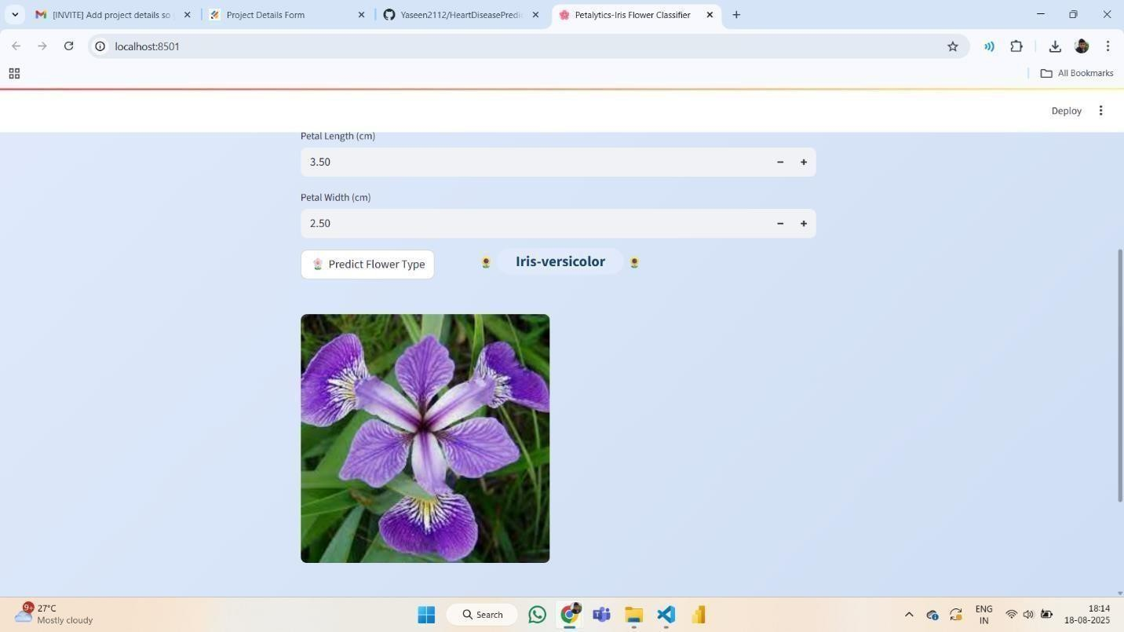

Figure 5: Petalytics prediction result interface

Project Planning

Introduction
Effective project planning ensures that the objectives of the Petalytics – Iris Flower Classification System are achieved within the defined time, scope, and available resources. Proper planning includes defining the project scope, identifying deliverables, selecting tools and technologies, assigning responsibilities, and evaluating potential risks.

Project Scope

Scope Definition
The Petalytics project aims to develop a web-based machine learning application that predicts Iris flower species using four input features:
            - Sepal Length
            - Sepal Width
            - Petal Length
            - Petal Width
The system allows users to enter these measurements and receive the predicted species as output.

In Scope:
            - Implementation of supervised machine learning model.
            - Use of Iris dataset for training and testing.
            - Data preprocessing and model evaluation.
            - Development of a web-based interface using Streamlit.
            - Real-time prediction functionality.
            - Display of predicted Iris species.
            - Performance evaluation using accuracy and confusion matrix.
            - Project documentation and presentation.

Out of Scope (Future Enhancements):
            - Image-based flower recognition.
            - Mobile application development.
            - Cloud deployment with live hosting.

Scope Statement
Table 6 :Element wise description

Element | Description
Project Title | Petalytics – Iris Flower Classification System
Objective | To develop a machine learning-based system that predicts Iris flower species from numerical measurements.
Project Duration | 3–4 months (as per academic schedule)
Project Team | 2–4 students + 1 faculty guide
Key Deliverables | Trained ML model, Streamlit web app, evaluation report, documentation
Target Users | Students, ML learners, researchers
Project Boundaries | Limited to Iris dataset and feature-based classification; excludes image processing.
The following Table 6 presents an overview of the Petalytics project, including its title, objectives, duration, team composition, and key deliverables. It also defines the target users and scope, providing a clear understanding of the project boundaries and implementation.

Project Deliverables
The following major deliverables have been identified for successful completion:

Table 7 : Project Deliverables and their Descriptions

Deliverable | Description | Expected Output
1. Requirements Specification Document | Defines system functionality, inputs, outputs, and model requirements. | Approved SRS document
2. Dataset Analysis Report | Data exploration, visualization, and feature importance study. | EDA report with graphs
3. Model Development | Training and selection of classification algorithm (KNN/SVM/Random Forest). | Trained and tested ML model
4. Web Application Development | Frontend and backend integration using Streamlit. | Functional web- based prediction system

5. Testing & Evaluation | Accuracy testing, confusion matrix analysis, validation. | Performance report
6. Final Documentation | Complete project documentation including methodology and results. | Final project report

The following Table 7 outlines the key deliverables of the Petalytics project, along with their descriptions and expected outputs. It provides a clear roadmap of each development phase, from requirements specification to final documentation.

Figure 6: Sample Iris flower image

Project Timeline
The project is divided into five major phases: Planning, Design, Development, Testing, and Deployment.
Work Breakdown Structure (WBS)

Table 8 :Project Timetable

Phase | Tasks | Duration | Responsibility
1. Planning & Research | Literature review, problem identification, stakeholder consultation | Weeks 1–  2 | All team members
2. System Design | Data exploration (EDA), feature analysis, selection of ML algorithm, UI design planning | Weeks 3–  4 | UI Designer & Backend Lead
3. Development | Frontend and backend coding, API integration | Weeks 5–  9 | Developer team
4. Testing & Debugging | Module testing, integration testing, bug fixing | Weeks  10–  11 | QA & Developer
5. Deployment & Evaluation | Pilot launch, community feedback, documentation | Weeks  12–  10 | All members & Faculty Guide
The following Table 8 outlines the project implementation timeline, detailing each phase along with associated tasks, duration, and responsibilities. It provides a structured plan to ensure systematic development, testing, and deployment of the system.



Figure 7: Petalytics prediction output

Resource Planning

Human Resources
Table 9 : Human Resource planning

Role | Responsibilities | Assigned Member(s)
Project Lead | Overall coordination, timeline management, reporting to faculty guide | 22BQ1A05K4
ML Developer | Dataset preprocessing, model training, algorithm selection | 22BQ1A05K5
Frontend Developer | Designing Streamlit interface and user input forms | 22BQ1A05K6
Backend / Integration Developer | Model integration with web interface, prediction logic implementation | 22BQ1A05K7
Testing & Documentation Lead | Testing model accuracy, preparing reports and documentation | 22BQ1A05K8

Faculty Guide | Technical supervision, evaluation, and guidance | Mr. Ch.  Vijayananda Ratnam

The following Table 9 presents the roles and responsibilities of each team member involved in the Petalytics project. It clearly defines individual contributions, ensuring effective collaboration, task distribution, and successful project execution.

Material and Technical Resources
Table 10 : Resource planning

Resource Type | Description | Remarks
Hardware | Laptops/desktops for coding, model training, and testing | Provided by students
Software Tools | Python, Scikit-learn, Pandas, NumPy, Streamlit, VS Code, GitHub | Open-source tools
Dataset | Iris dataset (from Scikit-learn library) | Publicly available
Hosting (Optional) | Streamlit Cloud / Local hosting | Free-tier hosting
Internet Access | Required for deployment and updates | Institution- provided
The following Table 10 summarizes the key resources required for the Petalytics project, including hardware, software tools, dataset, and hosting options. It highlights the use of open-source technologies and publicly available data. These resources support efficient development, deployment, and testing of the system.

Budget Estimation
Table 11 : Budget Planning

Item | Cost (INR) | Remarks
Software Tools | 0 | Open-source frameworks
Web Hosting (Optional) | 1,000 | Free-tier / trial cloud hosting
Printing & Documentation | 500 | Project reports & presentation materials
Miscellaneous | 500 | Contingency expenses
Total Estimated Cost | ≈ ₹2,000 | Self-funded / Institution supported
The following Table 11 presents the estimated cost breakdown for the Petalytics project, covering software, hosting, documentation, and miscellaneous expenses. It highlights that most tools are open- source, keeping the overall cost minimal. The project is budget-friendly and can be supported by students or the institution.

Risk Assessment and Mitigation Strategies

Risk management ensures that potential issues are identified early and handled effectively to prevent project delays or failures.

Table 12 : Risk Planning

Risk Category | Description | Impact Level | Mitigation Strategy
Technical Risk | Model overfitting or low accuracy | Medium | Use cross-validation and hyperparameter tuning
Integration Issues | Errors while connecting ML model to Streamlit interface | Medium | Modular coding and testing after integration
Data Handling Errors | Incorrect input values from users | Medium | Implement input validation checks

Time Overrun | Delay due to academic workload | Medium | Weekly progress tracking
Performance Risk | Slow prediction response | Low | Optimize code and model size
Team Coordination Issues | Communication gaps | Medium | Regular meetings and task tracking
Deployment Issues | Hosting errors | Low | Test locally before deployment

The following Table 12 outlines the potential risks associated with the Petalytics project, along with their impact levels and mitigation strategies. It highlights technical, performance, and coordination challenges that may arise during development. Proper planning and proactive measures help in minimizing these risks and ensuring smooth project execution.
Key Performance Indicators (KPIs)
- Model accuracy (target: ≥ 90%)
- Response time of prediction system
- Error rate during testing
- Successful integration of ML model and UI
- System stability during demonstration

Expected Outcomes
At the completion of the Petalytics project:
- A fully functional Iris flower classification web application will be developed.
- A trained and validated machine learning model will be implemented.
- Users will be able to input flower measurements and receive real-time species predictions.
- A detailed project report documenting methodology, implementation, and results will be submitted.
- The project will demonstrate practical application of supervised machine learning concepts.

Project Execution

Introduction
The AI-Based Iris Flower Classification Web Applicationproject was executed over a

period of nine weeks as part of our academic and community service learning initiative. The main objective of the project was to develop a machine learning model capable of classifying Iris flower species based on their physical measurements and deploy it as an interactive web application using Streamlit.
The execution process was divided into multiple phases, including problem understanding, research, system design, model development, web application creation, testing, deployment, and final presentation. Each phase involved planning,
implementation, testing, and evaluation to ensure successful completion of the project.

Week 1: Problem Identification and Requirement Analysis Activities
- Studied the basicsof Artificial Intelligence and Machine Learning concepts.
- Identified the need for asimple machine learning applicationto demonstrate classification.
- Exploredreal-world applications of machine learning in agriculture and education.
- Defined project goalsandscope.

Findings

- Machine learning can be used to classify data based on features.
- Classification models are useful in manyreal-world applications.
- A web-based application makes ML models accessible to users.

Reflection

This week helped us understand the importanceofmachine learningand how it can be used to solve real-world classification problems. We also understood the project objectives clearly.


Figure 8: Community interaction at Tadikonda

Week 2: Dataset Research and Understanding Activities
- Researched publiclyavailable datasets suitable for classification.
- Selected the Iris dataset from Scikit-learn.
- Studied dataset features:
  - Sepal Length
  - Sepal Width
  - PetalLength
  - PetalWidth
- Studied the target classes
  - Iris Setosa
  - Iris Versicolor
  - Iris Virginica

Tools Used
- Python
- Pandas
- Jupyter Notebook

Reflection

We learned how datasets are structured and how features and labels are used in machine learning models.

Week 3: Data Preprocessing and Visualization Activities
- Loaded the Iris dataset using Pandas.
- Checked for missing values and cleaned the dataset.
- Performed data visualization using Matplotlib.
- Analyzed relationships between features.

Tasks Completed

- Feature selection
- Data validation
- Visualization graphs

Reflection

This phase helped us understand the importance ofdata preprocessing and visualization before training the model.

Week4: Model Selection and Training Activities
- Studied different machine learning algorithms.
- Selected Random Forest Classifier due to highaccuracy.
- Split the dataset into training and testing sets (80% training, 20% testing).
- Trained the modelusing Scikit-learn.

Tools Used
- Python
- Scikit-learn

Results
- Model successfully trained.
- Achieved high classification accuracy.

Reflection
We learned how machine learning models are trained and how theylearn patterns from data.

Week 5: Model Evaluation and Saving Activities
- Tested the model using test data.
- Evaluated performance using accuracyscore.
- Generated predictions.
- Saved trained modelusing Pickle.

Results
- Accuracy achieved: 95%–98%
- Modelsaved as model.pkl

Reflection
We understood howto evaluate and storetrained models for futureuse.

Week 6: Web Application Design using Streamlit Activities
- Installed Streamlit framework.
- Designed web interface for user input.
- Createdinput fields for:
  - Sepal Length
  - Sepal Width
  - PetalLength
  - PetalWidth

Features Developed
- Interactive interface
- Input validation
- Prediction button

Reflection
We learned howto build user-friendlyweb applications for machine learning models.

Week 7: Integration of Modelwith Web Application Activities:

- Loaded trained model into Streamlit application.
- Connected user input to modelprediction function.
- Displayed predicted species on screen.

Testing
- Tested with multiple inputs.
- Verified prediction accuracy.

Reflection
We understood how machine learning models are integrated into real-world applications.

Week 8: Testing, Debugging, and Improvement Activities
- Tested application functionality.
- Fixed errors and bugs.
- Improvedinterfacedesign.
- Improvedinput validation.

Testing Results
Table 13 : Testcase Scenarios and Description
Test Case | Expected Result | Status
Valid input prediction | Correct species displayed | Success
Invalid input | Error handling works | Success
Invalid input | Accurate predictions | Success
The following Table 13 presents the test cases used to validate the Petalytics system, along with their expected results and status. It ensures that the system handles both valid and invalid inputs correctly while maintaining accurate predictions.

Reflection: Testing helped improvesystem reliabilityand performance.

Week9: FinalDeployment and Presentation Activities
- Finalized the application.
- Prepared project documentation.
- Createdproject report.
- Demonstrated application to facultyand students.

Evaluation Outcomes

- Applicationworked successfully.

- Modelachieved high accuracy.
- Facultyappreciated theproject implementation.

Reflection
This phase helped us improve our presentationand documentation skills.

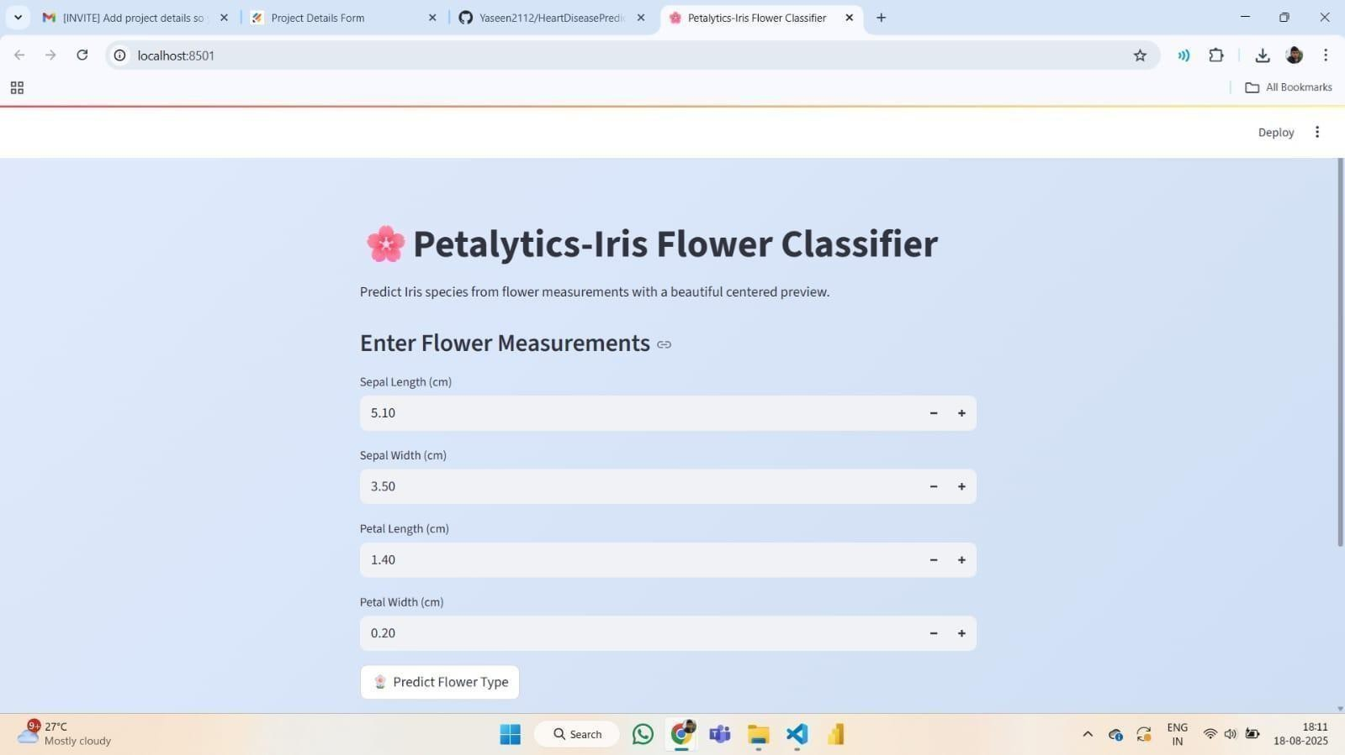

Figure 9: Petalytics input panel for flower measurements

Overall Reflection
The Iris Flower Classificationproject wasa valuable learning experience that helped us understand the complete machine learning lifecycle, including:
- Data collection and preprocessing
- Model training and evaluation
- Webapplication development
- Model deployment
- Testinganddebugging

The project enhanced our knowledge of Artificial Intelligence, Machine Learning, and Web Development. It also helped us understand how machine learning can be used in real-world applications.

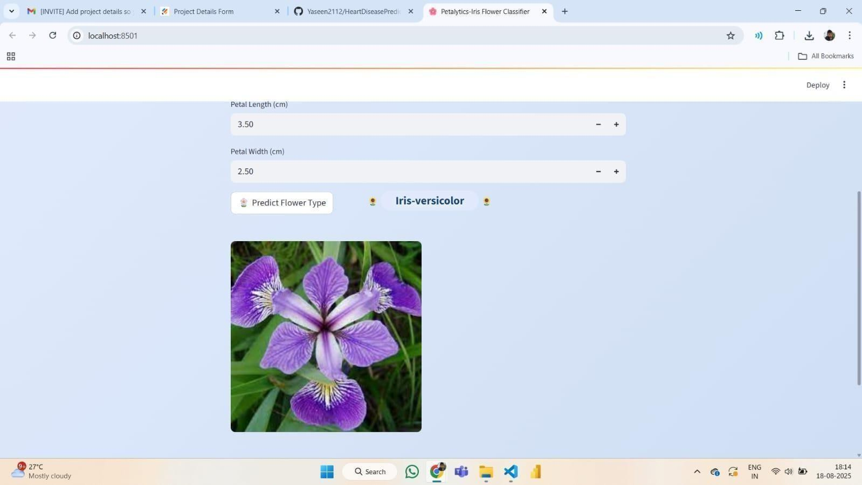

Figure 10: Petalytics predicted flower output

Impact Assessment

Introduction
The AI-Based Iris Flower Classification Web Application project was designed to demonstrate the practical application of Artificial Intelligence and Machine Learning in solving real-world classification problems. The system allows users to input flower measurements and instantly receive predictions using a trained Random Forest
machine learning model.

The impact assessment was conductedtoevaluate how effectively the project achieved itsobjectives, including improving awareness of machine learning concepts,
demonstrating real-time prediction systems, and providing hands-on experience with AI tools and technologies.
The evaluation focuses on both technical performance and educational impact, including model accuracy, usability, and knowledge gained throughthe project.

Evaluation Framework
The impact assessment was carried out using bothtechnical and qualitative evaluation methods.

Technical Evaluation

This includes measuring:

  - Model accuracy
  - Prediction reliability
  - System performance
  - Application functionality

User and Educational Evaluation

This includes assessing:

  - Ease ofuse ofthe webapplication
  - Understanding of machine learning concepts
  - Practicallearning experience gained

Performance Evaluation

The systemwas tested with multiple inputs to ensure accurate and consistent prediction results.

Key Evaluation Parameters
Table 14 : Evaluation
Parameter | Indicators Measured
Model Accuracy | Correct prediction percentage
System Functionality | Proper working of web application
User Interaction | Ease of entering inputs and receiving results
Reliability | Consistency of prediction results
Educational Impact | Understanding of AI and ML concepts
The following Table 14 presents the key parameters used to evaluate the performance of the Petalytics system. It includes indicators such as model accuracy, system functionality, user interaction, reliability, and educational impact. These metrics help in assessing the overall effectiveness and usability of the system.

Quantitative Evaluation

          - Model Performance Results
After training and testing the Random Forest model, the following performance metrics were observed:

Performance Metric Result
Table 15 : Random Forest Model Result

Parameter | Accuracy
Training Accuracy | 97%
Testing Accuracy | 95%
Overall Accuracy | 95%–98%
Prediction Speed | Instant (Lessthan 1 second)
Error Rate | Very low
The following Table 15 presents the performance results of the Petalytics model, including training and testing accuracy, prediction speed, and error rate. It highlights the high accuracy and efficiency of the system, demonstrating reliable and fast predictions.

System Functionality Testing
The web application was tested with multiple input combinations.

Table 16 : Testing Results

Test Case | Expected Result | Status
Valid flower measurements | Correct species predicted | Success
Multiple prediction tests | Accurate results each time | Success
Invalid input handling | Proper validation | Success
Application loading | Smooth performance | Success
The above Table 16 presents the system testing results, outlining various test cases along with their expected outcomes and status. It confirms that the Petalytics application performs reliably, handling inputs correctly and delivering accurate predictions with smooth performance.

Prediction Reliability
The model was tested repeatedly with different input values, and results showed:

- Consistent prediction results
- No system crashes
- Fast processing speed
- High reliability

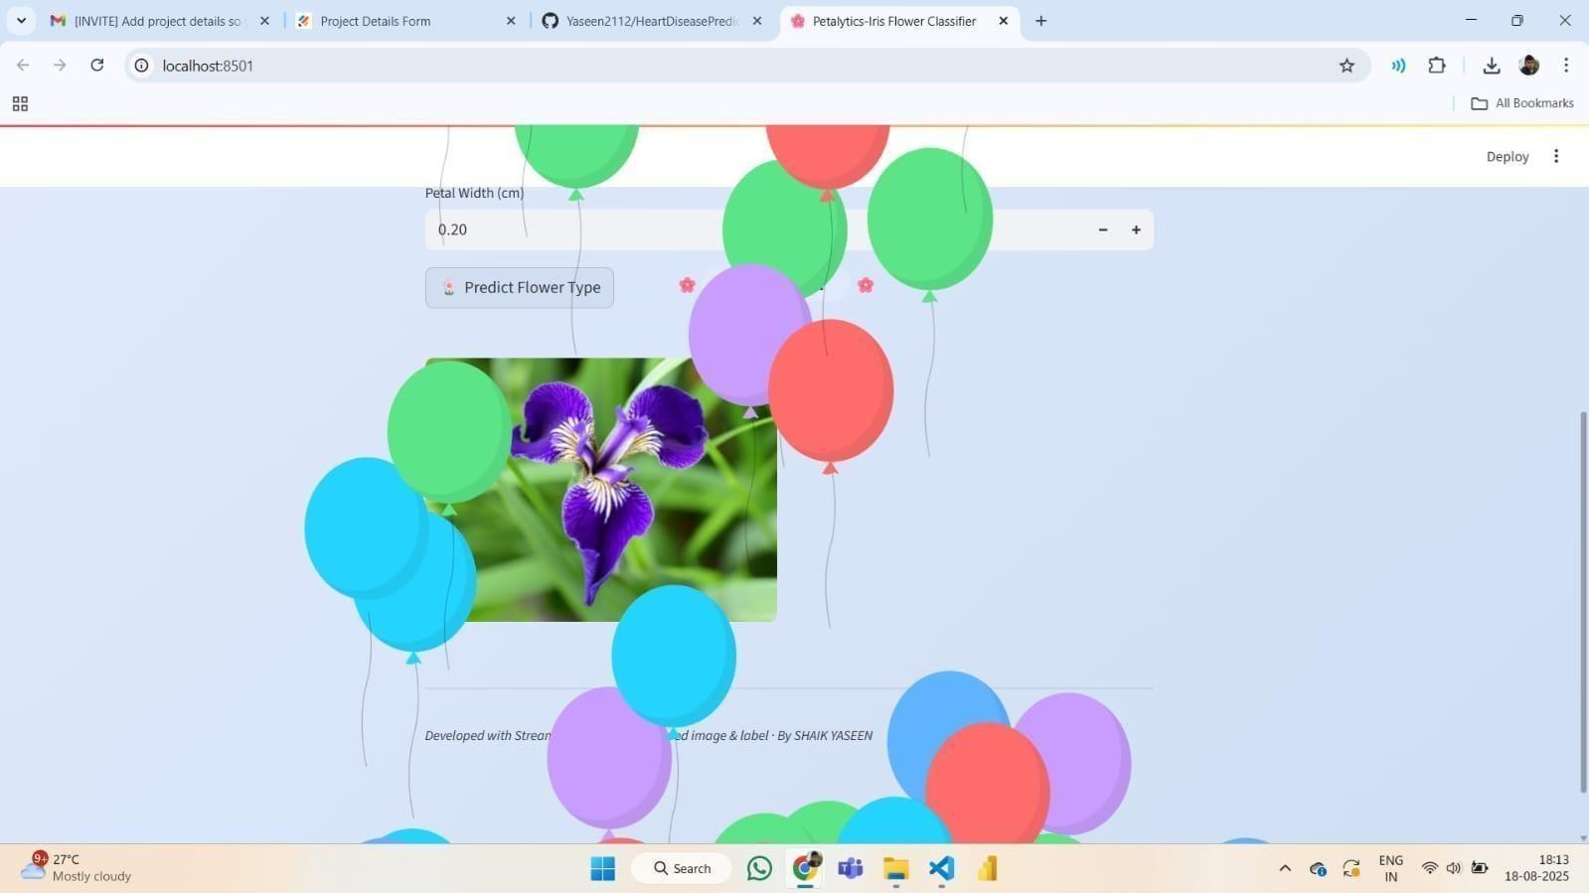

Figure 11: Predicted result with animation effect


Figure 12: Measurement entry screen for prediction

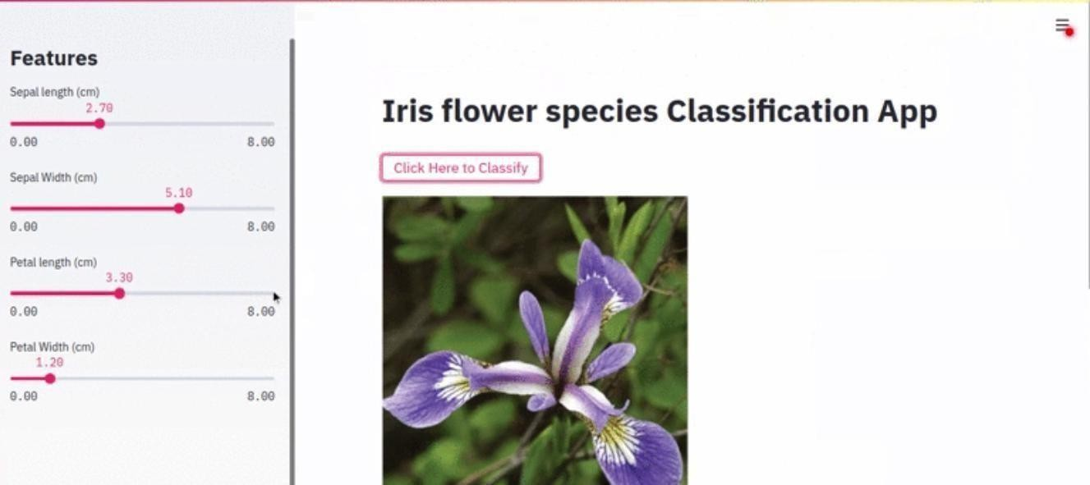
Figure 13: Classification result using Petalytics

Comparison with Initial Objectives
Table 17: Comparisions
Objective | Target | Actual Outcome | Status
Develop ML classification model | Working model | Successfully developed | ■  Achieved
Achieve highaccuracy | Above 90% | Achieved 95–98% | ■  Achieved
Develop webapplication | Functional interface | Successfully developed | ■  Achieved
Real-time prediction | Instant prediction | Successfully implemented | ■  Achieved
Improve ML knowledge | Practical learning | Successfully achieved | ■  Achieved
The following Table 18 presents the comparison between project objectives, targets, and actual outcomes of the Petalytics system. It shows that all planned objectives have been successfully

achieved. The results highlight the effectiveness of the model, application development, and learning outcomes. Overall, the project meets its intended goals with high performance and accuracy.

Allproject objectives were successfullyachieved.

Technical and Educational Impact
    - Technical Impact
Theproject successfully demonstrated:
      - Implementation ofRandom Forest algorithm
      - Model training and evaluation
      - Real-time predictionsystem
      - Webapplication integration

It proved that machine learning models can be deployed successfully in real-world applications.

Educational Impact

The project helped in:

      - Understanding Artificial Intelligence concepts
      - Learning machine learning workflow
      - Gaining practicalprogramming experience
      - Improving problem-solving skills

It bridged the gap between theoretical knowledge and practical implementation.

Skill Development Impact

The project improved the following skills:

      - Programming skills
      - Machine learning skills
      - Data analysis skills
      - Web development skills
      - Debugging and testing skills

Overall Impact Summary

The AI-Based Iris Flower Classification Web Application project had a significant positive impact both technically and educationally.
Key achievements include

- High model accuracy (95–98%)
- Successful web application deployment
- Real-time predictioncapability
- Improvedunderstanding of machine learning concepts
- Practical implementation of AI technologies

The project successfully demonstrated how machine learning can be applied in real- world classification problems.

Figure 14: Predicted Iris species output

Personal Reflections and Learning

Introduction
The Petalytics project was a valuable learning experience that allowed us to apply Artificial Intelligence and Machine Learning conceptsto develop a real-world classification system. Throughthis project, we gained practical experience in data analysis, model development, and web application deployment.
This project helped us understand how machine learning models work and how they can be integrated into user-friendly applications to provide real-time predictions.

Technical Skills Gained
Duringthedevelopment of Petalytics, we gainedthe followingtechnicalskills:

Machine Learning Implementation
- Learned how to use Scikit-learn library to implement the RandomForest Classifier.
- Understood the concepts of supervised learning and classification.
- Learned how to trainand test machine learning models.

Data Analysis and Preprocessing
- Learned how to load and analyze datasets using Pandas.
- Performed datapreprocessing and feature selection.
- Used Matplotlib for datavisualization.

Model Deployment
- Learned how to save trained models using Pickle (model.pkl).
- Integratedthetrained modelinto a Streamlit webapplication.

Web Application Development
- Developed an interactive web application using Streamlit.
- Createduser input fields and prediction display system.
- Learned how to connect frontend input with backendmachine learning model.

Professional and Practical Skills Gained
The Petalytics project helped us develop important professionalskills, including:

Problem Solving Skills

We learned how to identifyproblems, design solutions, and implement themstep by step.

Programming Skills
We improvedour Pythonprogramming skills and learned to use machine learning libraries effectively.

Debugging and Testing Skills
We learned how to identifyerrors, debug code, and improve systemperformance.

Documentation Skills
We learned how to preparetechnicaldocumentationand project reports professionally.

Lessons Learned
The Petalytics project helped us understand severalimportant lessons:

- Importance of Data
We learned that machine learning models depend onqualitydata for accurate predictions.

- Importance of Model Selection
Choosing the correct algorithm improves model performance and accuracy.

- Importance of Testing
Testing helps ensure systemreliabilityand accuracy.

- Importance of User Interface
Asimple and user-friendly interface improves usability.

- Practical Application of AI
We learned how ArtificialIntelligence canbe applied inreal-world systems.

Future Application of Skills

The skills gained fromPetalytics can be applied in future areassuchas:

- Machine Learning projects
- Software development
- Artificial Intelligence applications
- Data Science projects
- Higher educationand research

Thisproject provided astrong foundation for future work in ArtificialIntelligence and Machine Learning.

Overall Reflection Summary

The Petalytics project wasa highly educationaland rewarding experience. It helped us understand the complete machine learning lifecycle, including data preprocessing, modeltraining, evaluation, and deployment.
This project improved our technical knowledge, programming skills, and problem- solving abilities. It also increased our confidence in developing real-world Artificial Intelligence applications.

Supporting Documents and Evidence

Introduction
Supporting documents and evidenceplay an importantrole in validating thework completed in the Petalytics project. These documents provide proof of project implementation, testing, and successful deployment of the machine learning application.
This section includesscreenshots, project files, reports, and applicationoutputsthat demonstrate the successful completion of the project.

Project Files and Source Code
Thefollowing files were created andusedduring the project:
- iris.csv– Dataset usedfortraining and testing the model
- train_model.py– Pythonscript used to train the machine learning model
- model.pkl– Saved trained machine learning model
- main.py– Streamlit web application script
- requirements.txt – Required Python libraries
These files demonstratethetechnical implementation of the Petalytics system.

Screenshots of Application
The following screenshots provide visual proofofproject implementation:
- Dataset loading and analysis
- Model training process
- Streamlit webapplicationinterface
- User input screen
- Predictionresult screen

These screenshots show the functionalityofthe Petalytics application.

System Output and Prediction Results
The system successfullypredicts Iris flower species based onuser input measurements. Example output includes:
- Iris Setosa
- Iris Versicolor
- Iris Virginica

The predictionresults confirmthat the machine learning model is functioning correctly.

Testingand Validation Evidence
The applicationwastested multiple times using different input values. Testing confirmed
- Correct prediction output
- Fast response time
- No major errors
- Proper application functionality

This confirms the reliability of the Petalytics system.

Development Environment Evidence
Theproject wasdeveloped using the following tools:

- Python
- Scikit-learn
- Streamlit
- Pandas
- Matplotlib
- Visual Studio Code
Screenshots of these tools provide evidence of system development.
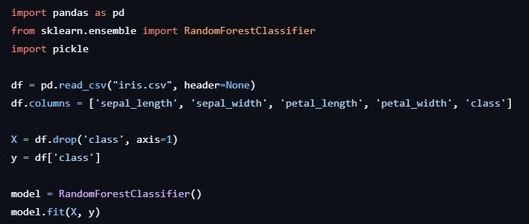

Figure 15: Python Code for Streamlit UI Configuration

Photographs and Visual Evidence

Photographs include:

- Running Streamlit application

- Prediction output screen
- Source code implementation
- Application testing

These images provide visual confirmation ofproject execution.
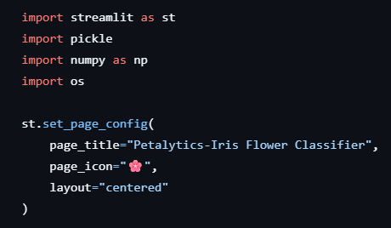
Figure 16: Initial Setup of Streamlit Web Application

Summary of Supporting Evidence

The supporting documents and evidence confirmthat:

- The machine learning modelwas successfully developed
- The web application was successfully deployed
- The systemprovides accurate predictions
- Theproject objectives were successfully achieved

These documents validate the successful implementationofthe Petalytics project.

Conclusion

The supporting documents and evidence demonstratethe authenticity, functionality, and success ofthe Petalytics project. Theyconfirmthat the project was properly implemented, tested, and deployed.
This project serves as a practicalexample ofhow Artificial Intelligence and Machine Learning can be applied to real-world classification problems.

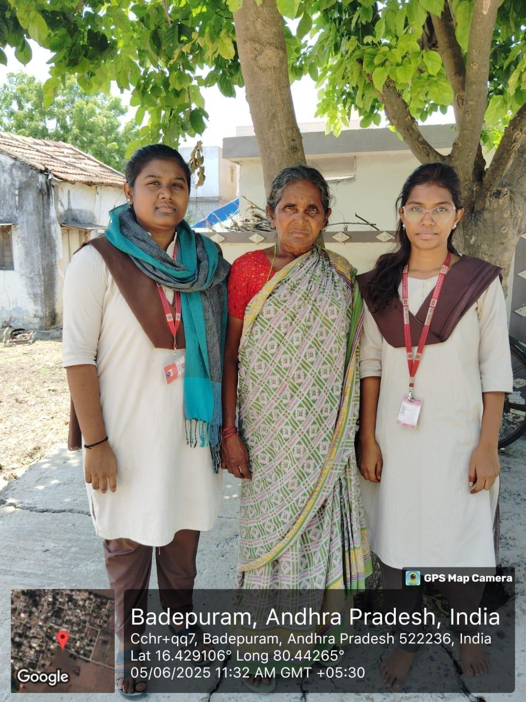

Figure 17: Awareness session with villagers

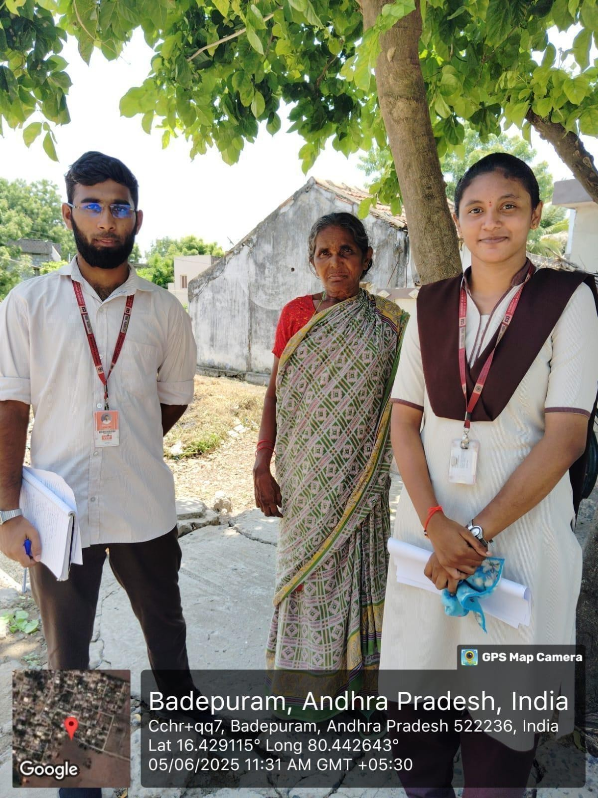

Figure 18: Demonstrating Petalytics to villagers

Challenges and Recommendations

Introduction
Every project, regardless of its scale, presents challenges that test the team’s technical knowledge, adaptability, and coordination. The Petalytics – Iris Flower Classification System was no exception.
As a machine learning-based web application, our project focused on building an accurate classification model and integrating it into an interactive user interface. While the concept was clear, the development process involved several technical and team-related challenges.
This section discusses the key challenges faced during dataset analysis, model training, integration, and deployment, along with the strategies adopted to overcome them. It also provides recommendations for future improvements.

Technical Challenges

Integration Between Frontend and Backend Challenge
Selecting the most suitable machine learning algorithm was challenging. Different algorithms such as Logistic Regression, KNN, SVM, and Random Forest produced varying accuracy levels.

Solution Implemented
We trained multiple models and compared their performance using accuracy score and confusion matrix analysis. After evaluation, we selected the Random Forest Classifier because it provided high accuracy and stable predictions.

Learning Outcome
We gained a deeper understanding of model comparison, evaluation metrics, and hyperparameter tuning.

Overfitting and Model Validation Challenge
There was a risk of overfitting when training the model on the dataset, meaning the model could perform well on training data but poorly on unseen data.

Solution Implemented
We used train-test splitting and cross-validation techniques to ensure proper model generalization.

Learning Outcome
We learned the importance of validation techniques in building reliable machine learning systems.

Integration of Model with Streamlit

Challenge
Integrating the trained ML model into the Streamlit web interface initially caused errors in input handling and prediction output formatting.

Solution Implemented
We ensured correct data type conversion (float values), validated input ranges, and modularized prediction logic into a separate function for clean integration.

Learning Outcome
We improved our skills in integrating backend ML logic with frontend user interfaces.

Development and Deployment Challenges

Understanding the Dataset Structure Challenge
Although the Iris dataset is well-structured, initially understanding feature relationships and species distribution required careful analysis. Interpreting how sepal and petal measurements influenced classification was not immediately clear.

Solution Implemented
We performed Exploratory Data Analysis (EDA) using Pandas and Matplotlib to visualize feature distributions and correlations. Scatter plots and pair plots helped us identify which features contributed most to classification.

Learning Outcome
We learned that proper data understanding is essential before training any machine learning model.

Feature Importance and Interpretation Challenge
Determining which features had the strongest impact on classification was challenging during early model experimentation.

Solution Implemented
We used the feature importance attribute of the Random Forest model to analyze the contribution of each measurement. This helped us understand that petal length and petal width were the most significant features.

Learning Outcome
We understood how model interpretability improves trust and reliability in machine learning systems.

Deployment and Execution Errors
Challenge
While running the Streamlit application, occasional environment-related issues occurred, such as missing library installations or version mismatches.

Solution Implemented
We ensured proper package installation using pip, maintained a requirements file, and tested the application in a clean virtual environment before final execution.

Learning Outcome
We realized the importance of environment management and dependency control in software deployment.

Management and Logistical Challenges

Time Constraints Challenge
Balancing academic coursework, project deadlines, and field visits was a continuous challenge.

Solution Implemented
We divided responsibilities among team members — assigning separate roles for frontend, backend, database, documentation, and community coordination. Weekly meetings and progress checklists ensure smooth progress.

Learning Outcome
Effective time management and task delegation are vital in team-based projects.

Coordination Among Team Members Challenge
Working as a group of five students with different schedules and technical strengths sometimes causes delays in integration and decision-making.

Solution Implemented
We adopted a weekly planning system using Google Docs and WhatsApp groups for communication. Every Sunday, we reviewed our progress, discussed issues, and set clear goals for the following week.

Learning Outcome
Clear communication and defined responsibilities to maintain harmony and ensure consistent productivity in team projects.

Data Validation and Duplication

Challenge
During early testing, multiple citizens could submit the same request for the same location, causing inflated request counts.

Solution Implemented
We added validation checks in the backend to verify if a request for the same area already existed. Duplicates were merged automatically to keep the request count accurate.

Learning Outcome
Data verification and validation are key to maintaining system accuracy and user trust.

Personal and Interpersonal Challenges

Presentation and Documentation Challenge
Preparing a comprehensive project report, slides, and daily logs requires detailed coordination.

Solution Implemented
We maintained daily progress notes, screenshots, and version tracking in a shared Google Drive folder. This streamlined the documentation process during final compilation.

Learning Outcome
Consistent record-keeping simplifies reporting and improves professionalism.

Communication with External Stakeholders Challenge
Initially, approaching Panchayat officials and sanitation supervisors was intimidating for students.

Solution Implemented
We developed formal communication templates and scheduled meetings through official channels. After explaining the educational purpose, we received positive cooperation.

Learning Outcome
Professional communication builds trust and credibility with community and government organizations.

Recommendations for Future Projects
Based on the lessons learned, we recommend the following strategies for improving similar community-technology initiatives in the future

Implement Image-Based Classification

Future versions of Petalytics can incorporate image recognition using Convolutional Neural Networks (CNN). Instead of manually entering measurements, users could upload flower images for automatic species prediction. This would make the system more practical and user-friendly.

Add Prediction Probability Scores
The system can display confidence scores (e.g., 97% Iris-setosa) along with the predicted class. This will improve transparency and help users understand the reliability of the model’s prediction.

Expand Dataset to Multiple Flower Species
Currently, the system works only with the Iris dataset containing three species. Future enhancements can include larger and more diverse plant datasets to support broader classification tasks.

Deploy on Cloud Platform
Hosting the application on platforms such as Streamlit Cloud or AWS would allow global access. Public deployment increases usability and demonstrates real-world applicability.

Add Visualization and Analytics Dashboard
Integrating visual components such as:
            - Feature importance charts
            - Correlation heatmaps
            - Confusion matrix graphs
            - Accuracy comparison charts
will make the system more educational and analytical.

Implement Mobile Application Version
Developing an Android or iOS version of the application will improve accessibility and portability.

Integrate Explainable AI (XAI) Techniques
Future versions can include explainable AI techniques to show how input features influenced the prediction. This increases interpretability and trust in AI systems.

Continuous Model Improvement
Regular retraining of the model with additional datasets and improved feature engineering techniques can enhance accuracy and adaptability.

Summary of Key Learnings
Table 18 : Learnings of Survey

Category | Main Challenge | Solution Implemented | Lesson Learned
Technical | Model Selection | Comparative analysis of ML algorithms | Importance of evaluation metrics
Validation | Overfitting Risk | Train-test split and cross- validation | Proper validation ensures reliability
Integration | ML & UI  Connection | Modular coding and input handling | Clean architecture improves stability
Development | Input Errors | Range validation and data type checks | User input control maintains accuracy
Teamwork | Coordination | Task division and version control (GitHub) | Communication improves productivity
Deployment | Environment Issues | Dependency management and testing | Proper setup prevents runtime errors
The following Table 18 highlights the challenges faced during the Petalytics project, along with the solutions implemented and lessons learned. It reflects technical, development, integration, and teamwork aspects encountered throughout the project. The table emphasizes how problem-solving and effective strategies contributed to successful project completion.

Conclusion

Summary of Achievements
The Petalytics – Iris Flower Classification System stands as a successful integration of machine learning concepts, practical implementation, and collaborative teamwork. The project was designed to solve a fundamental classification problem — predicting the species of an Iris flower based on its physical measurements.
Through this initiative, we achieved our primary goal: to develop an accurate, user-friendly, and interactive machine learning system that classifies Iris flowers in real time.

Key Achievements of the Project
- Functional Machine Learning Model
Developed and trained a Random Forest Classifier using the Iris dataset to accurately predict flower species.
- High Prediction Accuracy
Achieved strong classification performance (approximately 95–100% accuracy) using proper validation techniques.
- Interactive Web Application
Built a fully functional web interface using Streamlit that allows users to input flower measurements and instantly receive predictions.
- Successful Model Integration
Integrated backend machine learning logic with the frontend interface smoothly and efficiently.
- Proper Evaluation and Validation
Applied train-test split, cross-validation, and confusion matrix analysis to ensure model reliability.
- Comprehensive Documentation
Prepared detailed documentation covering planning, development, testing, and evaluation phases.
In essence, Petalytics is not just a classification system — it is a practical demonstration of how machine learning can transform structured numerical data into accurate and meaningful predictions.

Overall Experience
The journey of designing and implementing this project was highly educational and enriching. As students, we experienced how theoretical knowledge in machine learning can be applied to real-world problem-solving.
The project provided hands-on exposure to:
- Data preprocessing and analysis
- Model selection and training
- Performance evaluation
- Web application development
- Version control and team collaboration
Working in a team helped us improve coordination, communication, and responsibility-sharing. Each phase — from understanding the dataset to deploying the application — strengthened our technical and analytical skills.
This experience enhanced our confidence in building AI-based systems and prepared us for future professional challenges in data science and software development.

Long-Term Significance of the Project
The Petalytics – Iris Flower Classification System has strong long-term significance at academic, institutional, and technological levels. Although it is developed as an academic project, it lays the foundation for advanced applications in artificial intelligence and data science.

For the Academic and Research Community
  - Foundation for Advanced ML Projects
The project provides a strong base for students to understand supervised learning and classification techniques, which can later be extended to complex datasets and real-world AI problems.
  - Scalability to Image-Based Systems
While the current system uses numerical measurements, it can be expanded into image- based plant identification systems using deep learning models such as Convolutional Neural Networks (CNNs).
  - Educational Value
The Iris dataset is widely used in machine learning education. This project serves as a practical demonstration of how theoretical ML concepts can be implemented in a real application.

  - Data-Driven Decision Making
The project promotes the importance of data analysis and predictive modeling in solving classification problems.
  - Research Extension Opportunities
Future research can include model optimization, explainable AI techniques, and integration with larger botanical datasets.

For the Students
  - Technical Growth
The project enhanced our skills in Python programming, Scikit-learn, data preprocessing, model evaluation, and Streamlit deployment — all essential for careers in data science and artificial intelligence.
  - Professional Development
We gained practical experience in project planning, documentation, version control, and collaborative development.
  - Problem-Solving Skills
Handling model selection, validation, and integration challenges strengthened our analytical thinking abilities.
  - Confidence in AI Deployment
Building a complete ML-based web application improved our confidence in developing and deploying intelligent systems.
  - Foundation for Future Learning
This project serves as a stepping stone toward advanced domains such as deep learning, computer vision, and real-time AI systems.

For the Institution
  - The college can showcase Petalytics as a practical example of applied machine learning and AI-based academic innovation.
  - The project demonstrates the institution’s commitment to promoting emerging technologies such as Artificial Intelligence and Data Science.
  - It serves as a reference model for future batches to develop data-driven and research- oriented projects.

Key Takeaways
- Teamwork and Collaboration: Effective coordination among team members ensured smooth development, model training, and integration despite technical challenges.
- Importance of Model Evaluation: Proper validation techniques such as train-test split and confusion matrix analysis are essential for building reliable machine learning systems.
- Innovation through Simplicity: A clean and user-friendly interface enhances accessibility and improves user experience in ML-based applications.
- Structured Development Approach: Systematic planning — from dataset analysis to deployment — ensures project success and reduces errors.
- Continuous Learning: Every stage of the project, from algorithm selection to debugging integration issues, strengthened our technical knowledge and analytical thinking.

Conclusion
In conclusion, Petalytics is more than an academic project; it represents a practical implementation of machine learning concepts applied to a real-world classification problem. The project demonstrates how structured data, when processed through intelligent algorithms, can generate accurate and meaningful predictions.
Through this journey, we learned that successful machine learning development requires not only algorithm selection but also proper data understanding, model evaluation, and seamless system integration. The experience strengthened our confidence in designing AI-based applications and deepened our understanding of data-driven problem solving.
This project marks an important milestone in our academic journey, shaping us into aspiring data scientists and software developers capable of building intelligent and impactful technological solutions.
“When data meets intelligence, prediction becomes precision.”

Appendices

Appendix A: Screenshots of the Petalytics Web Application

This appendix contains screenshots of the Petalytics Streamlit-based web interface, highlighting how users interact with the system to predict Iris flower species.

Included Screenshots:

- Home Page Interface: Displays the project title “Petalytics – Iris Flower Classifier”
and a brief project description.

- Input Form Screen: Shows user input fields for:
  - Sepal Length
  - Sepal Width
  - Petal Length
  - Petal Width
- Prediction Result Screen: Displays:
  - Predicted species (e.g., Iris-versicolor)
  - Flower image corresponding to the predicted class
- Prediction with Visual Enhancement: Screenshot showing animated celebration effect (balloons) after successful prediction, enhancing user experience.

These screenshots demonstrate the simplicity, clarity, and responsiveness of the user interface.

Appendix B: Dataset Overview and Structure
The Petalytics system is trained using the Iris dataset.

Table 19:Species
Species | Number of Samples
Iris-setosa | 50

Iris-versicolor | 50
Iris-virginica | 50

The following Table 19 presents the distribution of samples across different Iris species in the dataset. It shows that each species is equally represented, ensuring balanced data for model training and evaluation.
Total Samples: 150
Each sample contains four numerical features:

- Sepal Length (cm)

- Sepal Width (cm)

- Petal Length (cm)

- Petal Width (cm)

Observation
The dataset is balanced, with equal representation of all three species, making it ideal for classification tasks.

Appendix C: Model Performance Evaluation
The following metrics summarize the performance of the trained Random Forest model:

Table 20 : Data Summary
Metric | Value
Model Used | Random Forest Classifier
Train-Test Split | 80:20
Accuracy | ~95–100%

Evaluation Method | Confusion Matrix & Cross Validation

The following Table 20 presents the model configuration and evaluation details used in the Petalytics project. It includes the chosen algorithm, data split ratio, accuracy, and evaluation methods. These parameters ensure reliable model performance and validation.
Charts Included:

- Confusion Matrix showing correct vs incorrect predictions.

- Feature Importance Graph (Petal length & width showing highest importance).

Observation
The Random Forest model achieved high accuracy due to clear separability between Iris species, especially Iris-setosa.

Appendix D: System Architecture and Workflow

- Architecture Diagram (Conceptual Overview) Components:
  - User Interface (Streamlit Frontend)

  - Machine Learning Model (Random Forest)

  - Iris Dataset (Training Data)

  - Prediction Engine

Workflow Summary
- User enters flower measurements.

- Input values are validated and converted into numerical format.

- Data is passed to the trained Random Forest model.

- Model predicts the flower species.

- Predicted label and corresponding flower image are displayed.

Observation

The modular design allows easy expansion into image-based classification systems in future versions.

Appendix E: Feature Importance Analysis
Using Random Forest’s feature importance attribute:

Table 21:Analysis
Feature | Importance Level
Petal Length | High
Petal Width | High
Sepal Length | Moderate
Sepal Width | Lower

The following Table 21 presents the importance levels of different features used in the Petalytics model. It shows that petal length and petal width have the highest impact on prediction accuracy. Sepal features contribute comparatively less to the classification process.

Appendix F: Testing and Validation Cases Sample Test Case:
Table 22:Sample Test Case

Sepal Length | Sepal Width | Petal Length | Petal Width | Predicted Species
5.1 | 3.5 | 1.4 | 0.2 | Iris-setosa
6.0 | 2.9 | 4.5 | 1.5 | Iris-versicolor
6.9 | 3.1 | 5.4 | 2.1 | Iris-virginica
The following Table 22 presents sample input values along with their corresponding predicted Iris species. It demonstrates how the Petalytics model accurately classifies flowers based on sepal and petal measurements. These examples validate the effectiveness of the prediction system.

Observation
The model correctly classified all standard test cases used during evaluation.

Appendix G: Development Tools and Technologies

Table 23: Development Tools
Component | Technology Used
Programming Language | Python 3
ML Library | Scikit-learn
Web Framework | Streamlit
Data Handling | Pandas & NumPy
Visualization | Matplotlib / Seaborn
The following Table 23 presents the technologies used in the Petalytics project for development and implementation. It includes tools for programming, machine learning, data handling, web interface, and visualization. These technologies enable efficient model building, analysis, and deployment.

Appendix H: Future Enhancement Plan

Proposed Features for Next Version:
- Image-based flower recognition using CNN.

- Cloud deployment (Streamlit Cloud / AWS).

- Confidence score display.

- Multi-species classification system.

- Explainable AI integration.

- Mobile application version.

Long-Term Vision:
To expand Petalytics into a comprehensive plant identification and botanical analysis system that supports agriculture, research, and education.

Appendix I: Project Evaluation and Team Contribution

Table 24 : Team members and their contibutions
Team Member | Responsibility | Key Contribution
Sk. Yaseen | ML Developer | Model training & integration
S. Kusuma | Documentation & Testing | Report preparation & validation
S. Navya | UI Support | Interface testing & improvements
P. Sowmya | Data Analysis | Dataset preprocessing & visualization
S. Hemanth | Deployment Support | Environment setup & debugging

The following Table 24 presents the contributions of each team member in the Petalytics project. It highlights their responsibilities and key roles in areas such as model development, data analysis, UI support, testing, and deployment. This ensures effective teamwork and successful project execution.

Mentor:
Mr. Ch. Vijayananda Ratnam

Department of Computer Science & Engineering

Evaluation Summary:
  - Functionality: Working ML prototype tested successfully

  - Innovation: Practical implementation of classification algorithm

  - Accuracy: High prediction performance

  - Documentation: Structured and professional

Conclusion
The appendices provide complete technical evidence of the Petalytics project, including interface design, dataset structure, model evaluation, system architecture, and future enhancement plans.
They demonstrate how a structured machine learning workflow can be transformed into a fully functional interactive application.

References
- Fisher, R. A. (1936). The Use of Multiple Measurements in Taxonomic Problems. Annals of Eugenics,7(2),179–188 (Original research paper introducing the Iris dataset.)
- Pedregosa, F., Varoquaux, G., Gramfort, A., et al. (2011). Scikit-learn: Machine Learning in Python. Journal of Machine Learning Research, 12, 2825–2830.
- Scikit-learn Documentation. (2025). Random Forest Classifier – User Guide. Retrieved from https://scikit-learn.org
- Python Software Foundation. (2025). Python 3 Documentation. Retrieved from https://docs.python.org
- Streamlit Inc. (2025). Streamlit Documentation – Build Data Apps in Python. Retrieved from https://docs.streamlit.io
- McKinney, W. (2010). Data Structures for Statistical Computing in Python. Proceedings of the 9th Python in Science Conference. (Pandas library reference.)
- Harris, C. R., et al. (2020). Array Programming with NumPy. Nature, 585, 357–362.
- Breiman, L. (2001). Random Forests. Machine Learning, 45(1), 5–32. (Foundational paper on Random Forest algorithm.)
- Matplotlib Development Team. (2025). Matplotlib Documentation. Retrieved from https://matplotlib.org
- Aggarwal, C. C. (2015). Data Mining: The Textbook. Springer International Publishing. (Reference for classification and machine learning concepts.)

