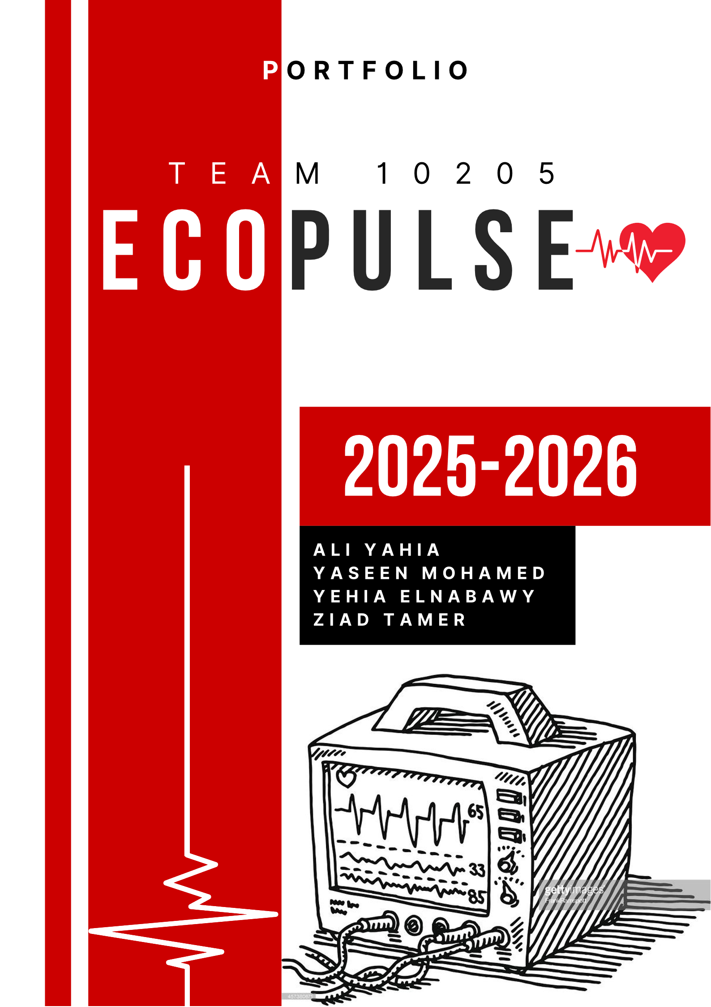

Table of Contents
Introduction 4
Chapter 1 5
1.1 Egypt Grand Challenges 6
1.1.1 Reducing the effect of climate change 6
1.1.2 Address & reduce pollution in air, water, and soil 10
1.1.3 Improve the scientific and technological environment for all 14
1.1.4 Recycle garbage and waste for economic and environmental purposes 18
1.2 Problem to be solved 23
1.2.1 Negative consequences 25
1.2.2 Positive consequences 27
1.3 Topics related to the problem 30
1.3.1 The effect of limited equipment on STEM education in Egyptian public schools. 30
1.3.2 The economic and environmental burden of e-waste in Egypt 30
1.3.3 Health and environmental hazards of improper e-waste handling 31
1.4 Topics related to the solution 31
1.4.1 E-waste low analysis and component collection 31
1.4.2 Sensor technology and data acquisition systems 32
1.4.3 Active learning and creativity-centered education 33
1.5 Prior solutions 34
1.5.1 Spectrophotometer 34
1.5.2 Microcentrifuge 38
1.5.3 Smart Heart Rate Monitoring System Using Arduino-Uno (2023) 41
1.5.4 Multimeter Using ATmega328p 45
Chapter 2 48
2.1 Solution requirements 49
2.1.1 Sustainability through e-waste recycling 49
2.1.2 Enable active scientific inquiry 50
2.2 Design Requirements 50
2.2.1 Selection of solution 51
2.2.2 Selection of prototype 53
Chapter 3 55
3.1 Abstract 56
3.2 Introduction 57
3.3 Materials and Methods 59
3.3.1 Table 1: Materials used in the implementation of the prototype: 59
3.4 Methods 60
3.5 Test plan 61
3.6 Results 62
3.6.1 Negative Results: 62
3.6.2 Positive Results: 62
3.6.3 Table 2: BPM and SPO₂ readings: 63
Chapter 4 64
4.1 Analysis & Discussions 65
4.1.1 Photoplethysmography 65
4.1.2 Amplifying and noise reduction 67
4.1.3 Phototransistor vs. Photodiode 68
4.1.4 Accuracy Validation & Mechanical Optimization 69
4.2 Conclusions 70
4.3 Recommendations 71
4.3.1 Empowering Education and Healthcare through Recycled Innovation 71
4.3.2 Integration of IoT and Telemedicine Capabilities 73
4.3.3 Cuffless Blood Pressure Estimation (PTT) 74
4.4 Recommendations to Other Teams 74
4.5 Project’s Positive Influence 75
4.6 Learning outcomes 75
4.7 Literature Cited 77
4.8 Acknowledgements 77

Introduction

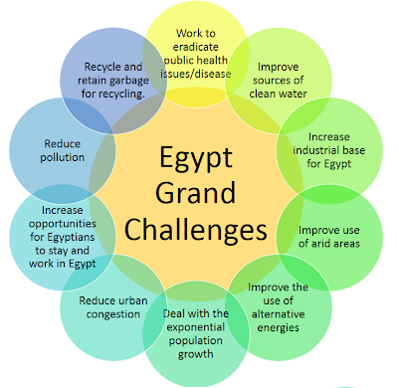
Egypt faces a range of big challenges that need urgent attention to ensure a sustainable future as shown in (Figure 1). The country’s Vision 2030 plan aims to guide its development by addressing key economic, societal, and environmental issues. However, rapid population growth and limited progress in technology make it harder to solve these problems. To move forward, Egypt needs innovative solutions that can tackle its challenges while promoting long-term sustainability.
Figure 1: the Egypt grand challenges
One major challenge is the fast-growing population, which puts pressure on housing, healthcare, and education. Rapid urbanization is another issue, leading to overcrowded cities and strained infrastructure. Economically, Egypt is working to diversify its economy and reduce its reliance on old industries. Environmental challenges are also significant, with pollution affecting the air, water, and land. At the same time, energy demand is increasing, making a shift toward renewable energy sources essential for the future.

Other challenges include the management of solid waste whereby the current systems cannot support the increased levels of waste being generated. The way such challenges are approached largely dictates the efforts made for securing the future development of Egypt. Now, let's dive into five specific grand challenges out of the eleven which face Egypt: we will take a closer look into their root causes and impacts for ensuring that the nation attains sustainable development and economical balance.

Chapter 1
Present and justify a problem and design requirements

Egypt Grand Challenges

Reducing the effect of climate change
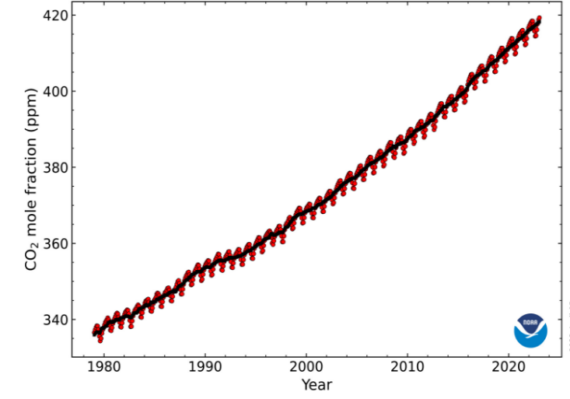
Figure 1- the increase of CO₂
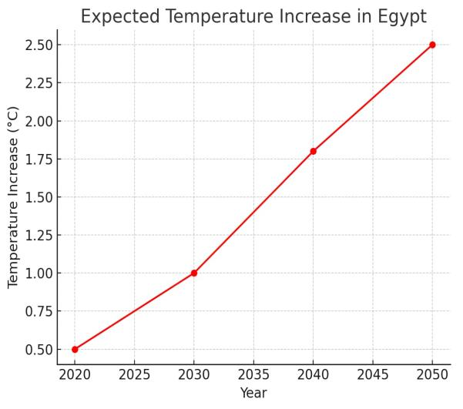
Climate change is a global problem facing countries all over the world. Climate change is used to describe the change of the climate in a particular region or for the whole world and that is driven by different human activities like deforestation and burning fossil fuels, that affects the climate with an increase in the percentage of greenhouse gases like carbon dioxide (CO₂); that increased with a percentage of 50% as shown in Figure 1 and methane (CH₄); that causes more problems in the whole world like global warming additionally, national cooperation tried to solve this problem, as in COP27 in Sharm El-shaikh in Egypt.
Figure 2 - expected temperature increase
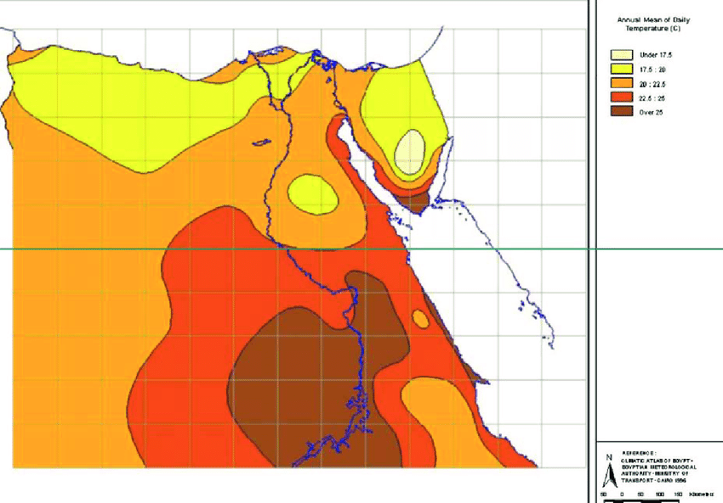
Climate change also has its influences on Egypt as the population growth rapidly, pollution increases in big cities which is a key cause to climate change in Egypt. Climate change has a great influence on Egypt, with the winter getting colder, and the summer getting hotter than ever before with a lot of differentiation in temperature. Predictions and expectations for Egypt’s future temperature increase is shown in Figure 2, with also the annual mean of temperature in Egypt increasing as illustrated in Figure 3, this increase will have many negative impacts for Egypt in different economic activities like farming and grazing. Climate change also influences the economy of Egypt; it badly affects the tourists and the coastal cities like Alex or Sharm El-shaikh.
Figure 3 - annual mean of temperature

Causes

Heavy Reliance on Fossil Fuels
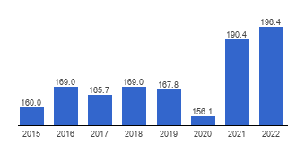
  - Greenhouse gas emissions and waste materials have influenced the climate, especially during the latest period, as the industrial revolution has risen in Europe and the factors have become more so the smoke that came out from the factories or the waste materials that were thrown at the Nile was an enormous factor for climate change. Another reason is burning fossil fuels which increases the percentage of carbon dioxide in the atmosphere and generates energy from coal, oil, or natural gas produces carbon dioxide and methane gas, which is also produced by the decomposition of landfill waste that Egypt mostly suffers from in the slum areas and the crowded outskirts neighborhoods. Also using non-renewable energy is considered a factor for climate change in Egypt because of the dependence on using gasoline for most of the vehicles in Egypt. The use of gas in Egypt annually is shown in Figure 4
Figure 4 - Egypt gasoline consumption

Global warming
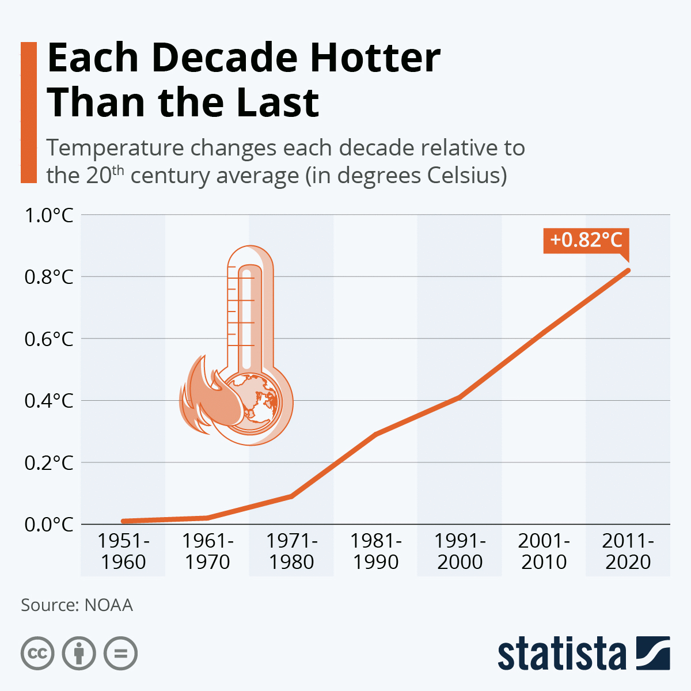
  - Global warming is a problem caused by the high increase in temperature in the whole world as it increased by 0.82 C in the last decade. In governments like El-Minya in Upper Egypt the temperature has reached 40 C and 44 C in recent years due to the increase in greenhouse gases caused by burning fossil fuels and landfill sites that increase the temperature due to the increase in population in Egypt, human activities, and car exhaust, especially in crowded cities in Egypt like Cairo or El-Giza and the temperature change is shown in Figure 5. One of the reasons for global warming and climate change is the Ozone hole that allows harmful rays like ultraviolet (UV) to get into the earth's atmosphere which also melts the ice in the polar.
Figure 5 – Temperature change

Human activities
Human activities in Egypt like deforestation present in cutting down trees and killing plants due to the expansion of roads and cities or benefiting from the wood and the other products from trees which decrease the absorption of corban dioxide and decrease in oxygen, an essential element for human lives, and that is shown in the opposite Figure 6. Furthermore, desertification that is caused by unsustainable farming which stresses the soil and doesn`t make it suitable for any plants afterward, or cooling of nuclear reactors in oceans that pollute the water and make fish die which also influences climate. Another activity is overgrazing which causes a chain reaction in the soil that makes it not suitable for agriculture and decreases the health of the soil and higher its temperature, making it more susceptible to wind erosion and water runoff.

Impacts

Sea level rise
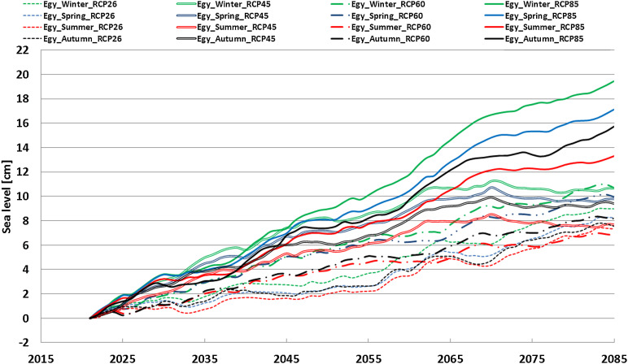
The rise in sea level is represented as a key impact of climate change, it occurs due to the melting of ice in the polar and the rise in the level of the ocean which will eventually lead to sinking of coastal cities in Egypt like Alex or Ismailia which are considered as crowded and important cities in Egypt as Alex is considered as the main port of Egypt and that will influence the economy of Egypt also the level of the Nile will increase as it connects with the Mediterranean and it will influence, there are expectations for rising sea levels to 1.8 and 4.9 mm/year with an average of 3 mm/year as it is shown in Figure 7.
Figure 7 - expectations for rising sea level

Reduced tourism
  - The climate is one of the most important majors for international tourism to relax in the sun or play in the snow and determine the destination of the tourists and what they need, so climate change also affects tourism in Egypt as it can sabotage different landscapes in Egypt, also the continuous rainfall prevents tourists from coming to Egypt and enjoying its antiquities like the pyramids which is affected by climate change and wind erosion. Changes in the weather is a disadvantage for Egypt because of the sudden rain that is unpredictable in summer. The crowded cities will suffer from the heat island effect as the people prefer to use air conditioning to be cool in summer which increases the consumption of energy, expelling hot air that makes cities like Cairo even warmer. Climate change can reduce the percentage of tourism due to the large population in crowded areas with an infectious disease and insects that will appear with the hot air.

Deterioration of the local economy
Climate change with high heat and lack of water in the soil has wide bad effects on the local economy of Egypt as it depends on the local industry products which mostly consist of the crops that have been influenced by climate change and heat stress and these crops that require several conditions to grow like rice which requires much water and sunny weather, other crops like vegetables and fruits that are used as healthy food for sports people, and vegetables used on traditional food that the most preferred food to the Egyptian nation, and lack of these crops will cause the low quality of meat and milk because of the caw that feeds on clover.

Address & reduce pollution in air, water, and soil
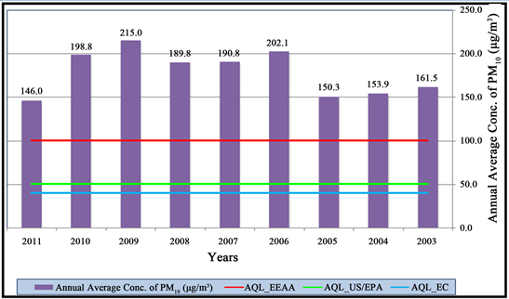
Egypt's current environmental crisis is a significant challenge. For example, air pollution in Alexandria has taken place on a massive scale, with its yearly PM10 levels averaging 136 μg/m³ as shown in Figure 8, which represents nearly seven times the WHO guideline of 20 μg/m³. the majority of the emissions are industrial and vehicle emissions. The Nile River is also highly polluted, with approximately 4.5 million tons of pollutants annually, among them toxic heavy metals like cadmium and lead above safety thresholds. Agricultural facilities add to the problems further, as pesticide and fertilizer chemicals pollute water sources and agricultural land. Industrial sites and even buildings also contain lead concentrations up to 1,200 mg/kg in soil, as 35% of agricultural land is already polluted. This leads to more than 12,000 premature deaths annually and also causes 22% of the rural infections. The country has environmental laws, yet its recycling rate stands at just 30%, demanding an urgent review.
Figure 8: PM10 levels in Alexandria over the years

Causes

Industrial & Vehicle Emissions
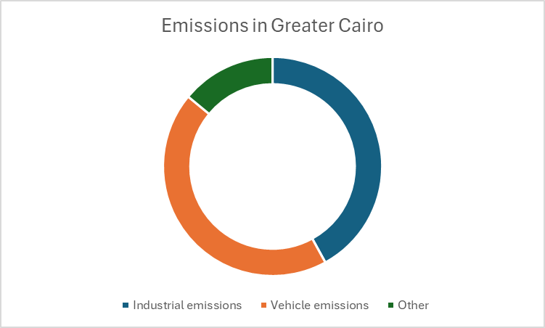
Transport causes 26% of PM10 emissions, over 90% of CO, 90% of hydrocarbons, 22% of SOₓ (Sulphur oxides), and 50% of NOₓ (Nitrogen oxides) in Greater Cairo, where 60% of the vehicles are over 10 years old. Private cars cause the greatest source of emissions from high concentrations (3.83 million cars nationwide) and traffic congestion, to causes fuel inefficiencies. Poor roads are responsible for 3–4% increase in fuel consumption through stop-start traffic patterns. Industrial zones like cement production contribute 42% of the emissions in Greater Cairo as shown in Figure 9.
Figure 9: Emissions in Greater Cairo

Agricultural burning & Pesticides
Overuse of pesticides contaminates (pollutes) Egypt's farmland, with 79.24% of the Nile Delta study area showing very high heavy metal contamination, as cadmium (25.5 ± 3.5 mg/kg) and lead (30.6 ± 10.3 mg/kg) in soil, higher than safe levels due to pesticide remains and fertilizers. Open burning of 90% of rice straw annually emits PM2.5 and dioxins, fueling Cairo's "Black Cloud" phenomenon. Agriculture accounts for 4.5 million tons of pollutants in the Nile every year and causes 40% of biodiversity loss within 30 years. While regulations exist, poor enforcement ensures that just 30% of agricultural plastic is recycled

Plastic & solid waste mismanagment
Egypt generates 80 million tons of solid waste annually, as shown in Figure 10, with the capital city (Cairo) itself generating 15,000 tons daily. The mismanagement is severe; 90% of the waste enters open dumps or water bodies, and Egypt recycles only 45% of its 970,000 tons of plastic waste annually. Egypt is therefore the biggest Mediterranean plastic polluter, responsible for 43% (1.2M tons/year) of the sea's plastic loss. The Nile is subject to 4.5 million tons of pollutants every year, while 92% of Alexandria's marine fish contain microplastics. Despite the recent new Extended Producer Responsibility (EPR) laws charging 37.5 EGP per kg on producers of plastics, rural collection is still 15%, and plastic recycling in agriculture is only 30%, contributing to severe pollution.

Impacts

Contaminated water
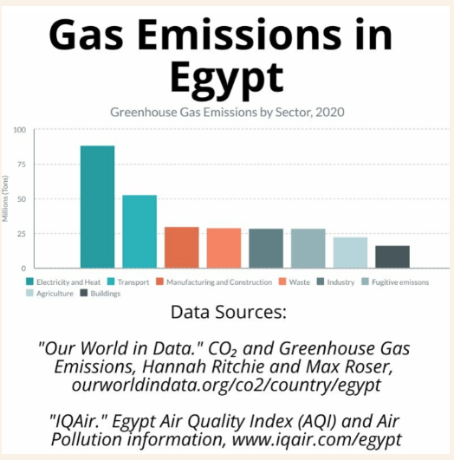
Egypt's water crisis is driven by raw sewage, agriculture, and industrial wastes, dumping 4.5 million tons of pollution into the Nile annually. Cadmium (0.1 mg/L) and lead (0.05 mg/L) heavy metals exceed manageable levels, and nitrate levels of 48.5 mg/L, as opposed to WHO's 50 mg/L, in groundwater are present in the Delta. It is the cause of 22% of rural infections as hepatitis A, for example, and has reduced fish output in Delta lakes by 40% over 30 years. Microplastics now eliminate 92% of marine fish off the coast of Alexandria. Per capita water availability is expected to decline to 350 m³/year by 2050, and treatment is a necessity.
Figure 11: gas emission in Egypt

Soil degradation
Soil degradation severely impacts Egypt's agricultural output, and the Nile Delta loses 45.82% of its productivity due to waterlogging, salinization, and alkalinization. Waterlogging and salinization impact approximately 1 million hectares of irrigated land in the northern-central Nile Delta, with up to 30% calcium carbonate content in the western regions. The coastal areas have multiple risks, such as a 1–5 mm/year land subsidence and sea level rise, putting 30–40% of Egypt's agricultural output at risk. Poorly degraded soil has extremely low organic matter (as low as 0.35–0.8% in sandy soil), thus reducing fertility. Reconstruction of the affected areas, for instance, Lake Mariout, can cost over $7.8 million.

Marine pollution
Egypt ranks top for Mediterranean plastic loss with 43% of the region's plastic loss into the sea (app.1.2M tons/year), and the Nile losing 6,772 tons/year to the Mediterranean. Pollution-heavy coasts are a sign of high pollution levels, 2.79 pieces/m² on average in Alexandria beaches post 2020, and higher lead (49.4 mg/kg) and zinc (78.2 mg/kg) in sediments in Sharm El-Sheikh tourist beaches. Microplastics penetrate the environment, reaching 835.6 particles/m³ through Nile drains in Lake Burullus and polluting 92% of sea fish in the surroundings of Alexandria. This pollution amounts to an economic loss of tourism and fisheries of over €641 million annually.

Improve the scientific and technological environment for all
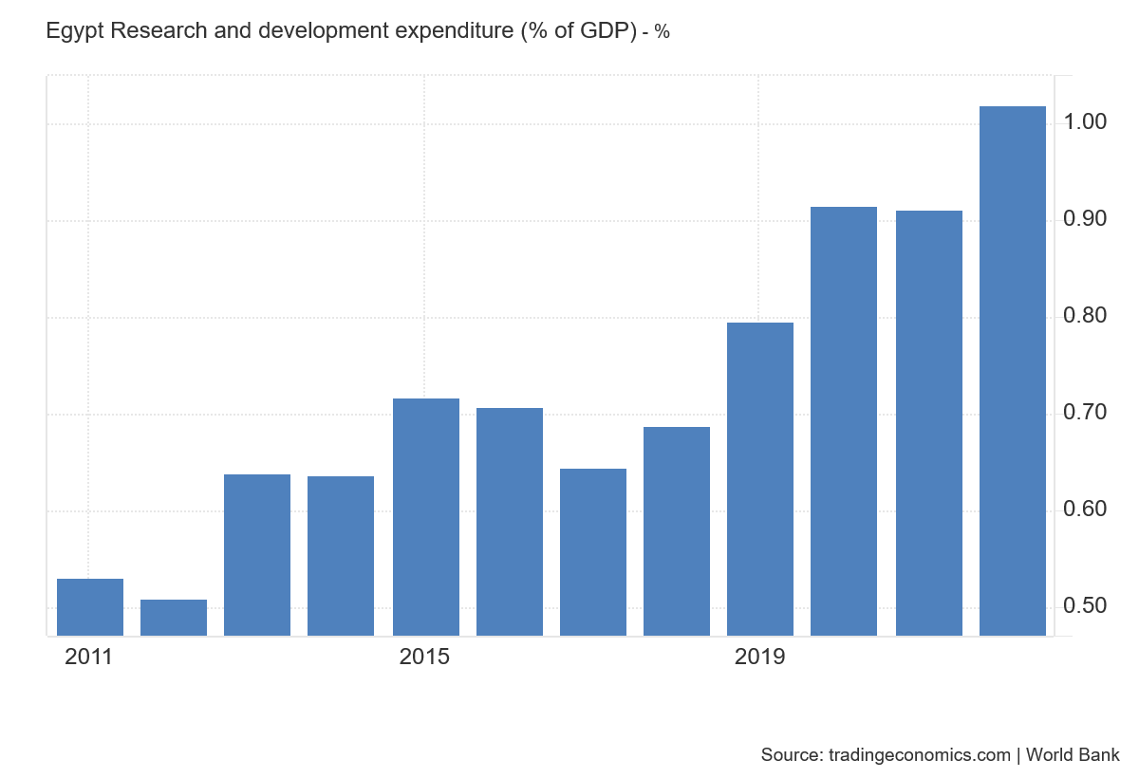
Egypt’s scientific and technological environment is in a state of serious decline. Despite the country’s historical legacy of innovation, current evidence shows that modern research and development (R&D) are grossly underfunded and inefficient. the evidence provided shows that Egypt only spends about 1.01968% as shown in figure 12. The average of developed countries is 2-3% which makes Egypt significantly below the average in developed countries. The lack of sufficient funding has always led to Egypt having old laboratories and subpar tools. resulting in a stifled innovation ecosystem. Students and researchers often find themselves lacking basic resources to conduct meaningful experiments, which, in turn, discourages local scientific breakthroughs and drives talent to look elsewhere for better opportunities.
Figure 12: Egypt research and development
Additionally, almost one-third of students who were the best academically in Egypt and decided to study abroad never came back which indicates a sharp decline in the quality of students. Furthermore, studies conducted by the government and universities show a great deal of inefficiency to progress scientifically while educational institutions remain mired in outdated teaching methods that emphasize rote memorization over critical, innovative thinking. In many cases, these returning students might bring back advanced skills or cutting-edge knowledge, but that possibility is undercut when they remain abroad in countries offering more research infrastructures and better funding opportunities.
The educational system in Egypt is a cause for concern. Students are often taught to memorize facts rather than question and explore. Graduates leave universities with strong test-taking abilities but limited problem-solving skills, which further compounds the challenges facing the research community. All these factors combine to create a scientific environment that struggles to adapt to global standards, ultimately weakening Egypt’s capacity for innovation and technological advancement.

Causes

Outdated Educational System
Egypt’s education system struggles to keep up with modern scientific and technological environment. Although the country has a good history of innovation, most schools and education systems focus on memorization instead of teaching problem solving and critical thinking. This leaves students with weak research and problem-solving skills, making it harder to innovate and solve critical problems.
Figure 13: GDP spending
The Global Innovation Index (GII) ranks Egypt 86 out of 133 countries, highlighting this gap. Low education funding is a key reason. figure 14 shows Government Expenditure Spending which Reflects education spending relative to the government’s total budget and priorities. Education’s share of government spending fell from 6.7% in 2020/21 to 5.3% in 2024/25. figure 13 shows GDP Spending which Reflects education spending relative to the entire economy's size. Drop from 3.9% of GDP in 2014/15 to 1.7% in 2024/25. the real value compared to overall spending and economic growth declined.
Figure 14: GES Egypt
These funding shortfalls led to outdated facilities and teaching methods. The British Council and local studies note that teachers often rely on rote learning, leaving graduates poorly prepared for advanced research or innovative work.

Underinvestment in R&D
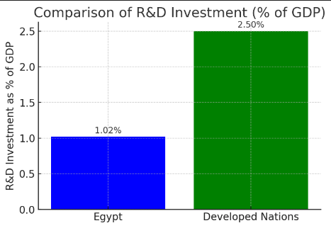
One of the biggest reasons Egypt’s science scene is struggling is that not enough money is being spent on research and development (R&D). Right now, Egypt invests only about 1.02% of its GDP on R&D as shown in Figure 15, advanced countries typically spend between 2% - 3%. With such low investment, many of Egypt’s research facilities are outdated and in need of serious repairs. The equipment in these labs is often old and not up to the task of supporting modern scientific work.
Figure 15: R&D
The situation is even more troubling because it drives many talented students and researchers to leave the country in search of better opportunities. Studies have shown that about one-third of Egypt’s best students who study abroad never return.

Impacts

BrainDrain

Another critical factor is the continuous exodus of talented scientists and engineers. Evidence from the British Council and local academic studies shows that a significant portion of Egypt’s top-tier talent leaves the country in search of better opportunities abroad. This persistent brain drain not only depletes the nation’s intellectual capital but also reinforces a cycle of underachievement by discouraging investment in local research and innovation.
Figure 16: brain drain

Global Crises
Heightened vulnerability to global crises is one of the most alarming consequences of Egypt’s underdeveloped scientific and technological environment. With a Global Innovation Index ranking of only 86 out of 133 countries and R&D spending at just around 1.02% of GDP compared to 2–3% in more advanced economies Egypt is not prepared to handle sudden external shocks.
One stark example is the energy sector. In 2021, Egypt produced 70 billion cubic meters of natural gas, but this figure is forecast to fall to 53 bcm by 2024. This decline has led to daily power outages lasting two to three hours during the peak summer months, affecting millions of citizens and disrupting critical sectors like healthcare and manufacturing.
Falling education spending from 2.3% of GDP in 2020/21 to 1.7% in the 2024/25 budget signals a weakening commitment to developing the skilled workforce needed for crisis response and technological innovation. This is compounded by a brain drain where roughly 33% of Egypt’s top students studying abroad never return, depriving the nation of essential human capital.

Reduce competitiveness
Egypt’s ability to compete on the global stage in science and technology is very weak, and this reduced competitiveness creates many challenges for the country. One major sign is that Egypt produces very few new inventions. Another issue is that Egypt publishes fewer scientific research papers compared to other countries. Fewer publications mean that less new knowledge is shared with the rest of the world, making it harder for Egypt to learn from global advancements or to contribute its own discoveries.
The number of researchers in Egypt is also lower than in many competitive countries. For instance, the number of researchers are 138,491 which is also considered low. With fewer experts available to work on innovative projects, the country misses out on the chance to develop new technologies. there is very little collaboration between universities and businesses. In many successful countries, strong partnerships between academic institutions and industry help turn research into products and services that can grow the economy. In Egypt, however, these partnerships are weak, so even when research is done, it rarely leads to new, useful innovations.

Recycle garbage and waste for economic and environmental purposes

Despite all the talk about the environment, for the past fifty years, Egypt has remained oblivious and continues to waste huge amounts of plastic with a generation of about 250,000 tons annually.
Recycling is important in taking care of the environment in which the collection and processing of materials that would otherwise be considered waste and transforming them into useful products are carried out, which reduces waste. Common materials subjected to this process include iron and steel scrap, glass bottles, paper, and plastics. It can reduce pollution, save energy, and lower the demand for raw materials by recycling. However, a large part of plastic waste in Egypt is currently disposed into landfills or to the environment, which leads to increase pollution. Much of this waste could be considerably reduced through increased recycling efforts, hence leading to a sustainable future. Raising awareness and investing in recycling infrastructure is vital in this direction.
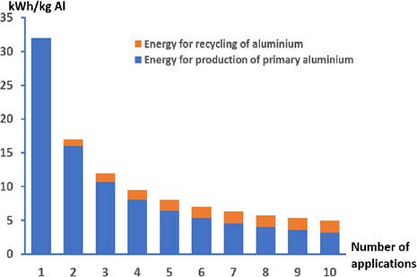
Many problems such as air pollution and water pollution are obstacles to the progress of societies, and recycling helps solve these problems. Producing new products from raw materials requires a lot of energy. Still, recycling uses less energy, as shown in Figure 6, the difference between manufacturing raw materials and recycling in energy consumption. In the second application of aluminum, to produce aluminum from primary sources it needs more than 15 Kwh/Kg, and to Figure 6 demonstrates the difference between manufacturing from raw materials and recycling in terms of energy consumption recycle aluminum it needs less than 5 Kwh/Kg. Landfills can cause environmental problems, and recycling can solve these problems
Figure 6 demonstrates the difference between manufacturing from raw materials and recycling in terms of energy consumption

Causes

Economic challenges
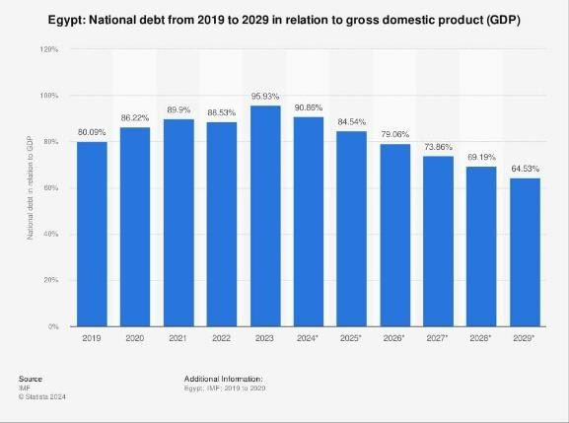
  - Egypt faces many economic challenges which are one of the causes of the lack of recycling. Recycling requires many requirements such as machines, technology tools, recycling factories, and technology expansion, which are difficult to provide all these requirements because Egypt has many economic problems, as shown in figure 7, Egypt suffers from a huge problem in the dependence of the local economy on debt currently. Egypt does not have sorting, processing, and manufacturing machines which are the base of waste recycling.
Figure 7, this graph shows Egypt's national debt as a percentage of GDP from 2019 to 2029.

Waste management challenges
  - There is a study titled "Status, Problems, and Challenges for Municipal Solid Waste Management in Egypt" that proved that most of the recycling activities in Egypt are driven by private initiatives and informal sectors. Recycling activities in Egypt face numerous challenges, with an underdeveloped waste management system paper and metals have relatively better recycling, while organic wastes are very underdeveloped because of the low market value and unavailable appropriate infrastructure. Cairo produces 15,000 tons of waste daily, and Alexandria, the second most populous city, produces 4,000 tons, but most are either burned or improperly disposed of. The lack of proper waste processing and recycling exposes a lot of health and environmental risks, such as polluted air from the waste burning, with a further lack of composting. Sustainable waste management cannot be possible without more robust governmental action and better market motives for Egypt.

Environmental neglect
In Egypt, environmental concerns are not a top priority for the government or the public compared to other pressing issues like economic challenges. According to UNEP, the government in Egypt sometimes does not care about the air pollution and water pollution that results from burning garbage and waste, and they do not recycle waste instead of burning it to reduce this pollution. In Egypt, most of the waste collection and recycling is handled by informal workers, who often work without modern tools or government support. This limits the overall recycling rate in Egypt.

Impacts

Waste of natural resources and energy
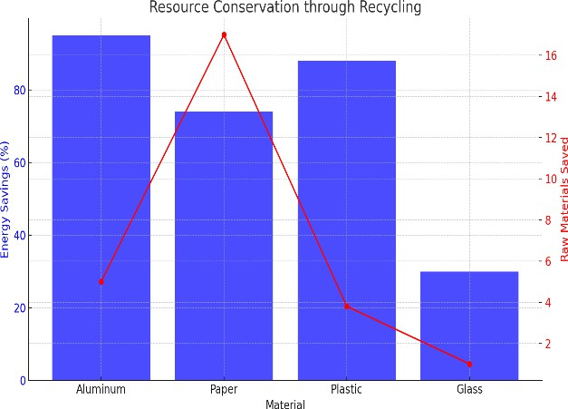
  - Without recycling the natural resources will be wasted, so Egypt should recycle garbage instead of burning it. As shown in Figure 8, the two most perfect materials in saving energy and saving the raw material are the aluminum & plastic they save a lot of energy also they save a lot of raw material. Recycling saves natural resources by reusing materials instead of extracting new ones, and saves the energy used in extracting raw materials, so now Egypt uses more energy Figure 8: This graph shows the resource conservation through recycling and natural resources because it does not use recycling but extracts new raw materials.
Figure 8: This graph shows the resource conservation through recycling

Greenhouse gas emissions
Recycling reduces greenhouse gas emissions, which causes climate change. Using recycled materials to make new products reduces the need for raw materials and avoids greenhouse gas emissions that would result from extracting or mining raw materials. Recycling saves up to 95% of the energy required to produce aluminum from raw materials, recycling steel saves about 60-74% of energy. Egypt has very high greenhouse gas emissions resulting from the burning and landfilling of waste that should be recycled. Burning waste produces a quantity of CO₂ around 1 ton per ton of waste, while recycling will reduce wastes emission by 30-50, together with saving much energy and reducing methane production in landfills.

Problem to be solved
Systemic Barriers to active science learning in Egypt: financial inaccessibility and E-waste liability

The future of science and innovation in Egypt depends entirely on the teaching methods applied in the Egyptian schools today. Unfortunately, a major, hidden problem is holding back pre-university education in Egypt. Schools are stuck using old, passive teaching methods that prioritize memorization over genuine discovery. This educational failure is worsened by a critical lack of practical equipment. To top it all off, Egypt has an enormous, growing problem with electronic waste (E-waste) that could actually hold the key to the solution. This trio of problems (bad teaching, scarce resources, and environmental mismanagement) needs to be fixed to build a stronger scientific future.
Modern science education requires students to learn actively through doing, questioning, and experimenting. While many Egyptian public schools still rely on a traditional, passive approach where teachers dictate facts, even advanced institutions like the STEM High School for Boys in 6th of October face barriers. The school’s curriculum is built on active learning, but this great idea breaks down in practice. In subjects like biology, students need to do hands-on experiments and collect real-time data (on cardiovascular responses, for example) which are essential for true understanding. The school's biology lab, for instance, is limited to figures, diagrams, and microscopes, lacking the essential physiological sensors for dynamic experiments. When this practical experimentation is limited by resource constraints, even bright STEM students miss crucial opportunities to develop deep critical thinking, data analysis, and scientific inquiry skills, which ultimately hurts the quality of national scientific research.
The shift to hands-on learning stalls immediately when schools look at the price tag for equipment. While one commercial sensor unit (costing from 500 up to 2,500 Egyptian pounds) seems affordable, the cost explodes when you consider the classroom size. Public-school classes often have over 50 students, meaning a single lab needs 10 to 20 durable devices just for basic small-group work. This drives the cost up to a prohibitive 5000 to 25,000 EGP per lab. This massive financial difference creates a deeply unfair divide between well-equipped private schools and financially strained public institutions, making it nearly impossible for the latter to adopt active teaching models at scale. Moreover, these expensive commercial devices are often fragile, requiring high maintenance and replacement costs that budgets simply cannot support.
This resource scarcity occurs while Egypt faces one of the biggest E-waste problems in Africa. In 2022 alone, the country had an estimated 690 kilotons of old electronics. This isn't just a junk problem; it’s an environmental crisis. When managed informally, this waste releases harmful toxins such as lead and mercury into our soil and water, which is a threat to public health. Furthermore, every piece of E-waste contains valuable resources, including functional electronic components and rare earth elements, that are currently being buried or burned. This material is a massive, untapped source of components that could be recycled and transformed into the very affordable, sustainable scientific instruments our public schools need for hands on learning.

Negative consequences

The Rote-Learning and Skills Gap Crisis

The educational system’s failure to evolve from reliance on memorization and standardized testing to active learning and critical thinking has created a severe and costly skills gap. This system equips graduates with none or very few High-Order Thinking Skills (HOTs) that modern, digital, and AI-driven economies require, causing even more unemployment, particularly among educated individuals. Frustration over this caused a devastating Brain drain, where the country loses investment in human capital and potential with its most talented professionals, such as physicians, engineers, and researchers, who seek fertile ground for their innovation and critical thinking. This outward flow of talent is a social issue, but more importantly, a devastating economic one. Research in Egypt and other comparable countries reveals that a 1% increase in the number of skilled workers abroad leads to a 5.7% contraction in the GDP, an impact on the very workforce and capabilities that are critical for future growth. This dynamic in the educational system is exacerbated by Egypt’s low global ranking (133 of 137 in 2017) and entrenches reliance on low-skill jobs, rather than shifting toward a robust modern economy that values knowledge and innovation.

Environmental and Economic Damage from E-Waste

Due to population growth and relatively new markets, Egypt has been increasingly growing in the consumption of electronic goods, and subsequently e-waste generation. In 2019, e-waste generation was estimated to be 0.586 million tons, over 0.5 million tons, one of the highest in Africa, and growing faster than the population. What makes the situation more critical and more dangerous is that there is, to this day, no legally sanctioned, formally regulated system of national management of this Waste Electrical and Electronic Equipment (WEEE). The informal sector, which is where the large majority of regulated e-waste gets placed, is one of the most dangerous sectors to work in. The informally contracted workers are to perform sensitive dismantling tasks without any precautions, and child labor is often employed through the informal sector. Ignition of unregulated disposal devices releases and burns hazardous waste, including lead, cadmium, and mercury. It is a public, long-term health crisis that affects the workers and people of the area. There is a large economic opportunity in the informal part of the e-waste sector that is lost. There is raw, valuable waste, including gold, silver, platinum, and palladium, that is lost. When these raw materials are exported, the green recycling industry that could be built in the economy and work for the economy loses money.

Erosion of Practical Technical Skills and Localized Green Innovation

Not embedding active and practical learning styles into the formal education system creates a big gap in the education system for technical skills. Science and Engineering education focuses too much on theory and exams, and this results in the absence of crucial skills in demand, such as the ability to diagnose circuits, identify repair materials, dismantle machines, and repair with accuracy and precision. These skills, among others, are precisely those that could thrive in a safe, formalized training environment anchored around Waste Electrical and Electronic Equipment (WEEE). Instead, the priceless opportunity to learn, having informal e-waste processing in the dangerous informal sector, is monopolized. The informal system utilizes exploited waste labor and seizes important practical knowledge, locking it away in the unsafe, hazardous, unregulated environment of the back streets. The knowledge is kept away from the practical component of formal technical education and professional post-secondary training in the e-waste processing work. The unregulated environment is monopolized by a Practical Skill Blackout, where the national economy is unable to establish a professional high-skill repair and refurbishment industry. This results in high material consumption and a dangerous dependence on imports. By forfeiting the chance to integrate e-waste recovery as a massive, real-world, hands-on laboratory for active learning, the nation ensures its citizens remain theoretical experts, incapable of fostering the localized innovation required for developing sustainable, circular economy technologies.

Positive consequences

Exponential Economic Growth and Societal Equity

A very important factor which triggers national transformations in their economies is the successful reform in education that shifts the tone from rote learning to active learning and develops High-Order Thinking Skills (HOTs) among the learners. This reform would indeed counter brain-drain by establishing a national talent pool with globally competitive skills to innovate and lead in the digital economy. The retention and empowerment of this highly-skilled human capital, they say, has a tremendous economic payoff; empirical models have projected that a 1% increase in the human capital variable leads to a spectacular increase of 4.4% in GDP. Boosts to the economy are expected from increased productivity at the national level, entry into higher-value sectors, and an influx of high-quality foreign direct investments through a sophisticated local workforce. Beyond economics, educational reform is a powerful tool for social equity. The enhancement of school quality, teacher training, and curriculum relevance for all students, especially those from marginalized backgrounds, has fostered true social mobility within the system. Targeted improvements in school conditions can lead to school enrollment of 42 percentage points; this indicates that a modernized education system will build stronger, more resilient, and truly equitable societies.

Environmental Stewardship and Resource Reclamation (E-Waste)

Creating a national plan to manage electronic waste (e-waste) is a great chance to turn a serious environmental problem into a “green economy.” This plan should include strong collection systems across the country and laws like Extended Producer Responsibility (EPR), which make companies responsible for their products even after people stop using them. Making e-waste management official and organized will attract private companies to invest in safe and modern recycling centers. This change will do two important things: protect people’s health by stopping unsafe waste-handling methods, and create thousands of new, safe, and skilled jobs in recycling and environmental work.
E-waste also has a lot of hidden value as it contains precious metals like gold, copper, and palladium. By recycling the 0.586 million tons of e-waste the country produces each year, we can recover these materials instead of throwing them away. This helps the economy, reduces the need to import expensive raw materials, and supports sustainable growth. In short, managing e-waste properly can protect the environment, improve public health, and create valuable new job opportunities for the future.

Transformation into a Hub for Science, Technology, and Innovation

Targeted and increased national investment in Research and Development (R&D) is the non-negotiable prerequisite for achieving technological self-reliance and global relevance. By increasing R&D expenditure and aligning university research priorities with national development goals (such as water scarcity, renewable energy, and digital transformation), the country dramatically increases its "absorptive capacity"—the ability to efficiently adopt, integrate, and commercialize new technologies. This environment fosters robust, genuine partnerships between research institutions, technology parks, and the industrial sector, leading to the successful translation of high-quality research into profitable, marketable products and innovative startups. This surge in domestic technological innovation creates a powerful positive feedback loop: it attracts high-quality Foreign Direct Investment (FDI), stimulates the creation of high-wage job opportunities, and reduces the economy's reliance on foreign technological imports. The ultimate success metric for this reform is the nation's improved international competitiveness. Historical projections show that achieving top-tier quality in the nation's education and research training system could elevate Egypt's Global Competitiveness Index (GCI) rank to the 46th most competitive nation globally, validating the national sustainable development agenda and establishing the country as a credible hub for innovation and technology in the region.

Topics related to the problem

The effect of limited equipment on STEM education in Egyptian public schools.

The lack of laboratory equipment, such as health monitoring systems, is one of the major challenges facing Egyptian public school systems. This gap creates a significant disparity between theoretical knowledge and practical application, particularly in subjects such as biology. When students cannot see the physiological reactions to physical activity or exercise in real life, some scientific concepts remain difficult to visualize. This may force students to rely on memorization of facts rather than practical exploration, making it difficult to develop the practical skills necessary for future scientific and technological progress in Egypt. The situation is exacerbated by the large class sizes in public schools. Classes can reach 40, with more than 50 students in each, requiring multiple devices for effective group activities. This makes a significant difference in the quality of education compared to better-equipped private and international schools.

The economic and environmental burden of e-waste in Egypt
Egypt faces two major challenges: it needs to improve its public schools and, at the same time, deal with its growing e-waste crisis. In fact, Egypt produces the highest amount of e-waste in Africa, estimated at 690 kilotons in 2022 alone. These discarded electronic devices are one of the most dangerous types of waste because they contain complex materials that are difficult to dispose of safely. Much of this waste is handled informally, causing long-term pollution as harmful chemicals leak into the soil and water, endangering the environment and people's health. This mismanagement causes massive economic losses as the valuable and limited natural resources contained in these devices are lost instead of being recycled. This situation runs counter to the national goal of recycling waste for economic gain and environmental protection.

Health and environmental hazards of improper e-waste handling
Improper management and disposal of electronic waste, commonly known as e-waste, poses a range of direct, often overlooked health and safety risks. Inside old electronic devices, high voltage components, particularly the capacitors and cathode ray tubes found in old monitors, can carry a powerful and dangerous electrical charge even after they have been unplugged. This residual energy poses a significant risk of severe electric shock to anyone attempting to disassemble them without proper training. Furthermore, these devices contain a cocktail of harmful chemicals, such as lead, mercury, and flame retardants, which can leak if the casing is damaged. When handled in poorly ventilated spaces or without the necessary protective equipment, such as gloves and goggles, these materials can be inhaled as dust or absorbed through the skin, posing significant health risks. In the broader community, improper disposal of e-waste results in these toxic materials seeping into the ground. Addressing this growing problem is crucial to reducing the widespread pollution that harms Egypt's air, contaminates its essential water supply, and degrades its precious soil, ultimately protecting public health and the environment.

Topics related to the solution

E-waste low analysis and component collection

There are many hidden components in the e-waste stream. Before starting any construction, it is essential to understand the available resources. This research identifies common e-waste items, like printers and computers, and creates a careful inventory of their valuable components. For example, printers often conceal micromotors and optical sensors, whereas older power supplies provide useful components such as transformers, fans, and heat sinks. A systematic process is then created for safely and efficiently collecting components. Proper disassembly techniques are learned to prevent damage to these delicate parts, and safety protocols for handling potentially hazardous materials are understood. A multimeter test is performed on each recovered item to ensure it remains functional. Through this careful approach, a pile of random e-waste becomes a cataloged library of functional parts, ready for a new purpose.

Sensor technology and data acquisition systems

The primary role of most scientific instruments is to sense something, usually using a sensor. The focus here is on the technology that enables the instrument to sense its surrounding environment. Part of the research focuses on identifying the different types of sensors found in electronics waste, including thermistors that sense temperature or photodiodes that sense light, and understanding the science behind them. The second, equally important, point is data acquisition. Data acquisition is a highly efficient process that converts an analog signal, the dim output from the sensor, into a meaningful digital number. This is often handled by a microcontroller, acting as the brain of the sensor. Further research can delve into how to amplify or filter the signal coming from the sensor to make it more accurate and easier to read for the microcontroller setup. This is the essence of how a simple sensing component can become the data acquisition hub, enabling the operation of a basic scientific instrument.

Active learning and creativity-centered education

Teaching methods are changing. One concern remains: the old method is still used in many schools, where the teacher lectures and students are expected to sit quietly and memorize. In the new method, students become active. Learning is not achieved by rote memorization, but rather by experimentation and discovery. The focus of learning is shifting from memorization to learning through research and investigation. This is particularly important in science classes in many countries. In this approach, learning is acquired through experience. During practical experience, teachers guide students in their investigations. Students discover and carefully research information. This method helps develop genuine curiosity in students. It also addresses the problem of not learning through practical activity. This method fosters important ways of thinking, such as careful reasoning and critical thinking about information. It allows students to think more like scientists. This is a broader form of education that far surpasses their previous experience of simply memorizing facts.

Prior solutions

Spectrophotometer
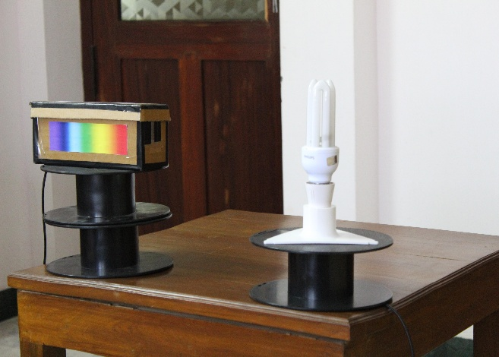
The recycled spectrometer serves as a green, economical substitute for laboratory spectrophotometers. The spectrophotometer enables students to perform spectroscopy experiments at home. The specific spectrophotometer illustrated in Figure X was developed by undergraduate physics students Kousheek Chakraborty and Satya Schiavina. This device breaks barriers to practical education, mainly during global disruptions like the COVID-19 pandemic, by facilitating hands-on analysis of physical light properties using everyday tools.
Excluding the webcam, it comes with a nearly negligible cost of 5$. It repurposes e-waste such as discarded DVDs to promote sustainability and reduce the environmental impact of electronic waste. Key materials include cardboard for the enclosure, black chart paper for light isolation, razor blades for the entry slit, and a webcam as the detector, emphasizing accessibility for environments with resource constraints.
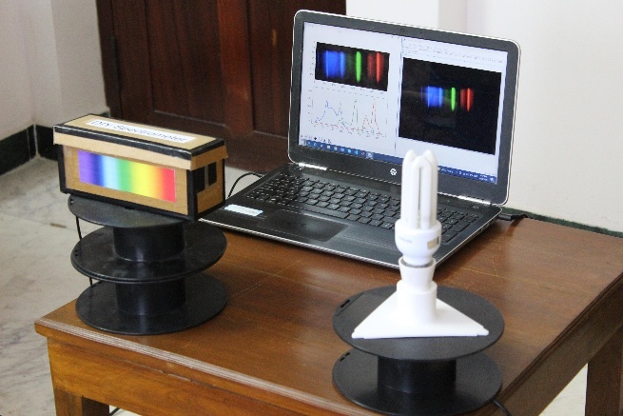
The applications of the device are various, including the examination of light emissions from household sources like CFL bulbs, neon lights, incandescent lamps, and color-changing LEDs, as well as natural phenomena such as sky observations. Additionally, it supports qualitative assessments, such as identifying sodium in table salt or chlorophyll in olive oil, and is integrated with Python software using libraries like OpenCV, NumPy, and Matplotlib for data visualization and intensity profiling.
The spectrometer adds experiential learning in physics to a new level, bridging theoretical concepts with accurate outcomes without requiring advanced experts. Environmentally, encourages recycling, minimizing waste while encouraging communities. Overall, this instrument expands scientific inquiry in introductory settings, promoting inclusivity and innovation in spectroscopy education.

Mechanism
The spectrometer works via diffraction spectroscopy, mainly dispersing incoming light into its wavelengths to display spectral features as shown in Figure X. It employs a diffraction grating sourced from a discarded DVD, which separates light based on its properties. Simply, shorter wavelengths bend at smaller angles, creating a more spread-out spectrum. The setup contains a cardboard housing or coating to block external light, an entrance slit formed by razor blades and paper to make a narrow beam for light to enter through, and a webcam acting as the sensor.
External light enters through the slit, becoming parallel before striking the grating layer positioned at an angle to center the spectrum on the webcam lens. Thus, producing an intensity pattern on the detector. Data analysis uses Python with libraries such as OpenCV, NumPy, and Matplotlib to record images, isolate the spectrum, and plot intensity against position. Calibrating the readings with familiar sources links positions to wavelengths, allowing identification of emission lines in diverse light emitters.

Points of strength

Low cost and accessibility
The spectrophotometer demonstrates excellent economic efficiency, with assembly costs under $5 —excluding the webcam. It utilizes available recycled elements almost anywhere, including cardboard for externa, structure, black chart paper for optical isolation, razor blades for the slit, and a diffraction grating extracted from DVDs. This design eliminates the high costs associated with laboratory spectrophotometers. Thus, increasing access to spectroscopic analysis in educational centers, and even houses, particularly where budget constraints prevail. By using salvaged materials, the design promotes environmental sustainability through waste reduction, enabling widespread use without compromising functionality.

Ease of assembly
Construction of the spectrophotometer requires only basic elementary skills and common tools, allowing construction in roughly one hour by following straightforward steps. The process goes by forming a precise slit with razor blades, integrating the grating into a cardboard enclosure, and programming with a webcam, all put together by basic adhesives like tape. This uncomplicated design supports usual modifications, such as optimizing slit dimensions for improved performance, while maintaining a compact, portable form. Such accessibility facilitates use among novice users, transforming complex optical principles into easier, replicable experiments that enhance practical understanding in science —especially physics— contexts.

Points of weakness

Resolution limitations
The spectrophotometer's resolving power is majorly restricted by the webcam's imaging sensor; producing spectra with reduced sharpness relative to more professional instruments featuring superior gratings. additionally, emission lines appear broadened, complicating the differentiation of closely spaced wavelengths in intricate light sources. Although it’s enough for basic evaluations in educational demonstrations, it proves insufficient for applications demanding high-accuracy quantitative data, such as detailed molecular spectroscopy. Calibration using reference standards partially compensates these issues. However, variations in sensor resolution, such as standard 640x480 pixel arrays, can still introduce inaccuracies that visualize the limits of low-budget optical systems.

Light leakage risks
The reliance on a cardboard-based enclosure makes the device subject to unintended penetration by ambient light. Thus, increases baseline noise levels and diminishes the clarity of spectral readings. Efforts to revamp this through black paper reinforcements often fail, as minor gaps adjacent to the slit or grating permit interference, especially in illuminated environments. This issue shows the necessity for controlled, darkened testing protocols to achieve dependable outcomes. In scenarios like low-intensity photometry, such vulnerabilities decrease measurement reliability, highlighting the value of supplementary sealing techniques guarantee optical isolation without additional costs.

Microcentrifuge
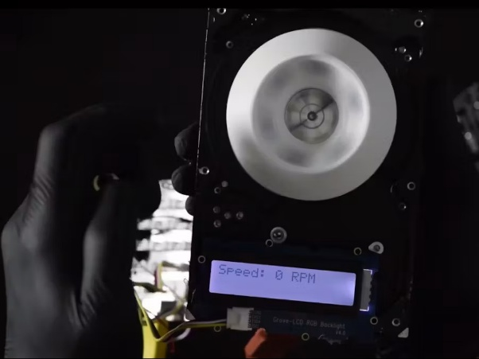
The microcentrifuge stands as a cost-effective solution for laboratory sample separation. It is made from electronic waste to solve the inaccessibility of used parts in constrained environments. The microcentrifuge achieves functionality within approximately three hours of assembly. The device is made of a recycled hard drive motor for rotational power, an Arduino microcontroller with WiFi extensions, and custom 3D printed/laser cut sample holders as shown in Figure X. While the cost for this specific project is not detailed, the use of recycled electronics and basic tools like soldering irons keeps expenses minimized and environmentally friendly, enhancing its appeal for educational and small-scale lab use. The software is developed using C++ by the Arduino IDE. It also supports adjustable speeds up to an estimated 7200 RPM, with measured outputs displayed on an RGB LCD.
This device works in biology and chemistry laboratories in many applications, such as cell pelleting or phase separation, while improving practical STEM learning through its assembly and programming process. It’s accessible and easy to assemble. It can also be easily replicated due to its open-source framework. The reuse of e-waste reduces environmental impacts by recycling materials from landfills or old electronic devices. However, the development stages face many challenges, including potential scaling issues with STL files and the absence of advanced safety mechanisms. Despite these disadvantages, it offers a promising, eco-friendly tool that improves access to scientific experiments anywhere.

Mechanism
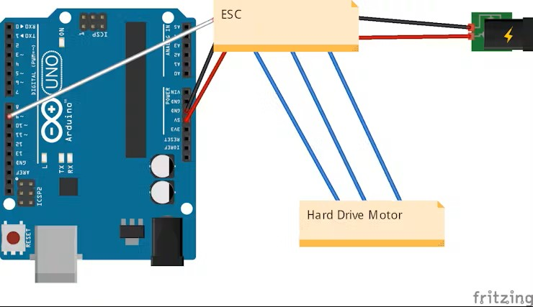
The microcentrifuge separates sample elements by exerting centrifugal force through its ability to rapidly rotate. It relies on a motor recycled from an old hard drive as its main power source. This motor drives a specially designed 3D printed rotor. The way the centrifuge works is simple; the rotor holds the sample tubes in place, then an Arduino microcontroller, extended with a WIFI module as shown in Figure X, handles the speed regulation process, allowing the rotor to reach up to about 7200 RPM depending on the input settings entered through the software. The rotor’s design balance plays a vital role, as it helps to push denser materials to the outer edges while keeping lighter ones nearer the middle for effective separation.
The device is activated by code developed in C/C++ through the Arduino IDE software, which connects to an RGB LCD screen to provide status updates. The Arduino is then controlled to give instructions to adjust the motor's pace according to the specific demands of the sample, delivering immediate feedback to the IDE to maintain accuracy. The overall build makes it easy to transport, and also maintains the rotor stability to avoid vibrations, thus ensuring consistent results in applications such as biological cell processing or chemical extractions.

Points of strength

Sustainability through E-Waste Reuse
The microcentrifuge encourages environmental sustainability by recycling discarded e-waste, such as hard drive motors, and turning them into functional laboratory equipment. This advantage conserves resources by extending the lifecycle of components that would contribute to pollution if not recycled, while promoting the recycling mindset in scientific tools development. By integrating open-source designs, it encourages wider adoption of reuse practices, reducing the demand for new raw materials and supporting long-term ecological balance in educational fields.

Low Cost and Accessibility
The device is a great example of economical stability solutions, combining salvaged parts and basic tools to create an affordable alternative to new centrifuges, with minimal costs required for manufacturing. reliance on e-waste and open-source software lowers costs for users in educational or low-resource environments, enabling small-scale labs, schools, or even individual researchers to perform essential separations without a huge investment. The design's simplicity enhances accessibility, allowing intermediate-level builders to easily replicate it, thus spreading advanced laboratory techniques and promoting scientific experimentation.

Points of weakness

Approximate Performance Metrics
The microcentrifuge's accuracy relies on estimated rotational speeds coming from the device’s potentiometer inputs, leading to imprecise RPM measurements (which can reach up to approximately 7200 RPM) without high-quality sensors for verification. In precision-dependent applications, this may lead to failure in precision-dependent experiments. This approximation can cause variability in outcomes, especially for sensitive biological or chemical processes requiring exact control, which may lead to catastrophic results, limiting its reliability compared to calibrated commercial models. While being suitable for educational demonstrations, it needs additional validation steps to ensure quality, making a trade-off between cost savings and analytical accuracy.

Smart Heart Rate Monitoring System Using Arduino-Uno (2023)
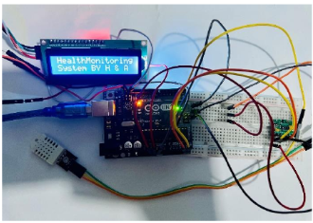
This project was designed and developed by a group of independent researchers, in response to the growing need for biomedical monitoring systems, especially in rural areas and underdeveloped regions. Where there is no access for advanced health care technologies. To address this issue these researchers proposed a low-cost, portable and easy to use electronic device which is capable of measuring heart rate and oxygen saturation in the human body.
The main goal of this project is to determinate the gap between the cost of commercial sensors while maintaining a good and affordable (e waste) sensor. Offering a prototype that could be reproduced in developing countries as a basic health assessment tool. The project also focuses on using easily available materials and simple circuits that can be assembled even with limited technical knowledge. This makes it not only cost-effective but also an educational tool for those learning about biomedical electronics.

Mechanism
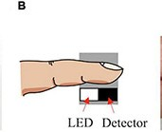
The system operates on the principle of photoplethysmography (PPG), this technique is used to measure changes in blood volume within tissue. Figure x shows the core of the design, which contains an infrared LED and a photodiode (receiver). and the used brain for the device which acts as the microcontroller for the device, which is Arduino uno. Which has the ability to process various sensors. The heart rate senor and oxygen saturation. When a user places the finger tip on the senor, the infrared light emitted by the LED passes through the tissue, thus the infrared red light is absorbed differently as the blood volume changes with each heartbeat. Then these signals are process by the Arduino which filters the data, calculates beats per minute, and estimates the percentage of oxygen saturation in the blood.In addition these data are then displayed in real time on a 16*2 LCD screen, while the entire system is powered either by a direct current supply or a battery pack, while allows mobility.

Points of strength

Low cost of the system
The most major point of strengths lies in the low cost of the system. The use if inexpensive and wildly available components such as Arduino uno and MAX30100 module makes it highly replicable with minimal knowledge and limited resources. Which allows both students and researches to build or modify the device with minimal expertise.

Multi functionality
The system not only offers a great cost compared to commercial products, but it also has multiple functions to enhance its practical value, as it can measure multiple vital signs simultaneously – heart rate, oxygen saturation and temperature. Which offers a better understanding for the users health condition. By correlating multiple readouts, users also obtain an indication of health trends and potential early-warnings of health results.Small areas
The small size of the turbines made the spaces among them small which, as a result, makes the areas that were built with turbines more, not such as horizontal. All these things have made a big space that can be filled with other VAWTs. As a result, the project has done a big result by using these areas.

Portability and simplicity
Another key strength is the portability and simplicity of the design. The design Is lightweight and it is battery-powered, which gives it the ability to work in different environments. It's possible to employ this system outside of a laboratory or clinical setting to make it applicable to healthcare, emergency tracking, and at-home applications. With its small form and battery-based operation, it's very portable and deployable anywhere, enhancing its accessibility and portability.

Ease of programming
Additionally, because the device uses an open-source microcontroller (Arduino), ease of programming and troubleshooting is ensured, allowing for quick software updates or customizations. In other words, with minor changes in the script, new features such as data saving, Bluetooth connectivity, or alarm system can easily be incorporated. This makes it continuously improve with minimal redesigns.

Points of weakness

Commercial modules
Despite its innovative and accessible design, the Smart Heart Rate Monitoring System exhibits several weaknesses that limit its effectiveness in professional or medical contexts. The first major limitation is its dependence on commercially available modules like the MAX30100 sensor rather than recycled or locally fabricated components. This reduces the project’s sustainability and makes it less aligned with e-waste reduction goals.

Accuracy of the readings
Additionally, the accuracy of the readings is significantly affected by external factors such as finger placement, skin tone, and movement. Since the sensors used are consumer-grade, they do not offer the precision required in medical diagnostics and may produce inconsistent results under varying conditions. In order to increase precision and minimize error to less than 5%, the circuit could contain superior noise filtering, superior calibration, and signal averaging methods. Inclusion of motion detection or adaptive filtering could also make the readouts more reliable.

Lack of advanced data management
Another weakness is the lack of advanced data management capabilities. The system only provides real-time readings on a display without any capacity for data storage, transfer, or wireless transmission. This means that it cannot record patient data over time for analysis or remote monitoring.

Multimeter Using ATmega328p
The multimeter based on the ATmega328p microcontroller provides a cost-effective and inn alternative to commercial multimeters. It enables students to learn fundamental electrical measurements such as voltage, current, resistance, and diode checking. It can be constructed with open-source Arduino hardware. With the incorporation of Atmega328p and significant components such as a 16x2 LCD, 7805 voltage regulator, and ACS712 current sensor, this project demonstrates that minimal hardware and simple circuits can give reliable results like traditional tools.
There are four modes in the device: voltage measurement (0–240 VDC), current measurement (AC/DC), resistance measurement, and diode testing. Switching modes is simple with a single push button connected to an interrupt service routine (ISR).

Mechanism
The way a multimeter works depends on the measurement mode you choose. For measuring voltage, a voltage divider network (R1 = 10 kΩ and R2 = 220 Ω) reduces input voltages up to 240 VDC so the analog-to-digital converter (ADC) of the microcontroller gets signals below 5 V. For measuring current, the ACS712 module senses the current flow and gives a voltage signal that matches the detected current.
In resistance and diode testing, the microcontroller applies Ohm’s law by supplying a fixed voltage through a known resistor and calculating the unknown resistance from the resulting voltage drop. This process is pretty much handled by the software developed in the Arduino IDE, which handles all data acquisition, calculations, and display outputs. The push button attached to the external interrupt pin enables smooth mode transitions through software modes.

Points of strength

Low cost and flexibility
The project’s primary advantage lies in its affordability and adaptability. It may be constructed with either discarded or easily acquired electronic components, such that overall expenses remain lower than those involving commercial units. Programmatic simplicity comes with the Atmega328p microcontroller or Arduino Uno. It also becomes possible to characterize both AC and DC using modules like the ACS712 with no additional circuitry, hence good for teaching and small research laboratory experiments.

Compact and educational design
Its simple design allows beginners to assemble and understand its function with basic circuit knowledge. By using an interrupt-based button for mode selection, students learn essential programming concepts like ISR handling and flag-based logic. The LCD display provides clear, real-time feedback for each measurement type, while the breadboard assembly enables modifications and expansions.

Points of weakness

limited precision
It's a good working device that has its accuracy compromised due to the 10-bit ADC resolution, voltage divider resistors' tolerance, and the intrinsic offset of the ACS712 module. All these lead to an inaccuracy that typically lies between 2% and 10%, depending on how accurately it is calibrated and the part selection. Without precise calibration with a lab-grade instrument, it becomes quite challenging to obtain readings that remain in a very tight 5% band.

Stability concerns
Because the circuit relies on the ACS712 sensor and a basic voltage reference, readings may fluctuate slightly due to electromagnetic interference or unstable supply voltage. The 7805 regulator mitigates some of these issues, but power noise can still cause small variations. Shielding the circuit and using low-tolerance resistors can enhance consistency, though at an increased cost. In addition, the breadboard prototype may experience loose connections, further affecting stability.

Chapter 2
Generating and defending a solution

Solution requirements
One of the major barriers identified in the problem analysis is the financial challenge of acquiring standard laboratory equipment for public schools. Commercial sensor units, which cost between 500 and 2,500 Egyptian pounds each, become extremely expensive when scaled up to meet the needs of typical Egyptian classrooms, which often have over 50 students. This creates a significant financial problem to active, hands-on learning application. Therefore, the key requirement for this solution is not just low cost, but an ultra-low cost that can be achieved at a fraction of the commercial price. This will be achieved by turning e-waste into a scientific opportunity and repurposing old, discarded, or previously used electrical devices. The design must also be simple and easy to replicate, ensuring it is a scalable solution for improving the scientific and technological environment for all, rather than a one-time project.

Sustainability through e-waste recycling
This project must directly address the largest challenge and specific national problem, e-waste. Egypt certainly faces a critical e-waste crisis, with an estimated production of 690 kilotons in 2022. This waste is managed informally, releasing hazardous toxins such as lead and mercury into the environment. This is directly linked to Egypt’s major challenges in addressing pollution and recycling waste for economic purposes. Therefore, this solution must be a model of sustainability. It must strictly adhere to the final project design requirements of integrating multiple components from old, used, or discarded electrical appliances, ensuring at least one electrical component is present. This transforms the environmental and economic burden into a valuable untapped resource for education, balancing discarded electrical equipment with the essential laboratory equipment required for this challenge.

Enable active scientific inquiry
The main goal of this solution is to tackle the issue of rote memorization and the skills gap by offering a tool that encourages active learning. Problem analysis indicates that current teaching methods often require students to memorize facts instead of developing critical thinking and data analysis skills. This solution must confront this issue directly. It needs to be a practical system and a useful tool, not just a static model. This meets the project's requirement to create a single scientific device prototype for use in a real laboratory. Additionally, the device should be applicable in at least one real lab, and results must be shown using graphical matching methods with at least five readings. This ensures that the device serves as a genuine scientific tool that helps students learn science through practice, questioning, and experimentation.

Design Requirements

The first design requirement that was chosen is accuracy, which determines how reliable heart rate reading compared to commercial devices which offers high accuracy. Since this project purpose is to provide a functional and low-cost heart monitoring system, to reach the minimal accuracy that can be trusted for educational and personal use. for comparison sensors reading to those of commercial pulse oximeter under the same conditions. The acceptable margin error is set to less than 5%, meaning if that if the commercial device reads 80 beats per minute (BPM), the prototype should show a value between 76 and 84 BPM. Sustainability is the second design requirement, which focuses on reduction of environmental impacts by reusing or recycling electronic waste which is a growing global problem, for instance old devices often contain valuable materials that end up in landfills. To address this, this project aims to repurpose the components from discarded electronics such as infrared LEDs from old remote controls, phototransistors from outdated circuit boards, lastly resistors and wires. Sustainability is measured by the percentage of reused materials to make the project. The third design requirement is cost efficiency, which ensures that the prototype can be produced at a very low cost without any loss in functionality. In many developing countries including Egypt, access to commercial devices is limited due to their high cost. Therefore, a solution that is cost effective and uses electronic waste is needed. To reach this requirement the total material cost needs to be under 200 Egyptian pounds which makes the solution accessible for schools, students, and local health centers. Cost efficiency will be measured by calculating the total expenses of all components used in the device, whether purchased or reused. The last design requirement is used friendliness, which is the way the used interact with the device, this ensures that the device can be easily operated by students, teachers and individuals with minimal technical background. It also increases the project educational value and encourages the use of it in learning environments. These chosen design requirements accuracy, sustainability, and cost-efficiency serve as a clear guide for the selected solution each design requirement contributes to ensuring reliable and environmentally friendly.

Selection of solution
The main solution chosen for the problem was based on the clear need for actual hands-on tools in the STEM school and also the fact that Egypt is dealing with a lot of e-waste that mostly ends up thrown away. So the idea that made the most sense was to go with a Low-Cost Infrared Heart Rate and Oxygen Sensor that can be built mainly from old electronic parts. It fits the gap in the biology lab because it gives the same type of physiological readings that normally need expensive devices, and at the same time it reduces the amount of electronic waste by reusing parts that are usually ignored or dumped.
The solution is made to be simple enough so it can be recreated in any school while still doing the main two functions which are heart rate and blood oxygen saturation. The thinking behind it is not only to make a working sensor but to make a kind of small model for how e-waste can be used again, especially because most of the needed components already exist inside devices that people throw away like DVD players, remotes, routers, broken toys and so on.
The scientific idea running behind the sensor is photoplethysmography (PPG), which basically depends on shining light into the tissue and then reading back the changes in the transmitted light. So the design is imagined as a small finger clip where the LEDs sit on one side and the detector sits on the other side. The body of the clip is meant to be made out of recycled plastic pieces taken from old printer covers or remote-control bodies, since this type of plastic is easy to cut and shape again.
In this way the whole solution becomes both useful for the biology activities and also connected to the recycling approach, where the materials and components are taken from discarded electronics instead of buying everything new. This was considered the most direct and practical answer to the two problems because it is cheap, it works for the lab needs, and it reduces the waste problem instead of adding more to it.

Selection of prototype
What makes the photoplethysmograph (PPG) unique in this case is its non-invasive measurement of heart rate and blood oxygen saturation (SpO2). It offers multiple functions that are ideal for The School’s biology lab applications aimed at monitoring vital signs. After evaluating various sensor setups, the transmissive PPG mode was selected for its better SpO2 accuracy compared to reflective modes. Light transmission through tissue, such as a finger, reduces interference. The design includes dual LEDs: one red at approximately 660 nm and one infrared at approximately 940 nm. This setup takes advantage of the different absorption rates of oxygenated and deoxygenated hemoglobin, thus facilitating the calculation of SpO2 using the ratio R = (AC_red/DC_red) / (AC_IR/DC_IR). A photodiode captures the transmitted light, then signal amplification and filtering are applied to ensure clarity.

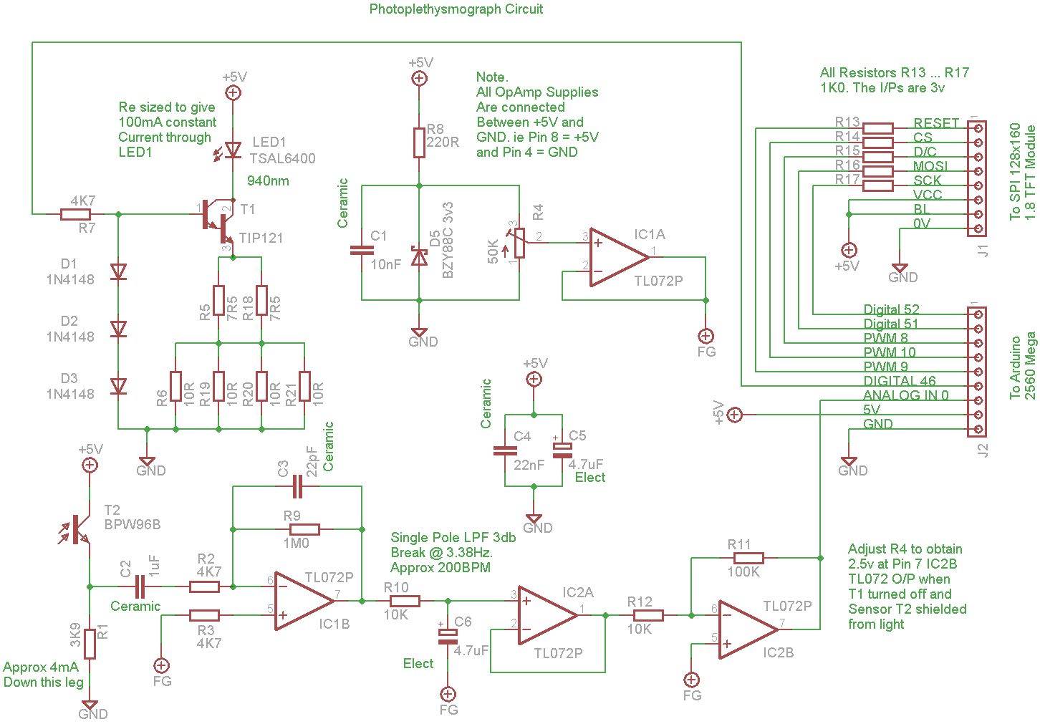
To boost performance, the circuit shown in Figure 26 incorporates electrical components such as amplifiers for a gain of about 100 and bandpass filtering (0.7-2.3 Hz) to extract pulse signals corresponding to heart rates of 60-140 BPM. A recycled microcontroller, an Arduino UNO for example, manages data processing and the LCD display output. The methodology follows established photoplethysmography standards based on past research papers, pulsing LEDs at a 50% duty cycle with a 250 Hz sampling rate to balance power efficiency and measurement accuracy.
Fig.26 :Plethysmograph Circuit Design

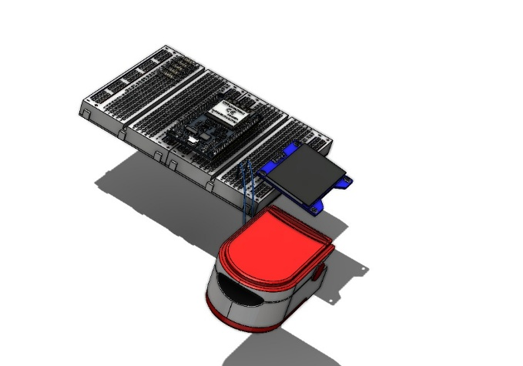
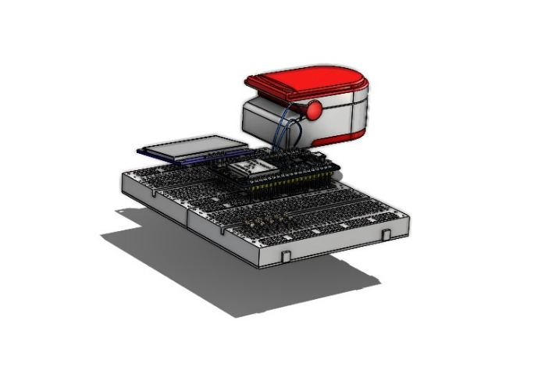
The dimensions were selected based on a research paper on small PPG sensors that examined wearable prototypes. The original dimensions were scaled down to fit within the challenge's specified requirements, resulting in 20 cm (length), 15 cm (width), and 10 cm (height) being the dimensions of the transparent container the prototype will be inside at max. This compact design allows for a convenient finger clip and e-waste integration. Larger dimensions would increase light scattering and reduce signal quality, thus prioritizing portability and ±5% accuracy. As shown in the 3D design in Figures 27 and 28, the prototype will use a transparent plastic housing from discarded waste.
Fig.27: Prototype Design Top View
Fig.28: Prototype Design Side View

Chapter 3
Constructing and testing a prototype

Abstract

Egypt has faced many grand challenges in recent decades, particularly in the quality of education and environmental management. This project aims to solve some of these challenges, including improving the scientific environment for all and recycling waste for economic purposes. These challenges were worsened by the high cost of laboratory equipment, which leaves many public schools relying on passive teaching methods, and the growing hazard of electronic waste (e-waste). The purpose of this study is to address the lack of practical biological monitoring tools in classrooms by transforming e-waste into valuable scientific instruments. The selected solution is a low-cost, eco-friendly heart rate and oxygen sensor based on the principle of Photoplethysmography (PPG). This device utilizes recycled components, including infrared LEDs extracted from an old mouse and photodiodes from discarded scanners, to detect blood volume changes and calculate heart rate. The prototype underwent extensive testing to ensure it meets accuracy standards (within $±5\%$) and portability constraints, as it showed an accuracy of 99% measuring the SPO₂ and 97.9% measuring the BPM compared to the commercial device, with only a margin of error of 1% for the SPO₂ and 2.1% for BPM, offering a reliable alternative to expensive commercial sensors. This project contributes to solving Egypt's challenges by bridging the gap between theoretical and practical STEM education while promoting sustainability through the innovative recycling of electronic waste.

Introduction
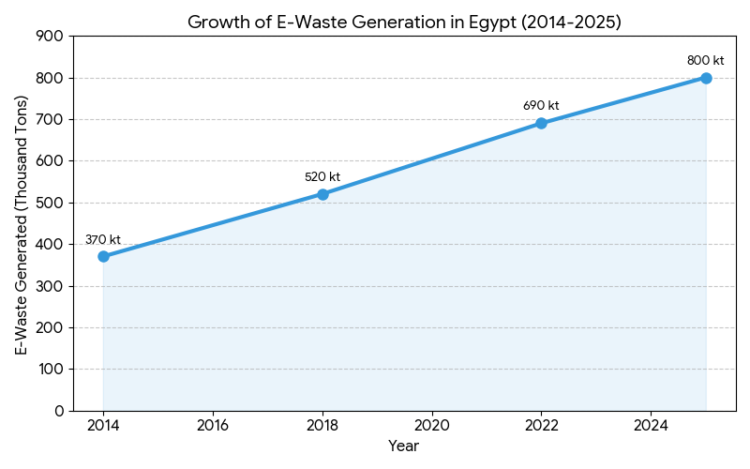
Figure 1: Growth of E-Waste Generation in Egypt (2014-2025)
Egypt strives to achieve sustainable development, yet it faces significant challenges that impact its scientific progress and environmental health. Furthermore, among these is the Egypt Grand Challenge to "Improve the scientific and technological environment for all". This challenge is compounded by the "Recycle garbage and waste" challenge, specifically concerning the massive accumulation of electronic waste. In 2022 alone, Egypt generated an estimated 690 kilotons of e-waste, as shown in Figure 1, one of the highest rates in Africa. While this waste poses a severe environmental threat due to toxins like lead and mercury leaking into the soil, it also represents a hidden treasure of valuable electronic components currently being lost to informal dumping.
The specific problem to be solved is the lack of accessible biomedical monitoring equipment in Egyptian public schools and rural healthcare sectors due to financial constraints. With reports from UNICEF and GAEB indicating that 20% of school buildings are unfit for use, and even advanced institutions like the STEM High School for Boys in 6th of October relying solely on diagrams and microscopes, schools often lack essential physiological sensors for biology education because commercial units cost between 500 to 2,500 EGP, a price that becomes prohibitive when equipping entire classrooms. This lack of equipment forces a reliance on rote memorization rather than active, practical learning. Simultaneously, the mismanagement of e-waste creates a toxic hazard, whereas these discarded devices could provide the components needed to bridge this equipment gap.
To understand how to address this, prior solutions were analyzed. One notable prior solution is the Smart Heart Rate Monitoring System Using Arduino-Uno (2023). A major strength of this system is its portability and low cost, as it uses battery power and simple circuitry, making it deployable in non-clinical settings. However, a significant weakness of this prior solution is its reliance on commercially available modules (such as the MAX30100 sensor) rather than recycled components, which undermines its sustainability and alignment with e-waste reduction goals.
Transitioning to the solution, our project aims to design a Heart Rate and Oxygen Sensor by extracting and reusing functional components from old electronic devices. This prototype will utilize the principle of photoplethysmography (PPG) to measure blood volume changes. By repurposing optical sensors and microcontrollers found in discarded electronics, such as old printers or computer hardware.
To evaluate the success of the prototype, specific design requirements have been established based on the Capstone Challenge. The prototype must achieve an accuracy within ±5% compared to a standard device. It must utilize at least one extracted electrical component from e-waste, and the housing must be made of transparent material to visualize the internal design. Furthermore, the device must be portable, safe to operate, and capable of displaying real-time physiological data to support active learning in biology laboratories.

Materials and Methods

Table 1: Materials used in the implementation of the prototype:
Name | Description | Quantity | Image
atmega328p | The microcontroller is used to calculate the heart rate and oxygen saturation. | 1 module | 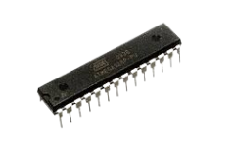
1KL3A Phototransistor | Detects changes in light intensity transmitted, allowing the device to measure pulse and SpO₂. | 1 module | 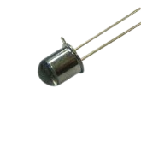
red led | Emits light at a wavelength which gets absorbed differently by oxygenated and deoxygenated blood. | 1 led | 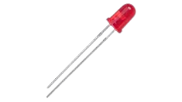
iR led | Emits infrared light that penetrates the finger, allowing the phototransistor to detect blood volume changes to calculate heart rate. | 1 led | 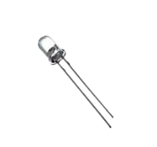
lcd display | Used to show the real-time pulse rate and SpO₂ values to the user. | 1 lcd | 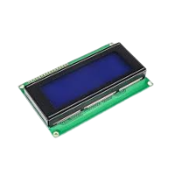
breadboard | To connect all the components of the heart rate and oxygen saturation monitoring system without soldering. | 1 unit | 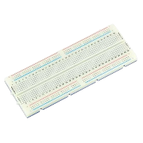
Resistors | Used to limit current and protect components. | 8 units | 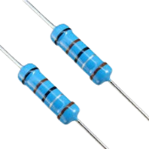
Finger clip | Holds the LEDs and phototransistor in the correct position to ensure stable and accurate measurements. | 1 clip | 

Methods
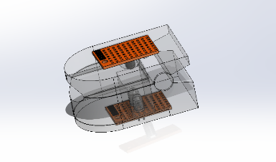1. System Design and Planning:
Figure 2: 3D design of finger clip and sensor placement
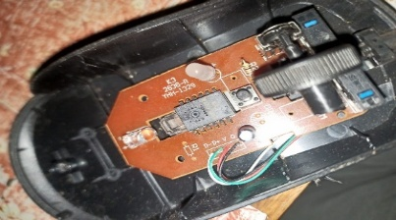The project started with meticulous planning and conceptualization to outline the prototype’s architecture. Where a 3D design was made to improve the workflow.
Figure 3: Red LED found in a mouse
2. Component Extraction and Sensor Preparation:
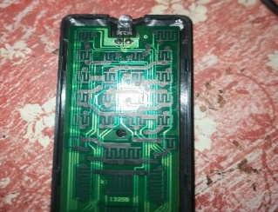To begin with, an old infrared remote control was disassembled as shown in figure 4, from which a working IR LED was extracted and cleaned for reuse. Then an old mouse was opened to get the red led inside it as shown in figure 3. A damaged receiver module was also opened to obtain a functional 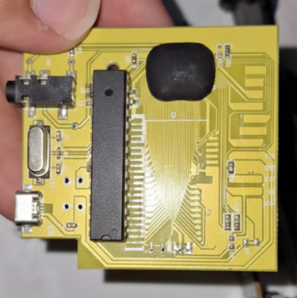phototransistor. Each extracted component was tested individually, from which the LEDs and phototransistor
Figure 4: IR from old TV remote
Figure 5: Fake ps5 board
were arranged in a way to ensure stability and high efficiency of heart-rate and oxygen saturation monitoring. Additionally, an ATmega328p from an old fake PS5 board was salvaged, carefully resoldered, and mounted for integration in the next step as shown in Figure 5.
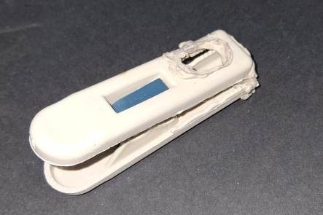3. Sensor Housing:
Figure 6: Finger clip
A small enclosure was prepared from a clip, then got sprayed black to ensure that the light error was minimal. The extracted components were fixed inside the housing, and the wires were soldered and routed through the openings, as shown in Figure 6.
4. Schematic Circuit’s Design:
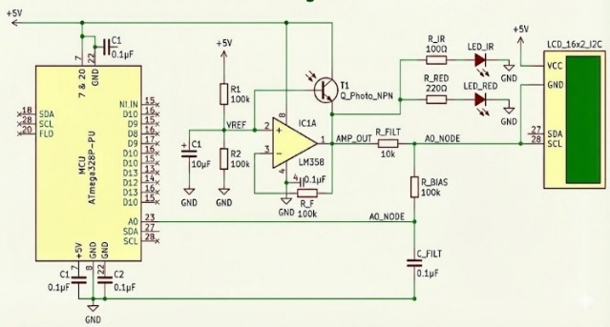Kicad was used to design a circuit containing the ATmega328p microcontroller, current-limiting resistors for the IR and red LEDs, and the phototransistor connected in a common-emitter configuration, as demonstrated in Figure 7. The LEDs, phototransistor, and power supply connections were then fixed onto a breadboard and connected to the microcontroller.
Figure 7: Schematic Circuit's Design

Test plan
The accuracy of the device was tested by comparing the Heart Rate (BPM) and SpO2 readings of the prototype against a standard commercial pulse oximeter. Readings were taken from five different individuals to verify consistency. The percentage error was calculated for each trial to ensure that the accuracy deviation did not exceed the required limit of ± 5%.
The sensing mechanism was tested by placing a finger between the extracted IR LED and the photodiode while powered by the battery. The signal was monitored on the LCD screen to ensure the e-waste components could successfully detect blood flow changes and generate a stable Photoplethysmogram (PPG) waveform without significant noise interference.
The physical constraints were tested by placing the entire circuit and housing inside the transparent container. This was done to ensure that the internal recycled components were clearly visible for evaluation.

Data collection

To verify the accuracy of the Ecopulse prototype, we used a commercial pulse oximeter as our standard reference tool. This instrument acts as the "ground truth" for our biological measurements, providing a resolution of 1.8 BPM and a Margin of error of $±2.1$% units. We collected data by recording simultaneous readings from both our prototype and the commercial device across five separate trials. The comparison revealed a minimal measurement error (bias) of only -1.8 BPM, proving that our low-cost sensor achieves a level of precision suitable for scientific laboratory use.

Results

Negative Results:
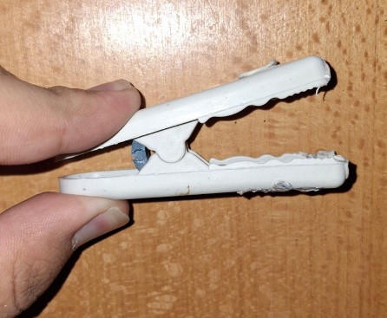Initially, a photodiode was used instead of a phototransistor in the early prototype phase. However, due to its lower internal gain, it produced weaker signals that were highly affected by irregular light interference, reducing the accuracy of the heart rate
Figure 8: loose finger clip
and oxygen saturation measurements. It also suffered from motion artifacts caused by finger movement, which distorted the PPG waveform and prevented stable readings. Furthermore, the IR and red LEDs were not properly current limited, resulting in insufficient light penetration through the finger. Additionally, the loose finger clip design created inconsistent optical contact between the LEDs and the phototransistor, further decreasing signal quality. Eventually, by learning from these failed attempts and addressing the flaws, the final prototype operated efficiently.

Positive Results:
- Signal Quality: After replacing the photodiode with a phototransistor and shielding the sensor from ambient light, the system produced a stable measurement.
- Heart-Rate Accuracy: In three separate 30-second trials, the system achieved accurate heart rate readings of 90 BPM, 81 BPM, 79 BPM, 85 BPM , and 88 BPM meeting the design requirement compared to the commercial device, which had readings of 90 BPM,83 BPM, 81 BPM, 88 BPM, and 86 BPM.
- SpO₂ Measurement: The improved setup allowed consistent oxygen saturation measurements of 99%, 98%, 99%,98%, and 97% across the three trials. On the other hand, the commercial device had readings of 99%, 97%, 98%, 99%, and 99% These results are summarized in figures 9, 10, and table 2.

Table 2: BPM and SPO₂ readings:
Trials | Ecopulse (BPM) | Commercial Device (BPM) | Ecopulse SpO₂ (%) | Commercial Device SpO₂ (%)
First trial | 90 | 90 | 99% | 99%
Second trial | 81 | 83 | 98% | 97%
Third trial | 79 | 81 | 99% | 98%
Fourth trial | 85 | 88 | 98% | 99%
Fifth trial | 88 | 86 | 97% | 99%

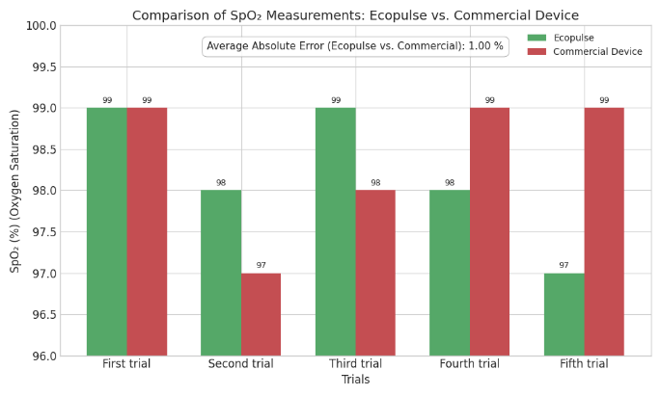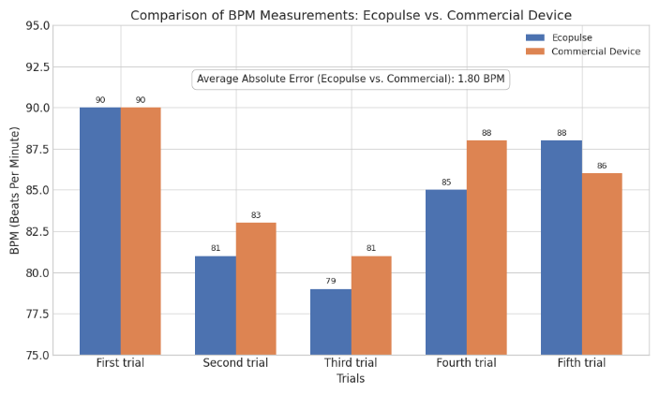
Figure 9: Comparison of SPO₂ Measurements: Ecopulse vs. Commercial Device.
Figure 10: Comparison of BPM Measurements: Ecopulse vs. Commercial Device.

Chapter 4
Evaluation, Reflection, Recommendation, and Discussion

Analysis & Discussions

Photoplethysmography
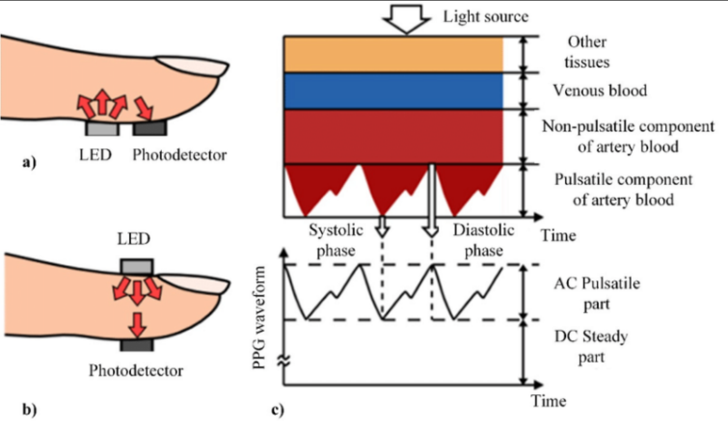Photoplethysmography (PPG) is a simple optical method utilized in the detection of blood volume variations in the microvascular bed of tissue. The PPG signal works by illuminating the skin with pulses of light from LEDs, measuring the transmitted or reflected pulse of light detected by a photodetector. This generates tiny variations in the absorption of pulses of light based upon the pulsatile blood volumes in the cardiac cycle; this recording is referred to as the ‘photoplethysmogram.’
Figure 11: Photoplethysmogram mechanism diagram
The essence of PPG lies in the detection of the two major components: the pulsatile or alternating current (AC) synchronized with the heartbeat and the direct current (DC), referring to the overall absorption attributed to blood and tissue (a relatively stable baseline level).
The process of photoplethysmography (PPG) involves pulsing the skin tissue with red (around 660 nm) and infrared (around 880-940 nm) LEDs in periodic flickers—500 ms or less—and collecting the intensity of the transmitted light using a photodetector, as shown in Figure 11. The values of 660 nm and 880-940 nm are chosen based on the absorbance of each wavelength to the oxygen saturation in hemoglobin; oxygenated hemoglobin absorbs more infrared light and reflects red, which gives it a bright red color, whereas the deoxygenated hemoglobin absorbs more red light and reflects the wavelength closer to infrared, which gives it a deep dark red color. The measurements can be performed in either transmissive or reflective mode. The acquired PPG wave can be processed by converting it into the alternating or pulsatile part (AC) and the direct current (DC) part. The ratio of ratios (R) can be calculated from AC/DC ratios. The processed data reduces noise using digital filtering by Op-Amps.
The pulsatile-to-baseline ratio in the two wavelengths, referred to as R, is a fundamental value in the calculation of oxygen saturation measurements (SpO2). The ratio of ratios (R) is calculated using the difference in absorption between the red and infrared pulses divided by the difference in infrared absorption, as shown in Equation 1. Because the relationship between SpO2 and R linearly inversely correlates with oxygenated hemoglobin absorption, the saturated oxygen percentage can be approximated by equations like Equation 2 and constrained between 80 and 100%. Although the PPG measurements are valid in many applications, their measurements may face small constraints due to different skin tones, resulting in errors between 2-4%.
The science behind the photoplethysmography concept was the backbone of building the pulse oximeter presented in this research and also has significant importance in the project’s methodology: identifying the calculations, circuit connections, and even the materials used in implementing the idea.
$$R=\frac{AC_{RED}/DC_{RED}}{AC_{IR}/DC_{IR}}$$
Equation 1: The Ratio of Ratios
$${SpO}_{2} ≈ 110-25R$$
Equation 2: SpO2 Estimation Formula

Amplifying and noise reduction
The study of electrical components is essential to understanding the behavior of electric circuits under certain conditions and the limitations faced when building circuits. In this study, studying amplifiers, resistors, and capacitors is one of the fundamentals of constructing and building a photoplethysmograph (PPG).
Amplifiers are electrical components used in circuits to increase a signal’s strength to a suitable level for processing, which are widely used in telephone wires. Without the use of amplifiers, signals coming from sensors, microphones, or photodiodes would be too small to process or detect, coming with micro- or millivolt outputs. In the PPG circuit, an LM358P op-amp was used to amplify the output signal from the phototransistor, as it fits perfectly with low voltage supplies (the 9V battery supply). Whereas other models like TL072 need higher outputs ($±10$ Volts or more). So while the TL072 model offers more noise signal filtration and amplification, it is harder to include with the 9V output PPG circuit.
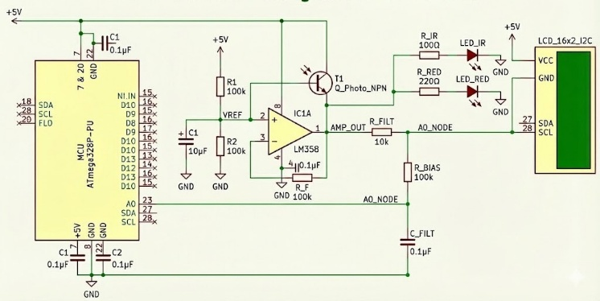As shown in the schematic diagram illustrated in Figure 12, amplification isn’t enough to maintain a clean, filtered psychological signal, but the use of additional capacitors and resistors throughout the circuit is essential. Resistors were used throughout the circuit, starting from the 100-ohm resistors connected to the LEDs to avoid burning, the two 100-ohm resistors that were used to create the Vref node, and even the ones attached to the op-amp to reduce its signal. Additionally, capacitors, which are most essential for removing noise, were used as a backbone for the circuit in many connections, such as the A0 node, which is connected to the A0 pin in the AT mega; the Vref node, which is used to change the voltage interval for the PPG signal; and even between the Op-Amps pins to smooth out current.
Figure 12: Schematic Circuit's Design

Phototransistor vs. Photodiode
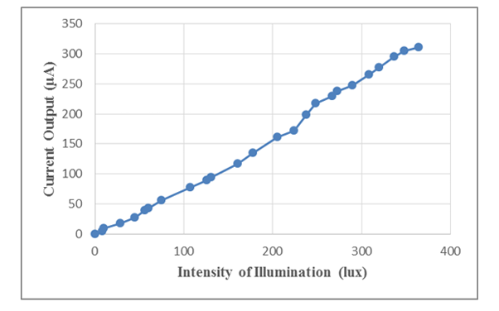Photosensors are designed to be sensitive to visible light or other electromagnetic radiation in a given spectral region of the electromagnetic spectrum that typically lies between ultraviolet and infrared radiation. Photodiodes operate primarily as a fast and highly responsive light detector that converts incident photons into electrical current through its simple p-n structure. This allows a very rapid response time, which makes photodiodes suitable for high-speed measurement. On the other hand, a phototransistor depends on internal current amplification, where the light generated is multiplied through transistor action. This amplification follows the relation
Figure 13: phototransistors current output to light intensity
$$IC = β ⋅ Iphoto$$
Equation 3: Phototransistor Current Amplification

where the small light-generated current is multiplied by the transistor gain β. Thus, very high sensitivity but a slower response time. It is basically a photodiode with a current transistor amplifier. So, it combines the characteristics of a transistor and a photodiode. For a heart rate and oxygen saturation monitoring system, a phototransistor was chosen because these biomedical sensing applications depend more on the signal strength under low light conditions than on extremely fast speeds. Figure 13 illustrates the phototransistor's high sensitivity, with the output current increasing from near zero to 300 µA as illumination rises to 400 lux. This pronounced current response under relatively low illumination supports its selection for heart-rate and SpO₂ measurements.

Accuracy Validation & Mechanical Optimization
The process of validating the accuracy and stability of the low-cost sensor was mainly focused on understanding how closely the readings follow the actual physiological values and how stable the signal behaves during measurement. The measurement bias was first considered since it shows the constant offset that appears when comparing the readings of the device to a calibrated commercial pulse oximeter. The bias is calculated by taking the average difference between the measured values and the reference values, as shown in Equation 4, and it gives a clear idea about the consistency of the sensor in many trials.
$$Bias=\frac{1}{N}\sum_{i=1}^{N}{\left(X_{device}-X_{reference}\right)}$$
Equation 4: Measurement Bias
Using the deviation values recorded in Table 2, which were (0, –2, –2, –3, +2), the calculated bias reached -1.8 BPM. This small negative value shows that the readings tend to under-estimate the heart rate by about 1.8 BPM, which is considered very accurate in relation to low-cost optical systems, especially when taking into account the natural fluctuations of the pulsatile component. This bias also indicates that the waveform is being captured correctly with very low distortion from motion or tissue interference.
Another major part of the analysis was done through studying the signal stability by using the Signal-to-Noise Ratio (SNR). The SNR is very important because it reflects how much of the signal obtained is truly the pulsatile information and how much of it is unwanted noise, especially since the AC component of the PPG wave is usually very small compared to the DC level. The SNR is calculated using Equation 5, which compares the power of the signal to the power of the noise and expresses it in decibels.
$$SNR_{dB}=10\log_{10}\left(\frac{P_{signal}}{P_{noise}}\right)$$
Equation 5: Signal-to-Noise Ratio
A transmissive finger-clip design was used because, based on recent studies, wrist-based reflective sensors normally suffer from a much lower SNR around 13.7 dB even when the subject is sitting still. This happens because reflective sensing depends only on the light bouncing from the top layer of the skin, which makes the readings very sensitive to any movements or changes in contact pressure. In contrast, transmissive sensing allows the light to travel through the tissue, which increases the amount of detected signal and reduces the contribution of noise from motion and external light.

Conclusions

This project addressed both the problem of resource constraints in Egyptian public-school laboratories and the challenge of how to dispose of or reuse e-waste. Using the principles of photoplethysmography, an operative model of a pulse oximeter that calculates heartbeats and blood-oxygen saturation rates was developed. Also, its development considered factors of sustainability through the reuse of essential components such as infrared LEDs and photodiodes from disposed devices like remote controls or outdated Circuit boards. Indeed, it was assured that the developed model possessed all the requirements of the Capstone design challenge. It demonstrated accuracy in measurement with no more than a 5% margin of error, exactly 2.1% relative to commercial standard pulse oximeters, which shows its effectiveness in the classroom setting. It further achieved its target in that it cost less than EGP 200, which is already far from the commercial prices ranging from EGP 500 to EGP 2,500.
This prototype provides a scalable solution for some of Egypt's grand challenges, like recycling garbage and waste for economic and environmental purposes. Compared to other commercial technologies that offer similar services but charge exorbitant prices unaffordable for most public schools, this innovative technology transforms hazardous electronic waste into a valuable tool that can enhance active learning. Furthermore, its portability allows for easy transport within most classrooms. In conclusion, the sustainable manufacturing of precision scientific instruments can be achieved through the development of such projects.

Recommendations

Empowering Education and Healthcare through Recycled Innovation
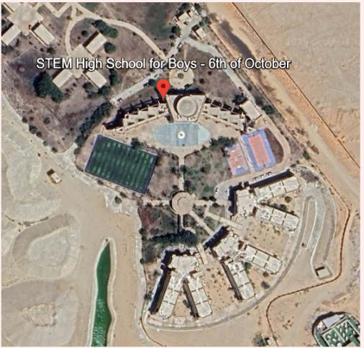The eco-friendly heart rate and oxygen sensor addresses two critical challenges in Egypt: the lack of practical resources in STEM education and the scarcity of affordable medical equipment in rural healthcare. By repurposing electronic waste into functional scientific instruments, we transform an environmental hazard into a tool for social development.
Figure 14: real life location
In the educational sector, the device serves as a vital bridge between theoretical knowledge and practical application. Even advanced institutions, such as the STEM High School for Boys in 6th of October, face significant resource barriers. Currently, their biology labs rely primarily on static figures, diagrams, and microscopes, lacking the real scientific instruments required for dynamic experiments. With commercial sensors costing up to 2,500 EGP per unit, equipping a full class is often financially out of budget. Our recycled sensor provides a sustainable, low-cost alternative that allows students to visualize physiological concepts, like heart rate response to exercise, in real-time. This shifts the learning model from passive memorization to active scientific learning.
Beyond the classroom, this device has profound applications in primary healthcare, particularly in underserved and rural communities. Many remote health units lack basic diagnostic tools due to high import costs. Our portable, battery-operated sensor offers an accessible solution for monitoring vital signs, including heart rate and oxygen saturation ($SpO_{2}$). It is ideal for use in mobile health caravans or for home monitoring of patients with chronic respiratory or cardiac conditions. By providing a reliable and inexpensive screening tool, we can facilitate early detection of health issues without the need for expensive hospital visits.
Ultimately, this project democratizes access to technology, ensuring that students in public schools and patients in rural villages have access to the same quality of education and healthcare monitoring as those in privileged urban centers.

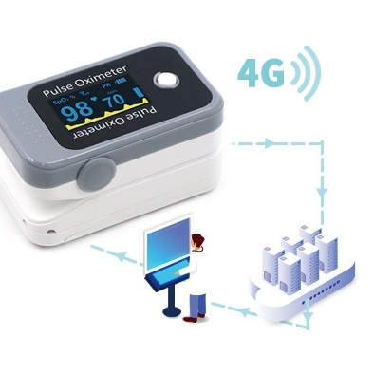Integration of IoT and Telemedicine Capabilities
Figure 15: A figure that shows how the IoT system works
The device works effectively as a standalone tool for real-time observation in the lab. However, a major limitation that was faced during testing is that it cannot store or share the data it collects. Once the user removes his finger, that valuable biological information is lost. To solve this and take the project to a professional level, it is strongly recommended to integrate a wireless communication module, such as the ESP8266 Wi-Fi chip, in future iterations. This module is specifically recommended because it is cost-effective, widely available, and easily compatible with our current microcontroller setup.
Adding this technology would fundamentally transform the device from a simple school instrument into a sophisticated Internet of Things (IoT) node. Instead of just displaying numbers on a small LCD screen, the system could transmit patient data wirelessly to a dedicated mobile application or a cloud server database. This upgrade unlocks two massive opportunities. First, it enables telemedicine, allowing doctors to monitor a patient’s vital signs remotely in real-time without requiring a physical hospital visit. Second, in the classroom, it will enable students to access long-term physiological data. They could download this history to computers to analyze heart rate trends over varying stress conditions, turning a basic biology lesson into a deep data analysis experience.

Cuffless Blood Pressure Estimation (PTT)
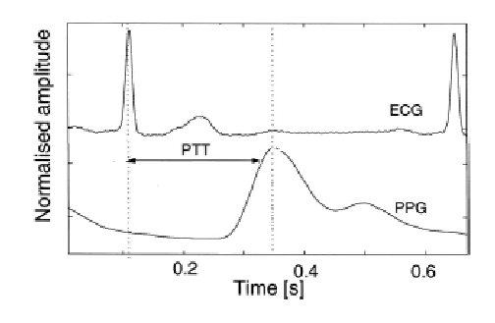Although Pulse Transit Time (PTT) is recognized as a scientifically valid technique for blood pressure estimation, its implementation in this prototype was ruled out due to strict hardware and safety constraints. It was determined that the simultaneous, millisecond-precision sampling of ECG and PPG signals, which is required for accurate PTT, as shown in Figure 16, exceeds the processing limits of the single-core ATmega328P microcontroller used here.
Figure 16: A graph that shows how to measure the PTT
Beyond processing power, a critical safety hazard is presented by the construction of an ECG front-end from scavenged e-waste. It was noted that such components lack the medical-grade electrical isolation necessary to protect the user from potential mains or USB faults. For future applications intended for real-life use, the adoption of a dual-core processor (like an ESP32 or STM32) is recommended to manage deterministic timing. Furthermore, it is suggested that a medically certified, optically isolated ECG module be integrated to ensure both the calculation accuracy and the electrical safety needed for human trials.

Recommendations to Other Teams

If another team in the future is going to complete the project from where we stopped, I recommend they research more about Signal Processing and Operational Amplifiers (Op-Amps) to understand how to better filter noise from biological signals. Also, they should try to improve the sensor housing and finger clip design perhaps using 3D printing to block ambient light more effectively, which was a significant challenge for the phototransistor readings. Furthermore, they could focus on the IoT capabilities by fully developing the mobile health platform using the ESP8266 Wi-Fi module, allowing for real-time remote monitoring of patients rather than just local display. Finally, replacing the general purpose LM358 Op-Amp with a dedicated instrumentation amplifier could significantly increase the accuracy of the SpO2 calculations.

Project’s Positive Influence

Working on this project resulted in some scientific and social impacts on the members of the team. For the scientific impact, it made the team members more knowledgeable about new concepts, such as Photoplethysmography (PPG) and operational amplification circuits. Also, the increase of awareness about the importance of recycling electronic waste and how it’s utilized to solve the high cost of medical devices. For the social impact, working on this project makes you know more intellectual and well-educated people who share the same interest in the biomedical field as you. For example, most team members knew and had spoken with some professors, electronics engineers, and even healthcare professionals. So, all of these new relations help in increasing the sociability of the team members.

Learning outcomes

Learning Outcome | Description | Concepts | Usage
PH.2.03 | Analyze current flow through conductors. | • Electric current  • Voltage  • Ohm's law | Used to calculate the necessary voltage drops and resistance for the LEDs and phototransistor using Ohm’s Law.
PH.2.04 | Analyze DC circuits with resistive elements. | • Connections of resistors  • Kirchhoff's laws | Applied to design the circuit network ensuring the correct current flows through the phototransistor receiver.
MA.2.02 | Model real situations with functions. | • Rational polynomial expressions  • Modeling | Used to create a mathematical model linking light absorption ratios to the SpO₂ percentage readings.
PH.2.05 | Analyze energy transfer in DC circuits. | • Power dissipation  • Power ratings | Used to ensure recycled components operate within safe power limits to avoid overheating the finger clip.
PH.2.06 | Analyze time dependence in capacitive elements. | • Capacitor charging  • Time constant  • Energy storage | Applied in the RC (Resistor-Capacitor) circuit to smooth the pulsating signal from the phototransistor for clearer readings.
PH.2.09 | Analyze filtering characteristics of circuits. | • Band-pass filter  • Resonance  • LCR circuit | Used to design the Op-Amp filter circuit that removes noise and passes only the specific frequency of the heart rate signal.
PH.1.06 | Understand restoring forces and Hooke’s Law. | • Elasticity  • Hooke's Law  • Stress and strain | Used to design the spring mechanism in the finger clip, ensuring consistent pressure on the finger for accurate sensor readings.
CH.1.03 | Demonstrate understanding of the EM spectrum. | • Electromagnetic spectrum  • Frequency & Wavelength | Used to select the specific wavelengths of the Red LED (660nm) and IR LED (940nm) required for measuring blood oxygenation.
MA.1.06 | Create and analyze linear and step functions. | • Linear functions  • Step function  • Direct variation | Used in the code to map the analog voltage input from the sensor to a digital Heart Rate value using linear conversion logic
PH.1.01 | Make precise measurements and identify errors. | • Measurement error  • Accuracy vs. precision | Applied when calibrating the prototype against the commercial oximeter to quantify the percentage of error in BPM readings.

Literature Cited

Obagade, T. A. (2022). Comparative analysis of photoelectric characteristics of photosensors: A case study between photoresistor, photodiode, and phototransistor. IOSR Journal of Applied Physics (IOSR-JAP), 14(3), 1–12. https://doi.org/10.9790/4861-1403020112

Ghalwash, O., Sheta, S., & Samra, M. (2021). The availability and quality of school buildings in Egypt. Journal of Al-Azhar University Engineering Sector, 16(59), 463–485. https://www.researchgate.net/publication/351477737

Tamura, T. (2019). Current progress of photoplethysmography and SPO₂ for health monitoring. Biomedical Engineering Letters, 9(1), 21–36. https://doi.org/10.1007/s13534-019-00097-w

Wuyart, A., Abensur Vuillaume, L., Maaoui, C., & Bousefsaf, F. (2025). A survey of blood oxygen saturation assessment from video. Biomedical Signal Processing and Control, 99, 108069. https://doi.org/10.1016/j.bspc.2025.108069

Abay, T. Y., & Kyriacou, P. A. (2018). Photoplethysmography for blood volumes and oxygenation changes during intermittent vascular occlusions. Journal of Clinical Monitoring and Computing, 32(3), 447–455. https://doi.org/10.1007/s10877-017-0030-2

Goma, A. A., & Phillips, C. J. C. (2021). The impact of anthropogenic climate change on Egyptian livestock production. Animals, 11(11), 3127. https://doi.org/10.3390/ani11113127

McCarl, B. A., Musumba, M., Smith, J. B., Kirshen, P., Jones, R., El-Ganzori, A., Ali, M. A., Kotb, M., El-Shinnawy, I., El-Agizy, M., Bayoumi, M., & Hynninen, R. (2013).
Climate change vulnerability and adaptation strategies in Egypt’s agricultural sector. Mitigation and Adaptation Strategies for Global Change, 20(7), 1097–1109. https://doi.org/10.1007/s11027-013-9520-9

World Bank. (n.d.). It is back to school in Egypt: Is it back to learning? World Bank Blogs. https://blogs.worldbank.org
UNICEF Egypt. (n.d.). Education. UNICEF. https://www.unicef.org/egypt/education
UNICEF, & General Authority for Educational Buildings. (n.d.). The availability and quality of school buildings in Egypt. ResearchGate. https://www.researchgate.net

Technovation. (2023, February 6). DIY low cost spectrometer. Instructables. https://www.instructables.com/DIY-Low-Cost-Spectrometer/

kemfic. (2017, March 27). Developing a Low-Cost microcentrifuge using E-Waste. https://www.hackster.io/kemfic/developing-a-low-cost-microcentrifuge-using-e-waste-04b525

United States Agency for International Development. (2017). Audit of USAID/Egypt’s science, technology, engineering, and mathematics (STEM) school project. USAID Office of Inspector General. https://oig.usaid.gov
Sports and urban biodiversity | IUCN Library System. (2020). https://portals.iucn.org/library/node/49127

World Bank Open Data. (n.d.). World Bank Open Data. https://data.worldbank.org/indicator/AG.LND.AGRI.ZS?end=2021&locations=EG&start=2021&view=map&year=2021

Collaboration improves water productivity in Egypt | FAO. (n.d.). https://www.fao.org/family-farming/detail/en/c/1604293/

Agriculture and Food Security | Basic Page | U.S. Agency for International Development. (n.d.). U.S. Agency For International Development.

https://www.usaid.gov/egypt/agriculture-and-food-security#:~:text=Agriculture%20is%20a%20major%20component,the%20country%27s%20gross%20domestic%20product.

World Bank Open Data. (n.d.-b). World Bank Open Data. https://data.worldbank.org/indicator/AG.LND.ARBL.ZS?end=2021&locations=EG&name_desc=false&start=1961&view=chart

Egypt | World Food Programme. (2024, March 29). UN World Food Programme (WFP). https://www.wfp.org/countries/egypt#:~:text=According%20to%20the%202023%20Global,than%20half%20of%20its%20staples.

Associated Press. (2019, July 31). Egypt: A Third of Population Lives in Poverty. Voice of America. https://www.voanews.com/a/middle-east_egypt-third-population-lives-poverty/6172941.html

Index, G. H. (2024, October 9). Egypt. Global Hunger Index (GHI) - Peer-reviewed Annual Publication Designed to Comprehensively Measure and Track Hunger at the Global, Regional, and Country Levels. https://www.globalhungerindex.org/egypt.html

Ersado, L. (2024, March 16). Education in Egypt: inequality of opportunity across three generations. World Bank Blogs. https://blogs.worldbank.org/en/arabvoices/education-egypt-inequality-opportunity-across-three-generations

International Monetary Fund. (2024). World economic outlook database: General government gross debt (Egypt). https://www.imf.org/en/Publications/WEO/weo-database/2024/April

U.S. Environmental Protection Agency. (2023). Warm version 15: Energy and greenhouse gas emissions factors. https://www.epa.gov/warm/versions-waste-reduction-model-warm

Instructables. (2017b, October 1). Photoplethysmography - (IR heart rate monitor). Instructables. https://instructables.com/Photoplethysmography-IR-Heart-Rate-Monitor/

Acknowledgements
First, we are grateful to Allah for guiding and aiding us in every aspect of this project. Further, we are thankful to our Capstone general Mr. Mohammed Ali, and our Capstone leader Mrs. Ninette, who helped us with their efforts and precious advice. Special thanks to our parents and colleagues for providing us with verbal support that helped this project come to reality.

