
Table of contents
Introduction 6
Chapter 1 7
Egypt Grand Challenges 8
Deal with population growth and its consequences 8
Causes 9
Impacts 10
Address & reduce pollution in air, water, and soil 11
Causes 12
Impacts 15
Health and financial impacts 15
Environmental impact 16
Global Warming 17
Reducing the effect of climate change 18
Causes 19
Usage of fossil fuels 19
Deforestation 19
Impacts 20
High temperature 21
The release of sea level 21
Recycling garbage and waste for economic and environmental purposes 22
Causes: 22
Impacts: 23
Increase the industrial and agricultural base of Egypt 25
Causes 25
Impacts 27
Problem to be solved 28
Protecting Siwa’s Crop Production from the Threats of Climate Change 28
Negative Consequences 29
Positive Consequences 30
Topics related to the problem 31
The Impact of Rising Temperatures on Crop Yields 31
Agricultural Reclamation Projects and the Redistribution of Population 32
Water Scarcity and the Depletion of Groundwater in Arid Regions 32
Topics related to the solution 33
Soil fertility 33
Water conservation 33
Fertilization types 34
Prior solutions 34
Automated Aeroponic Arugula Production 34
Mechanism 35
Points of Strength 36
Growth Efficiency and Speed: 36
Backup Power System: 36
Resource Management: 37
Points of Weakness 37
Mechanical Inconsistency: 37
Lack of Real-Time Adaptive Feedback: 37
High Initial Complexity: 38
El Bustan Aquaponic Farm 38
Mechanism 39
Points of weakness 39
Points of strength 40
Thanet Earth Commercial Greenhouse 40
Mechanism 41
Points of weakness 41
Points of strength 42
Agro Farmers Monitor 43
Mechanism: 45
Points of Strength: 46
Points of Weakness: 47
Chapter 2 48
Solution requirements 49
Cost-Effectiveness 49
Automation and Ease of Operation 49
Adaptability for Multiple Crop Types 49
Design requirement 50
1- Prototype scale 50
2. Construction Materials: 50
3. Actuator Implementation 50
4. Prototype’s Operation Ability 50
5. Operating time 50
6. Actuator Implementation: 50
7. Sensor Selection and Calibration: 50
Selection of Solution 51
Selection of Prototype 52
Chapter 3 54
Materials and Methods 55
1)Digital Modeling and Schematic Design: 56
2)Sensor Calibration Procedure: 56
2)Structural Assembly: 57
3)Actuator and Circuit Installation: 57
Safety precautions 57
Test plan 58
Planting area: 58
Prototype’s Operation Ability: 58
The three-deviation test: 58
Five-day environmental logging: 59
Database and software verification: 59
Data collection 59
Results 59
Negative Results 59
1)Actuator Failure: 59
2)Structure Failure: 60
3)Sensor Baseline Drift: 60
Positive Results 60
Chapter 4 63
Evaluation, Reflection, Recommendations, and Discussion 63
Analysis and Discussion 64
Feedback and Automation System: 64
Expected Optimal Time of Irrigation: 64
Light intensity calculations & actuating 65
Geometric shape analysis 67
Conclusions 68
Recommendation 68
Real-life Application: 68
Raspberry Pi Zero SBC 69
Shift Register Integration for Full Automation 70
Recommendations to Future Teams 70
Project’s Positive Influence 71
Learning outcomes 71
Literature Cited 71

Introduction
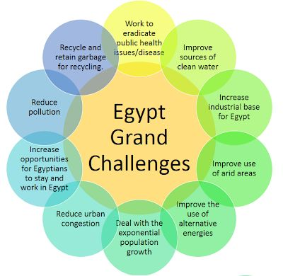
Egypt, like any country, faces some challenges that hinder its development and weaken its economy, agriculture, and industry. These challenges that Egypt faces, as shown in Figure 1, are collectively referred to as the “Egypt Grand Challenges." These 11 challenges cover important aspects like water quality, overpopulation, education, health, energy, and industry.
Figure 1: Egypt Grand Challenges
The environmental challenges include reducing and adapting to the effects of climate change, recycling garbage and waste for economic and environmental purposes, and addressing and reducing pollution that fouls our air, water, and soil. These challenges are related since leaving garbage and waste in the environment increases the pollution and gases that contribute to polluting our environment and increase the effects of climate change. The impacts of not facing these challenges affect Egypt's areas and pose another challenge ahead, which is improving the use of arid areas. This is a big challenge that Egypt faces since more than 85% of its total area is hyper arid, while the remaining area is arid and semi-arid and not well exploited. This leads to another challenge: dealing with urban congestion and its consequences, and dealing with population growth and its consequences, since 95% of Egyptians live on less than 6% of the land. Both challenges are related to the number of people and providing sufficient resources, including food, water, housing, energy, healthcare, and transportation. This requires solving another grand challenge, which is to increase the industrial and agricultural base of Egypt to provide the needed resources for Egypt’s development and provide enough jobs and opportunities for Egyptians to stay and work.

Chapter 1
Present and justify a problem and design requirements

Egypt Grand Challenges

Deal with population growth and its consequences
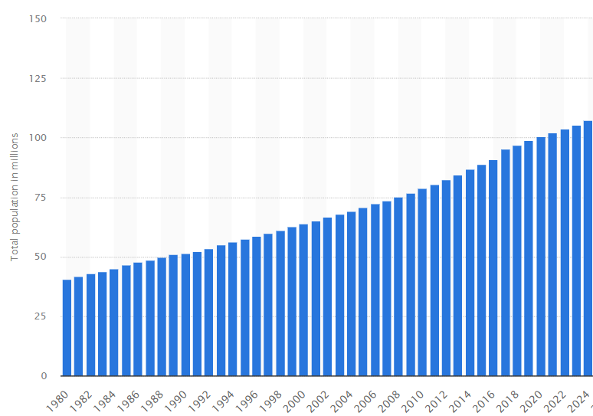
Population growth is the increase in the number of individuals in a population. In Egypt, the population is increasing year after year, as shown in Figure 1, until reaching 107.3 million people. Moreover, it is expected that the population of Egypt will reach 122.03 million people at the end of 2030. These numbers show that Egypt has to deal with a great challenge, which is dealing with this increase in population. This is because an increase in population means an increase in needs and services that should be provided. If the government can’t afford these needs and services, it will face great problems like economic strain, resource scarcity, infrastructure overload, education and health risks, and environmental degradation.
Figure 1: Total population of Egypt from 1980 to 2024
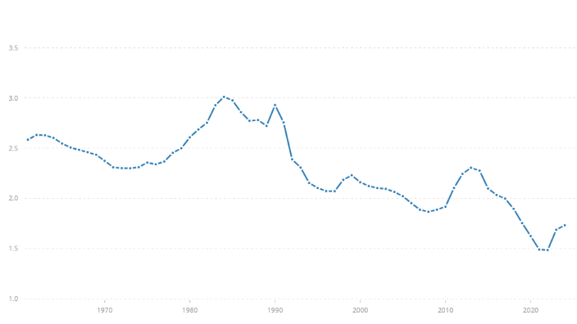
However, the rate of population growth in Egypt is noticeably variable, as shown in Figure 2. This means that it unexpectedly increases and decreases year after year. For example, the maximum growth rate Egypt reached was 3.0% in 1984, and the minimum growth rate Egypt reached was 1.5% in 2021 and 2022. Between 1984 and 2022, the growth rate fluctuated, as shown in Figure 2. Fluctuations and sudden increases in population growth rate are a great problem for the Egyptian economic and educational stability. For instance, governments plan schools, hospitals, and housing based on current trends, so a sudden increase in births will cause overcrowded schools or children unable to access their education. The same thing can be said about urbanization, where it is nearly impossible to time the expansion of new cities. In the economy, GDP growth needs to be three times the population growth rate to maintain the government's state, but the population growth fluctuations make it hard for the government to maintain this state quickly.
Figure 2: Population growth rate (%) from 1961 to 2024

Causes

Child Marriage:
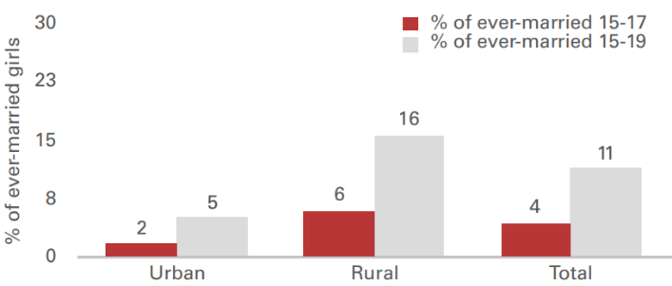
Cultural beliefs in Egypt, especially in rural and upper-Egypt areas, result in some dangerous acts that cause an increase in population growth. For instance, the prevalence of child marriage can be noticed in rural areas. As shown in Figure 3, 16% of girls between 15 and 17 years old and 6% of adolescent girls between 15 and 19 years old are either currently married or were married before. Early age at first marriage usually makes the wife have a longer period of subjection to the possibility of pregnancy and so higher fertility levels. Data shows that in 2014, almost half (46%) of married adolescent girls either had a child or were currently pregnant. This higher level of fertility affects the health of both the mother and the child.
Figure 3: Prevalence of child marriage, by urban/rural residence, 2017

Population Momentum:
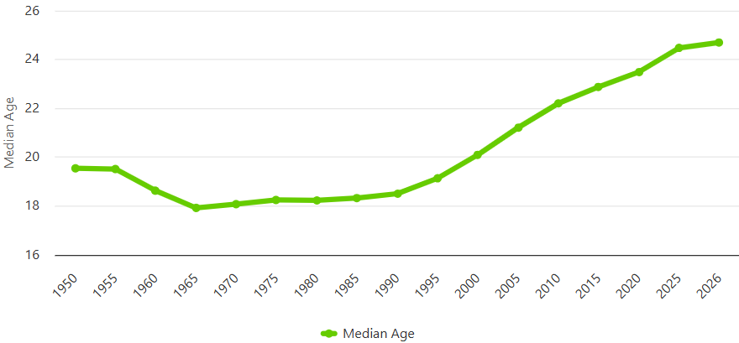
Population momentum is the futuristic effect of rapid population growth that causes the continuity of the challenge of population growth. As shown in Figure 4, the median age in Egypt in the period between 1960 and 1990 was approximately 18 years old, indicating the high percentage of children under 18 years old in the population of Egypt. Those children are now growing to become the new generation of parents, as shown in Figure 4, with a median age of 24.7 years old in 2026. So, even if each new family decided to have only 2 children, the population would still be increasing due to the population momentum caused in the 20th century.
Figure 4: Median age in Egypt (1955-2026)

Poverty and Ignorance:
Economic conditions of the household can cause child marriage. Many times, marrying the daughter early is used as a way to reduce the economic stress of the family and improve its economic state. As said before, early marriage causes a high fertility rate and thus greater population growth. Even though the median age at first marriage is lower among adolescents from the lower wealth quintiles, adolescents from the middle wealth households show the highest prevalence of child marriage (25%).

Impacts

Educational Resources Depletion:
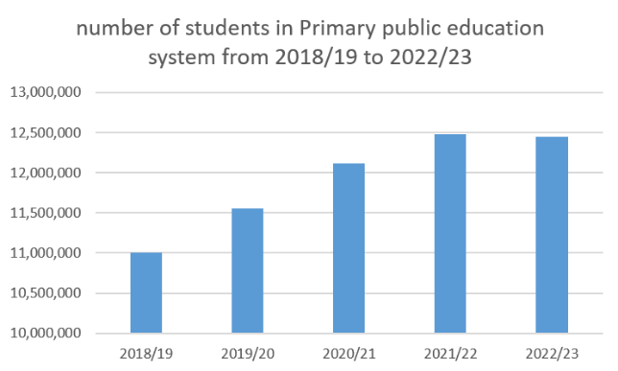
Educational resources like the school’s infrastructure, books, utensils, boards, and desks are being depleted due to the overuse of students due to their big numbers per class. As shown in Figure 5, the number of primary students in primary public education increased year after year until it reached 12,452,829 students in 2022/23. Because of the huge number of students, the country can’t afford essential things like infrastructure in its schools due to the continuous consumption of these things and their high cost.
Figure 5: Number of students in the primary public education system.
Some international assessments monitor trends in student achievement in mathematics, science, and reading, like TIMSS and PIRLS. Based on TIMMS 2015 and PIRLS 2016 results, more than half of the students in Egypt do not even meet the low benchmark in international learning assessments – 69% of grade-4 students in reading, and 58% of grade-8 students in science. Egypt ranks at the bottom of the participating countries - #49 out of 50 countries of grade-4 students in reading, and #38 out of 39 countries of grade-8 students in science.

Unbalanced population distribution:
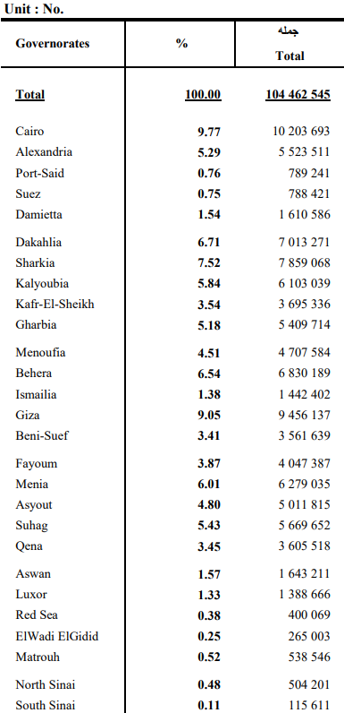
Egypt mostly consists of arid areas, making it very hard for Egyptians to live and settle there. Therefore, when the population of Egypt increases rapidly, in most of the cases this population will settle beside each other, concentrating in the governorates near the non-arid areas. According to Figure 6, most of the population is concentrated in the governorates near the Nile River. For example, 10,203,693 people live in Cairo (about 9.8% of the total population), and 5,523,511 people live in Alexandria (about 5.3% of the total population). On the other hand, few people live in governorates far from the Nile River. For example, only 504,201 people live in North Sinai (about 0.5% of the total population), and 115,611 people live in South Sinai (about 0.1% of the total population). This unbalanced distribution results in urban congestion and overcrowding problems in governorates near the Nile River, while leaving the other governorates unexploited.
Figure 6: Estimated population & their percentage distribution by governorate in 1/1/2023

Address & reduce pollution in air, water, and soil
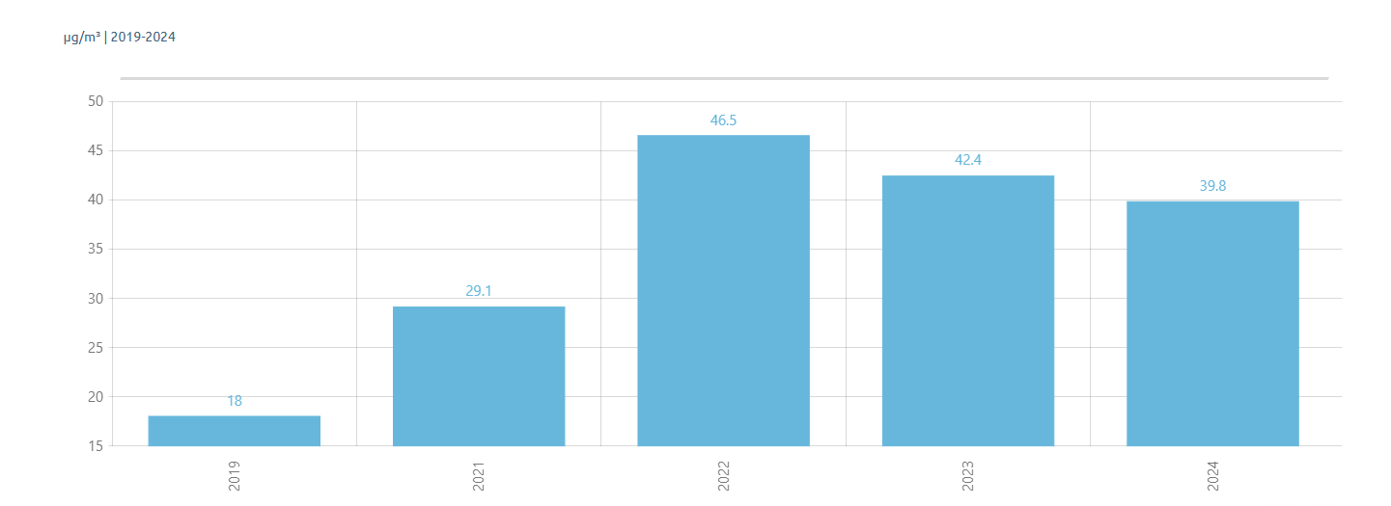
A severe environmental crisis is currently being faced by Egypt across its air, water, and soil. Worldwide, the highest number of deaths linked to PM2.5 air pollution is recorded here. In 2017, 19,200 premature deaths and over 3 billion illness days were caused by this pollution. In 2019, a low concentration of 18 µg/m³ was recorded, which is still over three times the WHO safe limit of 5 µg/m³. Despite a recent drop, a level of 39.8 µg/m³ was measured in 2024, meaning safe limits are still exceeded by about eight times as shown in Fig 7.
Figure 7: PM2.5 concentration in Egypt 2019-2024
In Assiut, severe heavy metal contamination is found in farming soils. High vulnerability is shown by an alkaline pH of 7.83 and low organic matter of 2.7%. Furthermore, oxide levels are reported at 53.6 ppm for SiO2 and 8.17 ppm for CaO, while sodicity risks are indicated by Na2O levels up to 5.32 ppm. High pollution is confirmed by trace elements, as global limits are frequently surpassed by arsenic (10.3–23.3 ppm), cadmium (0.6–2.16 ppm), and lead and chromium (26.7–203.5 ppm).
Additionally, the Nile River is polluted by 4.5 million tons of waste annually, including toxic metals. Land and water are heavily contaminated by farm chemicals. Lead concentrations up to 1,200 mg/kg are measured near industrial sites, and 35% of all agricultural land is considered polluted. Consequently, 12,000 premature deaths and 22% of rural infections are caused each year. Finally, an urgent review of laws is demanded, as a recycling rate of only 30% is currently achieved.

Causes

Burning Fossil Fuels
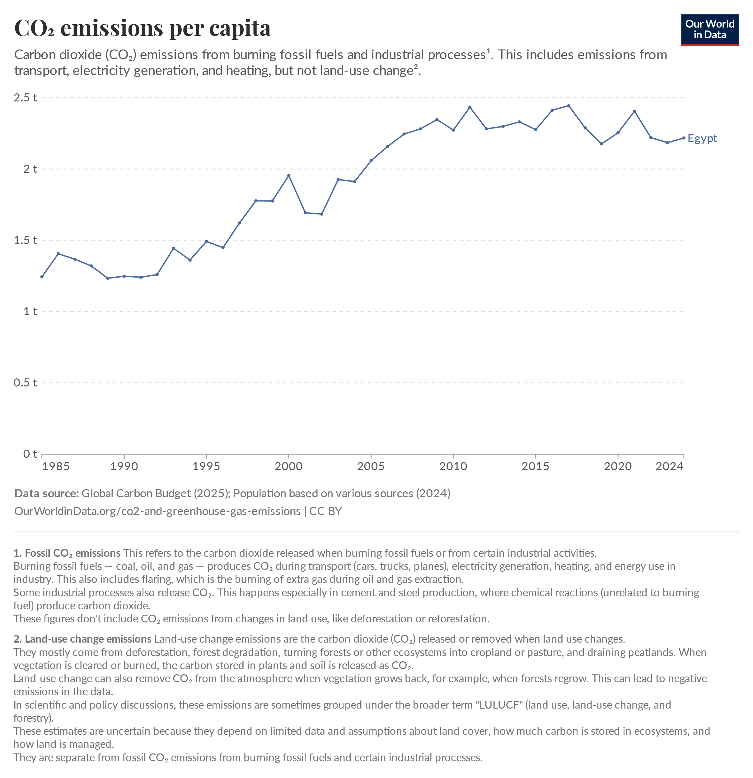
Energy is responsible for most climate change causing greenhouse gas emissions, mostly from the burning of fossil fuels. Despite efforts to reduce these emissions, the path of CO2 emissions globally remains far higher than what is needed to avoid the worst effects of climate change. Egypt relied on fossil fuels for 88% of its electricity in 2023. Egypt is Africa’s largest fossil gas-generating country, responsible for 45% of the continent’s gas generation in 2022.
Figure 8: CO2 emissions per capita in Egypt
Figure (8) illustrates the concerning increase in Egypt's carbon dioxide (CO2) emissions per person between 1985 and 2024. The Egyptian government is taking steps to diversify its energy mix and reduce dependence on fossil fuels. This includes increasing the share of renewables in power generation.

Over-Farming and Chemical Runoff
Agriculture is essential in Egypt for food production, but ironically, soil and water quality are being severely damaged by intensive farming practices.
In regions like the Nile Delta and Assiut, multiple crops are planted continuously throughout the year to maximize yield. To support this heavy rotation, excessive amounts of chemical fertilizers and pesticides are applied to the fields.
A major issue is the soil composition. The soil in these agricultural zones is highly alkaline, meaning a high pH level is present. Because of this chemistry, agricultural chemicals are not broken down naturally. Instead, toxic heavy metals are mobilized and allowed to spread much more easily.
In a 2025 study, nearly 80% of farmland in the Nile Delta was categorized as being at a "very high" ecological risk. Dangerous heavy metals, such as arsenic and cadmium, are frequently found at levels far above global safety limits. Over time, toxic chemicals and metals are washed out of the soil and drained directly into the Nile River. A continuous cycle of contamination is created, where the water supply is constantly polluted by the degraded soil.

Agricultural Waste Burning
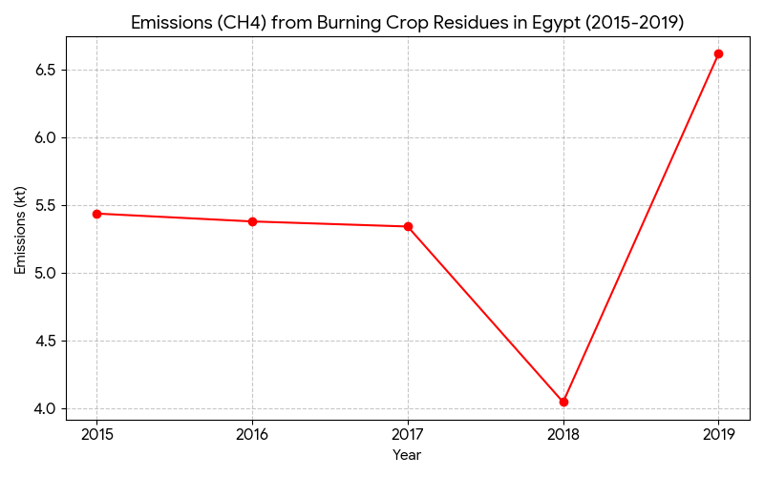
Egypt is the largest rice producer in the Middle East, but this comes with a
Figure 9: Emissions (CH4) from Burning Crop Residues in Egypt (2015-2019)
major environmental cost. Every year, farms produce about 12.33 million tons of dry crop waste, mostly from rice straw. To quickly clear their fields for the next season, farmers usually just burn this massive amount of leftover straw in the open.
This open burning releases a huge amount of toxic pollution as shown in Figure 9. Burning just one hectare of rice straw creates 11 tons of greenhouse gases, plus hnudreds of kilograms of carbon monoxide and dangerous fine dust called PM2.5. Every autumn, this trapped pollution creates a thick, toxic layer of smog over Cairo and the Nile Delta known as the "black cloud". Because of this smog, Cairo has even been ranked as the most polluted city in the world, with PM2.5 levels hitting 11.7 times the safe limits.
The health impacts are devastating. Illnesses linked to this poor air quality kill about 42,000 Egyptians every year and shorten the average life expectancy by 1.85 years. Recent 2025 research shows that during the burning season, local air pollution spikes to an average of 301 µg/m³, which is 12 times higher than the World Health Organization's safe limit (Mahmoud et al., 2025, PMC11934768).

Impacts

Health and financial impacts
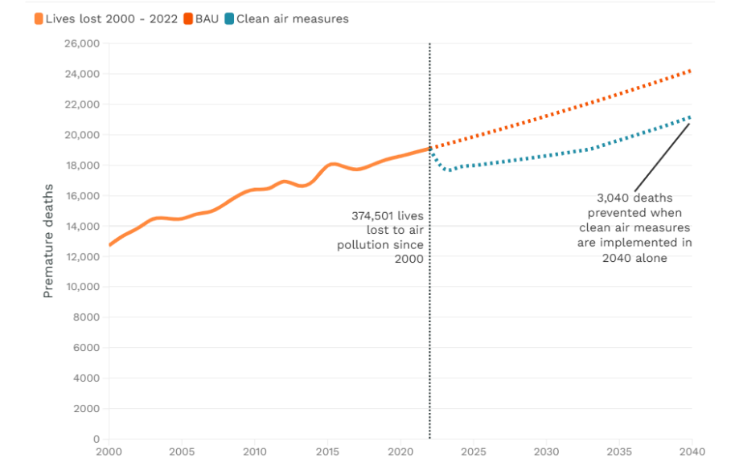
Air pollution in the Middle East and North Africa (MENA) is a massive crisis that can’t be ignored. toxic air causes 270,000 premature deaths in the region every single year. To put that in perspective, this is more than the deaths caused by car accidents, diabetes, tuberculosis, malaria, and HIV/AIDS combined. In Cairo alone, bad air quality is responsible for 18,000 early deaths each year, which makes up 16% of all deaths in the city as shown in Figure 10.
Figure 10: Premature deaths due to air pollution
Looking at the data, over 374,500 lives have been lost to air pollution since the year 2000. But the damage doesn't stop at people’s health; it also severely hurts the economy. According to the World Bank, the cost of air pollution wipes out about 2% of the entire MENA region's GDP every year. When people get sick from breathing bad air, work is missed, and hospital bills pile up. In busy cities like Greater Cairo, heavy traffic and exhaust fumes make the air worse and drain even more money from Egypt's national economy.
If governments step up and implement clean air measures, 3,040 deaths in 2040 can be prevented.

Environmental impact
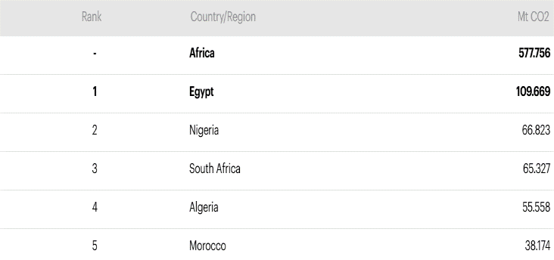
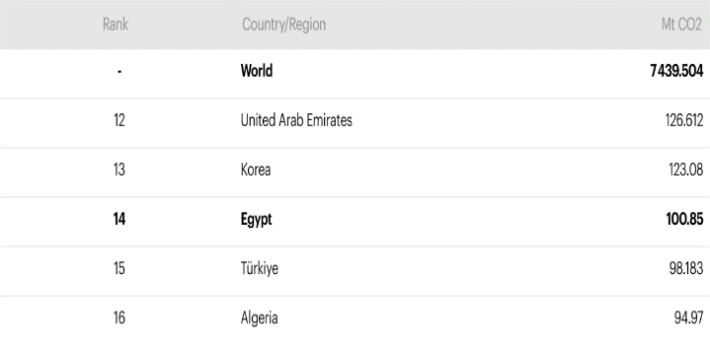
The dependency of Egypt on fossil fuels like oil and natural gas for energy has caused a significant negative effect on the environment and caused much pollution. For example, the burning of natural gas causes air pollution although it emits considerably less CO₂ and other pollutants as methane (CH₄), and nitrous oxide (N₂O), it remains a significant source of emissions that must be reduced to meet the international climate goals. For instance, the total CO₂ emissions from natural gas in Egypt have reached about 100.85 Mt CO_{2.} in 2022, it is ranked 14th globally, as shown in Table 1.
Table 2: CO2 emissions from oil, regional ranking, 2022
Table 1: CO2 emissions from natural gas, global ranking, 2022
Methane, the main component of natural gas, leaks from gas pipelines and processing facilities. That means that oil and gas extraction operations also pollute the environment, even before any fuel is burned.
Oil has the second largest share of CO₂ emissions globally, most of it in the transport sector, even though there is decent growth in EV (electric vehicles) sales, the majority of cars, ships, and aircraft are still powered by fossil fuels. Egypt’s total CO₂ emissions from oil is around 109.669 Mt CO₂ as 1st in the regional ranking of Africa as shown in Table 2.

Global Warming
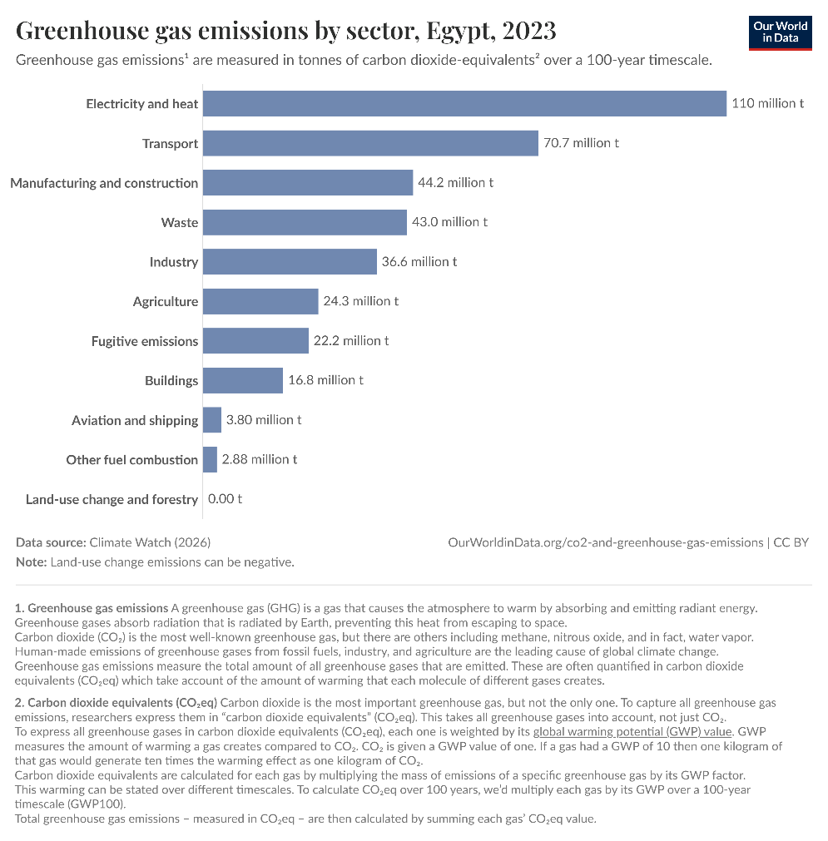
Greenhouse gas emissions in Egypt are primarily driven by energy demands, which significantly contribute to the global warming crisis. Based on 2023 data, 110 million tonnes of carbon dioxide-equivalent emissions were produced by the electricity and heat sector. Furthermore, 70.7 million tonnes were emitted by the transport sector, and another 44.2 million tonnes were generated by manufacturing and construction.
Figure 11: Greenhouse gas emissions by sector, Egypt
When these massive quantities of greenhouse gases are released, heat becomes trapped in the atmosphere, leading to severe climate consequences. Temperatures in Egypt are projected by the United Nations Development Programme to increase by up to 2.5 degrees Celsius by the end of the century. Consequently, extreme weather events, such as intense heatwaves, are experienced more frequently. Additionally, coastal areas and agricultural zones in the Nile Delta are severely threatened by rising sea levels caused by global warming. Thus, while economic growth is fueled by industrial expansion, the resulting pollution is directly linked to a warming climate that endangers national food security and environmental stability.

Reducing the effect of climate change
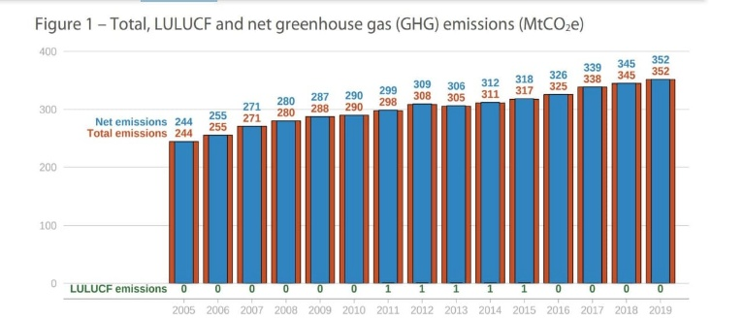
Climate change refers to changing the temperature and weather patterns. It can be natural because of the changing of the activity of the sun or the volcanoes. But since the 19_{th} century, human activities have been the main cause of climate change, primarily due to the burning of fossil fuels such as oil coal, and natural gas. That releases billions of tons of carbon dioxide (CO₂) and other heat-trapping gases into the atmosphere every year.
Figure 12: total, LULUCF and greenhouse gas (GHG) emissions (MtCO2e)
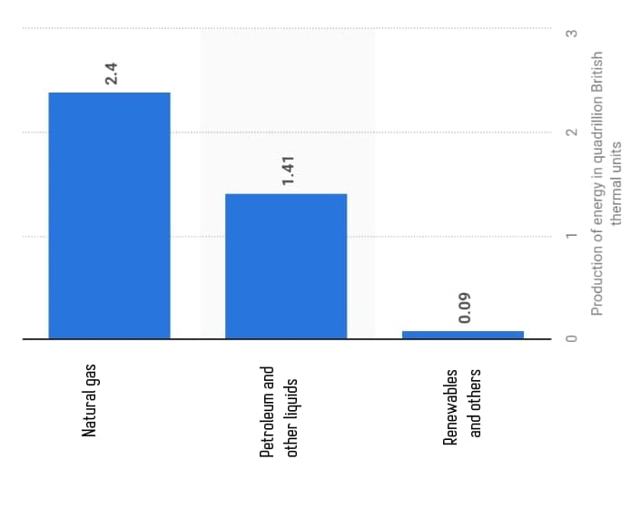
Although Egypt causes only 0.73 % of the global GHG (greenhouse gasses) emissions, it has become one of the most affected by climate patterns. Because of climate change, Egypt's already arid climate will suffer from other environmental problems, including maximum temperatures, irregular rain, high sea levels, coast floods drought, and deteriorating soil salinity. These effects will lead to worsening water scarcity, hindering food security, and maybe affecting the Egyptian economy. According to the European Parliamentary Research Service (EPRS): Egypt's total GHG emissions rose from 134 million tons of carbon dioxide equivalent in 1990 to 352 million tons of carbon dioxide equivalent in 2019 (As shown in Figure 13). Between 2005 and 2019, the country's GHG emissions increased by close to 44% a much faster rate than the world's average (24%).
Figure 13

Causes

Usage of fossil fuels
Generating electricity and heat by burning fossil fuels such as oil coal and natural gas causes a large number of global emissions which. Egypt’s primary consumption grew by 52% between 2005 and 2021. As of 2022, the total primary energy production in Egypt amounted to nearly 3.89 British thermal units. More than 90% of quadrillion Egypt’s primary energy consumption comes from fossil fuels. Natural gas was the source with the highest, with nearly 62% of the total energy production. Share Petroleum and other liquids came next with about 36.33%. Renewables and others' share was only 2.31%.

Deforestation
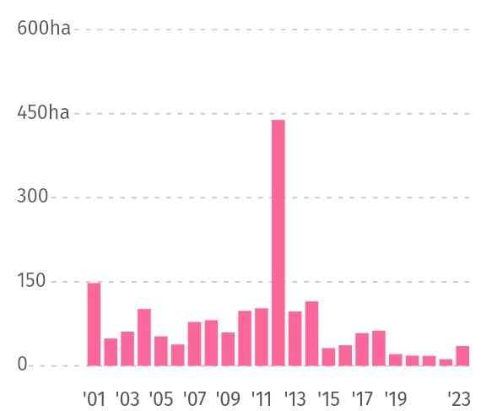
When deforestation occurs, much of the carbon stored by trees is released back into the atmosphere as carbon dioxide, which contributes to climate change. In the last decade, the largest amount of deforestation occurred across the humid tropics, mostly in Africa. As shown in Figure 14, from 2001 to 2023, Egypt lost 1.81 kha of tree cover, which means meaning 1.2% decrease in tree cover since 2000, and 553 kt of carbon dioxide emissions.
Figure 14: the number of lands that have been spoiled
As shown in Figure 11, according to the Global Forest Watch, from 2013 to 2023, 99% of tree cover loss in Egypt occurred within natural forests. The total loss within the natural forest was equivalent to 120 kt of CO₂ emissions.

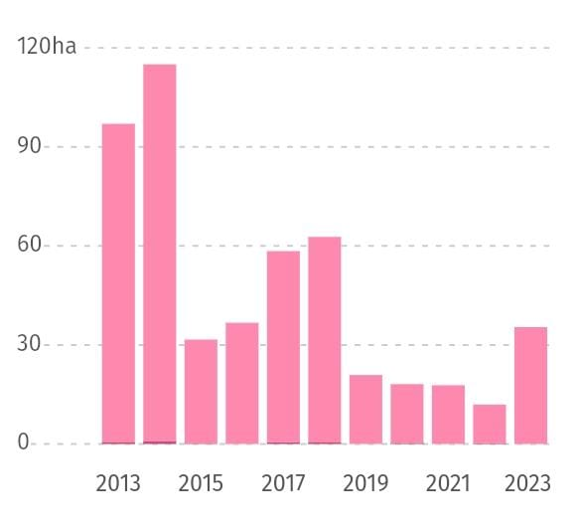
Industrial human activities
Figure 15: Tree cover loss in Egypt
Human activities have been the driver of climate change since the 1800s causing the emission of some greenhouse gases that caused temperatures to rise faster than at any time in history. That’s because, at this period, humans began to build factories after the Industrial Revolution in England which led to the spread of factory exhaust and carbon dioxide emissions. In wars and battles, people on each side of the war want to defeat the other side, so they use weapons to achieve it like the atomic bomb that can damage a big city and has a very bad effect on the surrounding area and environment where atomic bombs emit a lot of radiation and emissions of greenhouse gases. In Egypt, agriculture causes the second largest effect on climate change with an emission percentage of 10 percent of Egypt’s emissions of greenhouse gases.

Impacts

Desertification
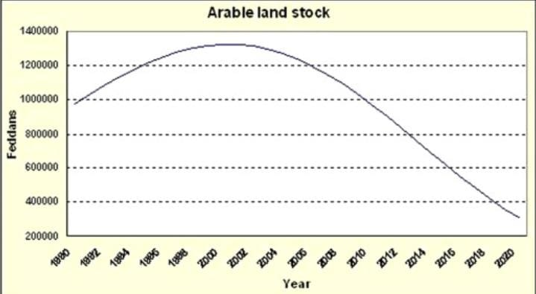
Desertification is a big environmental and economic problem that many countries face in many parts of the world. Desertification refers to land degradation in arid, semi-arid, and dry subhumid areas resulting from various factors, including climatic variations and human activities. Desertification is one of the impacts of climate change. Desertification impacts 3.5 feddans an hour in Egypt. This is a staggering rate for a country in which less than 3% of its land is arable. A rapidly growing population, over-cultivation, excessive usage of chemicals, and other unsustainable farming practices, as well as climate factors, all contribute to the problem. As shown in Figure 12, Egypt’s arable land stock decreased from nearly 1000000 feddans in 1880 to nearly 300000 feddans in 2020 with a decreasing ratio equal to 60% because of climate change.
Figure 16: arable land stock

High temperature
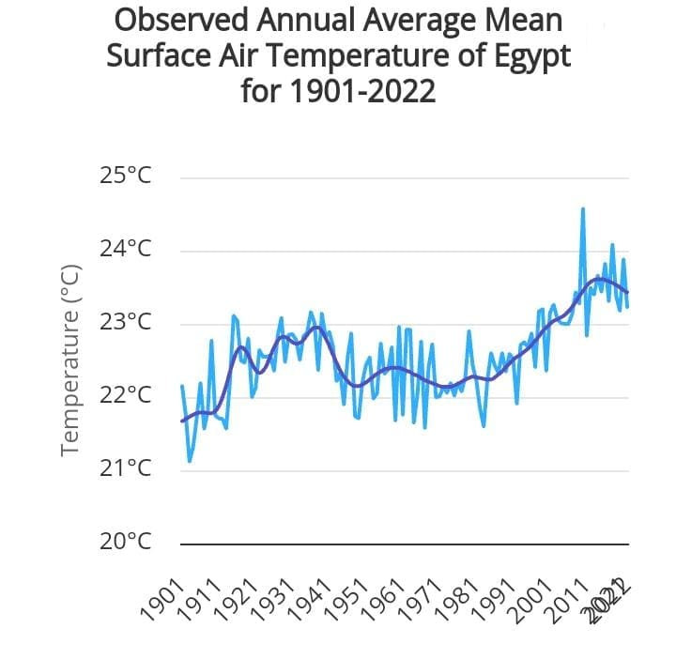
Most of the land areas of the world are facing more hot days and hot waves. 2020 was one of the hottest days. High temperature is one of the causes of illnesses that are related to heat. High temperatures can affect work quality and transportation. In addition to that, High temperatures lead to more forest fires. These fires spread with the highest speed when the weather is hotter. Egypt is one of the most affected countries by climate change. As shown in Figure 17, Egypt’s annual average mean surface air temperature increased from 21 °C in 1901 to 24 °C in 2022, and it is expected to increase temperatures if the country doesn’t face climate change.
Figure 17: Temperatures in Egypt

The release of sea level
Global warming is only one aspect of climate change. It happened because of the increase in greenhouse gases, mostly from factories. Global warming is an environmental problem that leads to a rise in the temperature of the Earth’s atmosphere. As the Earth’s atmosphere temperature rises, the ice in the polar regions melts more quickly. When the ice in polar regions melts, the sea level rises to about three halves-of the actual height at the global level since 1993. Antarctica loses an ice mass of 150 billion tons in a year, and Greenland loses an ice mass of 270 billion tons in a year, as shown in Figure 18. That led to the sinking of some cities in the future, such as Lagos in Nigeria, aaHouston in Texas, Jakarta in Indonesia, Dhaka in Bangladesh, Venice in Italy, and Alexandria in Egypt. Alex is considered the city most at risk of drowning due to climate change that led to rise at sea level.
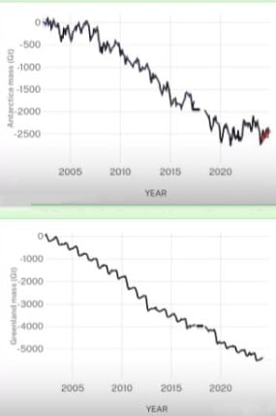
Figure 18: Antarctica and Greenland ice mass loss in a year

Recycling garbage and waste for economic and environmental purposes
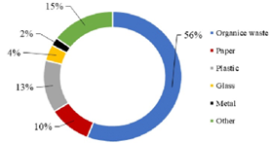
Egypt faces garbage waste problems, such as wasting useful solid waste materials and polluting the environment by disposing of these useful materials in harmful ways. Solid waste can be paper, bottles, cartons, or glass. This solid waste can be recycled to make new, useful products. But in Egypt, most of the useful solid waste is disposed of in non-scientific ways. The landfills dispose of garbage in polluting ways, such as open burning, which can pollute the air, and dumping in the rivers, which pollute the water, and drinking this water can cause infections and transmit diseases.
Figure 16: Percentage of the garbage types in Egypt
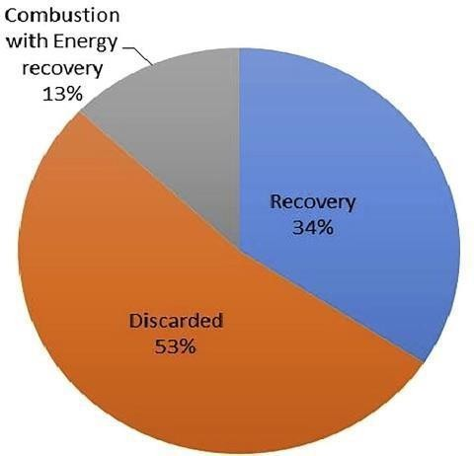
According to Egypt’s National Solid Waste Management Program, about 100 million tons of waste are produced annually. Figure 16 shows that 44% of the annual garbage is solid waste. Recycling this huge amount of garbage can save the environment and make new, useful, and powerful products. The other 56% is organic waste, which can also be recycled but in more complex processes, such as Anaerobic digestion and composting.
According to Figure 17, 53% of the 100 million tons of garbage are discarded and wasted without recycling. This is a large percentage. If this garbage had been recycled, there would be a lot of recycled products that could be very useful for people. However, this solid waste is being disposed of in harmful ways, such as open burning and throwing plastic bottles or cans. This behavior has a significant negative impact on marine life. Plastic bottles and cans are thrown into oceans or the Nile River, and they can prevent marine creatures' movement.
Figure 17: Percentage of Recycled and Discarded garbage

Causes:

Mismanagement of garbage
In Egypt, the “Zabbalen” collect the garbage without the country's entities. They collect the garbage and drop it in a place called “Zereba”. They prevent the country from collecting this garbage and recycling it. Also, they pollute the air by burning this garbage in the “Zereba”. The smell would impact the surrounding people. It is right that some of them collect garbage, recycle it, and make beautiful products. But most of them collect it and burn it without recycling it. Also, some cleaning companies don’t sort the garbage for recycling. The garbage is burned in the landfills.

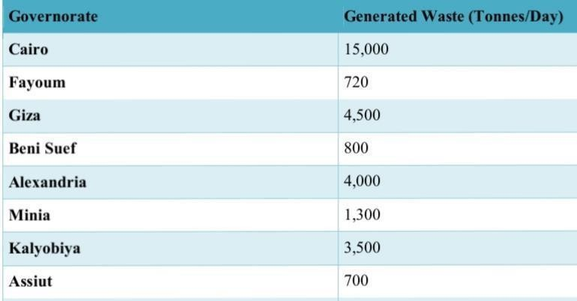
Overpopulation
Table 3: Generated government’s' garbage
Egypt has more than 100 million people. Those people are distributed among many governments. Cairo has the largest population, so according to Table 3, solid waste and garbage will be very much on it. Up to 15000 tons of garbage are generated per day in Cairo only. So, the country can’t handle all the people with that huge amount of garbage. So, some people dispose of their garbage without giving it to the country entities to recycle it. Giza comes after Cairo, with 4500 tons of garbage generated per day.

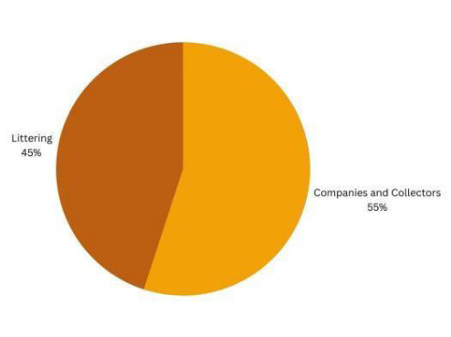
Littering
Some People in Egypt are not minded to dispose of the garbage into the recycling bins. They throw it in the streets. This Garbage, like paper and plastic bottles, can be recycled to make useful products instead of being disposed of in the streets and polluting the environment. Figure 18 shows that 45% of Egyptian householders dispose of their garbage in the streets by littering, while the other 55% dispose of it by using cleaning companies and garbage collectors. This percentage is not small few a huge negative impact can be made from it.
Figure 18: Littering percentage in Egypt.

Impacts:

Water pollution
Most of the factories in Egypt dump their industrial waste in the Nile River. These industrial wastes can be plastic remains, oil, chemicals, and metal industries. The Nile’s water is getting polluted with this waste and endangers any creature that drinks this water to contract many diseases. Also, this behavior endangers marine life and prevents marine creatures from living in clean water. For example, the Edfu factory for paper, pulp, and writing paper alone dumps more than 3.7 million cubic meters annually. This is a vast number that makes a noticeable impact on marine life and water quality. Also, Kafr-el-Zayat dumps more than 6.6 million cubic meters annually.

Health issues
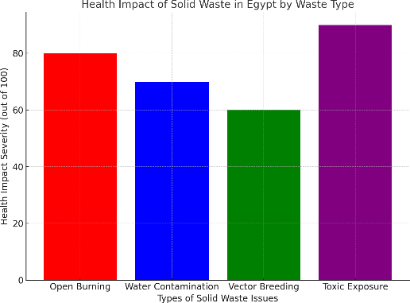
Wasting garbage and not recycling it can have a big impact on people's health. Open-burning, Ocean dumping, and littering are all harmful ways to dispose of garbage and have impact with high impact on people's health. Figure 19 shows the severity of Open burning that impacts 80 out of 100 people. This is a huge number impacting the environment. The people’s health who live near landfills is under direct threat. They can get infected with malaria, dengue fever, and leptospirosis. Adults with asthma are at risk of being admitted to intensive care because they cannot tolerate the smoke that the open burning produces.
Figure 19: Health impact of solid waste in Egypt by waste type.

Air pollution
Solid waste-induced air pollution causes major health hazards and seriously damages the ecology. While incinerating waste produces ash and hazardous particles that lower Egypt's air quality, organic waste decomposes to release foul aromas and greenhouse gases. The expanding number of women and young people is especially affected by this problem. Burning and other inefficient garbage disposal techniques contribute to creating carbon monoxide (CO) and particulate matter (PM), both of which are harmful to health, especially for expectant mothers. Air quality is further compromised by the emission of micro- and Nano plastics, which is made worse by inadequate waste management infrastructure and a lack of knowledge.

Increase the industrial and agricultural base of Egypt
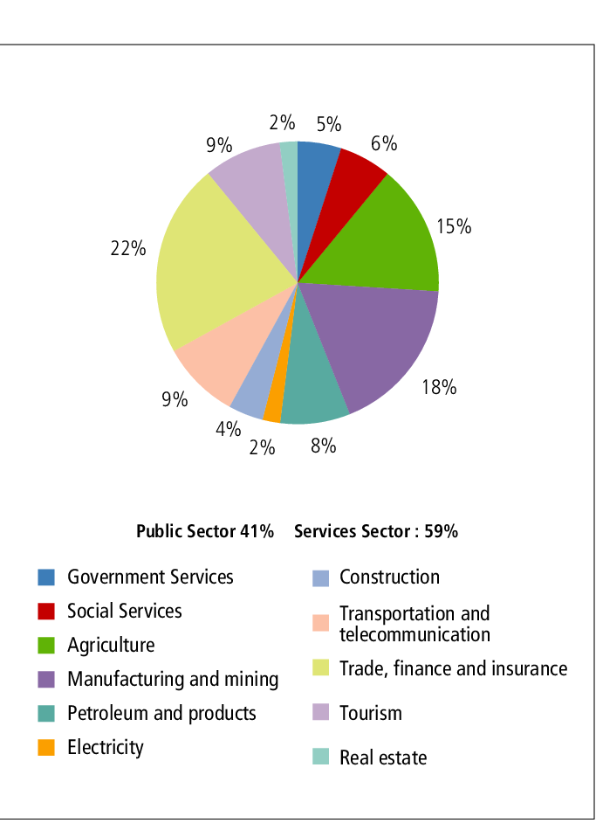
The Egyptian economy has been the most important factor in improving people’s lives and development levels. The economy is related to several aspects that significantly impact it, such as industry and trade. Industrial and agricultural sectors are the most significant components of Egypt's economy. As shown in Figure 20, these economic sectors account for around 33% of Egypt's economy; hence, they play a major role in the country's economy. Agriculture in Egypt is consequential for several services, such as trade, the food and clothing industries. However, agriculture is in continuous decline, which affects all the services it needs.
Figure 20: percentage of economic sides in Egypt
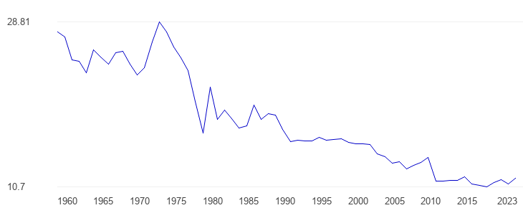
As shown in Figure 21, the GDP (Gross Domestic Product) share of agriculture in Egypt has decreased over the last 50 years, reaching only 10.7%. Although it exceeds the world average of 9.9, it is a small number because Egypt's dependence on agriculture is high. Industry, the second important side of the economy, has also declined in recent years. Although Egypt is one of the first countries to have begun industrialization (in the 1920s), it faces major problems in its industry, including a decline. According to the MPED Ministry of Planning, economic and international cooperation, there was a decline in the GDP of the industry in Egypt with nearly 4.7%, which represents the problem of the industry in Egypt.
Figure 21: (Egypt GDP Share of Agriculture - Data, Chart | TheGlobalEconomy.com.)

Causes

Agricultural Dependency and Food Security
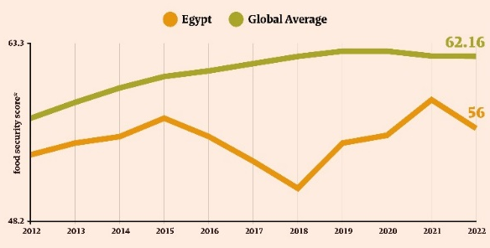
Agriculture is an important sector of the Egyptian economy; it contributed around 11.3 percent of the GDP in 2021 while employing around 55% of the total labor force. It remains an important source of income for millions of Egyptians. Despite agriculture's important role in the Egyptian economy, food security problems are increasing. The ratio of cereal import dependency increased from 34% in 1999 to 42% in 2013, demonstrating increasing reliance on imported foods. Increasing Egyptian dependency on imported foods implies increased vulnerability in the global marketplace, particularly during challenging times such as during and after the COVID-19 pandemic, and amid international conflict.
Figure 22: Egypt’s Food Security Across the Years
Food insecurity impacts over twenty-five percent of Egyptian people, with approximately 8.83 percent being considered severely food insecure. While these statistics exist to examine the state of food insecurity in Egypt, the results highlight the need for sustainable agricultural production systems in Egypt, food production in Egypt, and a reduction in dependency upon imported foods. Figure 22 shows Egypt’s food security compared with the global average across 10 years.

Water Scarcity and Agricultural Production
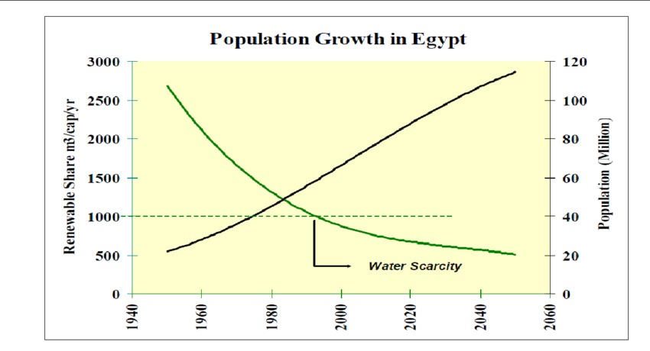
Water scarcity is becoming a serious challenge that Egypt suffers from due to rapid population growth and climate change. In 1977, the average share of renewable water per person was 1,426 cubic meters per year, but by 2022, it had dropped to about 558 cubic meters. Agriculture uses nearly 80% of the country’s freshwater, most of it coming from the Nile River, which is already fully used. Some analysts caution that as early as 2030, Egypt could reach the point of needing to import more viable fresh water than it can provide itself, which has never occurred in Egypt's national history. If Egypt is to safeguard its food future, it must act now by improving its use of water and supporting the more intelligent and sustainable agricultural practices. Figure 23 represents the population growth in Egypt and its relationship with renewable shared Water.
Figure 23: Population Growth in Egypt

Reduced Energy Impact on Industrial Activity in Egypt
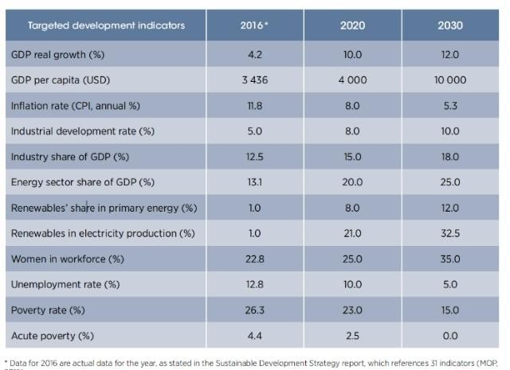
Between 2015 and 2022, Egypt’s industrial energy demand grew by more than 5% each year. However, electricity production hasn’t kept up, especially during the summer months when national usage peaks. In 2022, about 35% of small and medium factories reported alternating power cuts that affected their productivity. Some industries that consume large amounts of energy, such as cement, steel, and chemicals, have been especially affected, facing delays, rising costs, and reduced competitiveness. This makes it essential to meet industry needs as soon as possible to boost Egypt's industry and address its challenges, as shown in periods 4, 5, and 6 in Table 4, which aim to provide enough energy for factories and to do their best to achieve Egypt’s 2030 development goals in the future.
Table 4: The values of targeted development indicators in 1016, 2020, and 2030

Impacts

Trade issues
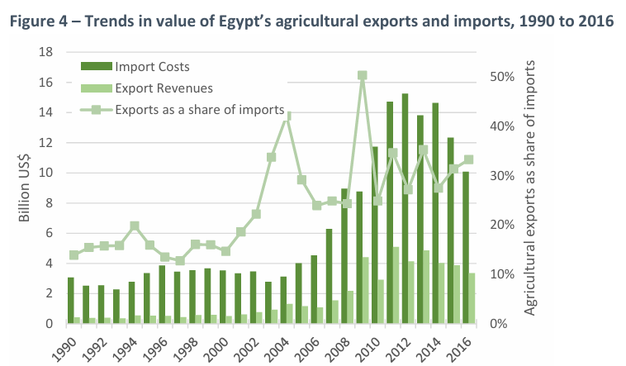
Industry and agriculture in Egypt form the backbone of trade. This is because their products are consequential for import, export, and other trade sides. The previously mentioned sides of trade face real issues as industry and agriculture play a major role in production. As shown in Figure 24, Agricultural imports have increased by nearly 15 billion USD over the last few years. This number has affected Egypt's economy, as exports are very low at 4.5 billion.
Figure 24: Agriculture share of imports and exports
The decline in Egypt's industrial base also affects the country's trade, as industry accounts for 40% of Egypt's trade. As the industry's GDP share has decreased, the country's trade has been affected, with export revenues declining by nearly 1.9% (MPED).

Job Losses
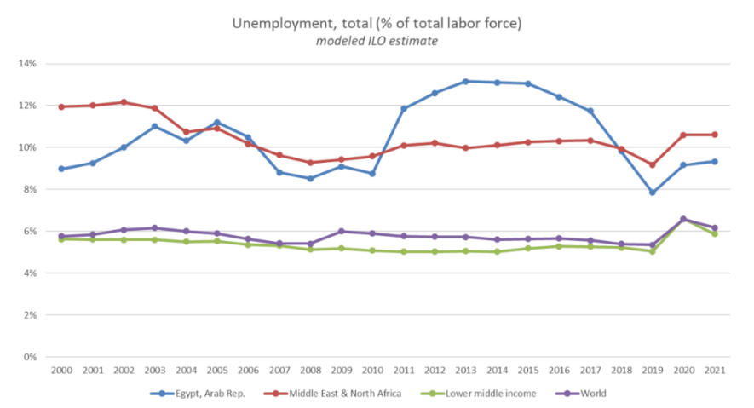
Decreasing of the industrial and agricultural bases in Egypt led to an issue of employment in the country. These activities, which represented as around 58% of the labor force (CAPMAS), are essential for employment in Egypt. However, their bases have been in decline in recent years, as shown in Figure 25, The unemployment in Egypt has increased and reached more than 13%. It shows that the country's unemployment percentage clearly exceeds the world average, highlighting the role of the decline in industrial and agricultural bases in the country's unemployment rate.
Figure 25: Unemployment rate in Egypt

Problem to be solved

Protecting Siwa’s Crop Production from the Threats of Climate Change
Food production in Egypt is threatened by climate change-related factors. Things like sudden changes in climate patterns, such as rising temperatures, changes in precipitation, and the quick spread of soil, air, and water pollution cause several challenges to Egypt’s food production. This is due to the absence of a stable and suitable environment for growing essential crops for Egypt’s development. Egypt faces water scarcity due to increased water evaporation caused by rising temperatures in Egypt’s already arid climate. Decreased crop yields are a great upcoming challenge for Egypt. It happens due to heat stress and changes in rainfall patterns that can negatively impact crop yields, particularly for heat-sensitive crops like wheat, fruits, and leafy greens (Abd El Maksoud, 2022).
Egypt’s proposed development project in Siwa is to reclaim 30,000 acres, which is part of the national project to reclaim 1.5 million acres, mostly in the western desert of Egypt. The Siwa region is a natural depression with an area of 0.28 million acres located in the northwest of the Western Desert in Egypt. The region is unique because it is a closed basin where groundwater from the Nubian Aquifer System (NAS) is the only source of high-quality water, with no recharge given the prevailing arid conditions. A study investigated whether stipulated government goals are possible under climate change during this century using different climate models under two representative concentration pathways (RCPs): RCP 4.5 and RCP 8.5. (Moghazy & Kaluarachchi, 2021).
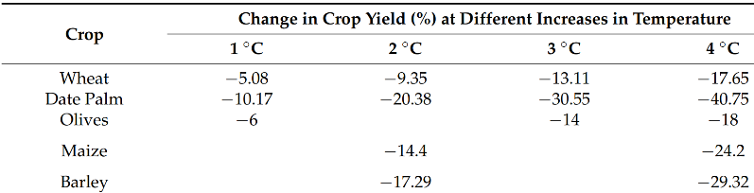
As shown in Table 5, a small increase in temperature, like 2°C and 4°C, causes large hardy crops like maize losses 14.4% and 24.2% of their yield, respectively. Using climate models, summer temperatures in Siwa are expected to rise by up to 4.65°C. Because of this heat, plants will need 18.2% more water just to stay alive. If this is the case for the large hardy crop like maize, tiny leafy greens, which have much thinner leaves and shallower roots, would likely face 100% crop failure if planted in the same conditions (Moghazy & Kaluarachchi, 2021).
Table 5: Impact of temperature on crop yield

Negative Consequences

Decrease in Agricultural Yields:
If the problem remains unsolved, the most logical consequence will be an increasing reduction in agricultural yield due to the increasing effect of climate change on the environment. According to the data in the Moghazy (2021) study, even hardy crops like maize are expected to face a 27.4% reduction in their production due to rising thermal stress. For small, heat-sensitive leafy plants like arugula and spinach, the result is even worse; they would likely face total failure as temperatures elevate. This loss of production will make the Siwa region remain an unutilized semi-arid area. Therefore, Siwa could see a significant rise in poverty and climate migration, where families are forced to leave their lands and go to urban centers.

Depletion of high-quality groundwater:
Failure to solve the problem will lead to the depletion and degradation of the Siwa groundwater basin. As the climate gets hotter, traditional farmers will be forced to extract more water from the aquifer to fight the 10.72 mm/day evaporation rate (Moghazy & Kaluarachchi, 2021). This increasing action of over-extraction will eventually exceed the recharge rate of the Nubian Sandstone Aquifer System (NSAS), causing wells to run dry. Also, when the water level drops too low, the remaining water often becomes too salty for plants to survive; this is known as saltwater intrusion. Watering the soil with this saltwater would lead to an irreversible environmental disaster where the soil becomes sterile and unable to support any life for plants.

Unbalanced Population Distribution:
Egypt’s population is continuously increasing. However, the problem isn’t in the increment itself. The problem is that the increasing population is accumulating in the places near water sources and agricultural activities. This causes stress on many sectors and places in Egypt. That’s why one of the goals that the government aims to achieve from the reclamation project of the Siwa region is balancing the population distribution (Moghazy & Kaluarachchi, 2021). However, if the problem of adaptation to climate change isn’t solved, the population distribution will still be unbalanced and hard to balance, leaving all the problems it causes as they are.

Positive Consequences

Enhanced Food Security:
If Siwa’s crop production is protected successfully, the crop production in Siwa will increase and be more stable. This will lead to enhanced regional food security due to the production of high-quality leafy greens like arugula and spinach year-round, regardless of the rising summer heat in Siwa Oasis. In this way, Siwa’s local market will have a consistent food supply, which will nourish it and makes more independent. In conclusion, solving this problem will change the Siwa region from a climate-vulnerable region that can’t be utilized in agriculture to a stable region of sustainable agricultural production.

Economic Stability:
If Siwa produces its own crops, the region will face decreased vulnerability to global food price shocks and supply chain disruptions. Egypt’s growing population places massive pressure on food production (Abd El Maksoud, 2022). If local agricultural sources like Siwa succeeded to work, the government will spend less foreign currency to import leafy greens and vegetables from outside. This makes the local economy resilient to inflation and international market fluctuations. In times of global crisis, the presence of local, climate-resilient farming becomes a strong securing shield. Without a way to grow food in 40°C+ weather, Siwa loses its self-sufficiency, making it entirely dependent on external aid and less economically stable.

More Job Opportunities:
Introducing enhanced agricultural activity in Siwa’s harsh environment will result in a new working agricultural sector in that place. Since this agricultural sector needs to operate using smart agricultural ways to be resilient to climate change, the job opportunities in Siwa’s region will increase. Starting from the simple farmer to the intelligent engineer, all of them will have the opportunity to work together in a highly efficient system. In conclusion, solving this problem will offer a wide range of different job opportunities, decreasing the unemployment rate in the Siwa region and therefore in all of Egypt.

Topics related to the problem

The Impact of Rising Temperatures on Crop Yields
National food security is heavily threatened by the continuous drop in farming output, which is caused by climate change. In areas where extreme heat and changing rainfall are common, the growth of essential crops is badly damaged. According to the International Food Policy Research Institute, a 10 percent drop in the yields of major food crops is expected for Egypt by 2050 if nothing is done. More specific dangers have been seen for certain crops. For example, when temperatures rise by just $2^{∘}C$ and $4^{∘}C$, large crops like maize lose 14.4% and 24.2% of their harvest, respectively. Summer temperatures in Siwa are expected to rise by up to ${4.65}^{∘}C$.
Because of this extra heat, plants will need 18.2% more water just to stay alive. For small, heat-sensitive plants like leafy greens, total failure is expected if they are planted in these conditions. This huge loss in crop production will lead to a greater need for foreign food imports. To stop these terrible effects, smart agricultural systems, like closed greenhouses, should be used. If crop production is protected successfully, regional food security will be enhanced with a steady supply of high-quality greens. By protecting crops from extreme heat, local food supplies can be kept safe.

Agricultural Reclamation Projects and the Redistribution of Population
The unbalanced spread of the Egyptian population is known to cause huge stress on areas near water sources and farms. To reduce this heavy pressure on the Nile River areas, a large national project to reclaim 1.5 million acres was started by the government. The reclamation of 30,000 acres in the Siwa Oasis is a big part of this plan. By having new farming communities built in these dry regions, it is hoped that the population distribution will be balanced better. However, the success of these new areas is totally dependent on how well climate change is handled. If smart and modern farming methods are not used, these new lands will fail because of the harsh desert weather. On the other hand, if advanced farming systems are successfully put in place, the local economy will be made much stronger. In addition, many new job opportunities will be created. These jobs will be offered to everyone, starting from the simple farmer to the intelligent engineer. In the end, changing weak desert regions into strong farming areas is needed so that economic stability and a balanced population can be achieved

Water Scarcity and the Depletion of Groundwater in Arid Regions
The severe problem of water scarcity in Egypt is made much worse by climate change. A critical limit for water scarcity is defined by the United Nations as 1,000 cubic meters per person each year. However, it is reported by the World Food Prize Foundation that only 560 cubic meters of water are currently available for each person in the country. This large shortage is caused by rapid population growth and high evaporation rates, which are driven by rising temperatures. Because of this, a heavy reliance on underground water sources, like the Nubian Aquifer System (NAS), has been developed for farming in dry areas like the Siwa Oasis.
This aquifer is unique because no new water is added to it due to the dry climate. As farmers are forced to extract more water to fight high evaporation rates of 10.72 mm/day, these underground reserves are drained very quickly. If the water is taken out too fast, the wells will be emptied completely. When water levels drop too low, the remaining water becomes too salty. If this salty water is used on the soil, it becomes completely sterile and cannot grow any plants, which is called saltwater intrusion. To stop this disaster, highly efficient irrigation methods must be used. By carefully managing these limited water supplies, desert farming can be saved for the future.

Topics related to the solution

Soil fertility
Soils are one of the main majors affecting the agriculture of Egypt (as well as the other countries). The fertility of the soil ranges between the layers of the lands and sediments, including the products of chemical and physical sedimentation. The layers of the soil called soil horizons which are divided into C, B and A, the most fertilized layer and the best for plants’ growing. In contrast, this layer depends on other factors. The main factor that affects the fertility of Egypt’s soil is Nile River. Thus, most of the agricultural lands are located close to the riverbanks, including Nile valley and delta, the most fertilized zone in Egypt. In the western desert, the soil extremely varies from zone to another. For the oasis, including Siwa, the soils have distinguished features including particular erosional patterns, special parent materials, different environmental sedimentations and different eluvial deposits (carbonate, salts and gypsum).

Water conservation
In agriculture, water conservation vastly affects the economic and systematic sides. The traditional methods for irrigation are insufficient because most of the water evaporates into the air or soaks into the soil, which creates a problem for plants’ roots as well. Thus, drip irrigation is an efficient method to conserve water. In drip irrigation, water is supplied slowly to the soil through special tubing systems the tubes have small holes which create an exit opening for the water with slow motion. Then, the plants get water requirements without high loss in the water. In Egypt, drip irrigation is known between the farmers, but it is still needing some improvements to increase the using of it. In contrast, it is used mainly for the public greenhouse systems. Another way to conserve water is xeriscaping. It is to use some plants that adapt to water loss. In contrast, it cannot be used for agriculture because it needs specific types of crops to plant them.

Fertilization types
Fertilization plays a major role for plants growing. In some areas, soil is rich with organic compounds and nitrogen, which helps plant growth, especially leafy plants. In contrast, other soil zones cannot meet plants reequipments, where fertilization can occur. Fertilization can be divided into two types, chemical and organic fertilization. In chemical fertilization, some chemical compounds are used for nutrition of the plants, including nitrogen compounds and some minerals, such as iron Fe, calcium Ca and potassium K. In contrast, organic fertilization uses wastes of other plants or animal wastes to produce these compounds. This includes the fertilization of the aquaponic systems, which is done by the wastes of the fish that is rich with ammonia. Then, the ammonia is converted into nitrite and nitrate to produce a large amount of nitrogen for plants’ growth.

Prior solutions

Automated Aeroponic Arugula Production
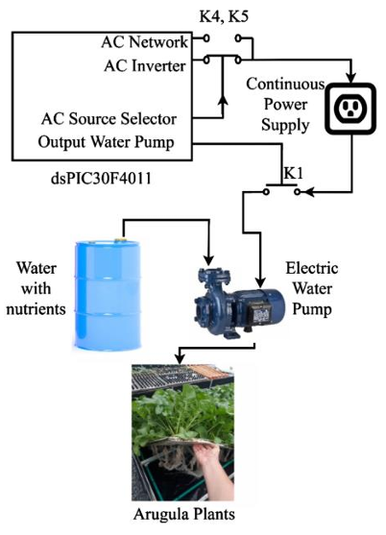
In a 120m² greenhouse in Medellin, Colombia, researchers at the Universidad Nacional de Colombia developed an automated aeroponic system for planting arugula. This system is made to optimize water and space resources while producing pesticide-free, cleaner food for a growing global population. In a Subtropical Monsoon climate, the study followed a continuous 35-day irrigation cycle, successfully reducing the typical 60-day field harvest time to just 42 days. The aeroponic method is a method where plants’ roots are suspended in the air, allowing for maximum oxygen exposure while delivering nutrients through high-pressure micro-sprinklers that sprinkle a nutritious solution (NS). As shown in Figure 26, the project is built around a central dsPIC30F4011 microcontroller, which serves as the "brain" of the operation. The system is divided into three main subsystems: the power supply, which includes an automated battery backup to ensure survival during electrical grid failures; the control logic, programmed via MATLAB-Simulink to perform specific irrigation operations; and the Culture Bed, which is a 6.0m × 1.0m aluminum frame with polystyrene sheets holding 36 plants per m² (Ríos Salazar et al., 2020).
Figure 26: Global system for cleaner production of pesticide-free aeroponic arugula
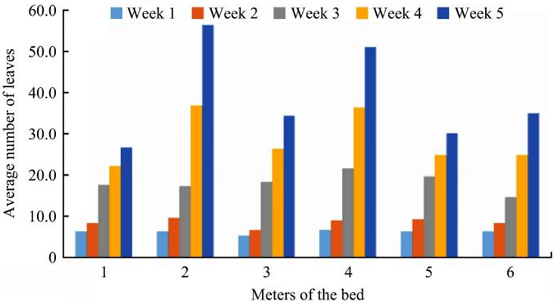
The project succeeded in planting full-grown arugulas in only 42 days period instead of the traditional 60 days in soil. Figure 27 shows the average number of arugula leaves per meter of bed across 5 weeks of noticeable growth. In the first few weeks, the number of leaves in each meter was almost similar to each other. However, in the end, the plants in beds 2 and 4 had more leaves. This may be due to some defects in the micro-sprinklers or pressure in the pipe, leading to an unequal spread of nutrients (Ríos Salazar et al., 2020).
Figure 27: Average number of arugula leaves per meter of bed

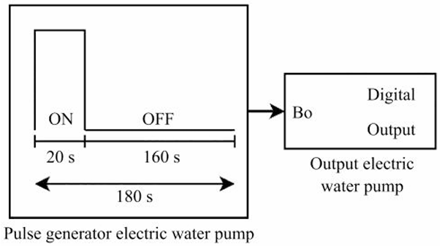
Mechanism
The mechanism of irrigation of this project aims to deliver a nutritious solution (NS) to the suspended roots in the air through high-pressure sprinklers. The NS is prepared by combining different concentrations (in ppm) of macronutrients like Nitrogen (250.81 ppm) and Potassium (278.82 ppm), alongside essential micronutrients. This chemical mixture is stored in a 130L hermetic tank before it is delivered through the micro-sprinklers. A dsPIC30F4011 microcontroller manages the timing of this delivery according to a specific digital logic. As shown in Figure 28, the logic uses a MATLAB-Simulink-generated pulse signal that maintains an irrigation cycle of 20 seconds of active misting followed by 160 seconds of rest. In this logic, the arugula roots remain well hydrated and nutrient-rich, while preventing root rot and saving big amounts of water and fertilizer compared to soil-based methods (Ríos Salazar et al., 2020).
Figure 28: Irrigation cycle programming in MATLAB-Simulink
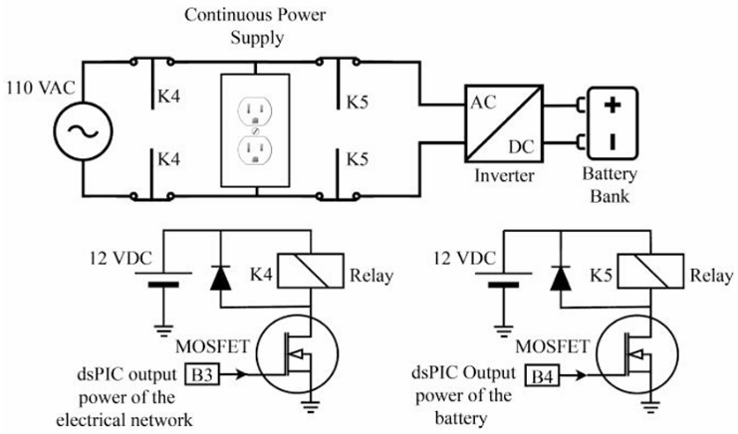
To keep the system working despite the frequent power instabilities common in many regions, the project offers a reliable power supply mechanism. This mechanism acts as an Uninterruptible Power Supply specifically made for agricultural needs. As shown in Figure 29, the mechanism relies on a voltage sensor that monitors the primary AC grid. When a power failure happens, the "AC Source Selector" logic instantly operates a transition to an auxiliary backup bank. This backup consists of two 12VDC batteries connected to a 3000W power inverter, which converts the stored DC energy back into AC power. To conclude, this power system provides safety and prevents crop failure. It also allows the whole system to remain autonomous and operating for up to 24 hours without external electricity (Ríos Salazar et al., 2020).
Figure 29: Diagram of the electrical circuit for the continuous power supply

Points of Strength

Growth Efficiency and Speed:
One of the most compelling strengths of this project is its ability to significantly outperform traditional agriculture in terms of production speed. By providing plants with an oxygen-rich environment and a precisely balanced nutrient solution, the system reduced the harvest cycle of arugula from the standard 60 days to just 42 days. This 30% increase in efficiency is a major breakthrough for food security, as it allows farmers to achieve more harvest cycles per year within the same physical footprint. For a capstone project, this proves that automation is not just about convenience, but about fundamentally improving the biological output of a system through environmental optimization.

Backup Power System:
The inclusion of an automated backup power system is a sophisticated engineering strength that addresses a common real-world failure point in hydroponics. Because aeroponic roots have no soil to buffer them, they can dry out and die within minutes of a power failure. The researchers solved this by integrating a voltage sensor and a 3000W inverter system that switches to a battery bank instantly when the grid fails. This level of "fault tolerance" makes the project highly practical where power stability can be an issue, ensuring that the investment in crops is protected 24/7 without requiring human intervention.

Resource Management:
This project has a great ability to manage resources used, such as water and nutrients. This happens through the system of a closed-loop 130L tank and a precise 20sec and 160sec irrigation cycle. In this way, the project decreases water evaporation and nutrient runoff, which are two of the biggest wastes in traditional farming. The use of a dsPIC30F4011 microcontroller to control these precise operations ensures that every drop of water is used by the plant. This strength proves that high-tech farming can actually be greener and more resource-efficient than old-fashioned methods.

Points of Weakness

Mechanical Inconsistency:
A notable weakness identified in the study's data was the lack of uniformity in plant growth across the six-meter culture bed. As seen in the leaf-count data, plants in certain sections grew significantly larger than those at the far ends of the pipes. This suggests a failure in the mechanical design regarding fluid dynamics; as water travels down the long irrigation line, pressure drops can occur, or micro-sprinklers can become slightly clogged. This inconsistency means that a commercial version of this system would produce uneven crops, which reduces its market value and indicates that the piping layout needs a more complex pressure-regulated design.

Lack of Real-Time Adaptive Feedback:
While the system is automated, it is not actually intelligent because it operates on a fixed timer rather than reacting to the plants' actual conditions. The 20-second irrigation action occurs every 160 seconds, regardless of air humidity, dryness, temperature, or other conditions. On the other hand, feedback sensors, like leaf moisture or ambient humidity, will result in a more real-time intelligent system that changes its decision according to the sensors’ feedback, not the code’s instructions. This static programming is a weakness because it can lead to water waste during cool nights or plant stress during extremely hot afternoons when the plants might need more frequent misting than the timer allows.

High Initial Complexity:
The system’s initial setup is considered complex and requires technical knowledge. This is because of the use of high-pressure micro-sprinklers that require complex maintenance. These tiny nozzles are subjected to clogging due to mineral accumulation from the nutritious solution, which can lead to operational problems and eventually the death of the plants. Additionally, the complexity of the dsPIC programming and the electrical selector circuit requires specialized technical knowledge to repair and maintain them. This makes the system less practical for average farmers than simpler hydroponic methods, as it requires high mechanical precision to prevent total system failure. This leads to a less user-friendly product.

El Bustan Aquaponic Farm
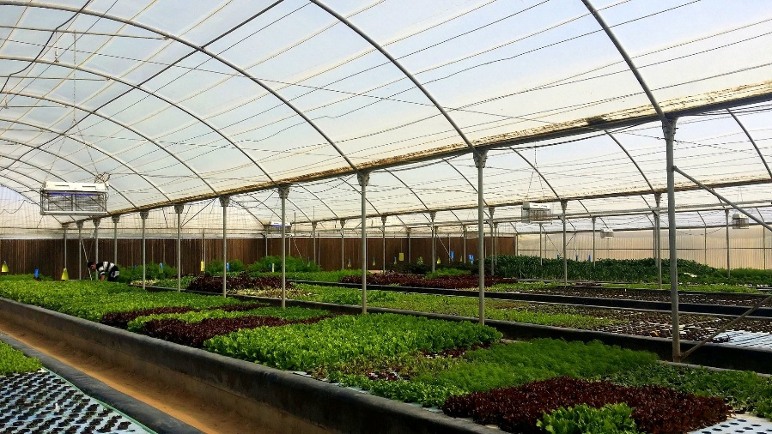
El Bustan aquaponics, shown in figure 30, is the first aquaponics project established in Egypt, located in Cairo, Egypt. The project, with its founder Faris Farrag, has been founded in 2011 to unravel the agriculture issues faces the desert lands in Egypt. As well, it aims to increase the feeding of the population in Egypt which supports the economy of the country. Parenthetically, the project was designed to be a 100% sustainable system including its powers sources and plants’ growing. The project was funded in the range of 300,000 Egyptian pounds (approx. US $ 50,000).
Fig 30: El Bustan Aquaponic farm
The project uses aquaponic system, a hypered system between greenhouse agriculture and aquaculture systems. Thus, it produces various types of leafy plants, including arugula, herbs, including basil and lettuce, including Green Batavia as well as fish production. The aquaponic farm sits on 1000 m² of land within an eight-acre olive orchard and consists of two greenhouses made of fine meshed netting material. The fish unit consists of 4 round tanks , each has a volume of 8 m³ and stocked with 600 tilapia Oreochromis niloticus. The fish are grown using extruded pellets, 32% crude protein level, to a market weight of 800 – 1000 gr. In winter water temperatures drops to 17o C or lower and fish growth comes to a near stand-still.
The vegetable unit consists of three long basins (30 m x 1.25 m, 30 cm deep). The walls of the basins are made of hollow blocks and concrete; a lining consisting of 400 micron thick PE makes the basins waterproof. The water surface is covered with 3 cm thick high-density floating polystyrene plates pierced with round holes of approx. 5 cm diameters at varying distances depending on the size of the plant.

Mechanism
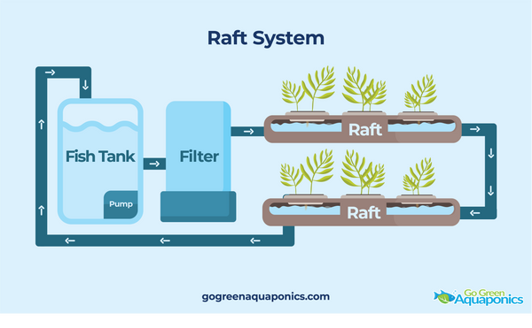
The aquaponic system has three parts, biofilter part, aquaculture part and agriculture part. The idea of it is to use the organic materials produced from the fish wastes and convert it into fertilizers for plants’ growing. In the other hand, wastes of the fish are rich with ammonia, a toxic material affects fish lives and plants qualities. Hence, it must be converted into nitrite and then nitrate which is done by the nitrification bacteria. Such bacteria, including Nitrosomonas and Nitrobacter, achieve the process with an aerated environment within a biofilter unit. The specific type of aquaponic used in this project is raft system. As shown in figure 31, the plants are watered by tubes passing through their roots. Hence, the water completes its cycle passing through biofilter and returns to fish tank.
Figure 31: raft aquaponics

Points of weakness

High initial cost
Compared to the other projects, EL Bustan project has a high initial cost with approximately 50000 USD. The average initial cost for the barley aquaponic projects ranges between 41000: 49000 which shows a slight increasing, but it is still shaping a drawback on the project.

Short-periodic maintenance
Because of the complexity of the irrigation and electrical systems, the aquaponic farm requires short-periodic maintenance which affects the economic side of the whole project.

Weak heating control
In winter water temperatures drop to 17 C or lower and fish growth comes to a near stand-still. Hence, the solution was to insulate the containers of the fish. Although, this method cannot regulate the slight changes of the temperature, which affects fish growth.

Points of strength

High production quality
The quality of the products of the farm is virtuous. According to Intercontinental transfers of species for domestication Future of Fish Nutrition and Technology, the response to the quality and size of the fish has been overwhelmingly positive. Hence, the response of the market has increased.

Variation of the products
El Bustan aquaponic farm involves production of various species of the product, especially plants. This includes lettuce and leafy plants. Thus, the economic availability of the farm has been increased.

Thanet Earth Commercial Greenhouse
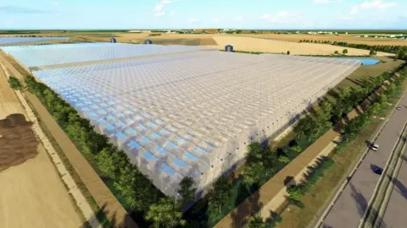
Thanet Earth is a massive commercial greenhouse complex located in Kent, United Kingdom. It stands as the country’s largest glasshouse facility, covering roughly 90 hectares (about 220 acres) of land. The project was born out of a critical, real-world need: the UK historically imported a huge percentage of its salad crops, like tomatoes, cucumbers, and peppers. This heavy reliance on imports made the country's food supply chain vulnerable and environmentally taxing due to constant shipping.
Figure 32: Thanet Earth Commercial Greenhouse
To solve this, specialist growers partnered together in 2007 to create a highly controlled, massive-scale indoor farming environment. Building a facility of this size required an enormous initial investment of well over £100 million. What makes Thanet Earth such a pioneering prior solution is its sheer scale and its commitment to environmental control. It essentially functions as a giant, automated feedback system. By using sensors and actuators to control every single variable of the growing environment, from the exact amount of sunlight hitting the leaves to the precise humidity in the air, the facility can grow crops year-round, completely bypassing the unpredictable British weather. Today, it produces a massive portion of the UK's domestic salad crops, proving that controlled environment agriculture is a viable, large-scale solution.

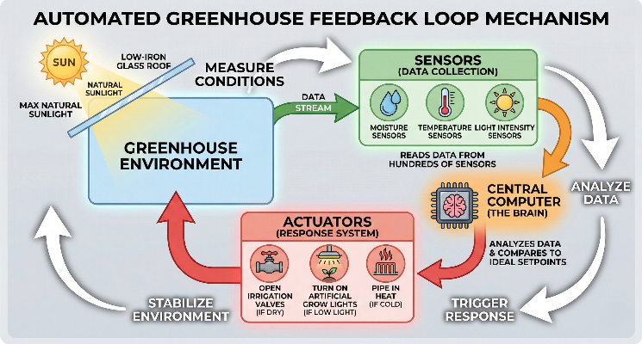
Mechanism
The entire facility runs on a highly sensitive, automated feedback loop. The greenhouse roofs use specialized low-iron glass to let in as much natural sunlight as possible. Inside, a central computer acts as the brain of the operation. It constantly reads data from hundreds of sensors tracking moisture, temperature, and light intensity. When the temperature drops or the soil gets too dry, the computer triggers actuators to open irrigation valves, turn on artificial grow lights, or pipe in heat.
Figure 33: The feedback loop system

Points of weakness

Massive Initial Investment
Building an agriculture project with this level of technological control is incredibly expensive. It requires a massive amount of upfront capital to build the physical glasshouses, install the specialized transparent materials, and wire the vast network of industrial sensors and computer systems required to monitor everything.

High Energy Consumption
Even with sustainable practices in place, running an artificial climate 24/7 takes a massive toll on the power grid. Powering the computer networks, the artificial lighting during the dark winter months, and the heating and cooling systems demands a constant, heavy draw of electricity.

System Complexity and Maintenance
Like any highly technical closed-loop system, having more moving parts means there are more things that can potentially break. The vast network of automated irrigation pipes and climate control actuators requires a team of specialized engineers and short-periodic maintenance to prevent a system failure that could ruin a crop.

Points of strength

Incredible Production Yields
Because the closed-loop system constantly optimizes the environment, the plants practically never experience stress from being too hot, too cold, or too dry. This perfect stability allows them to produce millions of vegetables a year, with yields that far exceed what traditional outdoor farming could ever achieve.

Resource Recycling and Efficiency
This is where the feedback system really shines. To offset their energy use, they capture the waste heat generated by their on-site power generators and pump it directly back into the greenhouses to keep the plants warm. They also capture rainwater from the massive glass roofs, filter it, and reuse it in their irrigation systems, drastically reducing water waste.

Pest and Weather Resistance
By physically isolating the crops indoors and using actuators to manage the internal climate, the system completely bypasses the dangers of traditional farming. The crops are protected from bad weather, unexpected frosts, and many traditional agricultural pests, ensuring a stable and predictable harvest every single time.

Agro Farmers Monitor
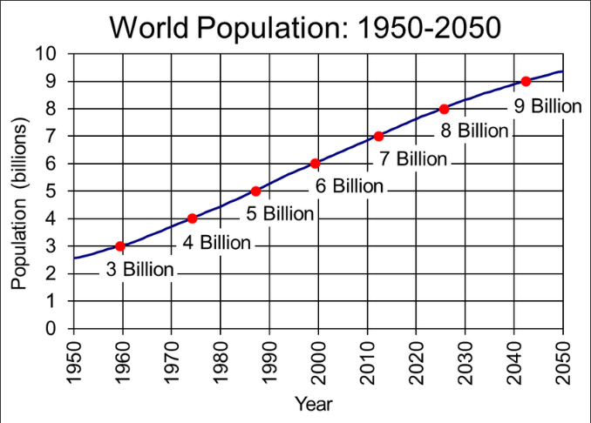
Agro Farmer Monitor is a sensor-based smart agriculture feedback system that monitors plants at a very low cost. It integrates web-based dashboards with IOT and sensors. According to the United Nations Food and Agriculture Organization, and as shown in Figure 34, the global population is projected to grow by 27% of what it is now by 2050. So, this project aims to replace traditional farming techniques, which are no longer productive enough to meet global food needs, with smarter, more precise technologies enabled by IoT-based monitoring. It will save more crops from dying, and provide healthier non-infected crops and agricultural products.
Figure 34: Population growth in the World. 1950-2050 (Malik et al., 2018)

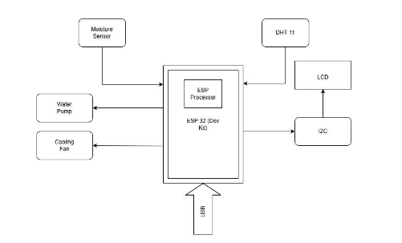
This solution core concept is the integeration of the IoT to bridge the information gap that many farmers face. The lack of timely and accruate data about the plant’s habitats. It uses a network of sensors to collect and gather data all the time and transfare them to the central ESP32 controller, then from there it whether uploads the data to a web-based dashboard that shows live graphs that updates all the time. As shown in Figure 35.
Figure 35: A simple logic schematic

Mechanism:

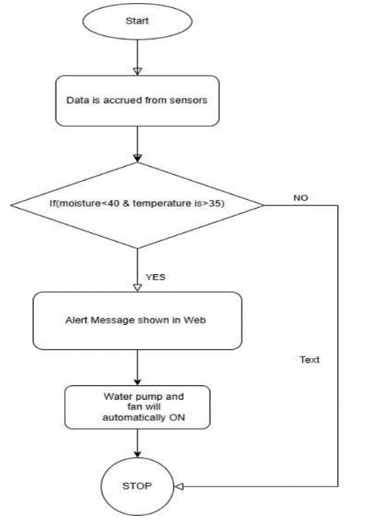
The system is based on a closed-loop feedback cyber-physical environment where some physical sensors drive digital logic to trigger mechanical responses. As shown in Figure Z, the workflow is divided into three layers: Data acquisition, responses based on the sensor readings, Uploading to the web-based dashboard. For example, the soil moisture parameter. The system use the soil moisture sesnor to measure the soil moistureness and if it is less then a specific range, the system trigger a servo motor that turns on a switch connected to the water pump to increase the moistureness. Along side uploading the real-time data from the sesnor to the web-based dashboard and save them in a database that has all of the data measures.
Figure 36: A closed-loop system example.

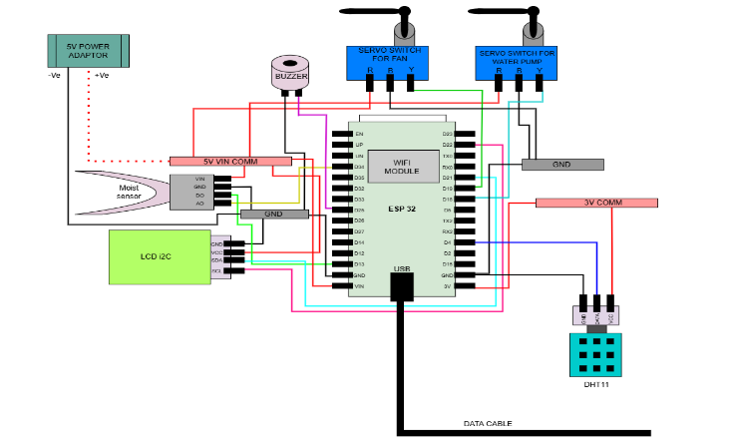
The system circuit as shown in Figure 37, is consists of 4 main groups. The first group, the sensors, a DHT11 digital module that measure the humidity and the temperature of the air, a Moisture sensor. The second group, the ESP32. It is the main central proccessing unit of the project. The third group, the LCD screen that shows the real-time measures of the sensors. The last group, the servos. There are two servos, one for the fan switch, and the other for the water pump switch.
Figure 37: Connections circuit.
There is a database system hosted on an apache PHP server. This database is using Mysql to maintain the tables and communicate with the ESP32 to receive and send data. Also, this Mysql data is connected to the web-based dashboard to maintain the user data interface and graphs.

Points of Strength:

Resource Efficiency and Optimization
This project has an exceptional resource efficiency, particularly ragarding water management. The traditional farming often suffers from water shortage and inefficient usage, but for this project, it is using a real-time soil moisture sensor that keeps tracking the soil moisture all the time and when it needs water it trigger a water pump to take the perfect amount that the plant needs. In that way, the project will be resource efficient. Statistical evidence from similar studies indicates that this automated control can reduce water consumpution by up to 30% (Patel et al. 2025).

Real-Time Data and Informed Decisionn-Making
The project focuses on providing a continuous real-time monitoring and data visualization, by offering graphical representation and history logs which fundamentally changes the way the farmers manage their crops. Unlike the traditional farming that is doesn’t not provide a continuous monitoring and can make some of the crop die. This real-time monitoring technique makes the farmers track the crtical parameters like temperature, humidity, and moisture, allowing for well-informed decisions that improve plant health.

Enhanced Operational Productivity and Lapor Reduction
The project will reduce the manual lapor by transforming the traditional physical lapor with the automated monitoring and instant alerts. Because the system generates acoustic alarms via buzzers and web notifications for extreme conditions, farmers no longer need a constant physical presence on-site. This "intellectual farming" approach is designed to be sustainable, inexpensive, and user-friendly, making it a dependable option for landowners to reclaim profitability. Ultimately, the automation of irrigation and ventilation improves "cultural management," leading to higher harvest revenues and a more efficient response to environmental stressors.

Points of Weakness:

Connectivity and Infrastructure Dependency
The project is highly dependent on a stable internet connectoin to stay online and uploads the data all the time, which is often lacking in rural regions where precision agriculture is mostly needed. Since the system functions as a cloud-integrated platform using the ESP32 microcontroller, any instability in Wi-Fi or mobile networks directly impedes real-time monitoring and data transmission. This "research gap" means that outages can lead to significant data loss or delayed responses from the automated irrigation and cooling systems during critical environmental events. While long-range technologies like LoRa are proposed as future solutions, the current reliance on.

Energy Consumption and Power Autonomy
Continuous data transmission significantly impacts the autonomous operation time of the ESP32-based devices, creating a major challenge regarding energy consumption and power management. Although the system can be powered by compact 9V batteries or 5V adapters, these portable units require frequent recharging or manual replacement to ensure the system remains active 24/7. This limitation necessitates the integration of expensive renewable energy sources, such as solar-powered modules, to support long-term field deployment in remote areas lacking consistent grid access. Without these stable energy solutions, the system’s reliability as an autonomous monitoring tool is diminished, as any power failure could halt the critical automated responses of the water pumps and fans.

Maintenance Complexity and Technical Barriers
The hardware components, particularly the DHT11 and soil moisture sensors, face severe environmental sensitivity and degradation when exposed to extreme weather, dust, and humidity fluctuations. These factors can quickly diminish sensor accuracy and lifespan, requiring regular calibration and technical maintenance that may exceed the capabilities of traditional farmers. Additionally, the high initial cost of deploying the necessary IoT sensors, cloud services, and web infrastructure serves as a major barrier to adoption for small-scale operations. The complexity of troubleshooting the Mysql database with the apache server and managing large sensor datasets demands specialized technical expertise, which could widen the digital divide for farmers with limited ICT literacy or no access to expert support.

Chapter 2
Generating and defending a solution

Solution requirements

Cost-Effectiveness
Cost-effectiveness must be selected as a key requirement so the project can be afforded by local communities. If the farming problem remains unsolved, the region will be made less economically stable, and it will be left completely dependent on external aid. By having an affordable greenhouse built, the local economy will be made resilient to inflation and international market fluctuations. Furthermore, less foreign currency will be spent by the government to import leafy greens and vegetables from outside. To make this project cheap, simple materials should be used instead of very expensive parts. When an affordable agricultural sector is created, many new job opportunities are offered. These jobs will be taken by everyone, from the simple farmer to the intelligent engineer. Therefore, an affordable design is required so that the local economy is protected and the unemployment rate is decreased.

Automation and Ease of Operation
Ease of operation and automation must be included as the final requirement. In the Siwa region, sudden changes in climate patterns and rising temperatures are constantly experienced. Extreme weather of $40^{\circ}C+$ is expected to be reached. If these changes are not handled quickly, total failure will be faced by sensitive leafy plants. To prevent this, the greenhouse must be run by an automated system where smart agricultural ways are used. The temperature and water levels must be measured by sensors, and adjustments must be made automatically by a computer. By having the system run autonomously, the need for constant human supervision is removed. However, the system must also be designed so that it is easily understood. If simple controls are provided, the technology can be operated by traditional farmers without difficulty. Thus, an easy-to-use system is needed so that regional food security is enhanced.

Adaptability for Multiple Crop Types
Because different crops are constantly needed by the population, adaptability must be chosen as a necessary requirement. It is known that heat-sensitive leafy greens and large hardy crops have entirely different environmental needs. Therefore, the project must be designed as a dual-species recycled mini-greenhouse. By having the internal space divided into separate zones, different temperatures and moisture levels can be perfectly maintained for two plant types at the exact same time. If this dual-species system is successfully built, the local market will be provided with a wider variety of food. Furthermore, when different crops are grown together under controlled conditions, the risk of total agricultural failure is greatly reduced. In conclusion, an adaptable design is required so that the varying nutritional needs of the Siwa region are fully met and regional food security is enhanced.

Design requirement
1- Prototype scale: The prototype volume must not exceed 0.25 m2 for the area of the crop growth.
2. Construction Materials: The prototype must be constructed using waste or recycled materials.
3. Actuator Implementation: The system must include at least two functional actuators capable of regulating variations in the three selected parameters. Actuators must operate in response to sensor feedback through the control algorithm. The power consumption (in watts) of each actuator must be measured and reported in the Results section.
4. Prototype’s Operation Ability: The greenhouse prototype ran automatically for at least full 6 hours while the actuators must be able to response for any deviation.
5. Operating time: The maximum time to stabilize a parameter reading must not exceed 30 minutes.
6. Actuator Implementation: The system must include at least two functional actuators capable of regulating variations in the three selected parameters. Actuators must operate in response to sensor feedback through the control algorithm. The power consumption (in watts) of each actuator must be measured and reported in the Results section.
7. Sensor Selection and Calibration: The system must include appropriate sensor types corresponding to the selected parameters. All sensors must be properly calibrated using standard calibration methods.

Selection of Solution
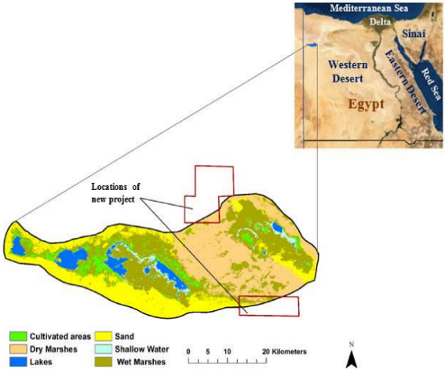
As shown in Figure 38, the chosen real-life location is the Siwa Oasis region. To help in protecting Siwa’s crop production from the threats of climate change, a solution was selected. This solution involves making a closed-loop feedback smart agriculture system that provides suitable environmental conditions for planting leafy plants, like arugula and spinach, in a greenhouse. It stabilizes the values of three primary environmental parameters, which are temperature, light intensity, and soil moisture, within a fixed range through the operation of certain actuators.
Figure 38: Reclamation Areas in the Siwa Oasis Region.
The system’s mechanism is simple, as its main purpose is to stabilize the values of three parameters: temperature, light intensity, and soil moisture, within a fixed range. For the soil moisture, a soil moisture sensor connected to a microcontroller is placed in the soil to measure soil moisture. If the soil moisture decreases, due to the water absorption from the soil by plants, the soil moisture value sent by the sensor will be lower than a specific threshold, then the microcontroller operates a water pump to pump water for a specific period of time. The water pump pumps water from another container and spreads it along the planting area using a rope with tiny holes to irrigate the field using the drip irrigation technique.
For the temperature, when the sensor senses an increase in the temperature, it sends signals to the microcontroller informing it of the latest values of temperature. In this way, the microcontroller operates a cooling actuator that consists of a fan with a cooling pad in front of it to cool the air around the plant. If the sensor senses an increase in temperature, the microcontroller will operate a heating actuator that heats air around the plant using a fan and a heating pad.
For the light intensity, a light intensity sensor will detect the light intensity reaching the plants inside the greenhouse. There are two actuators responsible for stabilizing light intensity values. For increasing light intensity, multiple regular light bulbs and UV-light bulbs are used to increase illumination. For decreasing light intensity, multiple plastic sheets with different light transmission levels are stuck together to form one long plastic curtain. This curtain will be placed at the top of the greenhouse to control the light transmitted from the sun. It will be attached to two servo motors to change between different gradients in this curtain.
As for the real-life materials, the body and other non-electronic parts in the project will be made from recycled materials when possible. Electronic parts don’t have to be recycled. For the real-life dimensions, the project can be applied for up to 30,000 acres of planting area. This is because the project is meant to be a solution for land reclamation of the Siwa Oasis region. The greenhouse is in the shape of a spherical dome for better heat management effectiveness. To achieve the safety requirement, there will be a strict warning not to approach the fans of the project when operating.

Selection of Prototype
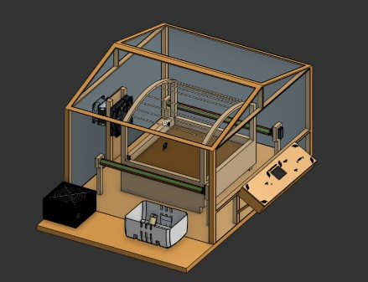
As shown in Figure 39, the selected prototype will be an agricultural greenhouse that takes the shape of a Gable greenhouse. It will mainly focus on measuring and actuating these three parameters: Light intensity, Temperature, and Soil moisture. Those parameters will be measured with high-precision, manually calibrated sensors connected to an ESP32 S3. This ESP32 S3 will take the data and check them with the conditions that are suitable for the chosen plant. Actuators for each parameter will also be connected, so when any of the parameters get away from its range. The ESP32 S3 makes the actuator work to handle it and get it back to its range.
Figure 39: CAD 3D Design
The light intensity mechanism specifically will be a little bit complex to achieve the best results with the minimum power consumption. The light mechanism will be two pips that rotate and spin a layer of different transmittivities above the planting area. The motors will rotate the pipes to change the transparent layer above and change the light intensity coming from the sun directly, rather than powering LEDs all the time and consuming a lot of energy. Also, the Peltier and fans will work only when the temperature goes out of the range, and the environment needs to be cooled or heated. The Peltier works and cools the environment, and when the sensor detects that the temperature returns to the range again, it stops the Peltier to save energy.
The prototype dimensions will be small, so the temperature can change quickly. So, first the base will be 50cm * 75cm, the height of the hole prototype 48cm, the width of the structure that holds the polyethylene 55cm, and 50cm long. The control panel that will have the full circuit inside, along the touch screen, will be 20cm * 15cm. The planting area itself will be 35cm * 38cm. The height of the light mechanism 37cm. The free area that holds the water tank and the power supply will be 17cm * 50cm. These dimensions were chosen to achieve the best temperature control with the best planting area and light intensity control. In that way, the fan in front of the Peltier will spread the cool air quickly and change the temperature of the whole area at once.

Chapter 3
Constructing and Testing a Prototype

Materials and Methods
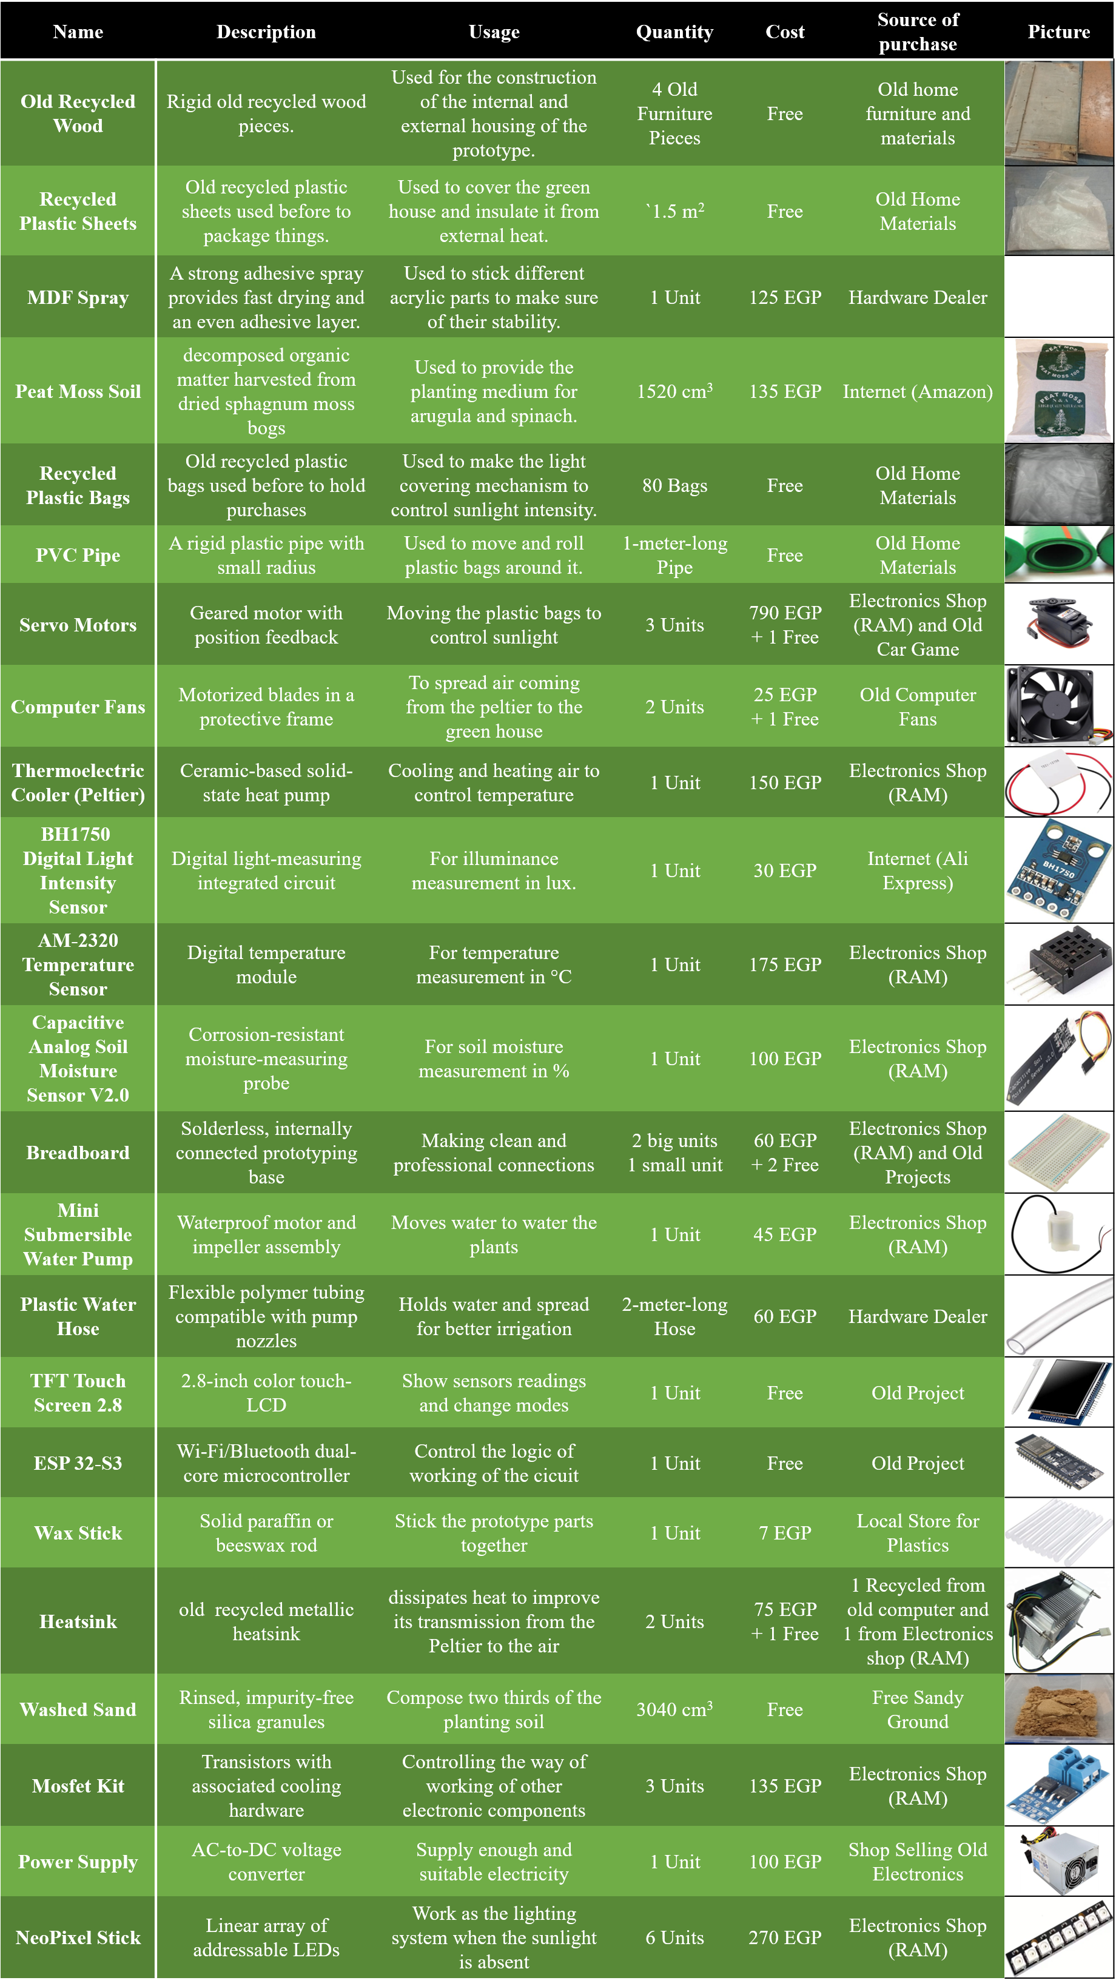

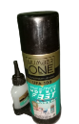
Table 6: Table of Materials
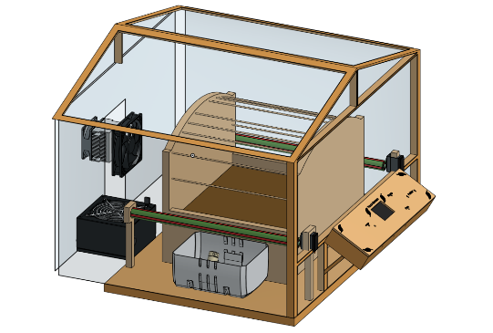
The greenhouse is constructed using recycled components for the main structure. As shown in Table 6, the materials are divided into structural components and the electronic feedback system components.
Figure 40: 3D CAD model for the prototype

1)Digital Modeling and Schematic Design:
Before constructing a 3D CAD model of the structure (Figure 40), a circuit schematic was designed for visualization and mapping the connections.

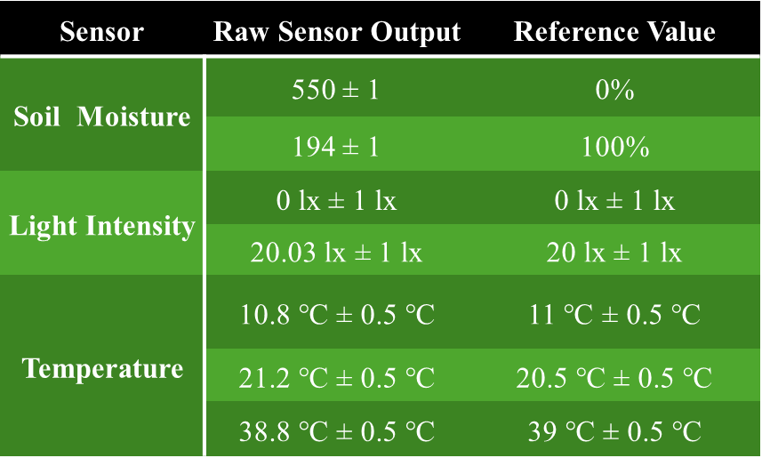
2)Sensor Calibration Procedure:
Table 7: Sensor Calibration Summary and Error Margins
The soil moisture, light intensity, and temperature sensors were calibrated against standard reference values, with the calibration process recorded on video. The raw sensor outputs, corresponding reference values, and the quantified error margins are summarized in Table 7.
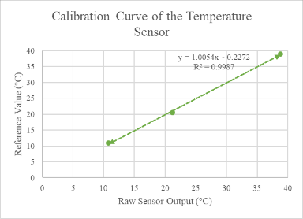
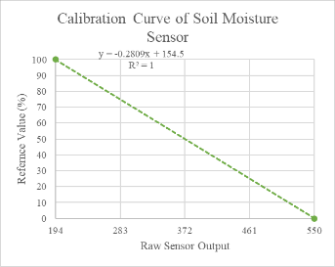
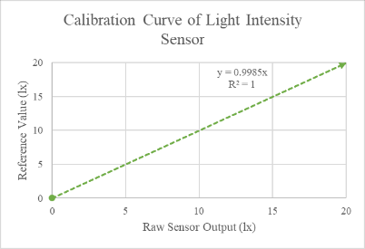
To ensure our greenhouse feedback loop operates with maximum accuracy, all three environmental sensors were calibrated. A simple two-point test was used for the soil moisture sensor (Figure 41), measuring it in dry air for a 0% baseline and then in a full cup of water for a 100% maximum. Defined by the equation $y = -0.2809x + 154.5$ . Similarly, the light intensity sensor underwent a two-point test (Figure 42) using absolute darkness for 0 lx and standard window light for 20 lx, resulting in the exact equation $y = 0.9985x$. Finally, a three-point test was performed for the temperature sensor (Figure 43) by placing it in cold, warm, and hot water baths. By checking these readings against a real reference thermometer, a highly accurate curve defined by the equation $y = 1.0054x - 0.2272$ was generated.
Figure 43: Calibration Curve of the Temperature Sensor
Figure 41: Calibration Curve of Soil Moisture
Figure 42: Calibration Curve of the Light Intensity Sensor


2)Structural Assembly:
Figure 43: Constructing the outer frame

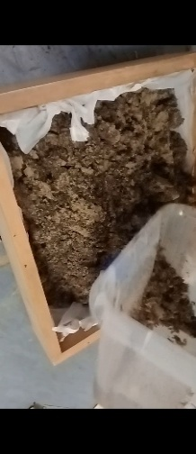
The structural frame (Figure 44), including the base, vertical columns, and two roof arcs connected by crossbeams, was assembled using MDF, nails, and recycled furniture wood. A plastic-lined wooden drawer with drilled drainage holes (Figure 45) was centered on the base as the planting bed, and filled with a two-thirds sand and one-third peat moss growing medium (Figure 46).
Figure 45: Making the drainage holes
Figure 46: Filling the planting area with soil mixture

3)Actuator and Circuit Installation:
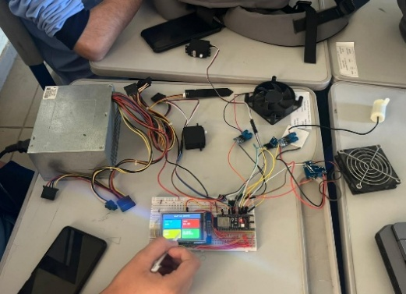

Wooden columns were mounted to hold four servo motors (Figure 47), which control PVC pipes wrapped in variable-transmissivity plastic for sunlight regulation. For thermal control, a Peltier plate with a heat sink and fan was housed within the side panels. Finally, a wooden control panel was built for the main circuit (Figure 48), and the water pump tubing was routed from an external tank to the soil
Figure 48: Feedback system's circuit
Figure 47: Attaching the servo motors holders

Safety precautions
Many safety precautions were taken into consideration while working on the prototype to ensure safety and prevent danger. We wore personal protective equipment (PPE), such as rubber gloves, when handling electrical components and heavy materials to isolate our hands from electrical current and protect us from electric shocks and injuries. We wore masks and laboratory coats while calibrating the sensors in the chemistry lab to preserve our clothes and skin from liquids, chemicals, and the heat effects of the experiments, and to respect the laboratory rules. When dealing with any electrical components, we make sure that these electrical components are not connected to high-voltage power sources. Also, we took care while handling tools, electrical components, and especially when handling heating tools like a soldering iron, high voltage components like batteries. Additionally, we tested the prototype in open, clear spaces away from people while keeping a safe distance between the prototype and us, to avoid any risk of injury from structural failure.

Test plan

Planting area:
The planting area should be measured to make sure it doesn’t exceed the required ${0.25m}^{2}$.

Prototype’s Operation Ability:
The greenhouse prototype ran automatically for a full 6 hours while the live sensor readings were being recorded. During this phase, the specific actuators, the Peltier fans, the water pump, and the XX mechanism, were artificially triggered to verify their responsiveness, and the power consumption of each actuator was measured and reported in watts.

The three-deviation test:
The system’s feedback control loop was evaluated by introducing three realistic deviations from normal conditions for the selected three parameters: Temperature, light, and moisture. For instance, the team artificially altered the conditions by applying external heat (triggering the Peltier cooling fans), drying the soil (triggering the water pump), or shining a bright external light (triggering the curtains to change to a lower transmission rate). The time required for the control algorithm to restore system stability and its maximum was recorded.

Five-day environmental logging:
While the prototype was placed outdoors, the data logging was conducted four times daily at fixed intervals for five consecutive days. Collecting three readings for each of the three parameters: the temperature, moisture, and light parameters, then calculating the average.

Database and software verification:
A preloaded database for containing environmental condition ranges for arugula and spinach was set up in the software of the prototype. The testing involved switching the active profile to verify that there is no deficiency in the data and that the system correctly updates its operating ranges, and that the Peltier, pump, and curtains work efficiently and accordingly.

Data collection
For measuring dimensions of the prototype along with the areas and volumes of it, a measuring tape and a measuring ruler were used. The measuring tape has a precision of 1 mm and an error of ±1 mm. However, the measuring ruler has a precision of 0.5 mm and an error of ± 0.5 mm. In addition, to calibrate the temperature sensor, a laboratory thermometer was used. The thermometer’s level of precision and error are 0.5 °C and ± 0.5 °C, respectively. Also, a calibrated phone lux sensor was used to calibrate the light sensor. The phone's lux sensor has a precision of 1 lx and an error of ± 1 lx. Finally, to measure the voltage and light intensity of any part in the electric circuit, a digital multimeter was used. It has a precision that can reach 1 mV and 1 µA, and it has a measurement error of about ± 0.5%.

Results

Negative Results

1)Actuator Failure:
Two servo motors were permanently damaged due to a wiring error. Accidentally swapping the Ground (GND) and Power (VCC) jumper wires led to an immediate short circuit and thermal overload that destroyed the motors.

2)Structure Failure:
The horizontal crossbeams connecting the upper roof arcs snapped completely during assembly. They were cut too thin, which lacked the necessary strength to withstand the weight applied when mounting the PVC curtain mechanism.

3)Sensor Baseline Drift:
The soil moisture sensor returned negative percentage readings when exposed to ambient dry air, despite being calibrated to a 0% baseline. To resolve this hardware issue, a software adjustment was integrated into the microcontroller's logic, ensuring that any calculated value dropping below zero was automatically constrained to exactly 0%.

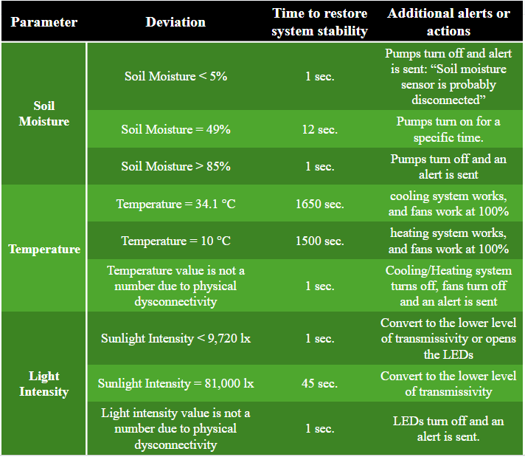
Positive Results
Table 8: Time to restore system stability
3)Table 8 confirmed the feedback loop's efficiency, successfully restoring system stability with maximum recovery times of 1,650 seconds for temperature shifts, 45 seconds for light changes, and 12 seconds for soil moisture deviations.

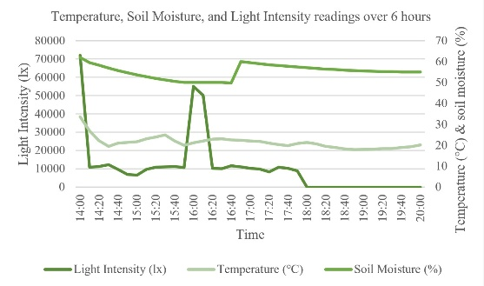
Figure 49: Temperature, Soil Moisture, and Light Intensity readings over 6 hours
- Figure 49 shows that the system successfully maintained stability across all three parameters during continuous operation.

- Table 9 shows the power consumption of each actuator.
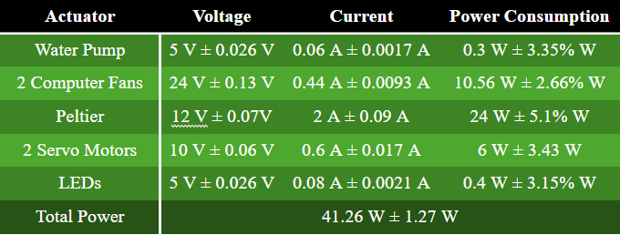
Table 9: Power consumption of each actuator

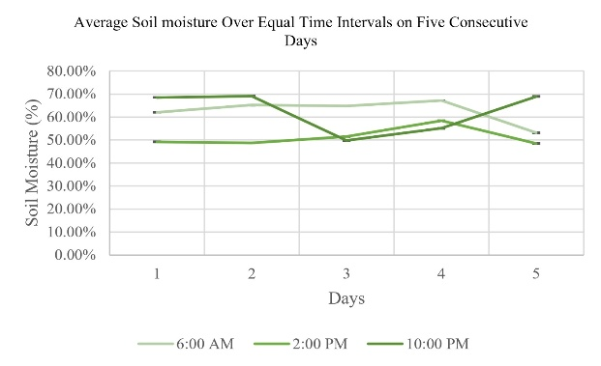
- As shown in Figures 50, 51, and 52, and Table 10, the prototype's consistency over five consecutive days. Accurately tracking distinct cycles at 6:00 AM, 2:00 PM, and 10:00 PM.
Figure 50: Average Soil Moisture over equal time intervals on five consecutive days

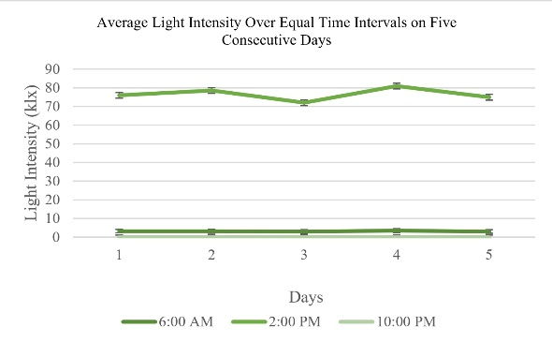
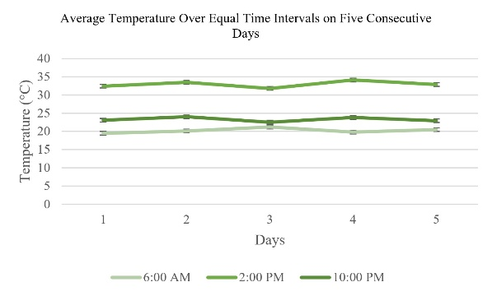
Figure 51: Average Light Intensity over equal time intervals on five consecutive days
Figure 52: Average Temperature over equal time intervals on five consecutive days

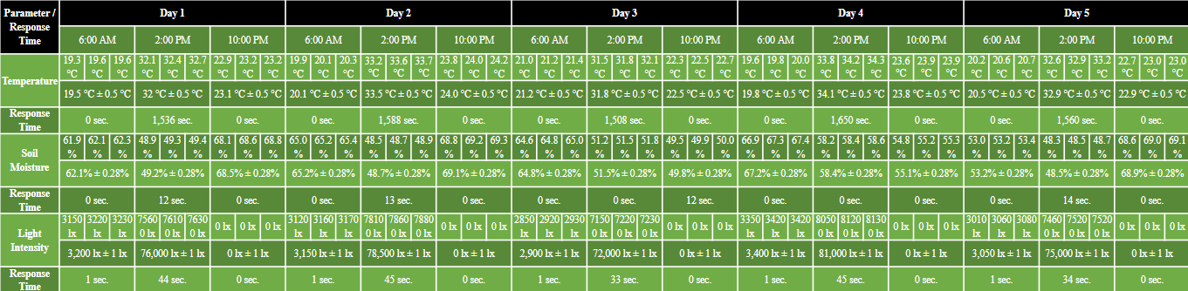
Table 10: Response time across 5 days

Chapter 4

Evaluation, Reflection, Recommendations, and Discussion

Analysis and Discussion

Feedback and Automation System:
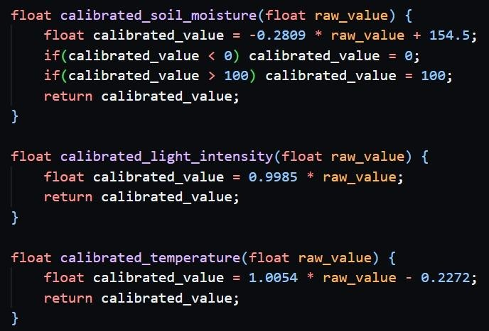
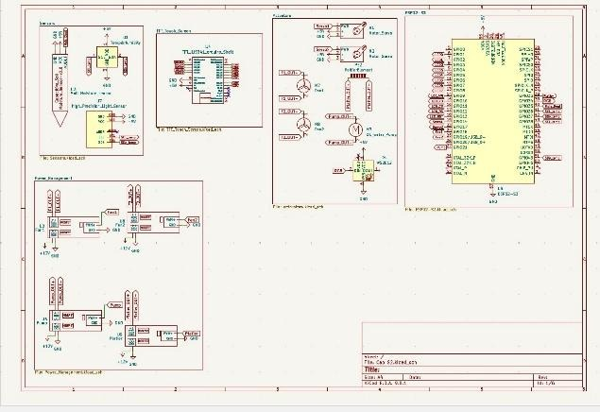
To achieve the best results, as shown in the results section, a feedback and automation system had to be made. As shown in Figure 53, the brain of the system that handles all the logic, sensor data processing, and control signals for the actuators is an ESP32-S3. It is connected to multiple sensors, which are a BH1750 digital light intensity sensor, an AM-2320 temperature sensor, and a capacitive analog soil moisture sensor V2.0, that sends environmental data via I2C or analog signals. Figure 54 shows the code that processes the data by converting the raw sensor outputs to the calibrated values according to the calibration equations using the ESP. After processing the data, the ESP sends orders to multiple connected actuators: 2 fans, 2 servo motors, 1 thermoelectric cooler, 1 water pump, and 6 LED sticks, to stabilize the system’s environmental parameters according to specific conditions and ranges. To manage the power getting to the actuators from the power supply, several MOSFETs were used, which can control the flow of electricity through the actuators. In addition, the microcontroller is connected to a TFT touch screen that represents the live sensor readings and their graphs, and it can be used to switch between the environmental condition ranges according to the selected plant species.
Figure 54: Mathematical calibration code
Figure 53: Circuit’s schematic diagram

Expected Optimal Time of Irrigation:
It is essential to keep the soil moisture within a suitable range for the growth of the arugula and spinach plants. For the arugula plant, soil moisture of approximately 58% to 62% is considered a suitable range (Lee et al., 2024). For the spinach plant, soil moisture of approximately 65% to 75% is considered a suitable range (Sun et al., 2023). To ensure that the system takes the least amount of time to irrigate the plants and reach the optimal soil moisture percentage, the expected optimal time of irrigation should be calculated. This will help prevent unexpected errors, such as over-irrigation, and check whether the irrigation time meets the design requirements.
$$V_{w}=ΔFC\%×FC\%_{total}×V_{s}$$
Equation 1: Required Volume of Irrigation Water
First, to get the time of irrigation, the required volume of irrigation water should be calculated. As shown in Equation 1, Vw is the volume of irrigation water, ΔFC% is the difference between the current percentage of water in the soil’s field capacity and the target percentage, FC%total is the standard total field capacity for sandy loam soil, which means the percentage of empty spaces in the soil that can hold water, which is equal to 20% in the case of sandy loam (Cornell University, 2010), and Vs is the volume of the soil. In the worst case of irrigating the plants, the current percentage of water in the field capacity would be 50%. So, to make it reach 60% for arugula and 70% for spinach, the difference in percentages is 10% and 20%. By substituting in Equation 1, the volumes of water needed to irrigate the arugula and spinach plants are approximately 151.22 ml and 302.44 ml, respectively.
$$t=\frac{V_{w}}{Q}$$
Equation 2: Time of Irrigation
Equation 2 is used to calculate the time of irrigation (t) using the required water volume (Vw) and the volume flow rate of the water pump (Q), which is equal to 1333 ml/min. In the worst case. By substitution, the expected time required for the arugula and spinach irrigation is 6.8 sec. and 13.61 sec. respectively. An additional 5 sec can be added due to the time of water flow through the hose to reach the openings.

Light intensity calculations & actuating
With its various units, the light intensity parameter is a main factor that affects plant growth because of its major role in the photosynthesis process. The units of light intensity are divided into 3 main types: photometric, radiometric, and quantum units. Firstly, the measurement unit of the used sensor, photometric unit, is the lux unit, which is equivalent to one lumen per square meter. Another type is radiometric unit, energy per unit time and unit area (W/m²). Quantum unit can be measured with
µmol. s⁻¹ . m⁻², which is based on the number of photons in a certain wave band incident per unit time (s) on a unit area (m2) divided by the Avogadro constant. The needed light intensity for the arugula plant to grow is 185:200 µmol. s⁻¹ . m⁻². Then, as the sensor uses lux units, the value must be converted according to equation 3 by multiplying by the conversion factor of sunlight, which is 54 (Thimijan & Heins, 1983), where L is light intensity measured with photometric and quantum units. As a result, 9990: 11610 lx is the resulting light intensity needed.
$$L_{Photometric}=F_{sunlight}∙ L_{Quantum }$$
Equation 3: units’ conversion

After finding the light intensity needed with a photometric unit, the actuation of light was done by using plastic films with different transmissivities. Transmissivity is the ratio between the light intensity entering the greenhouse and the sunlight intensity reaching it, as shown in equation 4.
$$Transmissivity=\frac{L_{entered}}{L_{sun}}$$
Equation 4: transmissivity
Then, plastic films and papers with different shades were exposed to lamp light, and the light intensity was measured to get transmissivity values shown in Figure 55. Hence, the plastic films can minimize the sunlight intensity throughout the day to reach the needed value, knowing that black films are used to block most of the light when the light intensity exceeds the needed value (cannot be minimized to reach it), and that is when the LED is turned on. Therefore, the light intensity reaching the plant is at the optimum value and provides favorable conditions for crop growth in addition to preserving energy consumption.
Figure 55: transmissivity for several plastic films and papers

Geometric shape analysis
To preserve the consumption of energy in the project, geometric shape plays a major role in minimizing the range of light intensity needed to actuate and then the energy consumption of motors and lamps. Thus, the average solar radiation in the region of Siwa is for one day is 6.3 kWh/m²/ day (Atia et al., 2023). Hence, dividing by 24 hours, the average sunlight irradiance is 0.2625 kW/ m². Since the light intensity needed for the arugula plant is measured in µmol. s⁻¹ . m⁻², the unit must be converted according to equation 5 by multiplying with the conversion coefficient of daylight (where L _{Quantum} is the light intensity measured by µmol. s⁻¹ . m⁻², and
L _{Radiometric} is the light intensity measured in W/m².
$$L_{Quantum}=C_{Daylight}∙ L_{Radiometric}$$
Equation 5: units conversion process
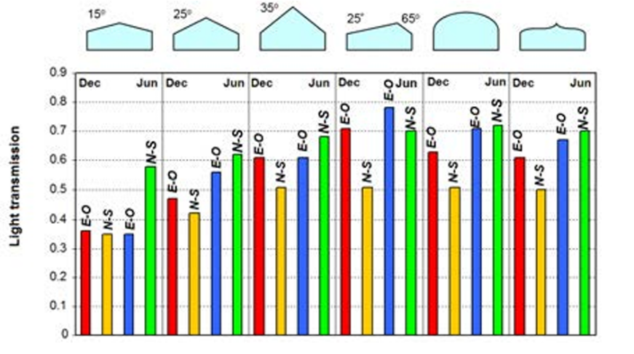
By substituting 4.57 for the daylight coefficient, the resulting value is 1199.6 µmol. s⁻¹ . m⁻², 4 times greater than the value needed (200µmol . s⁻¹ . m⁻²). As a result, because of its low transmissivity shown in Figure 55 compared to the other shapes, the selected geometric shape was a gabled greenhouse structure with a slope angle of 15°.
Figure 56: transmissivity for several greenhouses’ geometric shape
Figure x
After finding the suitable shape, the next step was finding the average light intensity
entering the greenhouse during the year. As shown in Figure 56, the transmissivity of the greenhouse with the selected structure averages between 0.35 (winter through north- south direction) and 0.57 (summer through north-south direction). Therefore, substituting in equation 4 (the previous analysis point), the resulting average light intensity enters the greenhouse ranges between 420 and 660 µmol. s⁻¹ . m⁻².

Conclusions
Climate change poses a severe threat to Egypt's agricultural development, specifically causing deviations in crop production in regions like Siwa. Eruca sync successfully addressed this challenge, proving that a smart, closed-loop feedback system can actively protect crops from environmental shifts.
Results demonstrated that the prototype met all specific design requirements. The system proved its reliability by operating automatically for a full 6 hours and successfully logging data at equal time intervals over 5 consecutive days outdoors. Furthermore, when parameters changed, the temperature, soil moisture, and light sensors efficiently triggered the actuators to restore optimal conditions. System stability was fully achieved in just 27.5 minutes maximum, beating the required 30-minute maximum.
Compared to traditional farming, which leaves crops entirely exposed to climate variations, Eruca Sync significantly minimizes crop loss. By continuously adapting to the environment without human intervention, this prototype offers to increase Egypt's agricultural base.

Recommendation

Real-life Application:
Figure 57: Reclamation Areas in the Siwa Oasis Region.
It is recommended to apply this project to the Siwa region, which is a natural depression with an area of 0.28 million acres located in the northwest of the Western Desert in Egypt, as shown in Figure 57. Egypt’s proposed development project in Siwa is to reclaim 30,000 acres. However, Siwa’s crop production is threatened due to global climate change. A study investigated whether government goals are possible under climate change during this century using different climate models under two representative concentration pathways (RCPs): RCP 4.5 and RCP 8.5. (Moghazy & Kaluarachchi, 2021). Using these models, summer temperatures in Siwa are expected to rise by up to 4.65 °C, which means that plants will need 18.2% more water just to stay alive. Hardy crops like maize losses 14.4% and 24.2% of their yield due to a small increase in temperature, such as 2 °C and 4 °C (Moghazy & Kaluarachchi, 2021). This means that tiny leafy greens, like arugula and spinach, would likely face 100% crop failure if planted in the same conditions. That’s why this location is perfect for confronting the increasing threats of climate change to Siwa’s crop production.
For the materials of the real-life project, the real-life project should mostly be composed of the same materials as the prototype, except for the plastic sheets covering the greenhouse, which could be replaced with isolating glass pieces. The electronic components don’t have to be recycled. The ratio between the dimensions of the prototype to that of the real-life project will be 2.00387:100 to make 1,000 greenhouses across the reclamation area of the Siwa region. The real-life project’s dimensions will be the same as the prototype, but with consideration of the scale conversion. The real-life project should have the ability to operate for multiple days without burning out.

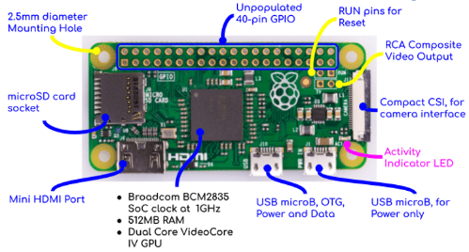
Raspberry Pi Zero SBC
Figure 58: Raspberry Pi Zero Specifications
A Raspberry Pi Zero is a single-board computer capable of handling more complex tasks, such as running AI agents and LLMs. Using it instead of the ESP32 S3 will increase the complexity of the tasks the project can perform, thanks to its 1GHz CPU, alongside 512 MB of RAM, in addition to a built-in Dual Core GPU coming together in one single board, along with other high specifications as shown in Figure 58. It can enable the project to use a machine learning model that analyzes all data it collects to improve its functionality. All that in offline mode without the need to use an online model. And they can be accessed anytime without the need to delete old logs every small period of time. The Raspberry Pi Zero is too expensive to be used with a project like this. But its features will make the project more sufficient and powerful.

Shift Register Integration for Full Automation
To improve the prototype’s automation and prepare it for larger farms, expanding the system's hardware capacity is a necessity. Currently, the greenhouse relies on a user manually switching the system between day and night profiles. This manual step is necessary because the ESP microcontroller does not have enough pins to run all the physical actuators while keeping the Wi-Fi connection active. To solve this problem, we highly recommend integrating a shift register into the main circuit. A shift register is a highly effective component that uses only a few pins from the microcontroller to create multiple new output pins. By adding this chip, the water pump, Peltier module, and all servo motors can be easily controlled while keeping the necessary pins free for the Wi-Fi module.
Once the hardware is upgraded with a shift register and Wi-Fi is safely connected, the system can be fully automated. The greenhouse will be able to connect to the internet and automatically sync its day and night cycles with the actual sunrise and sunset times. Finally, this internet connection will allow developers to build a smart web dashboard, letting farmers remotely monitor temperature, moisture, and light levels from anywhere, making this prototype a scalable solution for modern agriculture.

Recommendations to Future Teams
If another team in the future is going to complete from where we stopped in the project, I recommend they search more about the heat transfer mechanisms in greenhouses to understand them better. Also, they should have a clear and logical view of the mechanism of their circuit. So, they can design a good schematic diagram for the circuit easily and quickly. This will also result in a well-made and fast-made physical circuit. Maybe they can make a better sunlight isolation system that can block sunlight from all directions. As a result, the accuracy of the light intensity sensor will increase as the scattered sunlight decreases. This is because the light intensity sensor is very sensitive to any scattered sunlight coming from random places. Finally, it would be great if they searched more for optimizing the heating/cooling system and its relation to the light system.

Project’s Positive Influence
Working on this project resulted in some scientific and social impacts on the members of the team. For the scientific impact, it made the team members more knowledgeable about new concepts, such as light transmissivity and heat regulation concepts. Also, it increases awareness about the importance of smart feedback systems and how they are used to provide suitable environmental conditions for the survival of some species. For the social impact, working on this project makes you know more intellectual and well-educated people who share the same interest in the scientific concept as you. For example, most team members knew and had spoken with some professors, brilliant students, and even industry professionals. So, all of these new relations help in increasing the sociability of the team members.

Learning outcomes
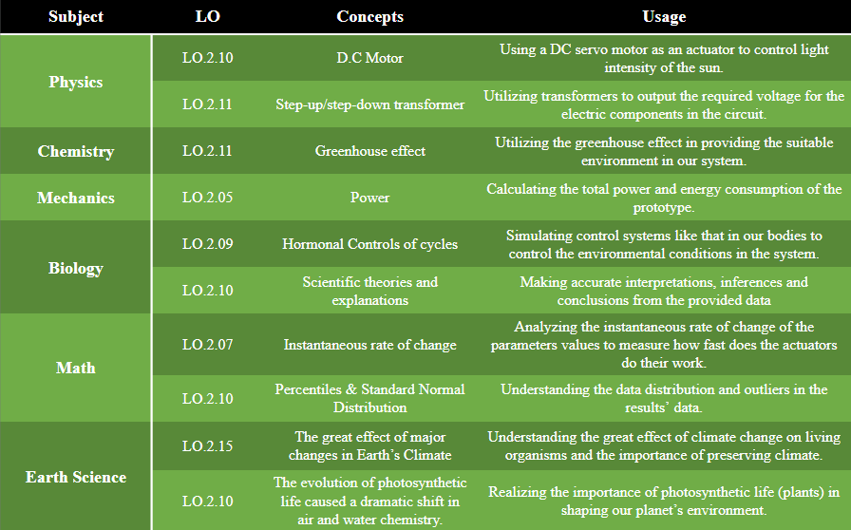
Table 11: Learning Outcomes

Literature Cited
Ríos Salazar, J. D., Candelo-Becerra, J. E., & Hoyos Velasco, F. E. (2020). Growing arugula plants using aeroponic culture with an automated irrigation system. International Journal of Agricultural and Biological Engineering, 13(3), 52–59. https://doi.org/10.25165/j.ijabe.20201303.5194

Abd El Maksoud, T. D. (2022). The impact of climate change-related factors on food production in Egypt. International Journal of Modern Agriculture and Environment, 2(2), 15–25.
Moghazy, N. H., & Kaluarachchi, J. J. (2021). Impact of climate change on agricultural development in a closed groundwater-driven basin: A case study of the Siwa region, Western Desert of Egypt. Sustainability, 13(3), 1578. https://doi.org/10.3390/su13031578
Gomah, H. H., Ahmed, M. M. M., Abdalla, R. M., Farghly, K. A., & Eissa, M. A. (2020). Utilization of some organic wastes as growing media for lettuce (Lactuca sativa L.) plants. Journal of Plant Nutrition, 43(13), 1891–1904. https://doi.org/10.1080/01904167.2020.1766077
American Geosciences Institute. (2016). Surface processes (Chapter 4). In EarthComm: Project-based space and earth system science (2nd ed., Section 7, p. 443). Lab-Aids.
Irrigation time (soil moisture parameters):
Arugula:
Lee, K., An, S. K., Ku, K.-M., & Kim, J. (2024). The optimum substrate moisture level to enhance the growth and quality of arugula (Eruca sativa). Horticulturae, 10(5), 483. https://doi.org/10.3390/horticulturae10050483

Sun, Y., Wang, J., Wang, Q., & Wang, C. (2023). Responses of the growth characteristics of spinach to different moisture contents in soil under irrigation with magnetoelectric water. Agronomy, 13(3), 657. https://doi.org/10.3390/agronomy13030657
Cornell University. (2010). PO 12.1-3 field capacity, permanent wilting point & available water capacity. Northeast Region Certified Crop Adviser Study Resources. https://nrcca.cals.cornell.edu/soil/CA2/CA0212.1-3.php
Ghanem, S., Ferrini, S., & Di Maria, C. (2023). Air pollution and willingness to pay for health risk reductions in Egypt: A contingent valuation survey of Greater Cairo and Alexandria households. World Development, 172, 106373. https://doi.org/10.1016/j.worlddev.2023.106373
Ritchie, H., & Rosado, P. (2025, December 19). CO₂ and Greenhouse Gas Emissions. Our World in Data. https://ourworldindata.org/profile/co2/egypt
Mohamed, A. (2019). Sustainability of e-waste Management: Egypt case study [Master's Thesis, the American University in Cairo]. AUC Knowledge Fountain. https://fount.aucegypt.edu/etds/783
Tarek, N., El-Nakib, I., & Abdelaziz, R. (2024). E-waste management in Egypt: Analyzing the impact of households’ e-waste awareness and e-waste disposal behavior on customer participation. Proceedings of the International Conference on Industrial Engineering and Operations Management, 2024, 1–12. https://doi.org/10.46254/AN14.20240584
Earth.org. (n.d.). Environmental impact of e-waste. https://earth.org/environmental-impact-of-e-waste/
World Health Organization. (n.d.). Electronic waste (e-waste). https://www.who.int/news-room/fact-sheets/detail/electronic-waste-(e-waste)
European Commission. (2025, January 8). Pollution and waste: Air, water and soil. Knowledge for Policy. https://knowledge4policy.ec.europa.eu/biodiversity/pollution-waste-air-water soil_en
Agriculture and Food Security | Basic Page | U.S. Agency for International Development. (n.d.). U.S. Agency For International Development.

https://www.usaid.gov/egypt/agriculture-and-food-security#:~:text=Agriculture%20is%20a%20major%20component,the%20country%27s%20gross%20domestic%20product.
U.S. Environmental Protection Agency. (2023). Warm version 15: Energy and greenhouse gas emissions factors. https://www.epa.gov/warm/versions-waste-reduction-model-warm
Valera Martínez, D. L., Belmonte Ureña, L. J., Molina Aiz, F. D., & López Martínez, A. (2016). Greenhouse agriculture in Almería: A comprehensive techno-economic analysis. Cajamar Caja Rural.

Thimijan, R. W., & Heins, R. D. (1983). Photometric, radiometric, and quantum light units of measure: A review of procedures for interconversion. HortScience, 18(6), 818–822.

Van der Heijden, P. G. M., Farrag, F., & Blom, G. (2013). Bustan Aquaponics: Egypt's first working commercial aquaponic farm. Aquaculture Europe, 38(2), 25–27.

El-Ramady, H., Alshaal, T., Bakr, N., Elbana, T., Mohamed, E., & Belal, A. (Eds.). (2019). The soils of Egypt. Springer Nature Switzerland AG.

